**Meet us in Droitwich**

You will be warmly welcomed at

our next meeting on Saturday October 28th 2017, 11am at Droitwich Methodist Church. After the meeting we chat over a bring and share lunch and are on our way home again by 2pm at the latest. We travel from the south coast, London, South Yorkshire Derbyshire and Leicester so look forward to meeting together 3 times a year. Please join us and share your interest in the welfare of children in Zimbabwe with like minded people. Please contact Gail, our secretary, for details.

**Christmas cards**

The Christmas card flyer is enclosed. We now have 5 designs left and they are available in single design packs or 2 of each design in a pack of 10. Price £2.99 for 10. Please place your order early to avoid disappointment.

**Thank you** to everyone who has donated or held fund raising events for the Children of Zimbabwe this year. Their need is still so great. Please continue your marvellous support.

# 

# Friends of Matthew Rusike Children’s Home

*We give mainly financial support directly to the Home*

September 2017 Registered charity 1120944

# Contacts

**Chair:** Carol Banham

64 Saffron Crescent

Tickhill, Doncaster,

South Yorkshire

DN11 9RU  
carol2021@banham.net

**Secretary:** Gail Richer

25 West Hill,

Aspley Guise

Bedfordshire

MK17 8DP

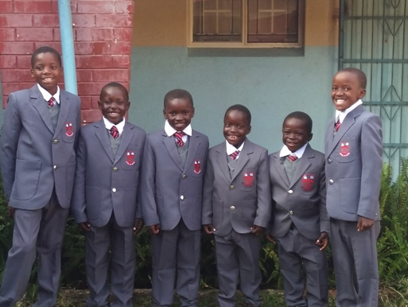**gmricher@btinternet.com**

**Treasurer:** Immanuel Mudzinge

103 Linney Road,

Leicester

LE4 0UX

[www.friendsofmatthewrusike.org](http://www.friendsofmatthewrusike.org)

This newsletter is distributed by

**The Friends of Matthew Rusike**

**Children’s Home.**

**News from the Home**

June We are now experiencing cold weather but we are all keeping warm. The children are in good health except the usual flus and colds which come with cold weather.

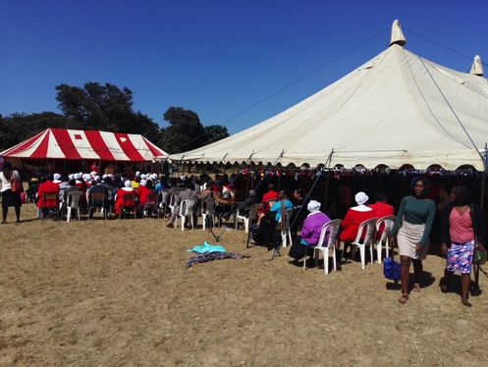Please tell the friends how grateful we are with the constant disbursements that continue to come our way. The children are all in school and have new winter uniforms.

Children dressed ready to start at Widdecombe Primary School.

Although it was extremely cold we had a huge turnout for **MRCH Big Sunday.** We managed to raise $5,833.30 on the day which is very good. Our sales are not very expensive so we gain on

volume. Almost everything goes for US$1.00.

We rented a swipe machine so people could donate with their bank cards straight into the MRCH bank account.This was necessary in deepening cash shortages. Amazingly people actually sleep at banks so they can withdraw $20 next day. We do most of our transcations through bank transfers so do not use real cash often

The building renovations are completed. We thank God that with several donations from W&S MWIB UK last year, Methodist Church in Zimbabwe and the Zimbabwe UK Fellowship all thehouses and semi-independence units are renovated and floors are tiled. You might remember our bare floors - now having all the houses tiled certainly eases the cleaning burden on the Caregivers they are so much easier.

We had a donaton from the MBCA Bank in Zimbabwe for the pig unit renovation.

**2 August news**

We are all doing well and experiencing a windy August. In a few weeks it will be very hot here but I know that you are experiencing the end of your summer now.

The children are generally in good health. But a new child, M, spent several weeks in hospital because she defaulted on her medication before she came to us. Among a host of other tests and medication, at one point she needed 3 pints of blood which we were able to cover, thanks to the monthly remittance that we receive towards the upkeep of the children in the Home. A pint of blood costs $180.00. We thank God that she is recovering now and is well on the mend.

12year old P was recently diagnosed with epilepsy. Through your support we managed to seek the necessary specialised treatment that she needed. (You will remember that, specialised treatment requires us to pay as it is not covered with the Assisted Medical Treatment Order from the Department of Social Services).

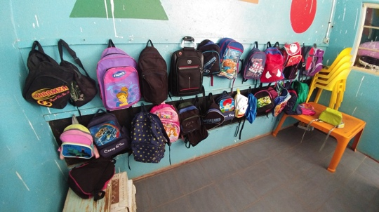Holidays with foster parents, which had been suspended by the department of Social Services as they carried out assessments on the foster families, started again this holiday. It’s very welcome as it allows the chldren to experience family life outside the walls of MRCH and gives our Caregivers the chance to return to their own familes for a rest. Not all the children have been able to go away but the department has assured us that by December all the children will be able to join their foster parents.

We are now looking forward to the annual dinner dance for local businesses which has been booked for the end of October. Hopefully we will be able to raise a substantial amount of money. We were encouraged by the MRCH Big Sunday and hopefully the same atmosphere will prevail and we can raise more. Our target for the dinner dance is

$15,000. Its certainly an ambitious figure but we are working hard to realise it.

Rev Margaret Mawire &

Zvirinane Matore

**A level studies**

The Home is able to fund the residential children upto A level and further skills training. The residential children remain our priority at all times. It is just unfortunate that most of them, because of various traumatic experiences, often do not do well enough to proceed to A level and as such enter other skills training soon after O level. Currently we have 3 promising students at

various levels, 2 of whom are

## 5 The children in the creche are both residential MRCH children and local Epworth children . They all receive a hot meal each day.

This is such a familiar sight in primary schools now – everyone has a big bag to carry **Ed**.

We were told about thei MRCH fundraising activities including regular jumble sales in the community when they receive a lot of clothing to sell.

## play 2As you will know there is a cash crisis in the country at the moment and this is proving to be quite a challenge for the home as well.  Less school fees are being paid by those families in the community who send children to school there.  This has meant that the Home has not been able to pay as many university fees as they would have wished.

Saltash Wesley Methodist Church

## A big thank you to Paul Melling for this detailed report and the lovely photographs he has sent. Also to the Saltash Wesley Methodist Church (Revd Jonathan and Fiona Budd, Robert Hambly, Derek Holley, Paul Melling and Catherine and Peter Noakes) which has supported the Mbare Church for so long as well as visiting and supporting MRCH over the years.

**Celebration**

From the 17th to the 20th of August we celebrate 40 years of autonomy from the British Methodist Church. We have a programme at the National sports stadium for the 4 days and we are all looking forward to it.  
 Rev Margaret Mawire

## Timely requests

About the the same time I asked MRCH for an up dated ‘wish’ list, a group wanting to raise money for a specific project contacted me- could I suggest anything? They chose to raise funding for new outdoor play equipment in the creche. The wish list will be on the website projects page soon Ed

“We were so delighted about news of potential sponsors for the creche. The play area really needs improving

## 3 in Boarding schools who we think will do well at O level. Just like in the UK, 10 good passes without Maths and English are not as good here too as they are needed as an entry point into university and tertiary institutions.

## Currently we have 3 residental children who are doing further studies with the support of the Home. L is in university studying Mining Science, N is studying Agriculture and W is studying Motor Mechanics.

School holidays are about to come to an end and the new term begins on 12 September 2017. Its the hottest term of the year but pretty busy especially for the examination classes as the exams start in October.

**A July visit to MRCH**

“A group of 7 went from Saltash Wesley Methodist Church to our partner church, Mbare Society in Harare for two weeks in July.

We had an amazing time with our friends, sharing with them, learning from them, and praying with them.  They looked after us very well.  Sadly the decline in infrastructure, employment and governance was evident as we shared with them in daily activities.

We spent a couple of hours at Matthew Rusike Children’s Home.  We were greeted by the Director, Revd Margaret Mawire, and the chaplain to the Home, Revd Chikomo.  They told us about supporting 4 children who go to boarding schools and 2 that are at university.  We were interested to hear about their outreach work with around 60 children in the Bulawayo area, nearly 130 in Gweru, and around 200 in Masvingo, supporting them with stationery and food.

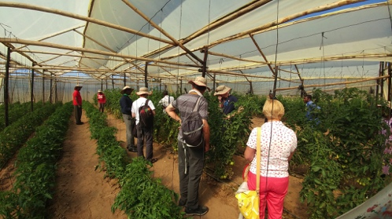We had a good tour of the site including the piggery, vegetable growing and gardening.

The crops growing in the greenhouses looked very healthy and it is good they grow surplus to sell to the local community.  Mark Edmonds’ work is incredible and his return this November to build a plants nursery to avoid the cost of buying seedlings is great to hear.

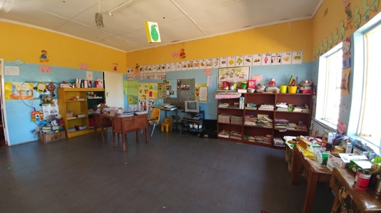We called in to see the crèche

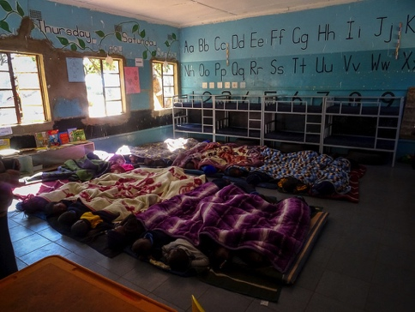**4** It was nap time and it was delightful to see 40 young children lying top to toe under blankets.  Some were awake and smiling at us and others were obviously enjoying an afternoon snooze

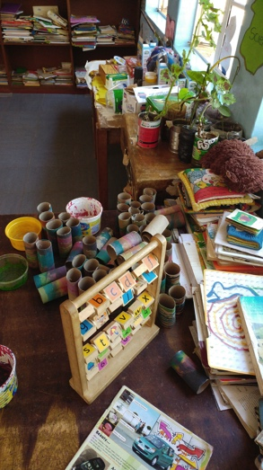We popped into the other rooms and saw lots of posters and drawings on the walls, things to play with around the side of the room and evidence of different activities which take place.  In the cultural corner were images of early Zimbabweans and some of the traditional tools they used for hunting and cooking.

They were growing plants in the science corner, and had a handful of musical instruments in the music area.

The wooden play equipment in the adventure corner looked to be almost brand new and very tempting to try out. (This was the climbing frame donated by a Doncaster playgroup)

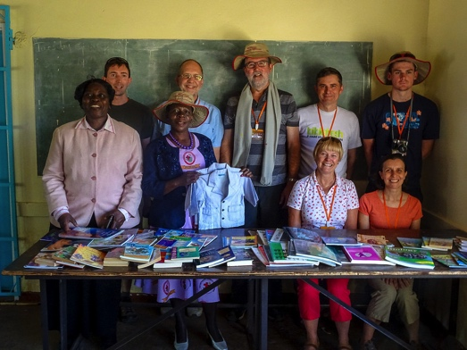The weekly timetable on the wall looked very organised and all basic subjects were included as well as some time to play indoors and outside.

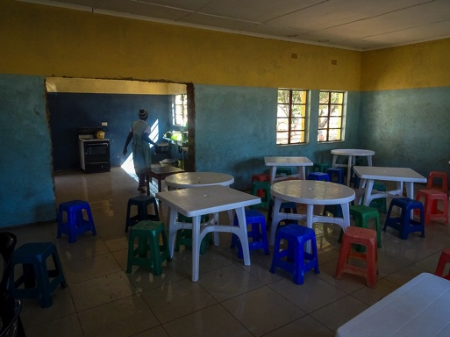We had taken some children’s story books and a few science text books which we handed over for them to use as they thought best.