had the following crops growing, cabbage, rape, spinach, peas , beans, sweet corn, butternuts, water melons, onions, carrots, tomatoes and capsicums.

I return to MRCH in April 2018 hopefully to replace the old greenhouse and build a passionfruit trellis. We trialled a couple of plants and they grow well in Harare. This should all leave MRCH self sufficient in vegetables, eggs and chicken whilst also assisting cashflow from sales of excess produce.

It was a pleasing trip and good to see that everything looked good and the children were happy.

Mark Edmunds, Australia

**Meetings at Droitwich Methodist Church for 2018**

**AGM** Saturday April 14th

**Executive committee** June 30th

**You will be made most welcome at either or both these meetings. Please contact us for details.**

**We are still looking for a New Secretary, could it be you?**

Unfortunately our secretary, Gail, is having to step down as our **minutes** secretary. Could **you** volunteer to attend our 3 annual meetings to produce our minutes. Contact Gail if you are interested in knowing more about this important job.

**Membership due**

# Friends of Matthew Rusike Children’s Home

***We give mainly financial support directly to the Home***

March 2018 Registered charity 1120944

Your membership of £10 each was due in January. If you wish to be a member please send your cheque to our treasurer, Immanuel Mudzinge, payable to FoMRCH.

**Fundraising**

Can you set up a standing order or sign a gift aid form (if you have done this once you don’t need to do it again) then contact our treasurer. Can you name FoMRCH as your charity when you shop on line or set up a project on Virgin Money Giving?

Thank you to all who have raised funds for the Children in Zimbabwe, their need is still so great. Please continue your marvellous support.

# Contacts

**Chair:** Carol Banham

64 Saffron Crescent

Tickhill, Doncaster

S Yorkshire

DN11 9RU

carol2021@banham.net

**Secretary:** GailRicher

gmricher@btinternet.com

**Treasurer:** Immanuel Mudzinge

103 Linney Road

Leicester

LE4 0UX

manu.mudzinge@gmail.com

**Take a look at our website**

[www.friendsofmatthewrusike.org](http://www.friendsofmatthewrusike.org)

This newsletter is distributed by

**The Friends of Matthew Rusike**

**Children’s Home.**

**Farewell from Rev Margaret Mawire** who moved on from MRCH at Christmas. They all had a huge party.

Rev Margaret and Dr Liberty Mawire at their farewell party.

“I would like to thank you all for your support during my term of office at MRCH as National Director. When I came the economic situation was as bad as it is now. You continued to help us. Staff had gone for 5 months without salaries and FoMRCH paid all the arrears, it was a great relief for me. You raised funds to buy a new minibus and it became safe to take the children out. Electricity supply was another monster but you raised money for a generator at just the right time. You had friends who raised funds to refurbish all the 8 houses. The regular monthly remittance has made planning and budgetting so much easier. Please pass my gratitude to all the Friends of MRCH and I pray for the same kind of support for the Incoming Director.” Rev Margaret Mawire

**We welcome to MRCH the new National Director, Rev Linrielink Mutendzwa.**



“I was born in 1972 in Chivhu in the Mashonaland East District of Zimbabwe. I am married to a supportive wife, Mercy, and we have been blessed with 2 sons and a set of twins a boy and a girl. I have been a Methodist minister since 1994. During my ministry I have served the church in different areas, rural and urban with different cultural settings, schools and at Head Office. I have been a circuit minister, minister in charge, Principal and synod secretary. I also served as the Research and Publications National Coordinator between 2006 and 2012. Before my appointment at MRCH I was a circuit youth minister at Hatfield Circuit where I had been for a year after a near fatal traffic accident that left me with broken limbs. The Lord raised me back to life on plated legs.

Professionally I hold an Executive Masters in Business Administration, BSc Management and Entrepreneurial Development Studies, Diploma in Theology and another Diploma in Religious Studies. I also hold various certificates in the areas of Development, Research Methods and Business and Project Management.

I bring to MRCH a warmed heart, braced up spirit, enduring soul and an open mind. I believe God will use me as a reliable instrument in this special child care ministry.”

Rev Linrielink Mutendzwa

**News from the Home**

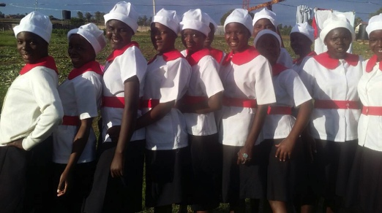“Thanks indeed for your continuous support. Soon the Home will be noisy again when the children return from their holidays. As usual the beginning of the year has challenges in child care institutions since most children will be going for Grade 1, Form 1 and Form 5. A lot of money is needed for their enrolment. The school fees will be high, new uniforms and a lot of stationery is also needed. We hope to normalise by the end of March when we have cleared most of the educational requirements.” Lloyd Kupeta

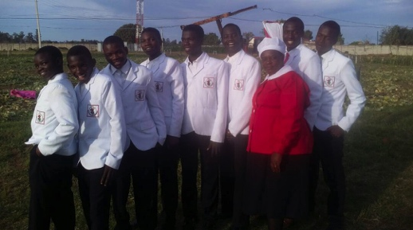“We have begun the year very well. We have 2 girls who did extremely well in their Grade 7 exams and will be starting Form 1 at Waddilove High boarding school. We wish them well and hope they continue to excel.

We have had many children ‘badged’ at church. This means children are grouped according to age, they learn about the Bible and do activities at church. The girls under 15 are called Tsungari and they are preparing to join Girls’ Christian Union.

The older girls in the Girls’ Christian Union wear a red and white uniform and take an oral or written examination.

The boys study the same things and join the Boys’ Christian Union.

The day they all start to wear their uniforms is such a big deal and exciting event for the children and usually comes with a mini convention, hence the smiles and excitement.

**A level students**

Two A level students have done extremely well and scored 20 points because they took 4 subjects. They have really put the Matthew Rusike college on the map and we are very proud of them.

Unfortunately we had no rain for a long time then it came late and some crops have been seriously affected. MRCH is fortunate to have bore holes and a good irrigation system but we may not get the bumper crop we had last year. Zvirinane Matore

**Garden projects**

“It was a very pleasant surprise when I drove into the Home on the first morning last November as the garden and surrounds looked great.

I had invited the Australian Ambassador to visit whilst I was there as the Embassy provided funds last year towards the installation of solar power to run the two bore pumps. Sadly he

cancelled at the last minute.



We made a new propagation greenhouse from recycled timber and plastic and now the locals want to buy the seedlings which will generate more income.

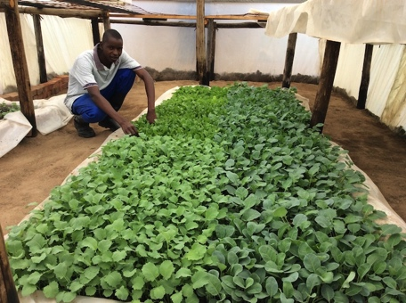

Lovemore has done very well with his seedlings

They had just harvested 40,000 onions many of which will be sold and also allow for the Carers to use many for the children over ensuing months. Lovemore also