## From our Treasurer

Zimbabwe is currently going through a transition period and facing some very challenging economic times. This has a direct impact on the country's local currency value and cost of living for the people. Its comforting for us that the money we send to MRCH is channelled through a US dollar Foreign Currency Account (FCA) and therefore retains its value for the full benefit of the children.

Immanuel Mudzinge

**Recent donations**

David and Wayne’s marathon Mongol Rally raised over £1000

The special appeal launched in September has so far raised **£4120.80** with more to come in from other events**.** Thank you and well done everyone.Shirley Richer

Sunday morning tea/coffee, homemade jam and homegrown vegetables sales at Threemilestone Methodist Church raised **£919.30**

Orpington Methodist Church raised **£1258.60** at their Harvest celebrations towards replacing the broken outdoor play equipment.

Special birthdays, anniversaries and funerals have also been very generous to MRCH recently.

## Christmas cards

We now have only 3 designs left so we didn’t expect to sell many cards this year. A big thank you to all who did and raised **£247** including **£65** which can be gift aided.

Carol Banham

Thank you all and please continue your marvellous support. Could you set up a standing order and/or gift aid your donation?

# Friends of Matthew Rusike Children’s Home

***We give mainly financial support directly to the Home***

December 2018 Registered charity 1120944

**Annual subscriptions** are now due for 2019. To be a member please send £10 per person **to our treasurer.** As a non member you still receive 4 newsletters and everyone is welcome at our meetings.

Please join us for our

next meeting **11am on Saturday 9th March 2019**  or the **AGM June 22nd** or even **October 19th 2019** , all at Droitwich Methodist Church. We have a bring and share lunch afterwards with time for a chat. Please contact our secretary for details.

# Contacts

**Chair:** Carol Banham

64 Saffron Crescent

Tickhill, Doncaster

S Yorkshire

DN11 9RU

carol2021@banham.net

**Secretary:** Michael Mapako

michaelmapako61@hotmail.com

**Treasurer:** Immanuel Mudzinge

103 Linney Road

Leicester

LE4 0UX

[manu.mudzinge@gmail.com](mailto:manu.mudzinge@gmail.com)

[www.friendsofmatthewrusike.org](http://www.friendsofmatthewrusike.org)

This newsletter is distributed by

**The Friends of Matthew Rusike**

**Children’s Home.**

**News from the Home**

§eptember

Thank you for your communications, they build my self esteem and confidence to help the children in our care.

****All the children who had gone for holidays to their foster families are back with lots of interesting stories about their holiday experiences. I am proud to say they are all in school now, their health is good and those who are in National Exam Classes are reading hard to pass their exams. We are happy that one of the children who is doing Form 4 at Waddilove High School attempted History and Geography in June and came out with ‘A’s in each subject. He will write the final in November.

We are in good hot season and there is need for another electric borehole if we want to continue with the level of production in our Income generating Projects.They thrive well in other seasons but when it is hot they suffer from lack of sufficient water supply.

I escorted our Boys Christian Union

(BCU) to a Convention in Masvingo. They interacted so well with their counterparts from different provinces and with different languages. We want them to know more about their society and country.

My prayers are with everyone of you because of the sterling work you do for the Home, God bless you all.

Lloyd Kupeta

Our half marathon on 15th September went very well. We

started at 0600hrs (before it got too hot for the runners) and was done by mid day. Zimbabweans from all walks of life came to support it and we are pleased with how it went.

Initially we were not sure whether the event would go on as public

gatherings had been banned in Harare in the face of a cholera outbreak. We could not afford another postponement so we were very relieved when the police cleared us. We hope to make it an annual event and hopefully many

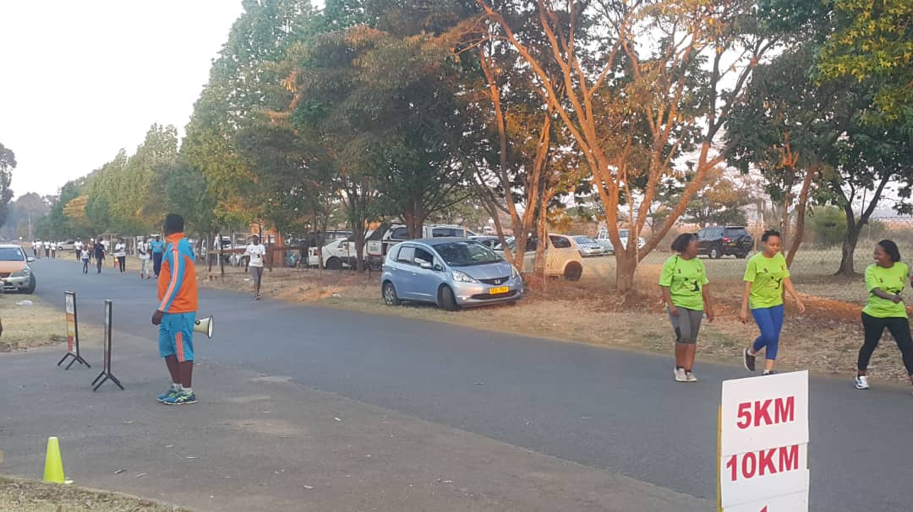

“I ran for a child at MRCH” t shirts

corperates will be involved from next year. This year we managed to get sponsorship towards t shirts, an ambulance, venue, drinks and water sachets. Four of our children and some staff members participated in the event and I did 5km in 39 minutes. Zvirinane Matore

Well done to everybody! Ed

**Retirement**



**Mercy Chimhau** is the longest serving carer at MRCH, she has been there for 32 years and retires at Christmas. “We will miss her wise council, her love, her warmth and above all her cooking”

Mercy cooked the main meal each day for all the staff and any visitors staying at MRCH as well as caring for her 10-12 children.

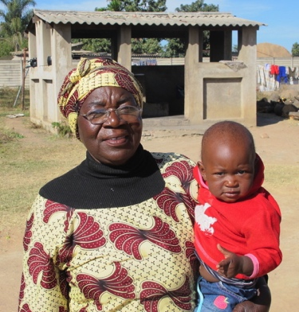

Mercy with one of ‘her’ babies

**New staff at MRCH**



Shorai Chindito joined MRCH in August and is the new Finance and Administration Officer.

**Two Visits to MRCH**

The financial system and economy in Zimbabwe is in chaos, I don't know how anyone can conduct a business there. I admire the people's resilience and I still came away feeling quite good and

positive about MRCH.

The pigs, poultry, egg production and fresh vegetables are all expanding well and improving the children’s diet; surplus is sold to local shops. Fertilised eggs are sent off to an incubator for hatching.

They grew 10,000 tomatoes this year as well as green vegetables.

The last of the old greenhouses has

been removed and I hope to raise the US$8,400 in Australia to return next April and build a second 500sq.m one to expand the range of crops to include

more vitamin A vegetables. It will have a metal frame and a single bay roof structure which will be better suited to the heavy rain/wind conditions in Epworth.

I was pleased to see the new

AgricultureTeacher at the High School utilising the area I set aside in a garden development to teach the students vegetable gardening.

The Nurse said the Children's Health at MRCH was 'generally good' but she too would like to see more vitamin 'A' veggies for the Children. Hopefully that will soon be rectified.

The new Project Manager is going to assist in training the new Head Gardener.

Mark Edmonds, Australia

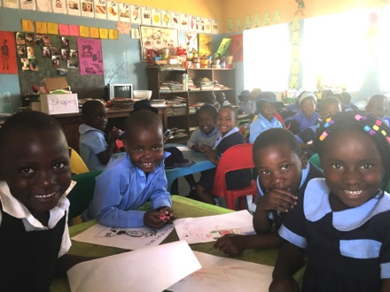

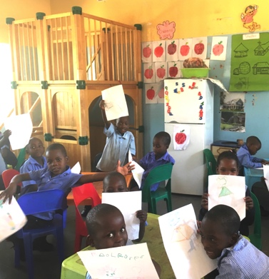It was good to be able to meet old friends and colleagues during my visit to MRCH as well as speak to Rev Linrielink Mutendzwa, the new director. He is very grateful for the 2 main sources of consistent support from the Friends in the UK and a Zimbabwe finance company. I felt very reassured that he seems to have a full grasp of the children’s needs and despite all the socio economic difficulties they are under they remain very focussed on the children’s needs. There are now just over 100 children.

Unfortunately the staff salaries are in 2 months arrears again.

Church circuits have an annual food budget for MRCH but cash donations are difficult for the people.

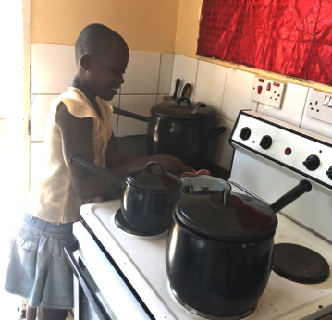I came across Lloyd instructing a class of community childcare workers having refresher training; I met Mercy who retires in December. While she is looking forward to rest and retirement she will miss her children and colleagues. I worked with Mercy in 1996-98 and she has always been very caring towards the children and kept in touch with former residents, a sign that the children value her care of them. Mercy will certainly be missed by both children and staff.

Econet wireless, the mobile phone company, has offered targeted support with school fees for some primary school children. However as it is based on some set requirements to do well, the fear is, because of the children’s traumatic backgrounds, the sponsorship might come to an end.

Zvirinane took me round and I saw the youngest children who happily posed for photos.

The

play tower we sent in 2012 is still being used

I met a young girl of about 9-10 who had recenly been placed at MRCH by Social Services and was waiting for a school place. She was cooking vegetables to help one of the mothers prepare the evening meal for her new family. Michael Mapako