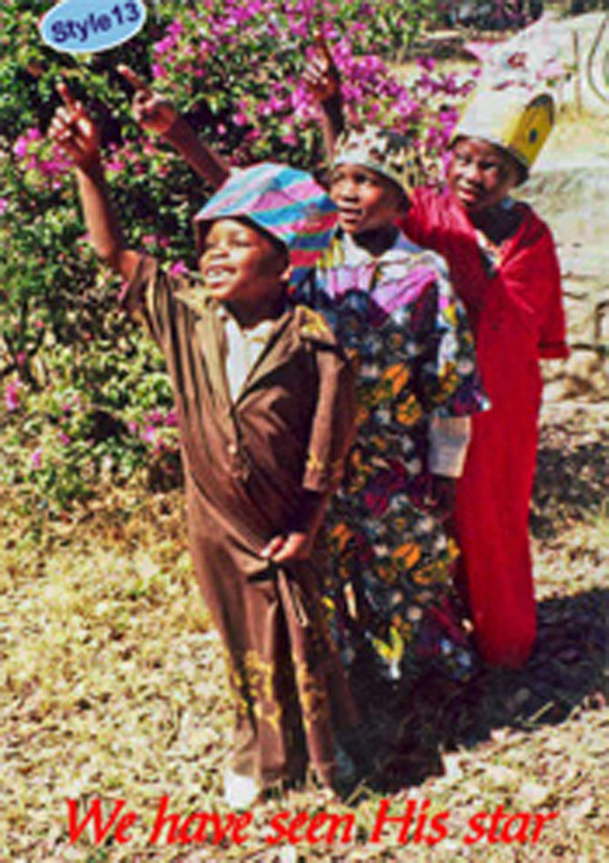
Friends of Matthew Rusike Children’s Home Christmas cards

£2.50 for 10 cards

In the past the sale of Christmas cards has averaged a profit of £2000 a year since we began selling them in 2004. All of this has gone directly towards the care of the children at MRCH. Thank you for your help in the past and your continued support is much appreciated.

We are no longer supplying new designs so we are selling the remaining cards
at less than our original 2004 price.

£2.50 for 10 cards with envelopes.

We shall not automatically send out packs of cards as in the past so please place your order as soon as possible

THIS WILL POSSIBLY BE THE LAST YEAR CARDS WILL BE AVAILABLE

Please contact me to place your order

Tel 01302 744 920 Email carol2021@banham.net

Post

64 Saffron Crescent
Tickhill, Doncaster
South Yorkshire
DN11 9RU

.

These 3 designs 11, 13 and 14, are all
available in single design packs but
choose any combination you would like

13

This photograph of the 3 Wise Men was
taken at the Home during their annual
nativity play

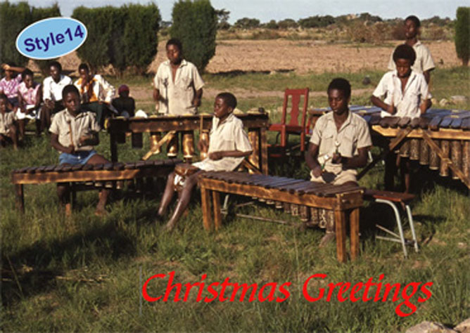

14

This photograph was taken at
the Home during some
celebrations when the Marimba
band often entertains visitors.

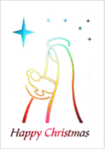

11

This design of Mother and Child is in silver
reflective holograph foil, the colours only
shine when they catch the light.

