how they see our world.

It is available to watch on Amazon Prime. Here is the link: [www.amazon.co.uk/House-Children-Daniel-Drema](http://www.amazon.co.uk/House-Children-Daniel-Drema) If you do not have Prime, it is free to join for a month.

David Graaff

A reviewer has said – This film is ‘an intimate, refreshing documentary…of visual beauty’ different from many in a similar vein. ‘The vitality, hope and stunning ordinariness of the children (and young adults) has ‘life affirming sincerity.’

A big thank you to those churches and individuals who responded to our urgent appeal in April when donations dropped at the start of the pandemic. By the middle of June we had received **£3,482.**

At the same time some of you used Smile when shopping on Amazon and we received **£5.48** from them – every little helps.

**£150** was donated by text from mobile phones. You are charged normal rate for a message plus the amount donated….. just text:

RUSIKE 20 to 70085 to give £20

RUSIKE 10 to 70085 to give £10

then around the same time we also received **£4028** from Gift Aid claimed for 2017. This was all a wondeful boost to our fund.

The situation in Zimbabwe is volatile and fragile. Our remittances to MRCH are £2000 per month (sent bi-monthly). Immanuel Mudzinge, treasurer

**CHRISTMAS CARDS**

# Friends of Matthew Rusike Children’s Home

***We give mainly financial support directly to the Home***

September 2020 Registered charity 1120944

**Only the same 3 designs are left as last year at £2.99 for 10, including the silver foil mother and child. If you would like further information any please contact me.**

**Carol Banham**

If you use Pay Pal or Amazon Smile please mention MRCH for charitable giving, it doesn’t cost the buyer or the charity anything.

Thank you to all who have raised funds for the Children in Zimbabwe, their need is still so great. Please continue your marvellous support and could you set up a standing order and/or gift aid your donation?

# Contacts

**Chair:** Carol Banham

64 Saffron Crescent

Tickhill, Doncaster

S Yorkshire

DN11 9RU

carol2021@banham.net

**01302 744 920**

**Secretary:** Michael Mapako

[michaelmapako61@hotmail.com](mailto:michaelmapako61@hotmail.com)

**Treasurer:** Immanuel Mudzinge

103 Linney Road

Leicester

LE4 0UX

[manu.mudzinge@gmail.com](mailto:manu.mudzinge@gmail.com)

[www.friendsofmatthewrusike.org](http://www.friendsofmatthewrusike.org)

This newsletter is distributed by

**The Friends of Matthew Rusike**

**Children’s Home.**

***FINANCE REPORT*** *FOR MATTHEW*

*RUSIKE CHILDREN’S HOME JULY 2020*

This report is presented under a volatile economic environment with rapid policy and currency changes in Zimbabwe. A multi-currency system was introduced in 2009 following the total collapse of the Zimbabwean dollar followed by a bond note in 2014. June 2019 saw foreign currency cease to be legal tender and the return of the Zimbabwean dollar. In March 2020, as a result of the Covid19 pandemic, foreign currency was re introduced and in June 2020 an auction system done every Tuesday results in weekly changes in exchange rate and frequent changes in prices of goods and services.

This situation hit us hard at MRCH. Planning the material and financial

support for the children in our care

was hit by the country’s economic

decline, shortage of cash, and run

away inflation pushing basic goods

and services beyond the reach of

the vulnerable. Rapid policy changes,

drought, poor health and education delivery exacerbated the situation.

Both the Finance and Administration

officer and the bookkeeper found

new positions and the Church’s

finance officer stepped in temporarily

to deal with our finances.

In a bid to stay afloat a number of

cost cutting measures have been put

in place:

1 The project officer was laid off and

the contracts of 2 ground staff were not renewed.

2 One qualified finance and accounts

person was hired to replace the two

posts mentioned above.

3 We stopped hiring contract workers

for the projects.

4 The administration of the College

and Home were separated.

5 Use of firewood and the out door

kitchens cut the cost of electricity.

6 A greater concentration on our

‘home grown food projects’ for feeding

the children.

**Income** **in 2019** was ZWL$2,579,335

**34%** came from Church, companies

and individuals in Zimbabwe.

**40%** came from the Friends of MRCH, World Mission Fund, and Methodist overseas Fellowships.

**26%** came from our fund raising

efforts, rent, fees from the Early

Childhood Development centre, and

sale of livestock.

Our main expenditures were childcare

costs and staff salaries.

We are still compiling records for

donations in kind received during

MRCH week in June but they are

generally lower than previous years.

In spite of the day to day challenges

we face to shelter, feed, clothe, treat

and educate the 98 children in our residential care and 51 in our

community outreach programme, we continue to see the Divine hand at

such a time. We are up to date with

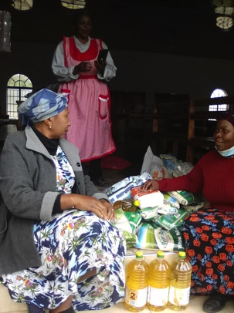staff salaries and statutory

obligations and our children have not missed a meal. We greatly express

our indebtedness to our partners, specifically FoMRCH, whose support

is extremely valuable for the running

of the Home. We pray for continued support especially in the face of the

Covid19 pandemic where donations

are going down as traditional

partners also grapple for survival.

National director Rev Linrielink Mutendzwa

June 11th We are still in lockdown as

virus cases are rising, mainly of

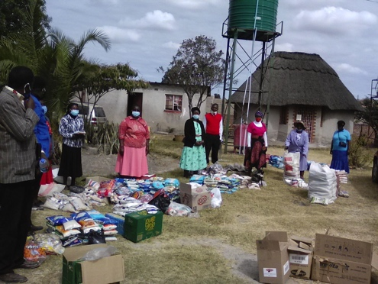returnees from South Africa testing

positive upon being quarantined.

There is very little local transmission

but we have to be extra careful now

we are in winter.

The children are all doing well. They

attend ''school'' from 11 am to 1pm everyday. You maybe interested to

know that the children are actually dressing up in their school uniforms

to improve motivation. They also

have a lot of recreational time on

their hands but otherwise

everything is going on well.

The educational needs of the

children are well taken care of as 4

staff members have teaching

backgrounds. The government has

said that schools will open on the

28th of July 2020 but the exam

classes will open a little bit earlier

than the rest. This means that

College students in exam classes will also start soon and the college has been preparing for this, buying in protective clothing etc.

We also had our “virtual” MRCH week from the 1-7 of June.

We had lots of online presentations about the Home showing in various Methodist Churches in Zimbabwe and on MRCH social media. It was encouraging that lots of people viewed the presentations. Due to movement

restrictions, staff had to drive round

to collect donations in kind from the churches this year.

Rairo tells me children really missed the celebrations we do every year. We pray that next year things will have normalised. Zvirinane Matore

July 7th We thank God for the Methodist community for responding very positively during our MRCH week with material donations. We are so surprised with the support considering the suffering people in Zimbabwe are going through.

The Methodist Church Connexional office bought food material worth US$3661. We also received from Kellie in Australia, US$500 to buy drugs for the children.

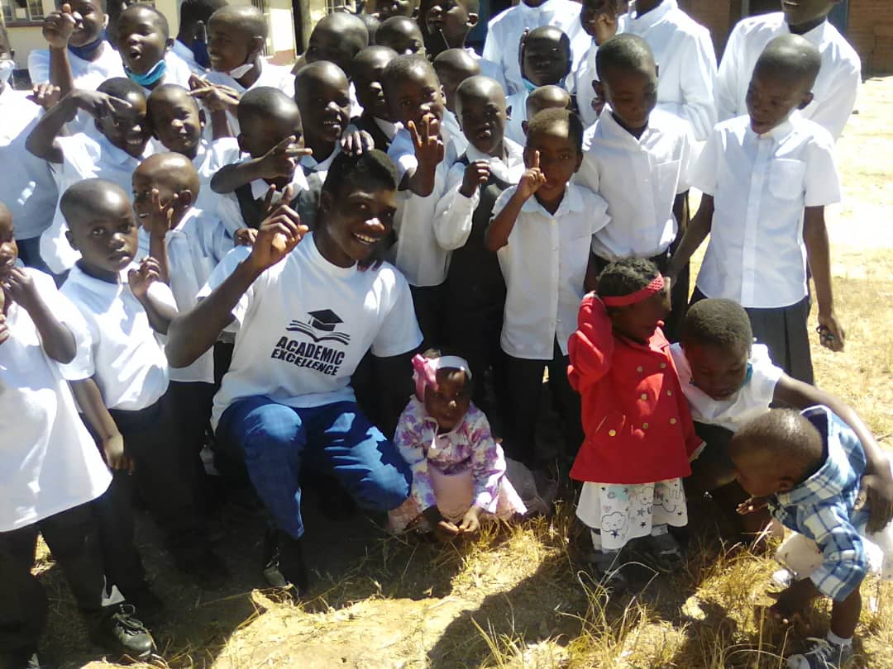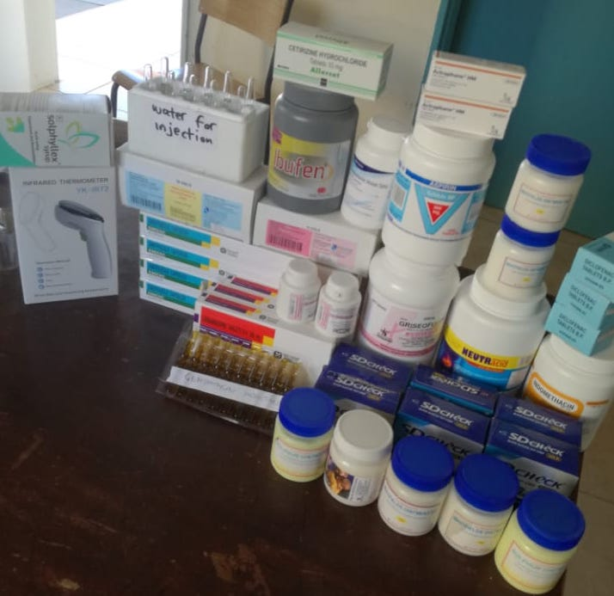

To date we have received $68000 Zimbabwean dollars donations towards Matthew Rusike week from churches and individuals**.**

The Government is opening schools in phases starting with June examinations. We are an exam centre and have put strict measures in place to keep children and staff safe.

One of our greatest challenges is how to give care-givers time off and still keep both children and care- givers safe. Bringing in relief mothers is a risk and releasing care-givers is also exposing them to the danger of corona. Rev Linny Mutendzwa

July 17th We are all doing well but it looks like we are headed for another lockdown as the numbers are increasing fast especially in Harare and Bulawayo. Opening of schools has been postponed indefinitely and we remain at home. Interestingly, the Home received a donation of free testing for all the children above 12 and staff and we are happy to say that everyone tested negative.

August 14th Everything is kind of a routine now and Linny and Rairo tell me everyone is in good health and good spirits. Rairo sent this photo of the youngest children who were responsible for Sunday service last week.  Luckily they are still able to hold church meetings in the hall as they do not have to mix with any

outsiders. With the help of Rev Faustine the children managed to lead the service and we are very proud of them. Zvirinane Matore

We received news of a film made in Zimbabwe by a young director Daniel Drema. This hour-long film, **House of Children,** was made in a children’s home in Marondera. It gives voice to the children’s view of the world and their hopes and aspirations. It is a wonderful insight into their world and