The Challenge.

This year I am President of the local branch of my professional association, and it has become the tradition that the President undertakes a challenge to raise funds for charity. The last four or five presidents have walked or run marathons. I thought this year might be a good time for a change and so in the spirit of the Plymouth Dakar banger rally and numerous Top Gear adventures I will be driving an elderly Mercedes Benz the 2,700 miles from London through Morocco and the Western Sahara to the Mauritanian border in West Africa.

The plan is to get sponsorship for the journey and to sell the car in the no-man’s land on the Mauritania border. All donations will go direct to FoMRCH, and the value of the vehicle when it sells will be my contribution.

I will be sharing the driving and navigation (and tent) with my co-driver and fellow adventurer Wayne Cooper.

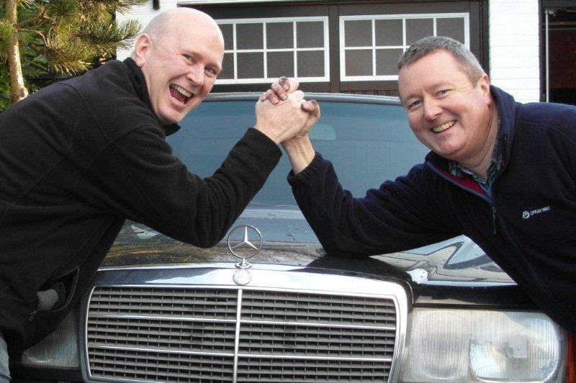

The Charity

The Friends of Matthew Rusike Children’s Home (FoMRCH) is a UK based fund-raising charity that sends everything it raises to support the children’s home. The Matthew Rusike Children’s Home (MRCH) is part of the Methodist Church in Zimbabwe and provides a protective and caring home for 145 children.

The children live in small family groups of ten to twelve children under the care of house mothers. A small number of young babies are cared for in a family group by one ‘mother’. Many have been abandoned, abused or have lost parents to AIDS. Each family unit has its own garden in which the children learn to grow vegetables and then learn to cook them in their own kitchen. They also learn to look after goats, rabbits and chickens to sell or to eat.

All the children receive an education, there is no free schooling in Zimbabwe and all the children go to schools which must be paid for. FoMRCH pays school fees to local schools (and some children receive external sponsorship to go away to boarding schools to do O and A level courses). All children are provided with school uniform and shoes to attend. The children can also learn tailoring, carpentry and basic computer skills. All the children have specific care plans, so each child’s talent is nurtured and they can be helped to realize their full potential.

All the buildings originating from the 1960’s have been refurbished. The old dormitory buildings have been developed into a new administration block and accommodation for staff, volunteers and visitors. The older teenagers live in independence units. These young adults, who are getting close to leaving the home, look after themselves, cooking and washing for themselves in a protected environment. The home still helps with skills-training after O level exams and a young person can stay at the home until they have a job or somewhere to go.

There is a clinic which houses a consultation room, a young child observation room, a room with five hospital beds, a small pharmacy and two tiled bathrooms. The qualified nurse cares for the HIV positive children living at MRCH and any other children and adults who are taken ill. She is part of a training team who give advice and support to the volunteer caregivers, especially in working with the many children who have HIV. There is always a shortage of basic medicines, first aid items and antiseptics.

My family has a long connection with the charity, my parents knew the Rev Matthew Rusike and his wife when they started taking in street children in the 1950’s and both my parents supported the charity through the rest of their lives. There is a slide show of a visit I made to the home with my mother in 2003 on YouTube.

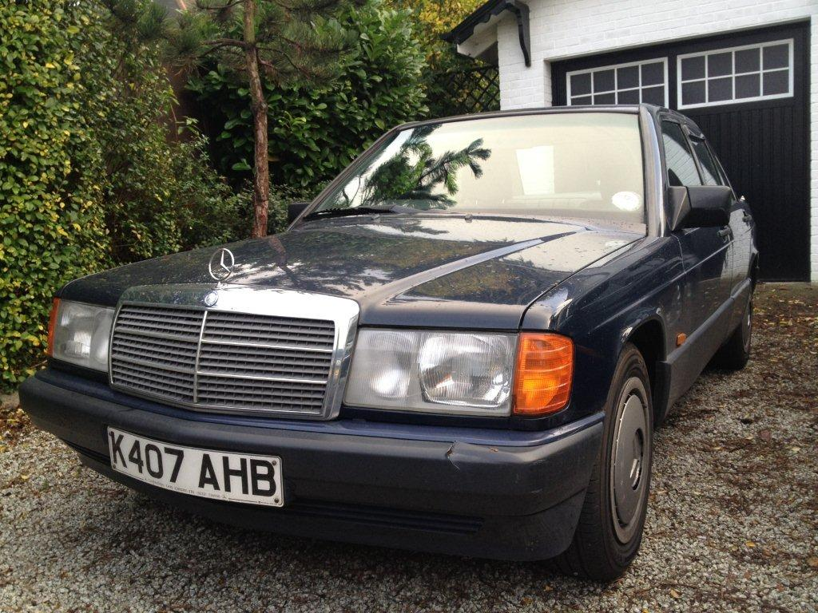

The car

We have tried to choose a car that will be both saleable and capable of getting there in the first place. The cars most prized in that area are Peugeots and Mercedes, so hopefully we will find an enthusiastic buyer. The car itself is 1992 Mercedes Benz 190E 1.8 litre petrol with automatic transmission. Resplendent in midnight blue, with a grey cloth interior, this car is from the bottom of the Mercedes range, but has the luxury of a sunroof and radio cassette! It was supplied new to its first owner by Continental Cars of Cardiff, and passed to its second owner a couple of years later, staying in Wales all of this time. I bought the car on eBay from the seller’s nephew who explained his elderly aunt, Mrs Williams, only used it to drive to Chapel on a Sunday. Chapel was evidently some distance away as the car has now done over 127,000 miles. Mrs Williams’ reason for selling it was that she was getting on, and the car had become too big. She clearly struggled to negotiate the vehicle safely between her gateposts and the car bears scars as witness to that difficulty. A new driver’s door mirror has sorted out the worst of the damage. Other than the battle-scars the vehicle seems sound and runs well. It has had a thorough service by Mersh Brothers in Lewisham including repairs to the exhaust. It has just passed its (final) MOT without any trouble. I have ordered a sump guard from Germany, and we are looking to raise the suspension slightly and fit some tough van tyres to improve the ground clearance and protect against punctures.

The Journey

We head for Dakhla in the Western Sahara leaving on April 9th 2014, taking the ferry to Santander than crossing Spain via to Tarifa where we take the ferry to Morocco. Our first night will be spent in Fes. We then traverse Morocco via Marrakesh before heading off-piste; crossing the Atlas Mountains via the stunning Todra gorges and diving out into the desert. Nights will be spent camping under the stars. The aim is to get to Dakhla using as little tarmac as possible.

Once there, we will sell the car in the no-man’s land on the Mauritanian border and the proceeds will all go to FoMRCH.

We will then fly back to London via Las Palmas in the Canary Islands, with hopefully a couple of days rest and recuperation on the way so we can return to work on the following Monday.
.

How you can help?

Please sponsor me!

Every penny goes direct to the charity:

- £20 will care for 10 children for a day
- £30 will provide medical care for a chronically sick child for six months
- £50 will educate a child for a term

http://uk.virginmoneygiving.com/team/RevsandBenz

