MY LIFE
by Eurelia aged 15

No one looked upon me, I was useless for now my life was in a horrible situation. This started as all my parents had passed away. The earth was now unfair. My life suddenly changed as I was taken to Matthew Rusike Children's Home and it was now in my hands. I cannot believe that I am an orphan as I now have brothers and sisters and parents. For there was a sudden change to my life.

To learn more about Matthew Rusike Children’s Home send for our leaflet from

64 Saffron Crescent, Tickhill, S. Yorks. DN11 9RU

or visit our website at

www.friendsofmatthewrusike.org

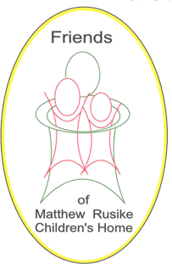
Registered Charity 1120944

Thank You

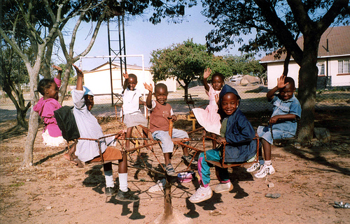

MY LIFE
by Eurelia aged 15

No one looked upon me, I was useless for now my life was in a horrible situation. This started as all my parents had passed away. The earth was now unfair. My life suddenly changed as I was taken to Matthew Rusike Children's Home and it was now in my hands. I cannot believe that I am an orphan as I now have brothers and sisters and parents. For there was a sudden change to my life.

To learn more about Matthew Rusike Children’s Home send for our leaflet from

64 Saffron Crescent, Tickhill, S. Yorks. DN11 9RU

or visit our website at

www.friendsofmatthewrusike.org

Registered Charity 1120944

Thank You

