Action for Children and its integral part in the continuing development of
the work of the Matthew Rusike Children’s home in Zimbabwe.

A Brief History by Joe Withington
1 May 2009

The relationship between NCH and MRCH is of long standing through it's partnership of NCH and the Methodist Church of Zimbabwe, particularly since until the 1970s the Methodist Church was the Rhodesia District of the British Methodist Church. In the 1950s the Rev. John Jabangwe & his wife - he was then the Superintendent of MRCH - was sent to the Princess Alice College, Sutton Coldfield to train in Residential Childcare on the joint NCH/Home Office Course under the management of NCH Education Secretary. At the end of the course Rev. Jabangwe returned to MRCH.

In 1975 the NCH Development Officer (a relatively new post) Mr. Arthur Lenton who had been Superintendent at Princess Alice Children’s Home was a delegate to the Methodist Conference in Kenya: he took the opportunity to visit Southern Rhodesia and MRCH. Before he left and at the end of his visit, the then President or District Chairman agreed that as there was no Residential training in Rhodesia that at the end of the "Liberation struggle" NCH should help to rectify the training deficit expertise for Care Staff at all levels. It was therefore in 1981 that the then President of the Methodist Church in Rhodesia/Zimbabwe requested that NCH explore the possibility of putting the 1975 agreement into action. In 1981 Rev. Gordon Barritt, then NCH Principle, circulated a memorandum in NCH regarding possible secondment to MRCH to develop and provide training for staff at MRCH along with Management & Financial expertise in all aspects of MRCH operations.

Following considerable correspondence between NCH and MRCH/Methodist Church in Zimbabwe Joe Withington then Assistant Regional Director of Social Work South West Region, also NCH's Senior Training Officer and National Chairman of Nat. Assoc. of Training Officers in Social Services U.K. agreed to go to Zimbabwe to see what exactly was meant by "no resources, expertise, training materials or professional standards of residential provision". This visit was in February 1982.

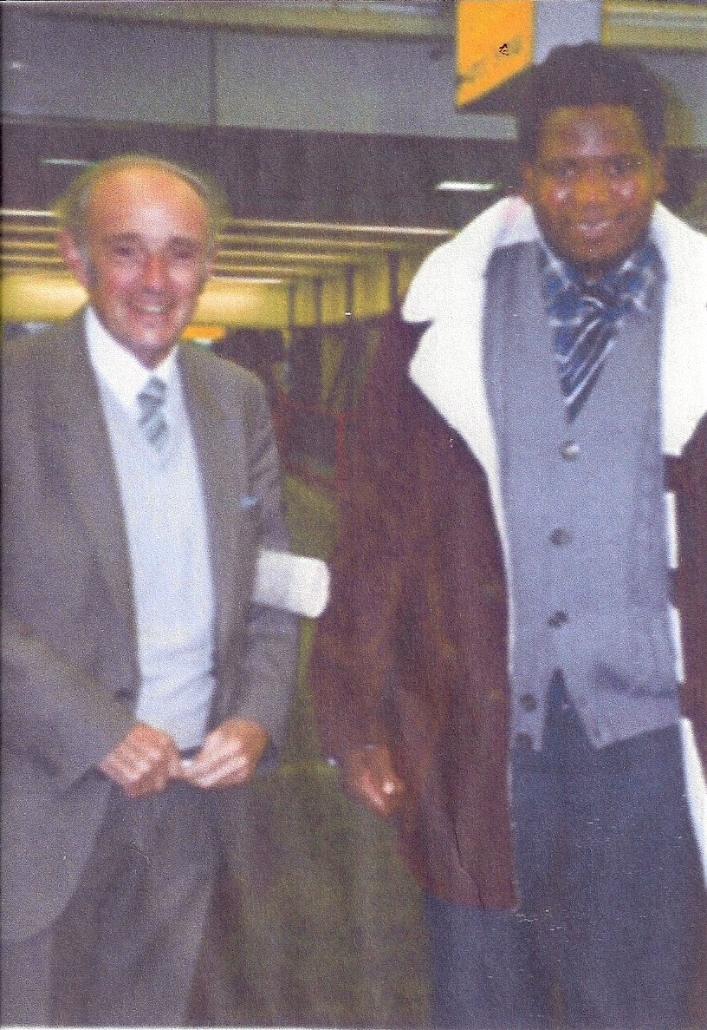
The assessment of the state of Childcare provision at MRCH and its inevitable links with Social Welfare provision in the Country proved that NCH had a valid contribution to make to the development of a greater quality of care provision and a desperate need of training input. Joe Withington returned to Zimbabwe for three months in September 1982 and along
with the Superintendent at MRCH Mr. Sheunesu Matamavi who was a Social Work Graduate established an In Service Training course at Ranche House College, Harare. It also became evident following visits to other Institutions predominantly in the NGO sector that such a course would be crucial to the development of Child Care provision in Zimbabwe. Three further secondments in 1984, 86 & 88 were made by Joe of 3 months, 8 weeks & 8 weeks respectively until his early retirement in 1989 at which time he & NCH received letters of appreciation of the development at MRCH and the Zimbabwe Council of the Welfare of Children.

Joe Withington with Sheunesu Matamavi who, as the Home’s Superintendent, was the first MRCH representative to visit the UK. He also established the independence unit at MRCH for young people ready to leave the home but with nowhere to go.
It was decided in NCH that the further secondment of a Training Officer from NCH should continue the professional input to MRCH and the wider care network, building on the movement for alternative care initiatives already in hand. This was undertaken for over two years by Mr. David Newstead Training Officer NCH Midlands. Further reviews of NCH involvement and its input eventually led to the visit of Mr. John Bromley & Mrs Bromley who further developed the links with what were now established courses at Colleges and the University.

This is I know a lengthy synopsis of NCH's role viz. a. viz. MRCH and the distinctive relationship it continues to have with the latter and the present Superintendent of the Home but I thought it would be helpful to have an overview of NCH's involvement with MRCH and the Methodist Church in Zimbabwe.

MRCH now of course is operational in at least three other parts of Zimbabwe, with a complex range of types of care provision from residential in Epworth to Community Care and alternative care provisions, requiring a range of skills and expertise in its overall management. The role of Mr. Barry Barnes on behalf of Action for Children has been invaluable particularly given the difficult social, political and economic situation that has obtained in Zimbabwe over the last 10 years, to walk away from their need for continuing support from Action for Children would be both a professional social work negation and a spiritual one of the working relationship that has enhanced the reputation of NCH's expertise and the quality of care by MRCH. I was once asked by the NCH Principal what NCH gained from it's investment in Zimbabwe, I could only quote Matthew's Gospel 25 vs. 35 - 45, we have a lot to learn from them too. I have visited the Home on a further 8 occasions and have been greatly encouraged to see that the foundations laid in the 1980's have been developed with increasing confidence and credit to the staff at all levels. The relationship, professional input and commitment of Action for Children is as essential today as it ever was and their sense of abandonment if this support should be withdrawn would be laid at our door.

The contribution by Barry Barnes to the work of FoMRCH has been of great significance over these past years. It has kept us in touch with the real world of life in Zimbabwe and such a role within Action for Children is their lifeline with the world outside their difficulties. Action for Children and FoMRCH as partners with the Home, have given and continue to give them hope. The way NCH has enabled FoMRCH to function in it's outreach and publicity has been invaluable and it is greatly appreciated.

In conclusion I feel that MRCH still need continued support in the present climate in Zimbabwe.
Joe Withington. May 2009

