which is great news. In September we held a concert with the Salvation Army Songsters and Band and raised £250. At the beginning of October we held an Auction of Promises and raised £1052, a total beyond our wildest dreams! It was a super fun evening, more like a social than an auction, what caring generous friends we have at GMC. More activities are planned during our Festival of Trees weekend in December – watch this space
Joan Sanger

My hobby of making jewellery has raised several hundred pounds for MRCH over the last few months. Friends have hosted parties and the guests have seen the DVD of MRCH and then had the opportunity to buy hand crafted jewellery and support the Home. All the profits are donated to FoMRCH. Marilyn Roinson

Christmas Cards
This year you have bought or sold for us around 10,300 cards from which all profits go to help the children. Thank you for your generous support. Thank you to those people who ordered early and paid promptly, distribution has been easier this year as a result. Later orders are welcomed too but this year I have had to disappoint some people because some designs sold out. The same thing will happen next year because some earlier designs are now quite depleted. Two new designs are already in the pipeline for 2011. To help cover the VAT rise in January we shall have to slightly increase the price of the packs next year but this will be the first increase in several years. Another thank you to everyone who adds a donation to the cost of their order, as these are gift aided if you have signed a form and sent it to our Treasurer.

Some payments are still outstanding so please pay them before Christmas.

Well done to all these fundraisers and thank you for your invaluable support for the children…..please tell us what YOU are doing, every little helps.

Catch up on Quantas Cabin Crew new website
www.matthewrusike.org

Contacts
Chair: Carol Banham
carol2021@banham.net

Secretary: John Richer
jricher001@btinternet.com

Treasurer: Paddy Coles
9 Ashley Drive West,
Ashley Heath
Ringwood, HantsBH24 2JW
Tel: 01425 478244
Padjen@ukonline.co.uk

Membership Sec: Gail Richer gmricher@btinternet.com

Catch up with our website
www.friendsofmatthewrusike.org

This newsletter is distributed by
The Friends of Matthew Rusike Children’s Home.

Friends of Matthew Rusike Children’s Home
Registered charity 1120944

December 2010

A warm welcome in Epworth

‘Hello Mama’ A little boy in ragged khaki shorts took the hand of Lynda, my wife, as we walked through Victoria Falls town on a family holiday in 2008. From that moment, Lynda knew she had to return to Zimbabwe and work with deprived children. As for me, I was eager to get back to the country I was raised in but hadn’t seen for 39 years before that holiday.
Looking for an opportunity, we contacted Astonishment Mapurisa and met him at Paddy and Jenny Coles’ home on his visit in October 2009. Anyone who has met Astonishment will know his irresistible enthusiasm and we were left convinced that we had to go to MRCH. Astonishment promised to put us both to work - Lynda as a teacher of disturbed and difficult children; me as a writer, helping him produce a fund raising leaflet.
We spent two and a half weeks at MRCH in August 2010. As it was school holidays, many of the children were away staying with foster parents – part of the MRCH ethos of integrating children into the community. We shared a home with
Shamiso, one of the house mothers, and four of the smaller children who’d stayed behind. They all became great

We give support, mainly by cash, but also by advice and assistance
to the Home for the benefit of the Children

friends. Three year old Patrick had Shamiso in fits of laughter on the first evening when he had tugged at Lynda’s leg and demanded in Shona: ’White woman, dance!’

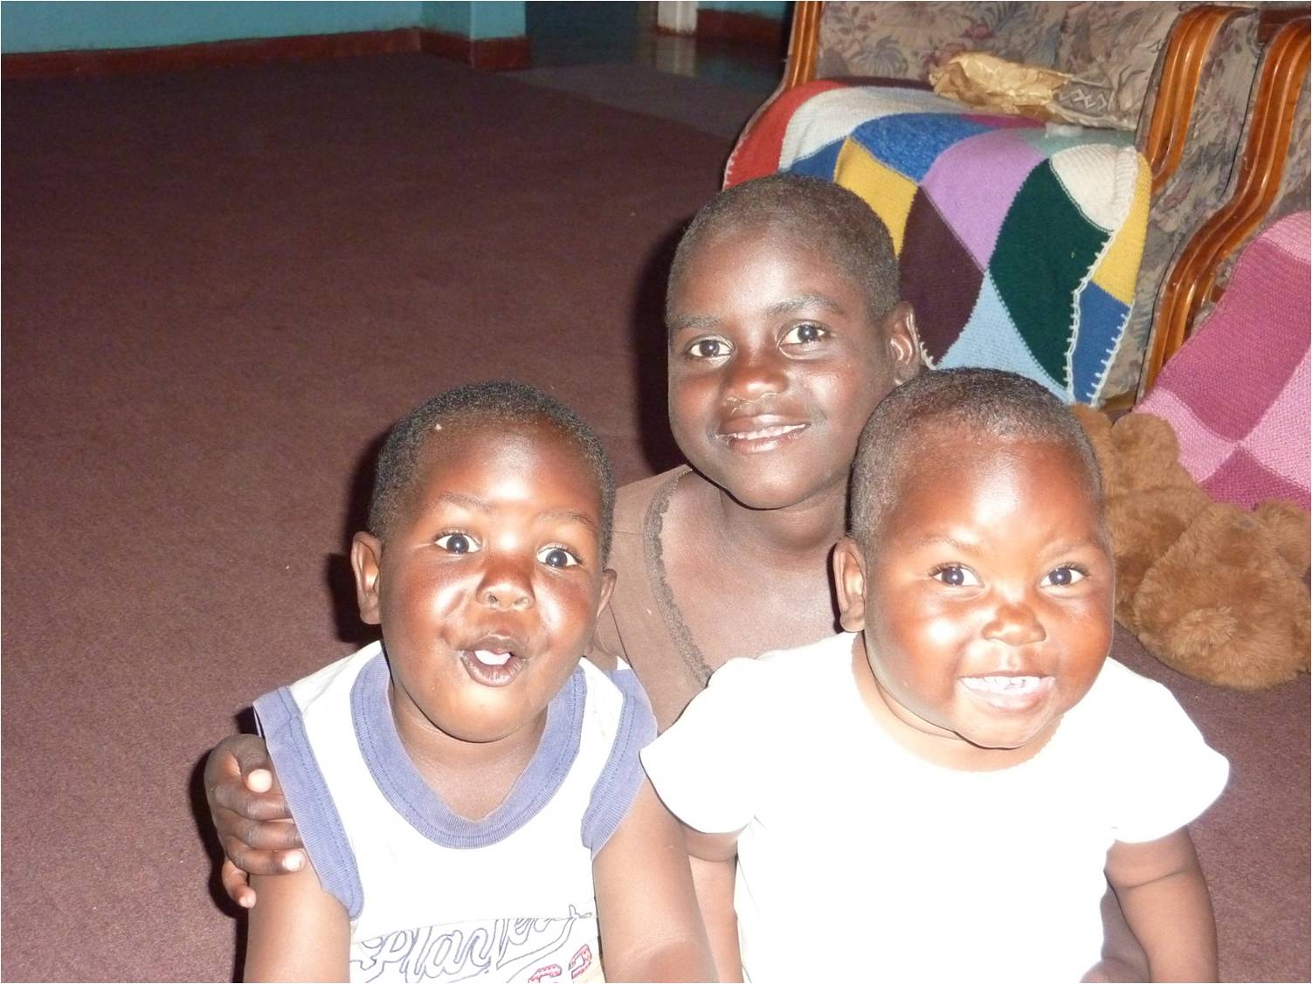
Patrick, Priscilla and Clotie three of the children whose home we shared at MRCH

While I worked on the leaflet, Lynda spent time with the MRCH teachers with a view to introducing lessons on emotional well-being for children whose experience of abuse, malnutrition, abandonment or fending for themselves on the streets has often left them emotionally damaged.
Although it’s a sanctuary, life at MRCH is still hard. There’s constant financial uncertainty: the staff when we were there hadn’t been paid for at least two months. Harare’s electricity and water supplies are hopelessly unreliable, so cooking is often done on an outside fire and water collected in buckets from a borehole. But the spirit of the adults and children alike was humbling. Their welcome and acceptance and love and generosity and good humour in the face of adversity made a deep impression.
Some of our other abiding memories? The Shona singing at Epworth Mission. Playing rough and tumble with the children. Astonishment’s fund of funny stories. The African sense that people and relationships are important. Sitting on a rock watching amazing sunsets. It was a rich experience and we loved it.
Graham Jones

From our Treasurer
I would like to thank you all for your continuing support and generosity. We have received close to £50,000 so far this year, and I have remitted to date a little more than that, which has depleted our reserves somewhat. The reason being that we only recently discovered that the roof had not been completed on the crèche. This was something that was expected to be funded by a donation from USA but did not materialise. However, with the rainy season about to commence it was necessary to ensure that this work could be done. Astonishment advises us that the price of food, fuel, electricity and other services continues to rise, and there are some months when they are unable to pay all the staff salaries. The basic salary by Government order is US$200 per month, but few in Zimbabwe get this and certainly the staff at the Home do not receive this sum regularly. However, when a number of the staff live at the Home (house mothers etc) they are provided with their food and accommodation but their families aren’t.
You will understand that the need for support is as great as ever, and anything that you can do in terms of fundraising will be greatly appreciated.
Paddy Coles

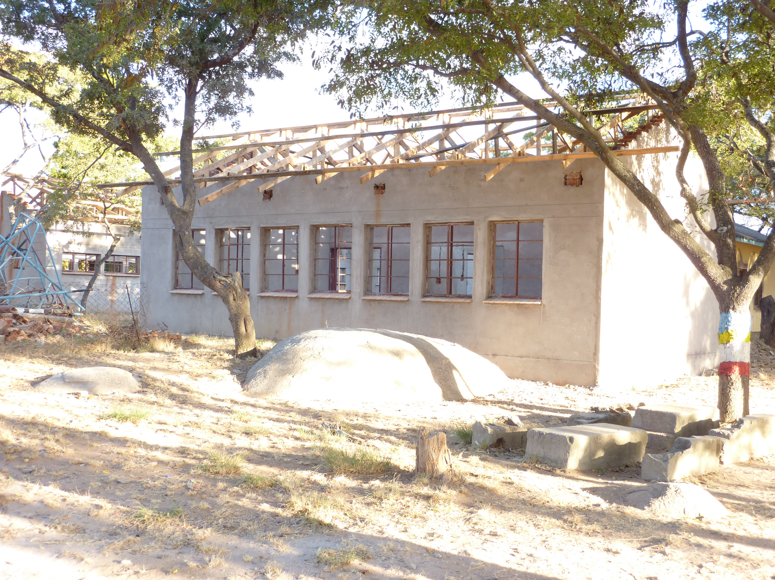The Crèche awaiting its new roof

We have heard that Senior staff received ONE month’s salary during the 5 months from June to October this year.
Astonishment says: ’Our salaries are mainly hand to mouth but we praise God when we get it’

A Mission Partner for MRCH
When National Childcare Director and Superintendent of MRCH, Astonishment Mapurisa, visited the UK in October 2009 he met a young woman based in one of Doncaster’s action for Children centres. She had been applying to work overseas through VSO but after talking to Astonishment they decided that MRCH needed Shelley’s expertise and she really wanted to work at MRCH.

Shelley Cooling

At the beginning of October 2010 Shelley heard that the Methodist Church had accepted her as a Mission Partner for at least 3 years. In January she will commence 3 months training in Selly Oak and then she will go to Zimbabwe. For months she has been fundraising for the crèche and learning Shona, the local language. In November she visited the Home for 10 days.
Shelley Cooling is a specialist in Early Learning Development, particularly working with under fives in deprived communities. As an early learning consultant she will work closely with the management team and will be:
- Helping design an education curriculum for the pre-school
- Working with management to resource the centre
- Working with psychologists to design programmes for orphaned and vulnerable children
- Managing the link between the project and the community it serves
- Training staff
Shelley is a dedicated, hard working person who believes God will continue to support and guide her as she starts out on this venture, please remember her in your prayers.

We wish you every success Shelley, well done!

Fundraising
Our Harvest Weekend at Trinity Church Enfield went very well.
We had lots of interest in the photographs you sent us, having the display will certainly encourage further fundraising. People were asked to fill empty jars and water bottles with ‘small change’ which they wouldn’t miss but it would be of great value to MRCH. £410 was given in the collection and the ‘small change’ amounted to £150! Several Teddy bears were adopted too, raising a further £20. Our fundraising will continue! Sally Reader

Our frugal lunches continue, they are held on the 1st Monday of the month, and we are getting around 12 people now. The meal consists of a bowl of homemade soup, homemade bread with cheese followed with tea or coffee for an inclusive charge of £2.50. I also showed the DVD to a group last week.
I have another little project crocheting baker boy style hats, I am on my fourth order with 2 more ordered – I’m aiming for twenty. All proceeds to MRCH. Sheila Williams

The Methodist Church in Gainsborough has adopted MRCH as their charity for this year (September 2010 to August 2011)

