Matthew Rusike Children’s Home

A Brief History of its Partnership with FoMRCH and Action for Children

The first part of these notes are based on a brief history written by Joe Withington who was
NCH’s representative in the 1980s.

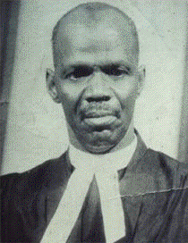
The relationship between NCH (AfC) and MRCH is of long standing through the partnership of NCH and the Methodist Church of Zimbabwe. The Rev Matthew Rusike was a Methodist Minister in Harare in the 1950s. Unwanted children found on the streets were brought to him and his wife to be taken care of. When he retired, and with the support of NCH, he and his wife set up a home to care for vulnerable children. As the history shows, the wish to give the best childcare was felt from the first days and the UK charity National Children’s Home was seen as the chief guide.

Later in the 1950s the Superintendent of MRCH, the Rev. John Jabangwe & his wife approached NCH for advice and he came to the UK on the joint NCH/Home Office Course at the Princess Alice College, Sutton Coldfield, to train in Residential Childcare. The residential home at Epworth, Harare, continued to grow.
Rev Matthew Rusike

In 1975 the NCH Development officer, Mr Arthur Lenton, was a delegate to the Methodist conference in Kenya and he took the opportunity to visit Southern Rhodesia and MRCH. Before he left Rhodesia, the President or District Chairman agreed that, as there was no Residential training in Rhodesia, at the end of the "Liberation struggle" NCH should help to rectify the training deficit for Care Staff at all levels. It was therefore in 1981 that the President of the Methodist Church in Rhodesia/Zimbabwe requested that NCH look into putting the 1975 agreement into action.

In February 1982, Joe Withington, then Assistant Regional Director of Social Work South West Region, also NCH's Senior Training Officer and National Chairman of Nat. Assoc. of Training Officers in Social Services U.K. agreed to go to Zimbabwe to see what exactly was meant by "no resources, expertise, training materials or professional standards of residential provision" and to develop and provide training for staff at MRCH along with Management & Financial expertise in all aspects of MRCH operations.

Through the 1980s Joe went to MRCH four times more for 2-3 months each, during which time he and Mr Sheunesu Matamavi, a Social Work graduate and Superintendent of MRCH, established a training course at Ranche House College, Harare. It soon became evident that the course would be crucial to the development of Child Care provision in Zimbabwe. When Joe retired in 1989 he & NCH received letters of appreciation of Joe Withington
of the development at MRCH and the Zimbabwe Council of the Welfare of Children.


Further secondments of a Training Officer from NCH continued the professional input to MRCH and the wider care network, until in the 1990s, when Munomato Mangobe was MRCH superintendent, John (who was an Honorary member of the NCH Board) and Mary Bromley, both highly qualified child care specialists, continued the staff training over several visits and further developed the links with what were now established courses at Colleges and the University.

In the late 1990s a group of people who had all recently visited or worked at MRCH. (Mary and John Bromley, Paddy & Jenny Coles, Malcolm and Fay Payne, Carol and Don Banham, Shirley and John Richer, Gail Richer) decided to start the Friends of MRCH “to raise funds to provide ‘something extra’ at Christmas”. Joe and Eileen Withington were keen members of Munamato Mangobe the Friends from the start.

Over the years more people have become committee members after visiting the Home (Mandy Spalding, Michael Mapako, who was deputy director of MRCH for a few years, Marilyn Robinson, whose daughter Kate was a volunteer at the Home for 10months in 1999, Revs Ed and Audrey Standhaft and more recently, David Graaff became our second treasurer.)

The aim of the FoMRCH has always been to provide funds and advice in partnership with the Home. What started as funds for minor Christmas treats became, for several years, the major donor contributing over 80% of the running costs of the Home. Recently, as the economy has started to recover, while our funding has increased, local funding has increased, so that our contribution has dropped to 42%.
Our main achievement over 18 years, has been the steady progress in raising Child Care standards at the Home while the economy faltered. With a loyal number of members and supporters (almost 300 on our mailing list) our annual income has risen steadily which has resulted in being able to send £5,000 on a regular monthly basis for the care, education and health of the 145 residential children at MRCH in Epworth. We have also occasionally been able to support other projects and staff salaries when they fell into arrears.
Other organisations in Zimbabwe and overseas support the Home but FoMRCH is the only one to give regular monthly support which gives the administration staff at the home the confidence to plan the childcare for the residential children in Epworth.
FoMRCH is a registered charity, all our work is voluntary and Executive members fund their own costs.

MRCH is now operational in several other parts of Zimbabwe, with a complex range of care provision from residential in Epworth to Community Care centres requiring a range of skills and expertise in its overall management.


Barry Barnes became the NCH representative in Child Care for South Africa and Zimbabwe in 1999. Barry had a strong concern and expertise for good Child Care and had considerable skill in maintaining a close partnership with the staff at the Home and the Zimbabwe Methodist church committee who controlled it. He set up international residential care home conferences in Johannesburg which the MRCH superintendent attends. He paid visits to South Africa and the Home several times each year and as well as reporting to NHC/AfC he briefed FoMRCH on life at the Home and encouraged our
continuing support of MRCH.

Barry Barnes

Barry supported Mr Astonishment Mapurisa who took over as Superintendent from Munomato Mangobe in 2001, in the plans for further development at the Home playing a very major part in the change from dormitory living to the creation of family units so that the children experienced a near normal life in a mixed age group with typical family interactions. In 2004 AfC provided funds towards building Family units to replace the dormitory type of accommodation while FoMRCH supported the fitting out and extra running costs. Astonishment Mapurisa
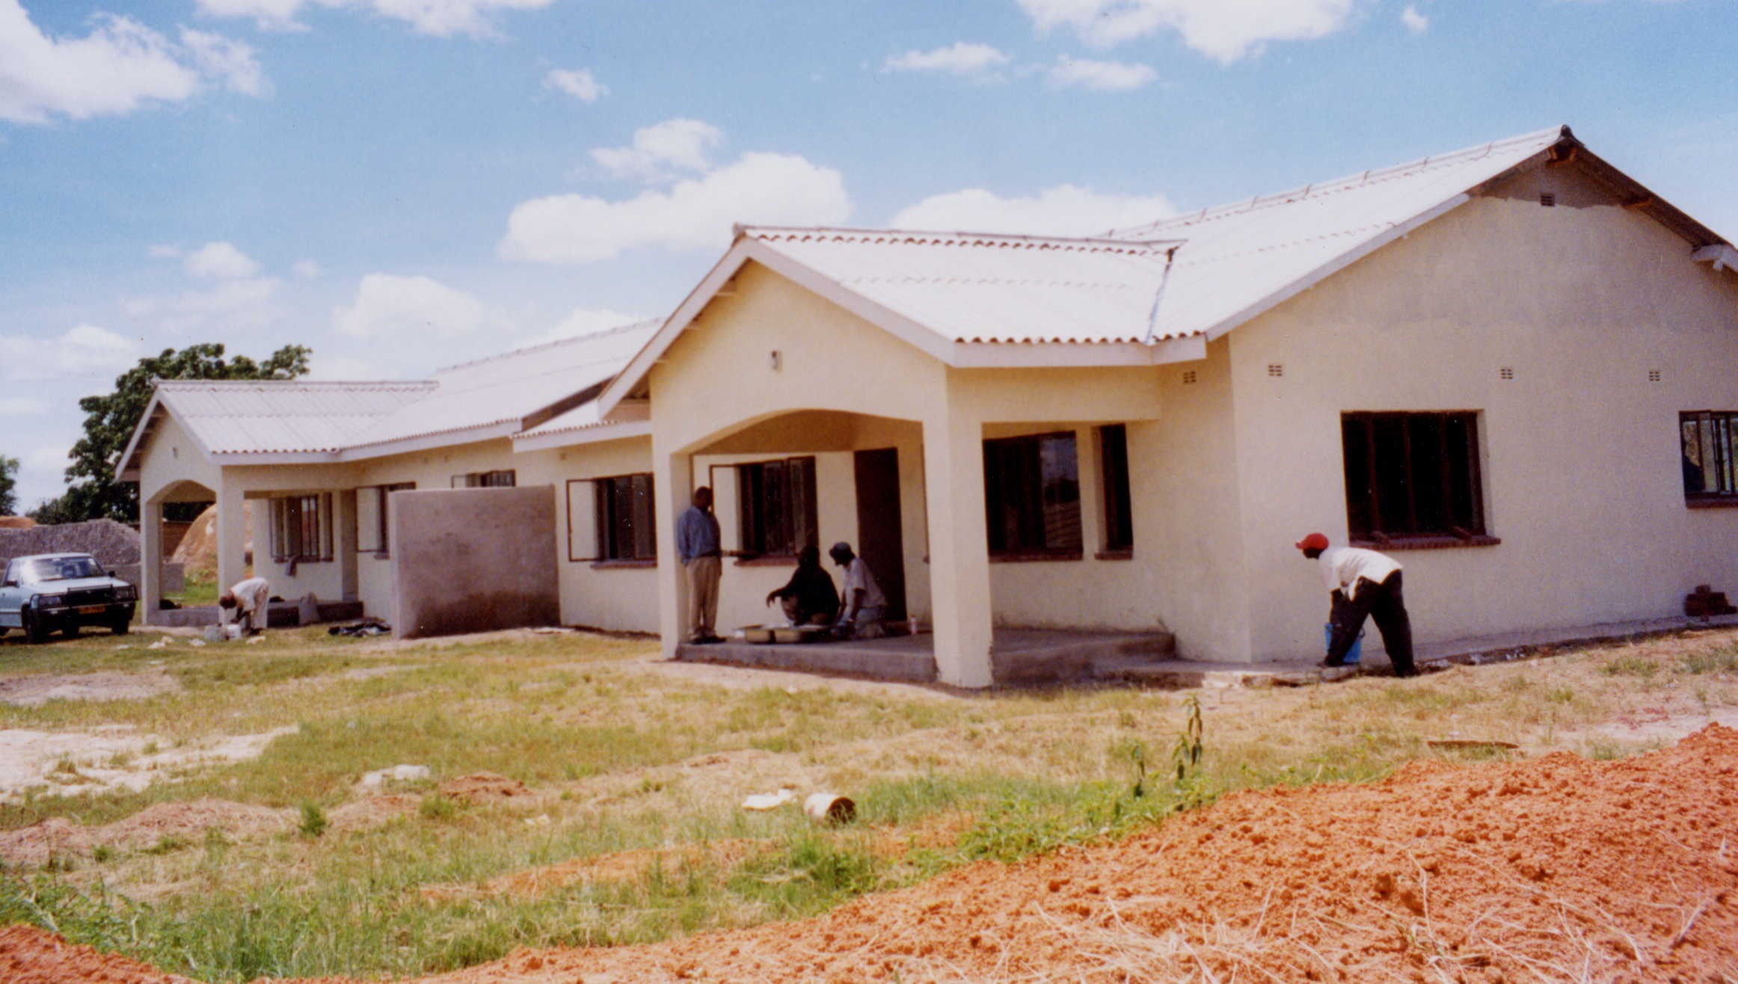
This photograph of one of the Family units nearing completion, was taken by NCH Barry Barnes on one of his visits.

Astonishment Mapurisa led a vigorous campaign to strengthen and extend the child care at the Home into other parts of Zimbabwe. He became the National Child Care Director for Zimbabwe for the Methodist Church. This led to setting up of volunteer groups near Harare and then to the building of three satellite childcare centres in Gweru, Donga, Mutare. Action for Children funded the salaries of three care workers to head these centres for 3 years to get them established. Further Outreach centres are being built. Astonishment also set up a Health centre at MRCH which was eventually recognised by the health department who paid for the registered trained nurse. Barry Barnes had a warm relationship with Astonishment who valued his role as mentor.

FoMRCH sponsored Astonishment 3 times to visit the UK so that he could meet FoMRCH groups and AfC staff and publicise the Child Care work of MRCH and also Rev Margaret Mawire in 2014.

Both Barry’s and Astonishment’s role ended in June 2012 after many very valuable years.

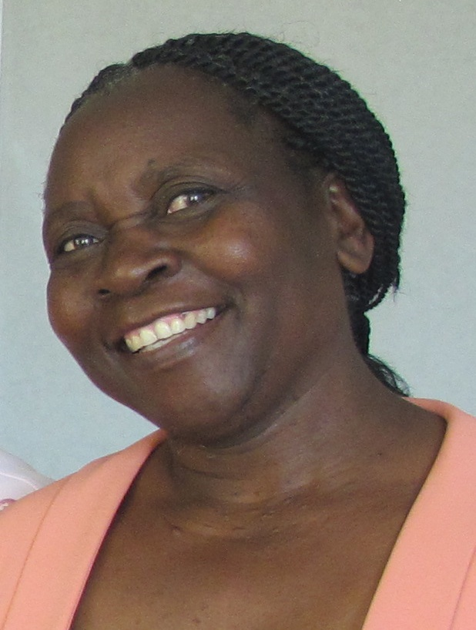
In 2011 Shelley Cooling, a well qualified and committed early years teacher, planned to spend 3 years at MRCH. After some very active fund raising in the Doncaster area, she spent less than a year at MRCH extending a much improved Early Childhood Development Centre, ECD. The facilities were extended and put into operation successfully. Unfortunately her plans were cut short by Government rules.

In June 2012 the Rev Margaret Mawire became Superintendent of the Home and National Director of Child care for the Methodist Church. She continues the expansion whenever funds became available. Seeing teenagers in the local area who could not afford the usual school fees, the Home set up a Secondary school on its site and this now serves over 300 vulnerable local children.

In 2013, Graham and Lynda Jones visited the Home and saw the increased need for a standby generator for which they led the fundraising so that it could be installed and operational in 2014. Rev Margaret Mawire

In 2014, thanks to a couple of legacies and specific fundraising we have been able to buy a new minibus and contribute to further projects such as the generator, extension of the secondary school building and an extension of the irrigation system.

The operational details of the Home, its history and the successful outcome in the lives of its children, would also be interesting but is not addressed here.

Reference 2014 11 26

