A
Special

Gift

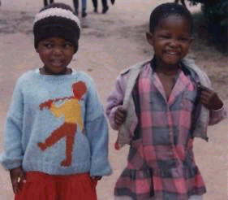

Destiny Child – written by S. S. – an "O" level student

If you turn around the corner you will encounter a heart-moving scene. There, just five metres away from you, you are sure to sight a tear-stained five-year-old. If you look carefully, you can see a pained expression on his face. His face turned to the heavens as if in pleading for a change of his fate. Suddenly a friend gestures to him to come and freshen up as supper time is four minutes away. He scrabbles away at him. I have a home with loving friends. What expression or feeling is that in your heart? Joy, pain, tranquillity or nothing? Anyway this boy lives at Matthew Rusike Children's Home not because he has lost both his parents as a form of punishment from God, but as an example to you. At Matthew Rusike, we children are looking forward to your donations, in order for us to survive. Matthew Rusike Children's Home is a home for less-privileged children set up for orphans. The main task at this home is to try and privilege the less fortunate. Matthew Rusike is a home for children who do not have parents and those who do not have relatives to rely on at all. I kindly ask you to consider your budget to include us because we are also your children. Yes, the economy in Zimbabwe and everywhere is hard, but remember that life at Matthew Rusike depends on the support of people like you. Save a life by being generous.

To learn more about Matthew Rusike Children’s Home send for our leaflet from:
64 Saffron Crescent, Tickhill, S. Yorks. DN11 9RU

or visit our website at
www.friendsofmatthewrusike.org

Registered Charity 1120944

