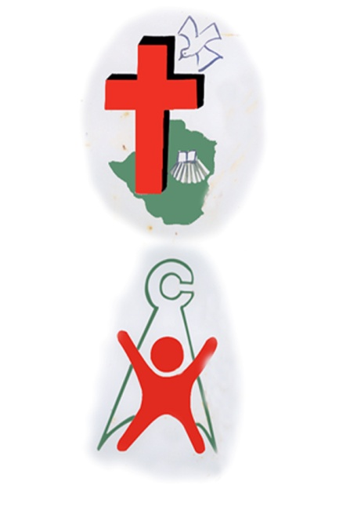
News from the Home
(Received from Matthew Rusike Children’s Home. September 2011 )

The first half of the year has been very exciting at Matthew Rusike Children’s Home. We received three new additions to the children in the residential care facilities. The children seem to have adjusted well to their new environment and are being cared for by our Transitions Officer and their respective caregivers in the housing units……..
……Community Outreach Programme
We are getting more and more experienced as we get deeper and deeper into Zimbabwean communities in our quest to assist the orphaned and vulnerable children in our country. We are learning from communities and they are also tapping from our years of childcare professional experience.

Each day we are enrolling children in our Community Based Orphan Care Programmes and a lot of children continue to receive Psycho Social Support at our various centres. Those who had lost education opportunities are being assisted. A lot more have been enrolled back into school whilst others like Tendai have been assisted with a roof over their head through the MRCH Community Based Orphan Care Programme (in picture below).

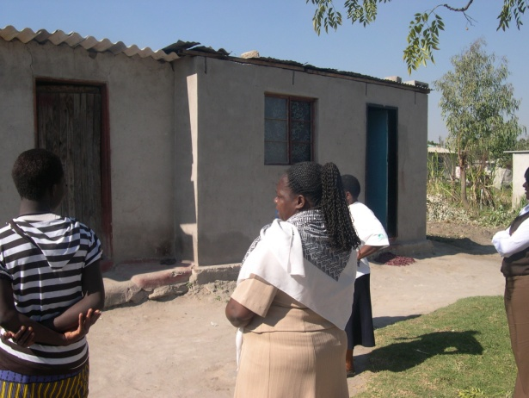

Tendai Madziyire is a 16 year old double orphan whose parents died from AIDS in 2007 leaving behind 3 young sons to fend for themselves. At the time of their parents’ death, the children had no proper accommodation, dropped out of school, and on several occasions would go to bed on empty stomachs. With the support that we receive from our partners, today Tendai is back in school and is doing exceptionally well. The boys live in a two roomed house that MRCH built for them under the care of their big brother, Kudzai who is now 19years old. He is not yet employed so MRCH assists them with food..

Emerging Partnerships
We are very excited about two new partnerships that we have managed to secure this year. The Uniting World of Australia and MRDF of the UK came on board to fund MRCH small self help projects for the benefit of the less privileged societies that MRCH operates in. The Uniting World Projects are based at MRCH in Epworth whilst MRDF projects are in Chitungwiza at Zengeza 4 and Nyatsime Community Resource Centres.

The overall objectives of these projects are to socially and economically capacitate communities and enable them to assist the needy children in their care and in the long run attain self sustenance.(see some pictures below).
The Uniting World is funding the poultry, the garden and the tailoring projects. At the moment there are 1 400 birds in the poultry project at Epworth and 30 beneficiaries from very disadvantaged households were selected to participate in the project. The garden project also has 30 beneficiaries coming in everyday and work has already started. Part of the project output in poultry and gardening will contribute to nutrition and the rest will be reinvested in the project. With each household averaging
8 members, these two projects are set to change the lives of over 400 people in six months.
Another group of 15people is being trained in the tailoring project for the next 6 months. At the completion of this skills training and resources permitting, beneficiaries should be able to set up their own small co-operatives and generate income to take care of the orphaned and vulnerable children in their families.

At the Zengeza 4 Community Resource Centre, the MRDF from the UK has supported us by drilling and installing a borehole. This has helped with the setting up of a garden project. At the moment, over 50 households are participating in this project and overall the project is benefitting over 200 people. In Nyatsime, the community initiated a poultry project which MRDF provided the funding for. We are pleased to report that the project is well on course and they have just sold off a batch of 200 chickens. They have a ready market among their congregants.

The second phase of the project at Zengeza 4 Community Resource centre involves the refurbishment of an exisiting building into a child friendly facility for Psych Social Support Programmes.
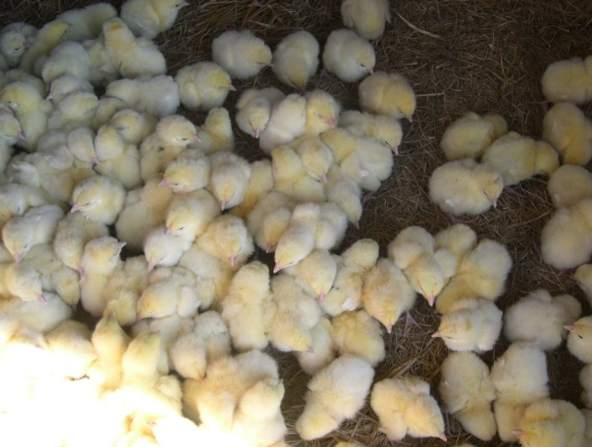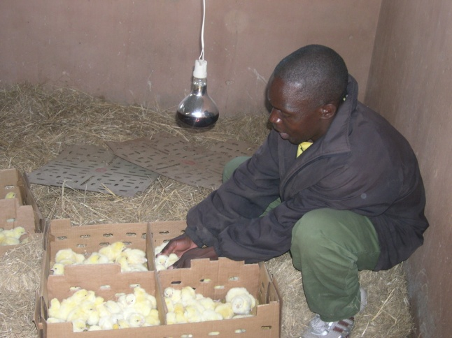

The above pictures show the chickens in the Poultry Project being funded by Uniting World at MRCH Epworth
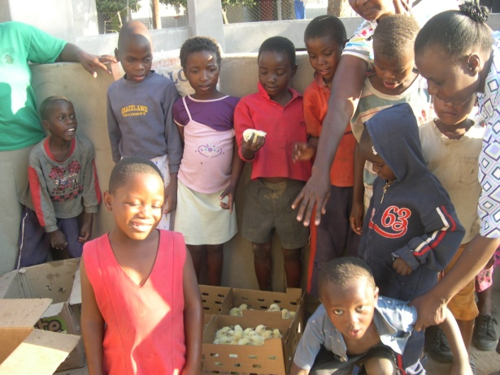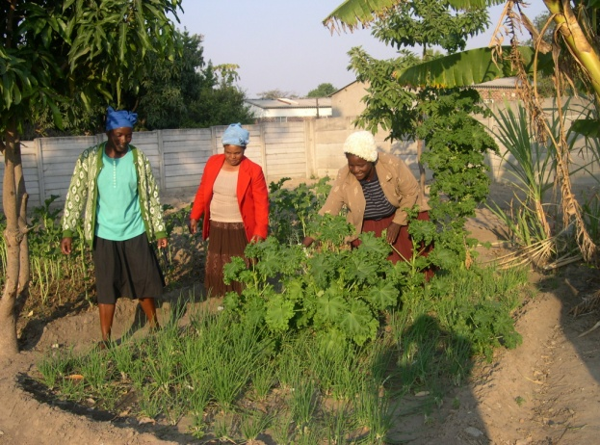

Above2 photos: Beneficiaries of the Nyatsime and Zengeza 4 poultry and garden projects respectively.

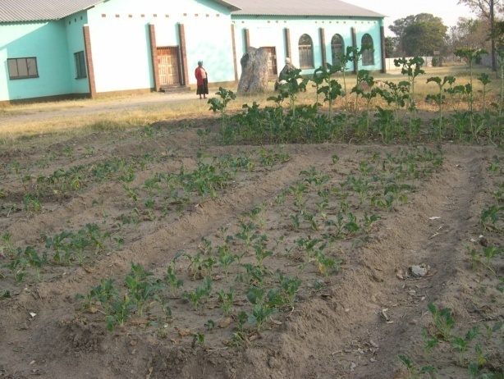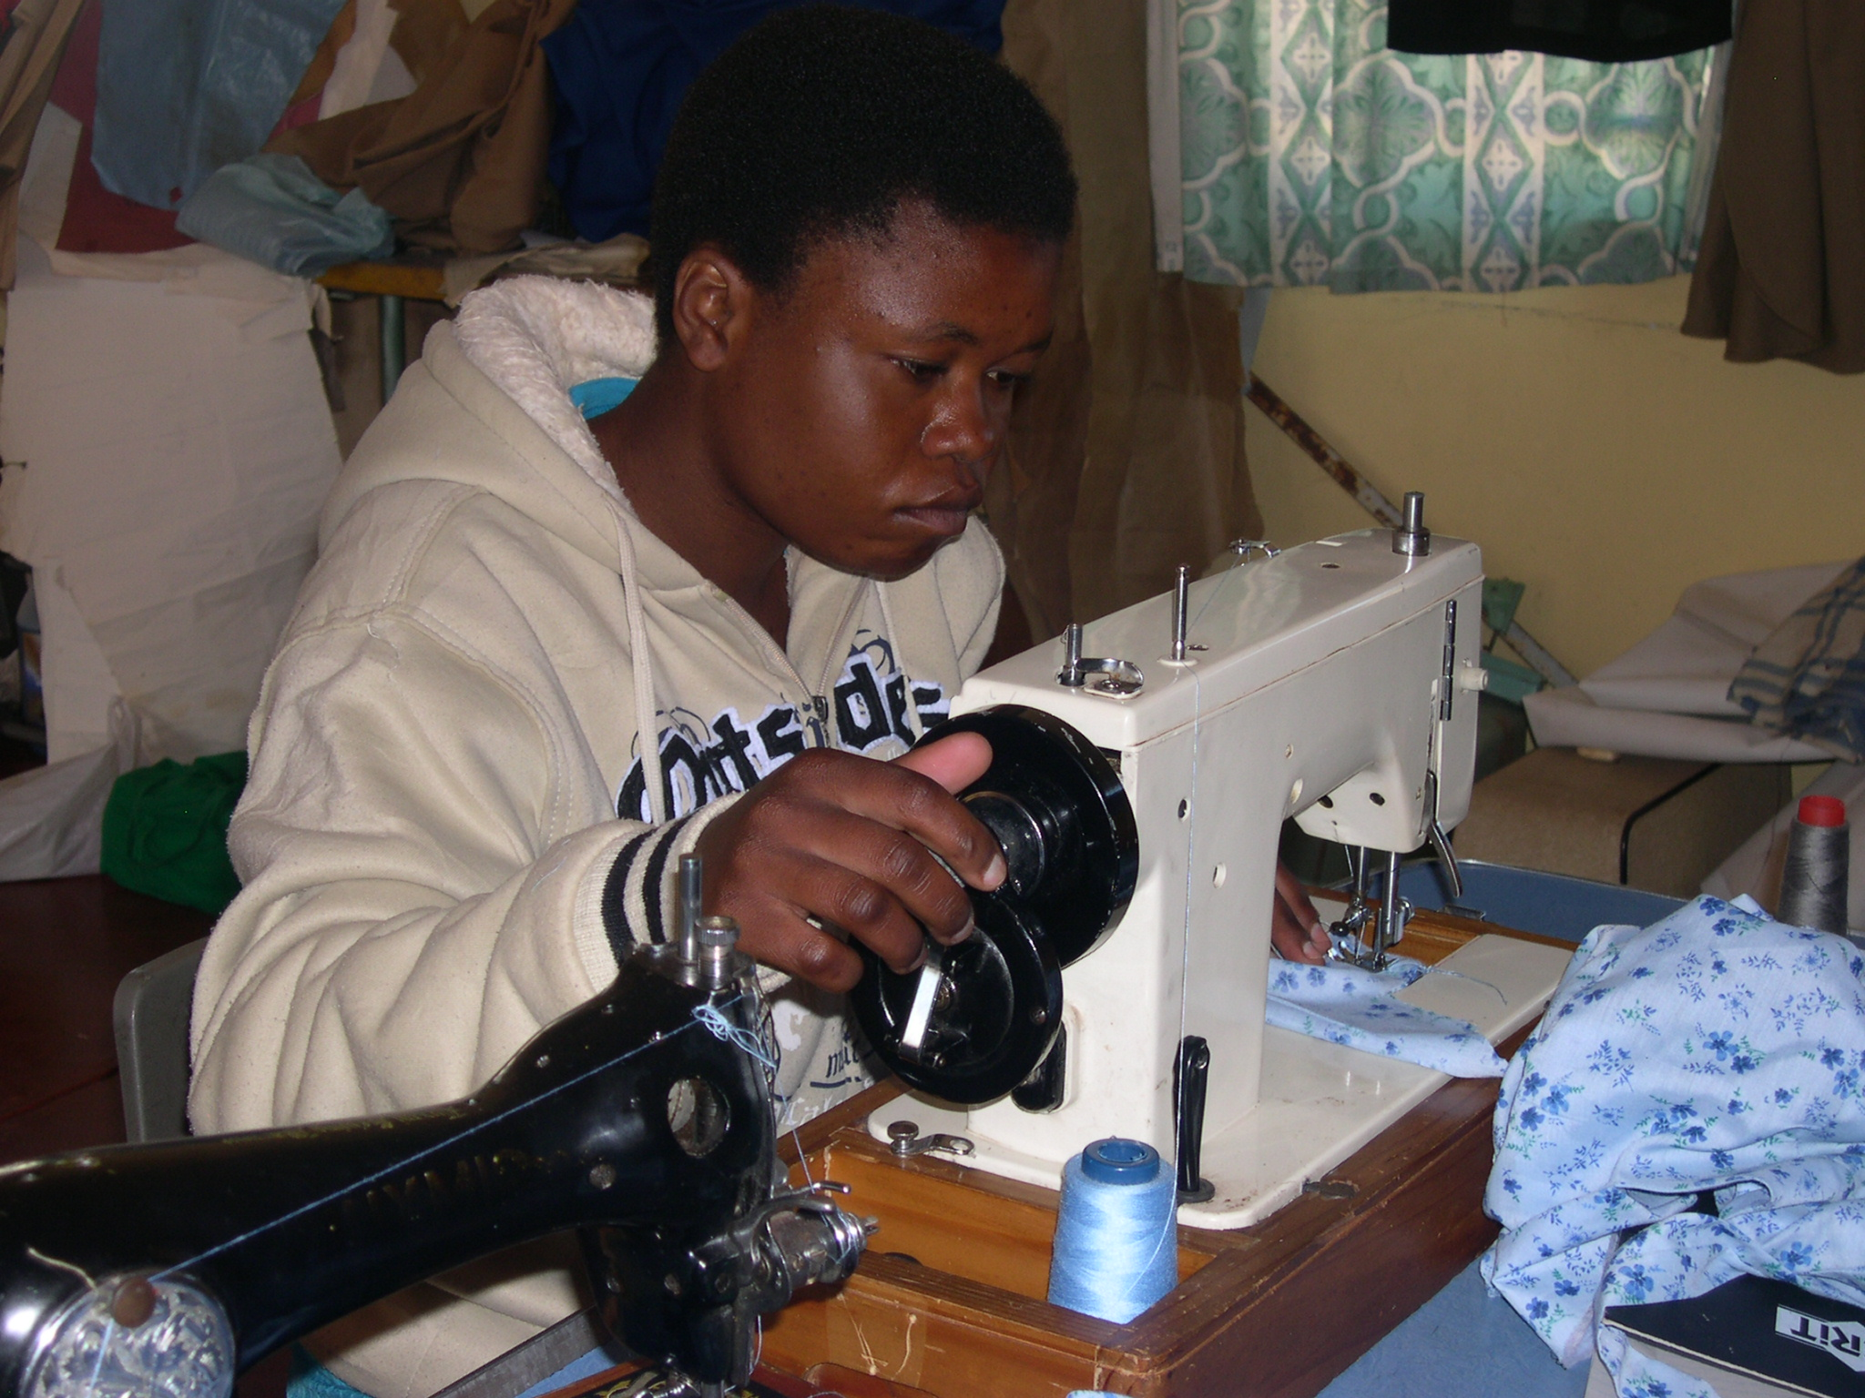

Above left, the garden that MRDF supported in setting up and above left, a beneficiary during a tailoring skills training that the Uniting World is funding.

Creche update
The crèche building is on course. With additional funding from the Qantas Cabin Crew Team and Nyaradzo Funeral Assurance Company all electrical installations are complete. The plumbers are finishing their work by the 23rd of August. We will proceed to fit the ceiling and painting once we get additional support. These are the remaining major tasks.
Visitors
The MRCH welcomes Shelley Cooling of the United Kingdom who has come to join us for the next 3 years. Shelley, an Early Learning Specialist will be working in the Early Learning/Therapeutic Centre together with Audinney and Lizzy. Concerning her time at MRCH so far Shelley says”……………………………….I arrived at Matthew Rusike Children’s Home on 28th of July and was immediately made to feel at home. I’m staying in a lovely three bed roomed bungalow which will be used to house other volunteers who come to visit the project. We are now in the process of making it homely including purchasing furniture and equipment. Maybe you will come and visit one day?
I have been very impressed by the newly established ECD classrooms, much of it paid for by your donations. Lizzie and Audinney, the teachers have great vision for the project and are doing an excellent job in supporting 54 children who are now split into two classes, almost like Nursery and Reception classes in England. The children have been proudly showing me their newly learned skills in counting and writing and are using the brand new outdoor area to maximum effect. We even went on an end of term trip to a local park where the children went on boats and a train. It is a pleasure to see how the children are making even more progress following the recent changes. It is hoped that plumbing will be finished in the next week so that during school holidays we can move into the second classroom my role will be to support stuff to promote quality provision and emotional support for the children in the ECD.
Your money really is making a difference to the young lives of children in the community and who reside at MRCH. As I begin my work in the newly established projects across Zimbabwe, I’m confident that I will see the successes at MRCH reflected nationally”
Welcome Shelley, we hope you will enjoy your stay at MRCH.
……On the same note, we welcome Rebecca Hookins who is an intern from the UK. Rebecca will be at MRCH until October 2011. Carol and Don Branham of Friends of MRCH also from UK are visiting the Home. Welcome friends. We hope you will enjoy your stay at MRCH.
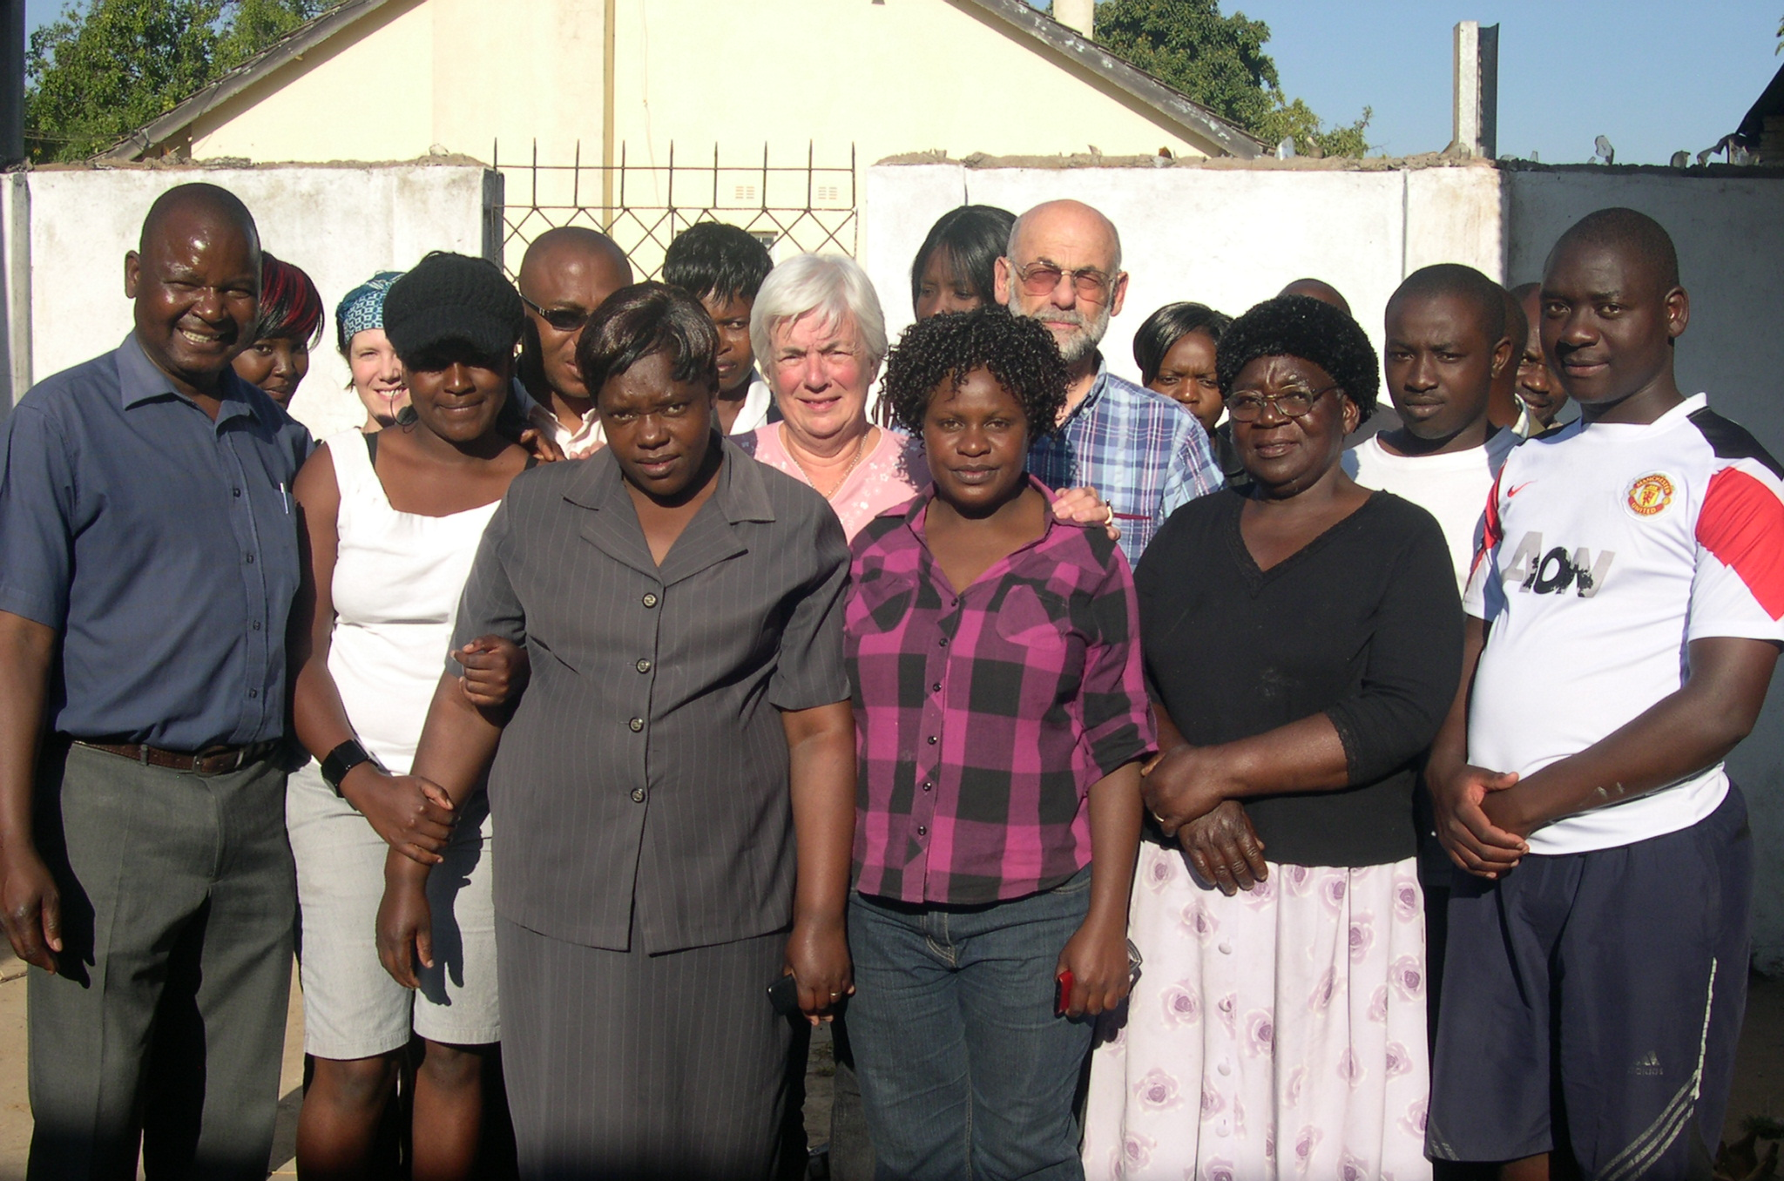
Above: Carol and Don Banham of the FoMRCH with staff of Matthew Rusike Children’s Home soon after their arrival at the Home.
Contact us
Should you require any further information, or want to contribute to this newsletter please write to us on:
Matthew Rusike Children’s Home
P.O Box H99
Hatfield
Harare
Email: matthew_rusike@yahoo.co.uk
Or call us on +263 772 416 221-4
For your donations our bank details are as follows
Account Name: Matthew Rusike Children’s Home
Barclays Bank FCDA Branch
Branch code 2157, Account Number: 6290535

