In England….

I finished my studies at Queens Foundation in April. Since then I have moved back to my parents’ home in Sheffield and have been busily preparing for my trip.

This has included

* Weekly visits to Queens to have Shona lessons, Spiritual guidance and continue networking
* Engagements to speak at various churches, social groups etc.
* Attending training, for example, Action For Children training about Trauma, a conference about Education in Zimbabwe, An international HIV conference and more!
* African cookery lessons -vegetarian dishes for me!
* Pastoral visits
* Making contacts!!

I was lucky enough to attend two retreats, Spring Harvest with its focus on ‘Route 66- Getting to know all the Bible’ and Cliff College Bible Summer School- both were amazing!

My ‘Farewell BBQ’ was a wonderful night, despite the British weather! I was joined by family and friends for a memorable night, where there was also a cake auction for MRCH organised by my church.

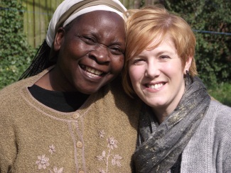

*Shelley is finally leaving!!*

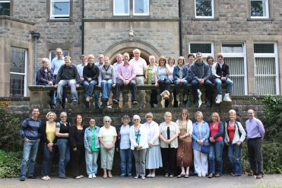

**On to Zimbabwe…..**

So now my freight has been sent, my visa is due any day and my flight is scheduled for the 27th of July!

My work at Matthew Rusike Children’s home will focus around working with children who are in their early years, many of whom will have been traumatised or who are vulnerable.

Please keep in touch by email [waif_uk@yahoo.ie](mailto:waif_uk@yahoo.ie) or Facebook.

Prayer requests

* Safe delivery of freight that has been donated to the Children’s home
* Work permit to be quickly authorised
* New relationships to be quickly established with myself and my new colleagues at MRCH

Sara zvakanaka!

Shelley Cooling

