FRIENDS OF MATTHEW RUSIKE CHILDREN’S HOME

www.friendsofmatthewrusike.org

The STAFF at MRCH were interviewed about their jobs and asked if they could identify areas for further development. They are all so skilled in their roles and dedicated to the care of the children, yet there is a hunger for more advice and training.

“Our goal is to develop the whole child, spiritual, physical, emotional, intellectual. We need more staff development. The children are like little birds with broken wings – we need to repair their wings so they can fly and achieve their goals in life. We need support to grow, I get support from Mr Mapurisa.”
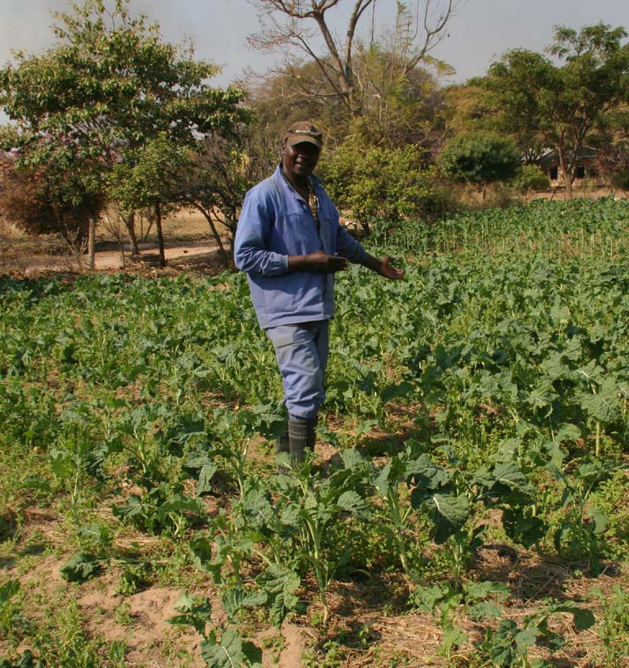
Abel is in charge of the garden and the team of local volunteers who are part of the outreach project. He teaches them to grow their own food on a plot of land set aside for this purpose. He grows spinach and rape a tall plant grown for its leaves, fennel, rosemary, tomatoes, onions, a few strawberries and carrots. The produce is eaten on site and excess is sold to local people. There are several fruit trees around the site – mangoes, avocadoes and haches (small oranges)
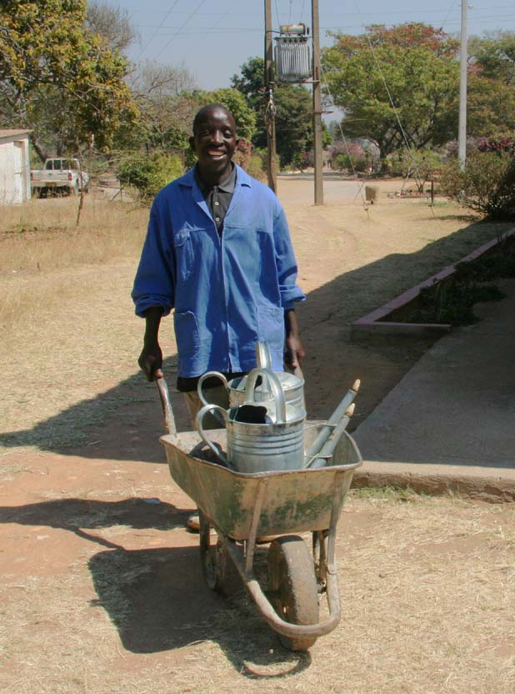
He needs plastic sheeting for the huge greenhouses so he can grow more food, the water tower is leaking and only 4 of the 15 irrigation pipes are working.

Emmanuel is the assistant gardener who waters all the plants grown as landscaping around the whole site. He sweeps up the endless supply of fallen leaves. He came to MRCH as a child so has seen many changes.

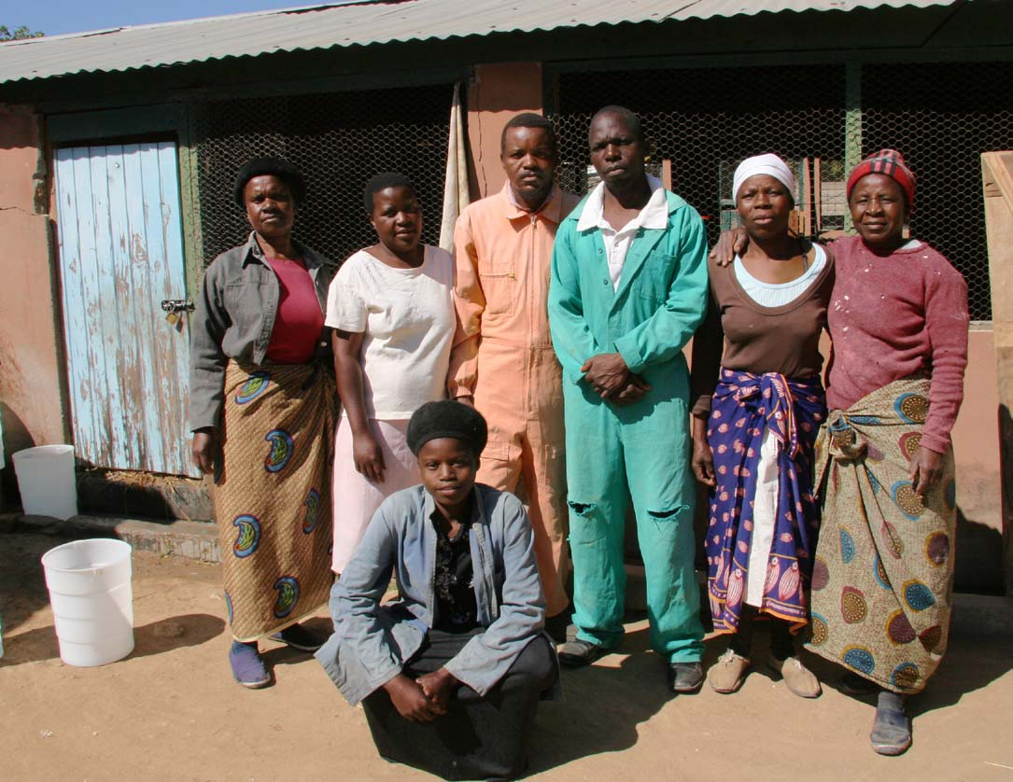
Abiyot is in charge of the poultry and piggery projects sponsored by Uniting World in Australia. 450 day-old chicks are bought in and reared until they are about 2 months old. They are then ready to eat or sell to locals. Abyoti (in green overalls) organises a team of local people who help him to care for the animals. In return the younger children attend the Early Childhood Development centre (ECD)
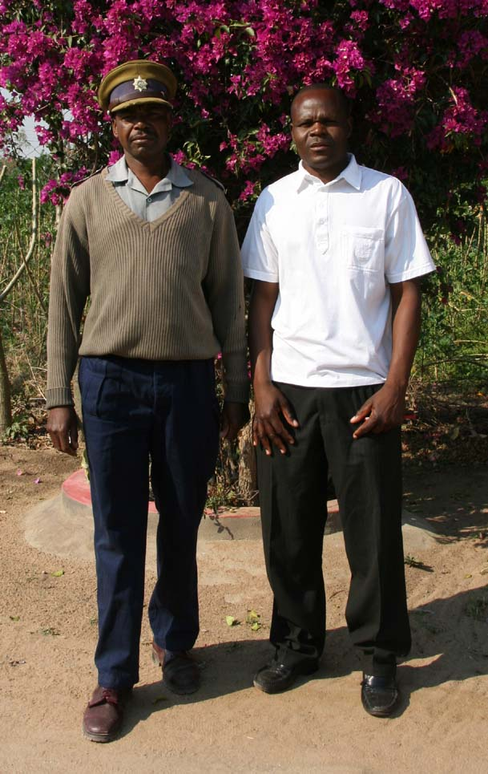
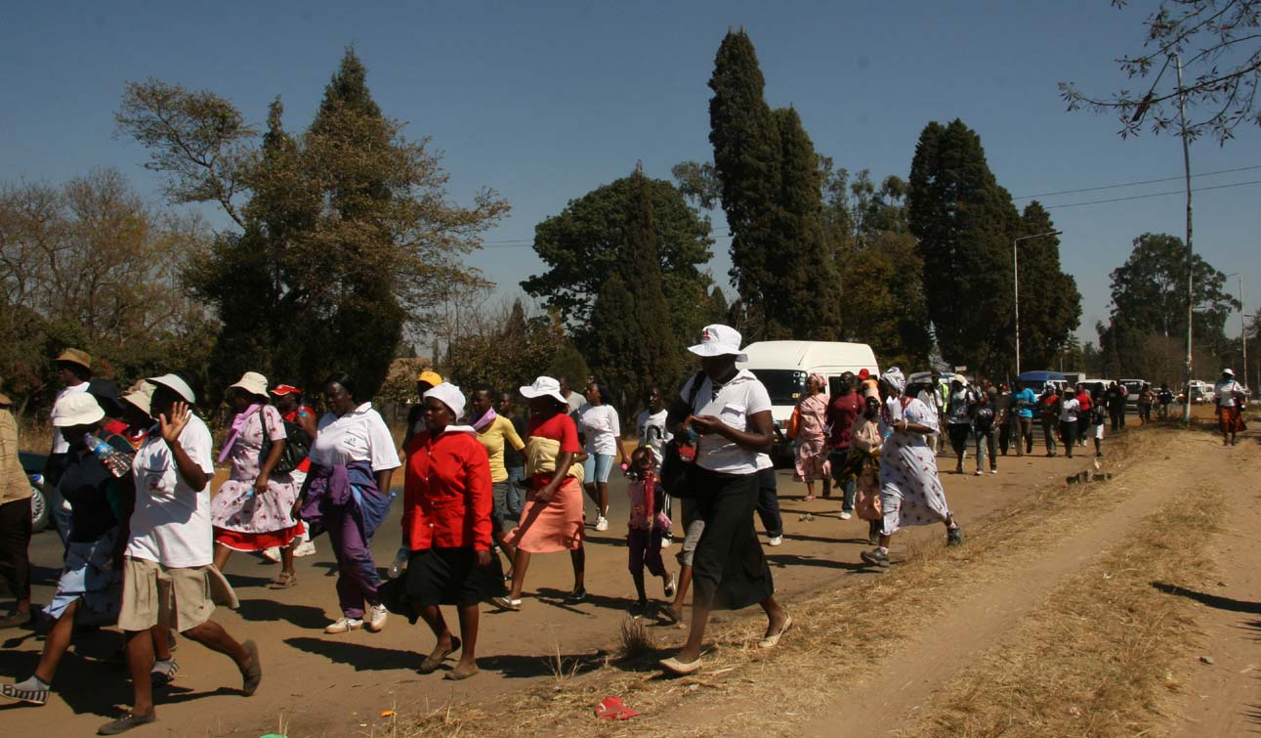
Abyoti killed the large pig to be barbecued on the Fun Day in September. This is an annual sponsored walk event to raise money for the Home. Staff and older children, volunteers and members of supporting churches and organisations walk the 15km from Connexional Office in Harare to the home where they can buy from a good choice of “fast food”- burgers, hot dogs and barbecued chicken and pork. Abyoti would like to be able to buy more day old chicks each time. Double the number would mean more food, more people to work – more jobs. He would also like smart worksuits and gumboots for everyone who works with the animals.

Joseph (white shirt) is the Security officer in charge of a team of 6 local police officers based at MRCH and Chitungwiza. There is a good relationship with the local police station. Joseph regularly checks all
safety catches on doors and windows are working correctly, that all
1

doors are locked at night and often returns to the site after his shift to check the perimeter again. Community people’s bags and vehicles are all searched as they leave the site. Big, Servous, Gona and Wilbert are security guards.
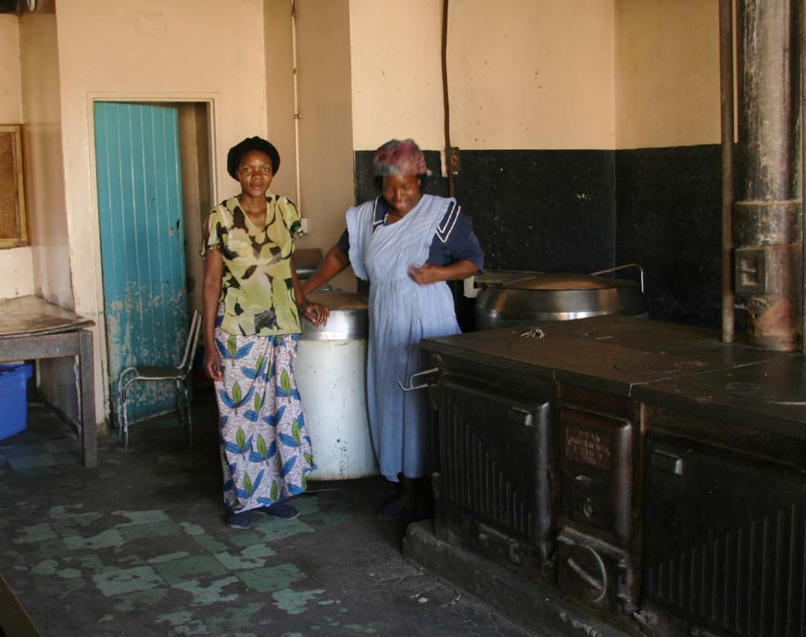
Joseph also had unofficial tasks – that of helping Shelley to get online and have a working mobile phone which would reach beyond Zimbabwe’s border This involved trips to town and getting an IT person to visit Shelley and after a lot of effort over 5 weeks Shelley was online at last though still often difficult due to a very unreliable electricity supply . He also helped Shelley with settling in and caring for her African puppy who has needed to learn to be cross cultural and sleep at night instead of being a guard dog and roam the grounds.

Susan (in blue) is Abel’s wife. With Beauty’s help, she cooks the meals in the large kitchen for the local community children in the ECD and parents who attend the tailoring and are volunteer workers in the garden and the poultry.

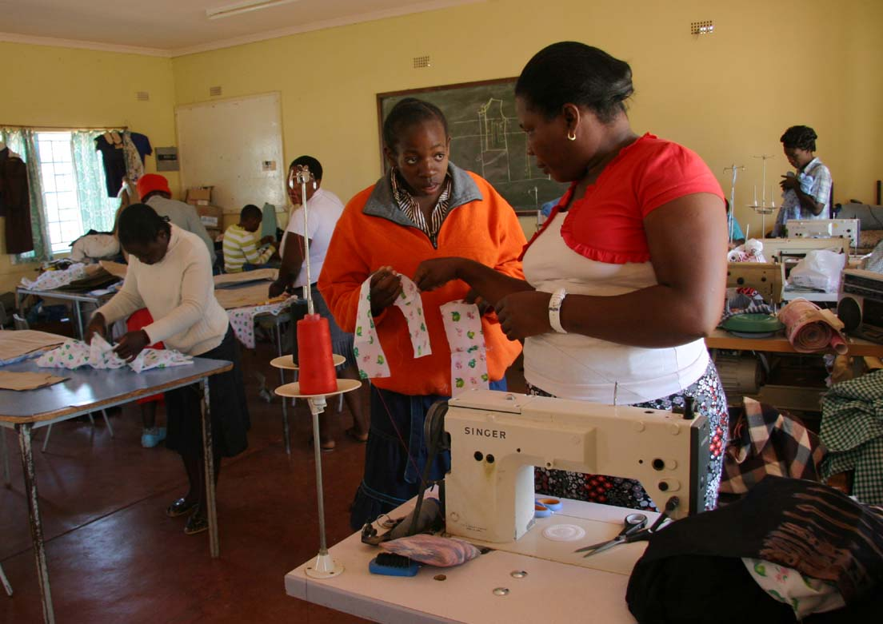
Mauline is the tailoress, she trains the local women to sew for their family so empowers them to become more independent and maybe able to earn money.
The tailoring is part of the outreach project whereby local needy families are identified by the trained caregivers in the community, come to MRCH and work in the garden, receive training to look after the animals and their children attend the ECD centre or the teenage study group.
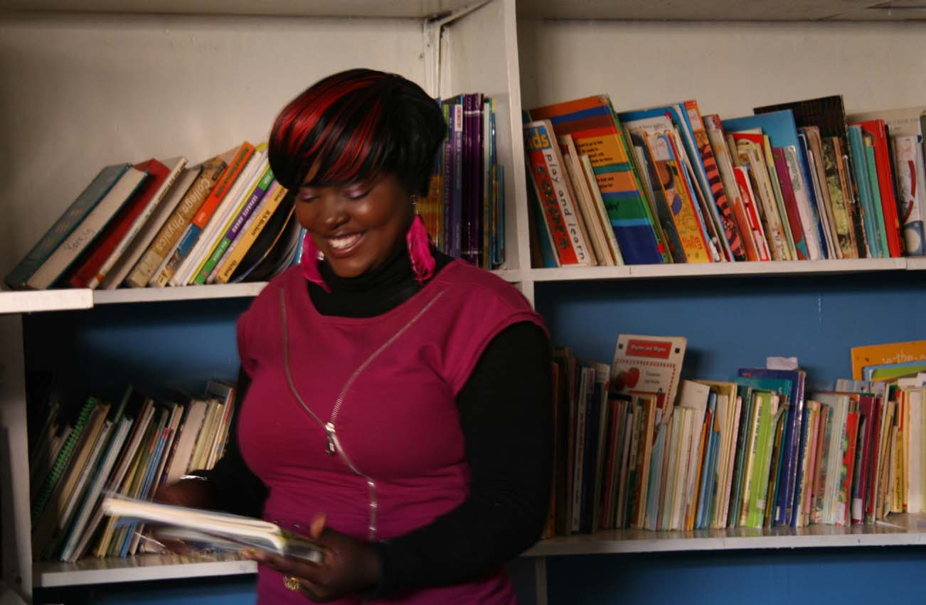

Kudsi is the librarian and IT instructor for the children. She was setting up the library in a ‘new’ room while we were there. Books of all kinds, fiction and non fiction, poetry and plays included, for teenagers and young adults are particularly needed.

She has only 2 computers, and one wasn’t working well, which she uses to instruct the children in IT. Books donated by other countries are good supplements but there is a serious need for Zimbabwe curriculum books.
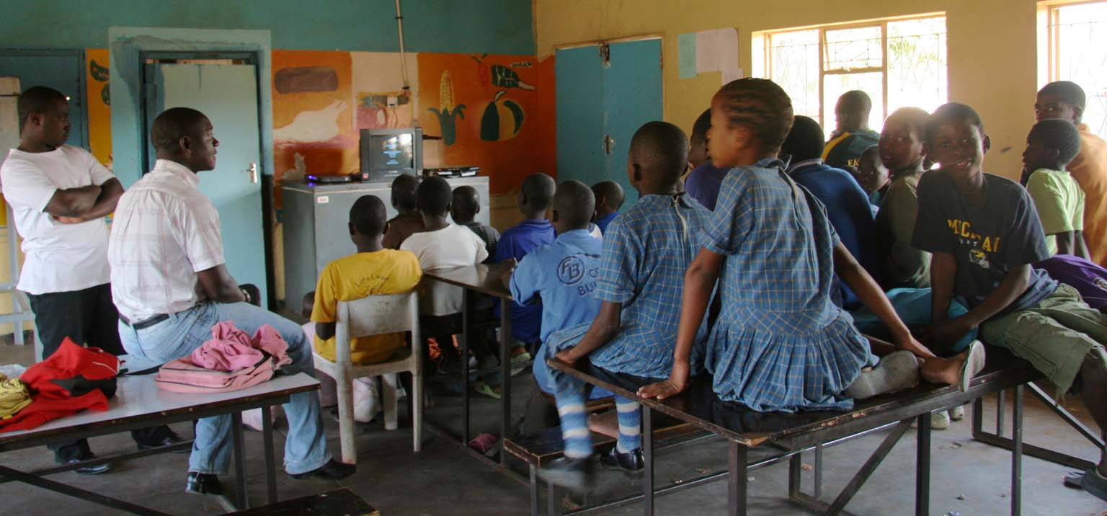
Liberty is a social worker who runs the psychosocial support group for many traumatised children in the home and from the local community. He has a tiny TV on which he shows DVDs about various issues to help the children to discuss their emotional/psychological problems. He needs more of these kinds of resources. He also teaches some basic literacy and numeracy as extra help during school holidays. The children are taught in groups and are given a free cooked breakfast and lunch. Their parents attend the tailoring classes and give their service as payment for this, the meals and the support for their children by working with Abel in the garden, with Abyoti in the poultry and piggery and as general extra help around the home. The parents work on a rota basis, learning these useful skills which empower them and in this way the whole family is helped. 2

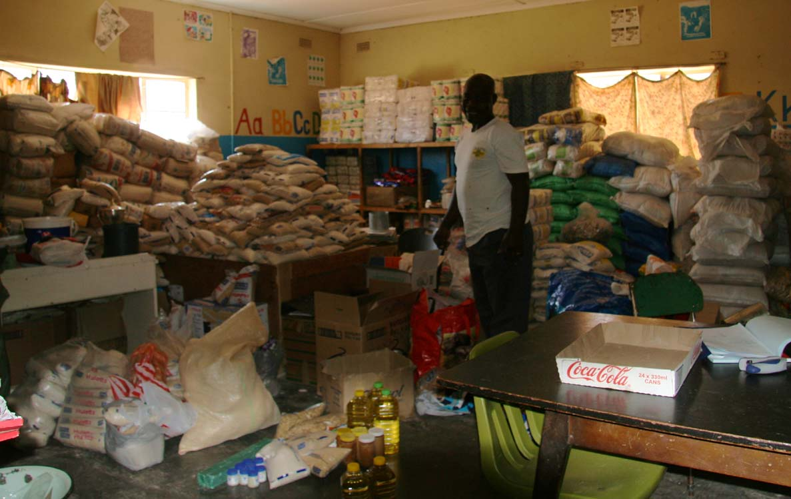
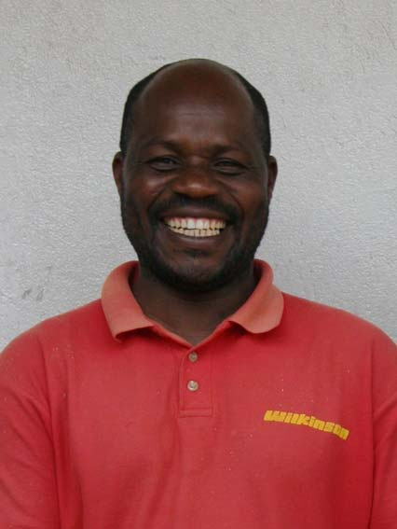
Julius is the storesman, maintenance man and keeper of the keys. He receives, records and stores all food, toiletries, house cleaning materials, crockery, cutlery, stationery, clothing and all donations in kind. Staff must fill in a requisition form for anything they need. He also reorders items, getting quotations before he buys and conducts a monthly and an annual stock take.
Jullius is also the maintenance man, making sure that all the doors and locks are working well on the storerooms. “I also do a little bit of electricity, iron work and repairing”. His wish list is for more shelving in his storerooms so he can organise everything better but there is never enough money for such materials.
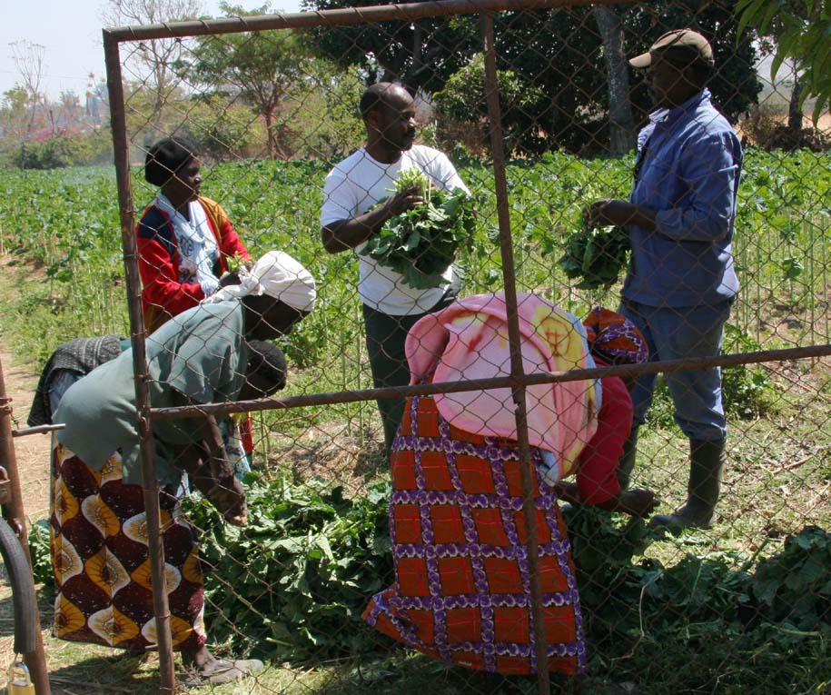
I also discovered that his hands are the MRCH standard for ‘weighing’ the vegetables in the garden. Customers thrust bunches of greens into his hands until he can’t hold any more and that amount is worth US$1. Here he and Able are selling greens to local women.
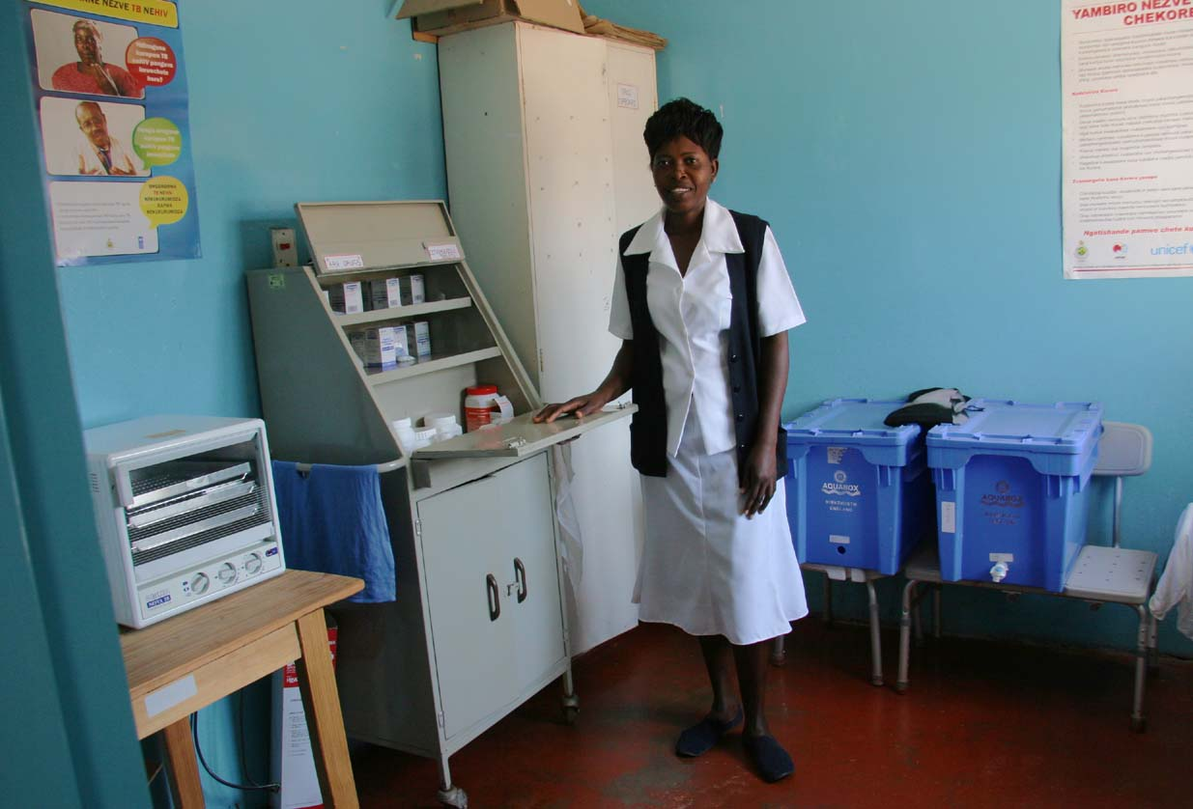
Lita is the nurse who cares for children and staff when they’re ill. The clinic is now officially registered and awaits the government inspector so she can claim more free medication. There are 5 rooms: a consultation room, a young child observation room with 2 beds, a room with 5 adult beds, a drugs room and 2 tiled bathrooms.
Lita needs more basic medications, disinfectant, antiseptic creams and first aid items and she would like the floors tiled so it is even more hygienic. There are 11 HIV children living at the home who she was happy to say are all well at the moment, but very many of the community children in the outreach projects are also HIV positive. Lita visits the outreach projects across the country to give help and support to the volunteer carers.
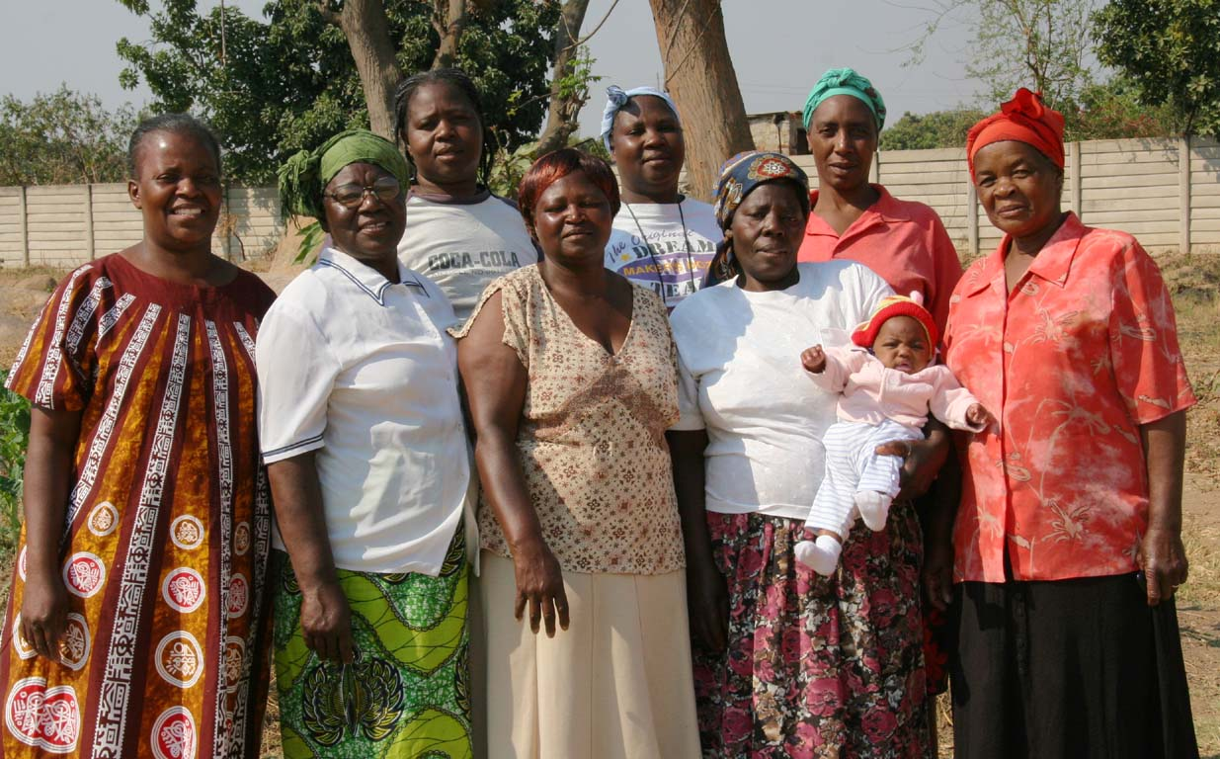
8 House Mothers
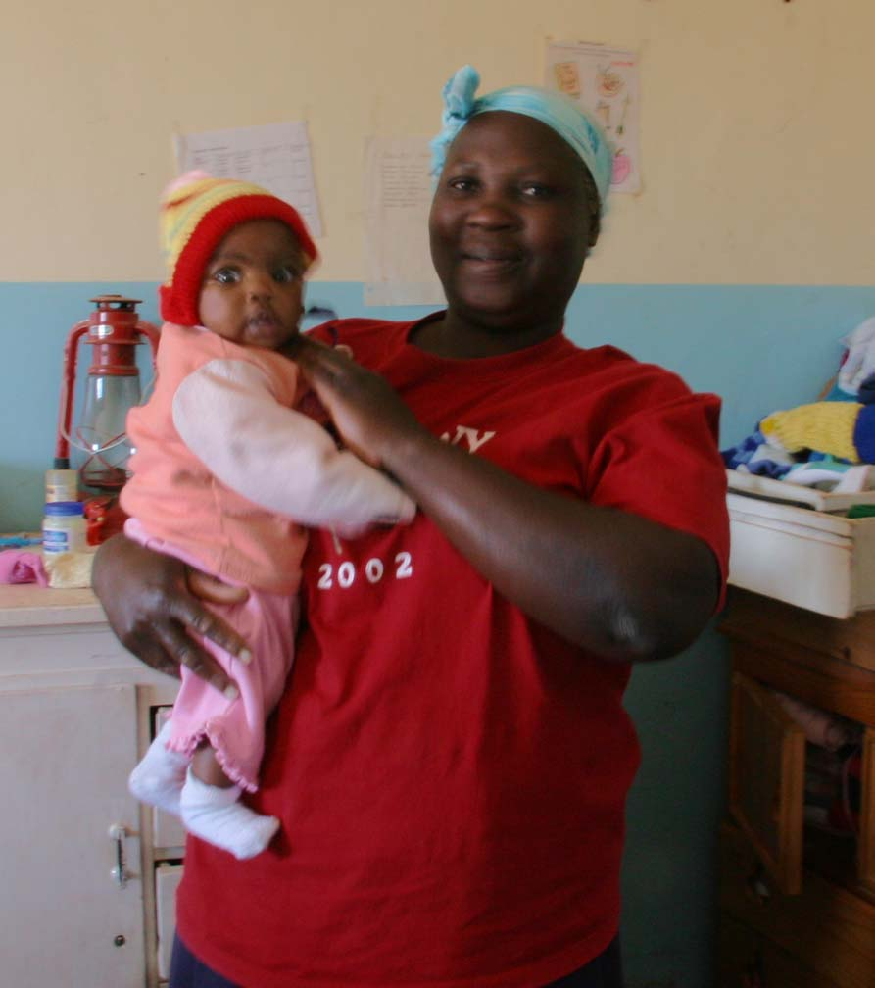
Mercy, Lillian, Faith, Fungai, Mildred, Alice, Nancy and Sylvia. These warm hearted ladies lovingly care for the children in the house units. Each of them has a family of their own, mostly grown up now, who they leave with other family members for 30 days at a time while they’re at MRCH then they have 10 days break to go home. All of them have very obvious pride in their homes at MRCH.

Mildred cares for 6 babies, all under three. Amelia is the youngest at 3 months old. I said it must be a lot of work looking after so many small children and she said “it’s not hard when you love little ones”

The other mothers each care for 11 –12 children ranging from 2 to 16. Once they reach 16 they move to live in the independence units where they look after themselves with help and support available from the house mothers when needed. 3

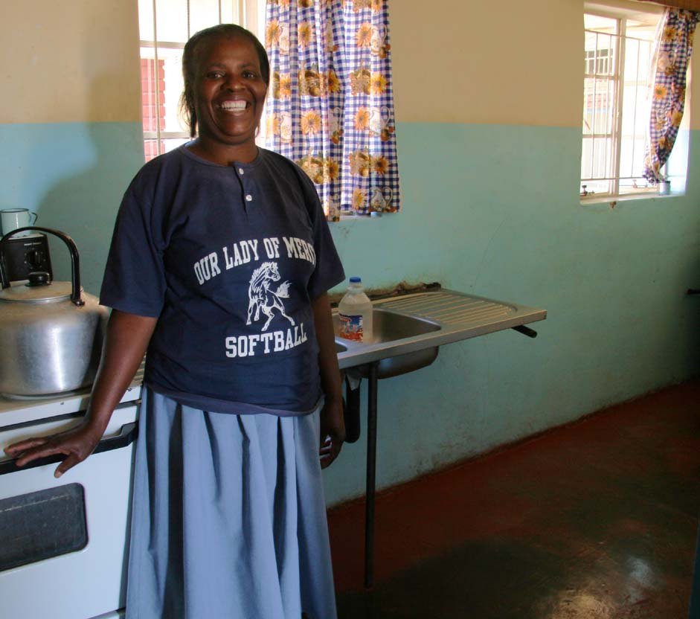
Sylvia has been at the Home for 5 years and cares for 11 children, 6 girls and 5 boys. She teaches them their duties around the house, cooking, washing and cleaning and helps them with their homework.. She doesn’t have a counter or cupboards in her kitchen and some of her smaller children have to share beds. She feels the children need more weekend activities to take them off site “but we can’t afford trips. When a child has a birthday we want to do something special but it’s so difficult. They see other children from the community have cakes and drinks. We try to cook what’s in the house a different way but it’s usually the same as usual and we sing to them. They say ‘ but why didn’t you make me a cake to take to school to give to others’? It would also be nice for all the staff to go out together again. We did it before, we did team building games and it was very good and helpful to us.”
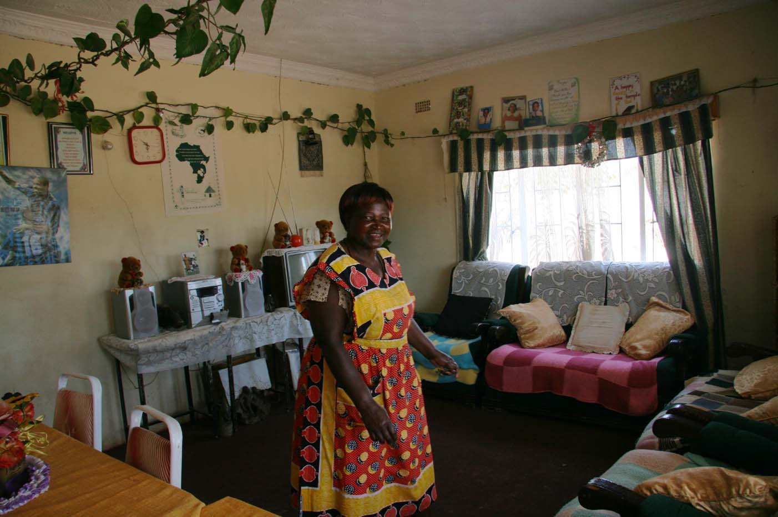
Mildred and Sylvia live in the 2 last houses to be adapted from the old boys’ dormitories so they are sparsely furnished and lack storage

Lillian has been at MRCH for over 20 years. She was the first of the mums to move into the new houses in 2004. “The houses are wonderful! Now I have time to talk with the children and listen to their problems and help them. I teach them how to cook and clean and take care of the garden. I have 11 boys and 2 girls from 2-16. When they come home from school they say. ‘O mum the garden is dry can I water it? One child likes animals and we have 6 guinea pigs. They eat green leaves from these plants we grow. I love the flowers. I look at the flowers and don’t think about problems. When I look after them I don’t think about anything. Now I have time to do all my work in the house as well as cook and make bread.”

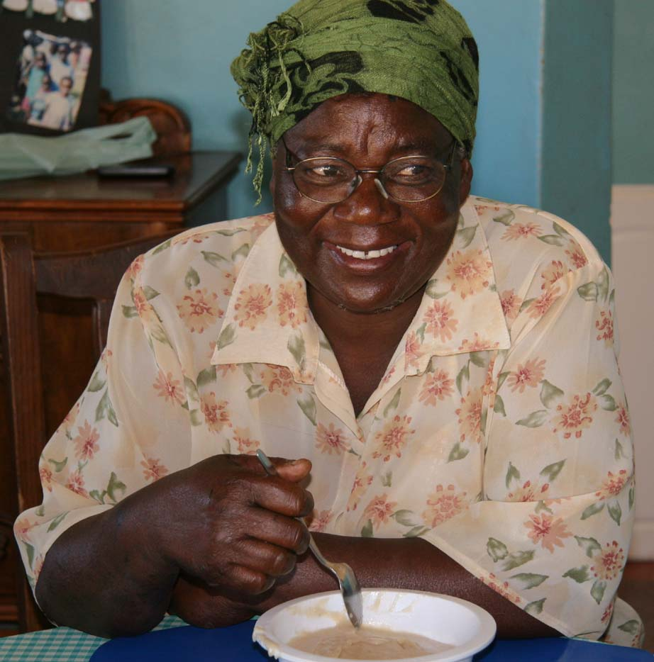
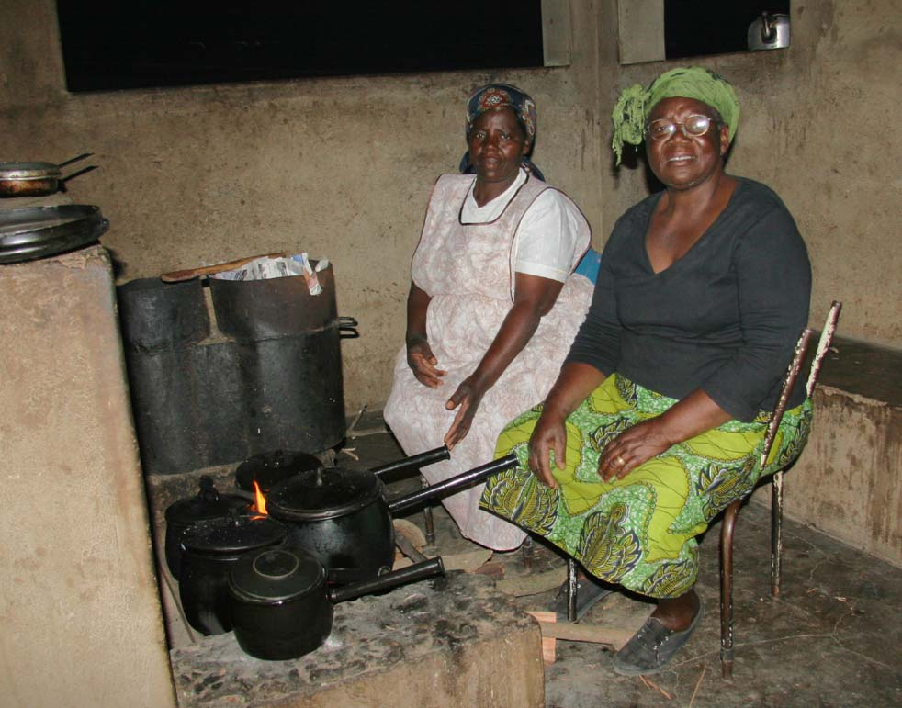
Mercy has been at MRCH for 26 years. She also has 11 children to care for and teach house skills to.
When the electricity goes off cooking is done in the outside kitchen. Fungai and Mercy cook a good lunch for the 38 staff each weekday. Mercy loves cooking, she says it is her hobby.

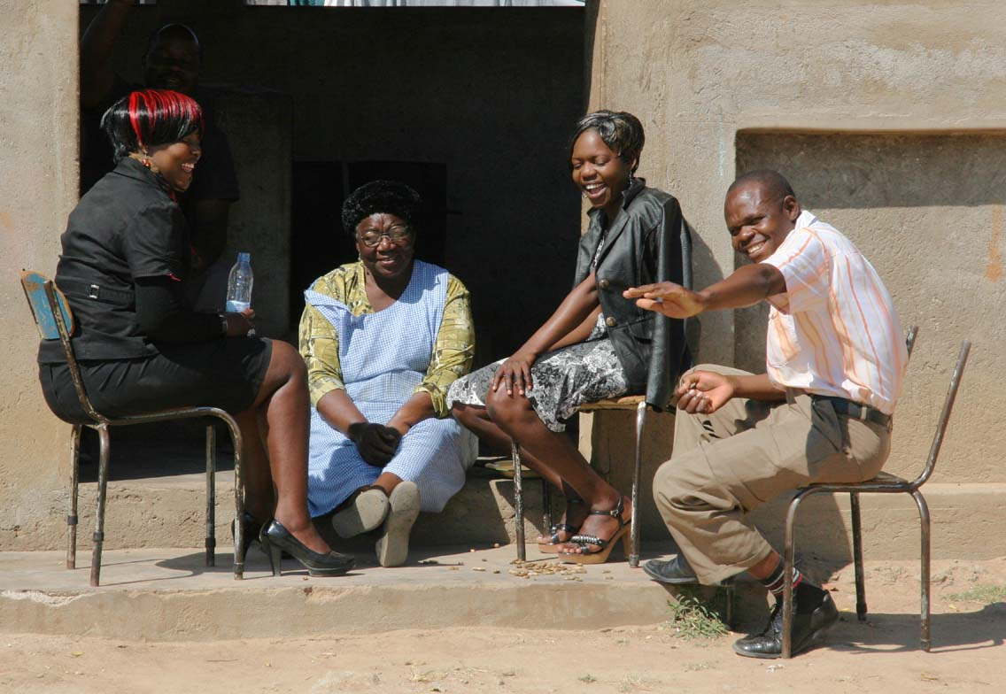
Here staff relax after their lunch

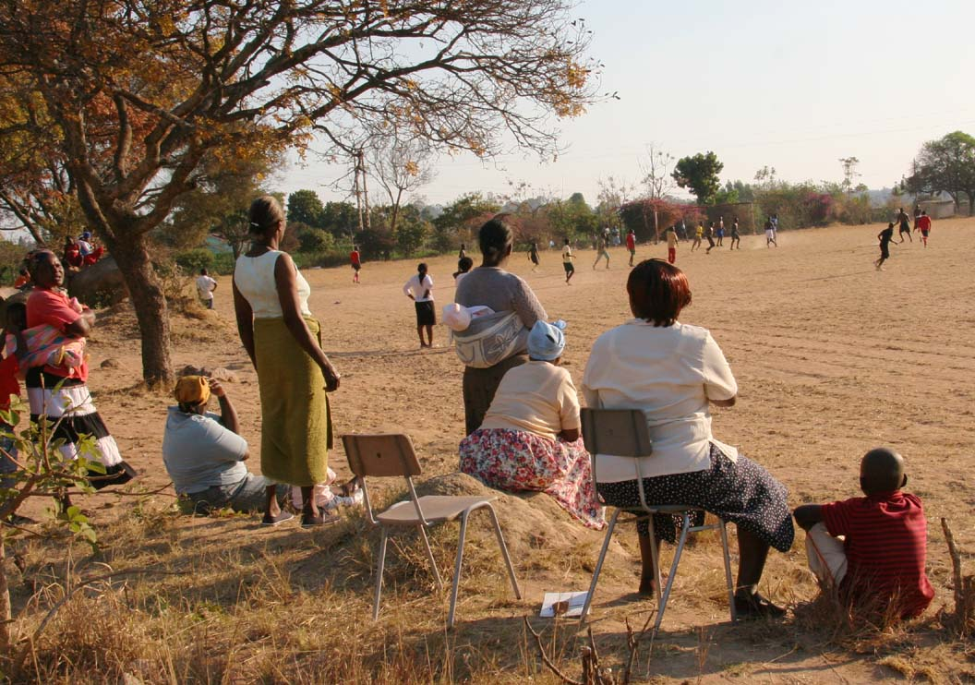
One Sunday afternoon a visiting football team came to play against the MRCH team of children and staff. I joined the mums who went to support them. They heckled and encouraged the players loudly. Each time their team got a goal (5 in all) 3 of the ladies ran down onto the field yodelling, clapping and dancing their encouragement. “We have to encourage our children” “It’s a time to relax and forget everything” Mildred’s little children were playing nearby and then went to play on the climbing equipment. It was a very happy afternoon.

4

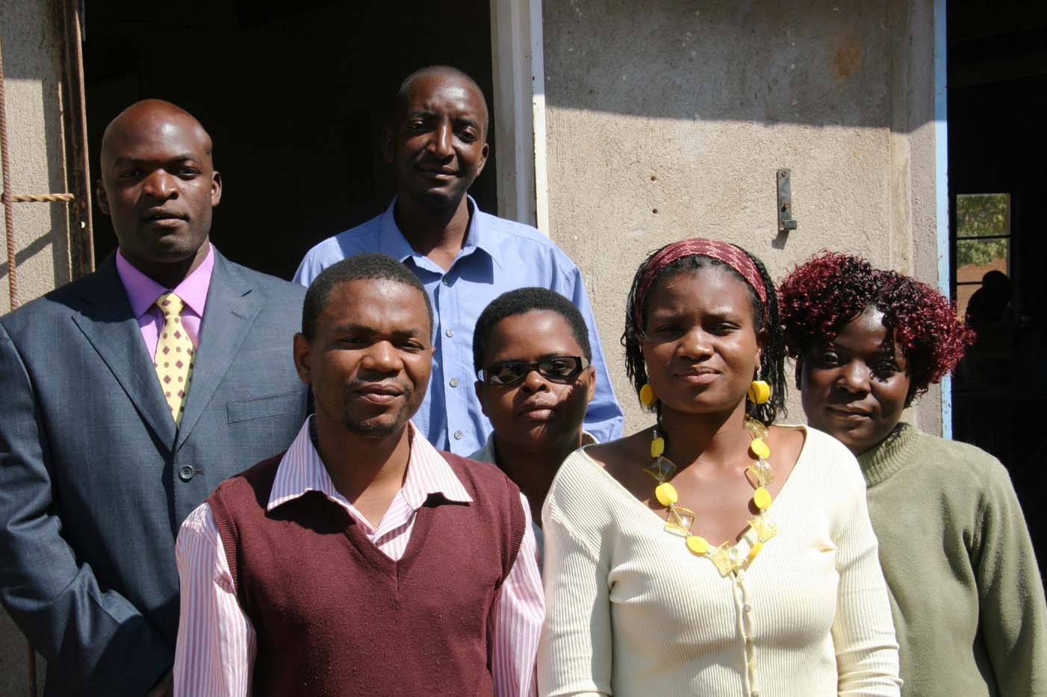
6 Teachers
Gladys, the head, teaches Shona and RE Kuda, English, Oliga, history and geography, Tawanda commerce, accounts and sports , Major, maths Francis, integrated science and biology.

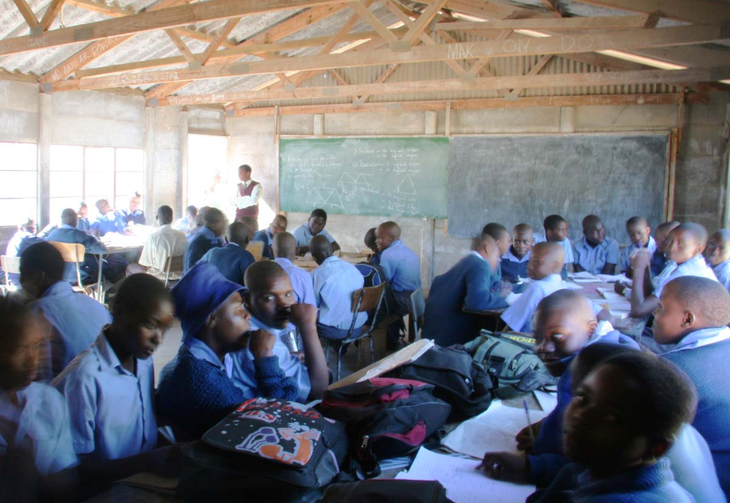
The study group was registered in the 1980s as a community resource to help secondary age children with their homework. In 2007 it was decided to try to formalise it into a small secondary school for children from the community aged 13-16, whose families can’t afford to pay the full fees of secondary education. In 2009 6 qualified teachers (with degrees and some studying for masters degrees) joined the staff at MRCH. The vision for the future is to transform it into a school where more subjects would be available and it could become an official examination centre for O and A level exams.
This is unfortunately a long way in the future because of the poor quality of the buildings, furniture and lack of educational equipment. Just to be able to apply for school status the building would have to be refurbished and all windows fixed, new and up graded toilets available. Every child needs a chair and a decent table to work on.
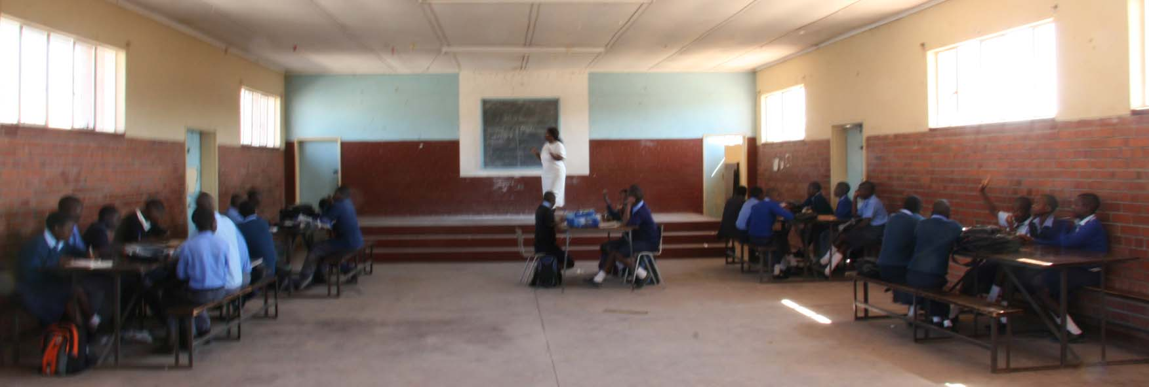
250 teenagers, 150 girls and 100 boys, are registered and are taught in 3 poor quality classrooms, a large echoing hall or outside in the shade. 45 children per class in two sittings spread over 8am – 4pm. There are not enough chairs for each child to have one and the few they have are shared with the tailoring group at the other end of the site.
Their choir practices in the hall and there are plans to make a DVD of them performing to help raise funds for their project. Gladys and Kuda live on site and they are in charge of homework and any extra help that the children need. The social work students sometimes help the staff.

“We desperately need (money for) text books for the Zimbabwe curriculum and English novels for extra reading”

Tawanda trains 2 girls’ football teams and 3 boys teams. He is concerned that when they play against other schools they stand out because they don’t have a team uniform. He has some good athletes who again do not have the correct clothing so they can compete as equals with other teams. He would like basketball nets too.

Francis would like to be able to take his science classes to visit industrial companies to widen the children’s ideas for careers. Science books are soon out of date and he would like some biology wall charts. Ideally he would like a science lab but some science equipment would be a start.

Imagine teaching classes of 45-50 teenagers without any text books! Science without any laboratory equipment! English literature without plays, novels or poetry! Commerce with only 1 book which is years out of date. No maps or books for geography or history. Maths without any equipment – calculators or computers.. There is a whole set of donated new maths books in the home’s library but of little use because the Zimbabwe curriculum is quite different.

5

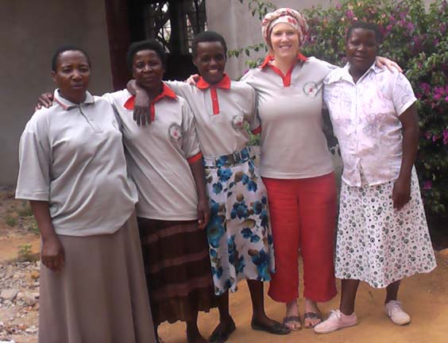
Shelley UK Mission Partner and Early Years education specialist. Here she is with the ECD staff
Shelley is living at MRCH until 2013. She supervises the Early Childhood Development Centre (ECD) supporting the 2 teachers, Lizzie and Hilda, to plan the curriculum, write reports, organise trips and parents meetings. 54 children are divided into 2 classes of 3-4 year olds and 4-5 year olds. 30 of the children are part of the community outreach project in Epworth the rest live at the home with a small number of children of MRCH staff. When the buildings are all completed they hope to have around 100 children and another teacher.
Shelley aims to train staff across the national early years project to understand the power of play as therapy and to develop relationships with the children that encourage emotional well being and skills for the future.
Her role is to listen, look and learn so that good early years principles can be developed which are culturally appropriate to Zimbabwe. She keeps the Methodist Church in Britain informed about the work she is doing and attracts funding for MRCH from UK supporters.
Her dream is to have a sustainable ECD that acknowledges and caters for the development of the whole child and facilitates children’s playfulness whilst purposefully developing their skills for the future.

What do we need? Our ECD environment to be finished.
I would like to set up a resource library for the outreach projects. The resources will encourage local volunteers and children to play and learn and then we will look at ways they can make these resources themselves through use of free and found materials.

At any given time MRCH has interns in Social Work, Psychology and Developmental Studies who are available to help any of the staff where needed. The placements are usually for several months and sometimes a new group arrives before the others leave.

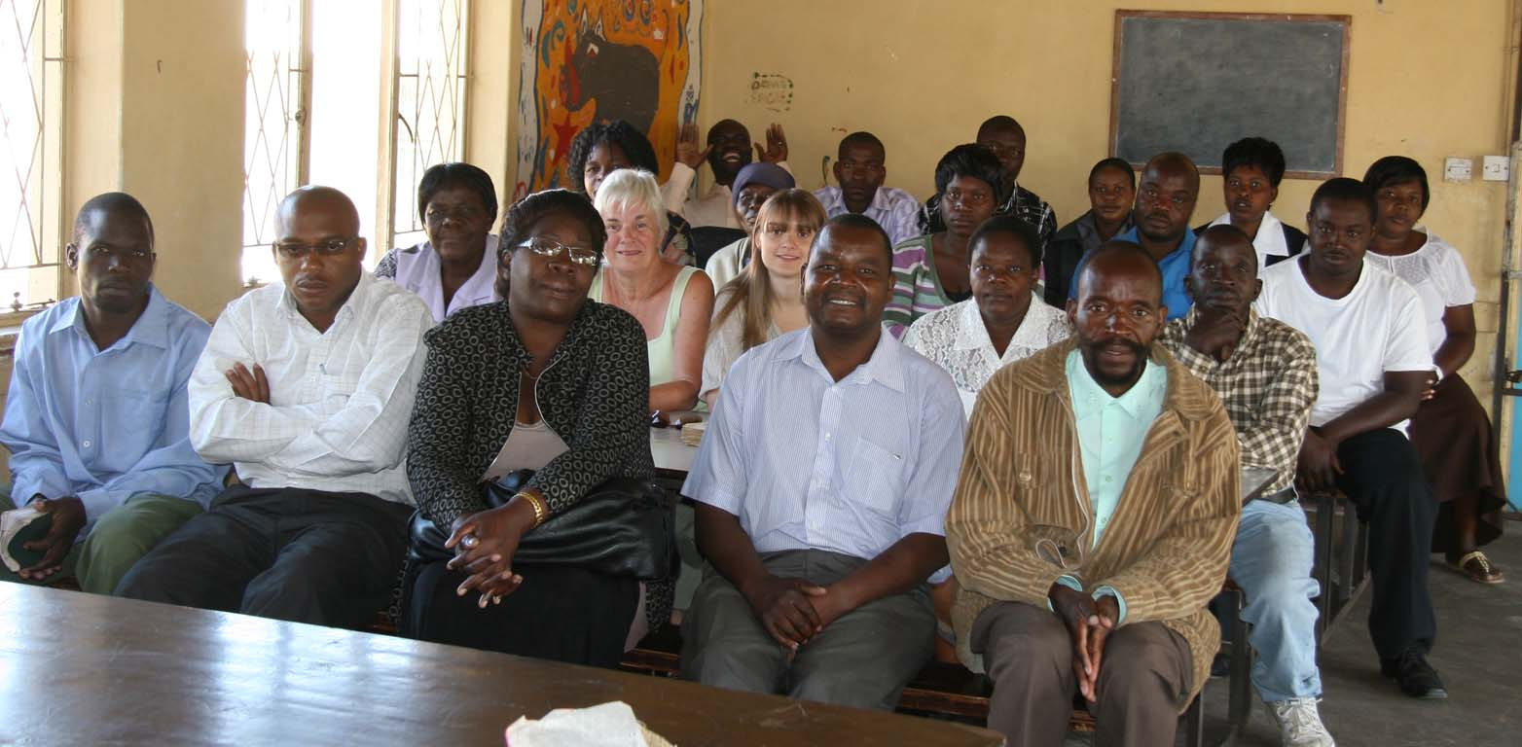

Rev Saul Tadzaushe the resident minister in charge joined the staff in December 2011. His role is the spiritual support and development of children and staff.

All the staff are on the rota to take devotions at 8 o’clock each weekday morning and here are some of them.

6

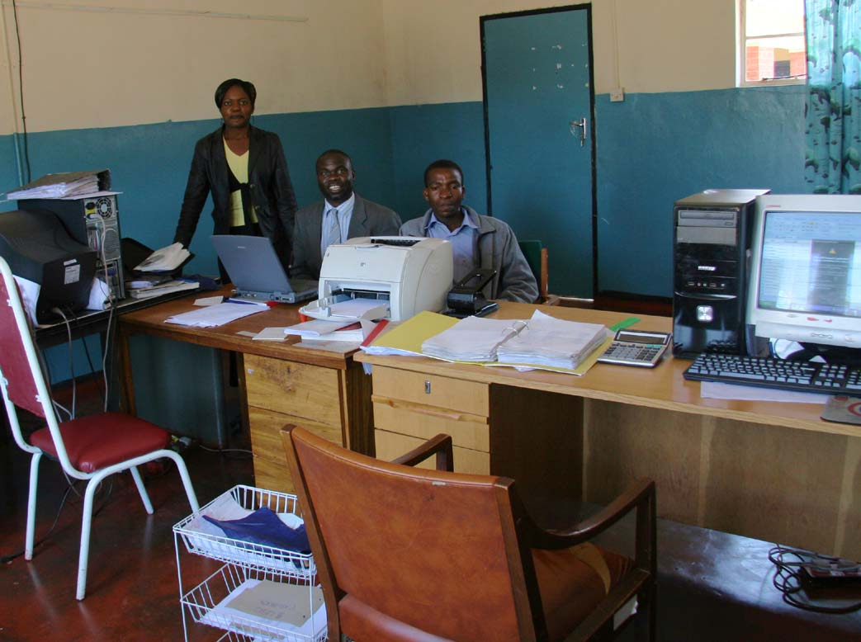
Tapiwa , Finance officer, Portia, the book keeper and Ernest the accounts clerk, all work together in the finance office
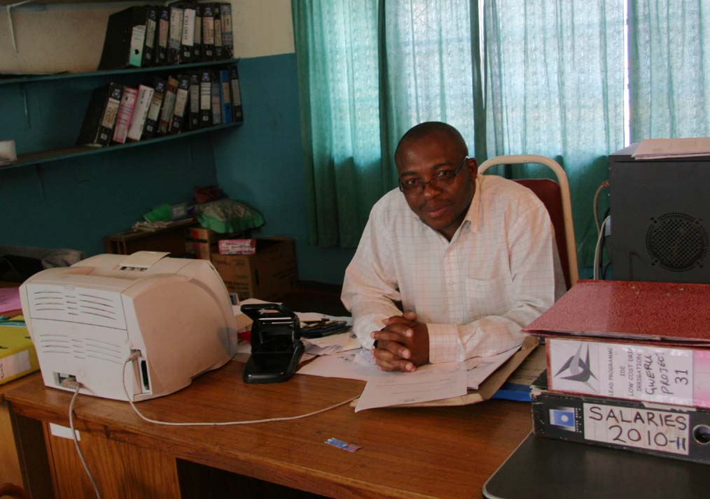
Tapiwa is studying for his masters degree in business administration. He ensures all money is banked before it is used. All expenditure is properly requested and authorised to be used for the purposes for which it is intended. Records and data are strictly kept and he prepares the payroll for all employees. He produces reports and accounts for the finance committee and the National Board and coordinates external and internal audits. He ensures all material donations are properly recorded, stored carefully and distributed as requested. Tapewa also supervises the poultry and piggery, making sure supplies for them are ordered on time and markets the produce from these projects to the local people. He’d like to have better breeding stock and feed so that these projects operate efficiently. He needs reliable computers so the stores can be categorized. “When the electricity returns it means work time is at a premium so another computer would be very useful for all Jullius’ stores as well”. The budget is presented to the church monthly and he and Astonishment prepare the budget in December for presentation to the Finance committee, which then goes to the National Board.
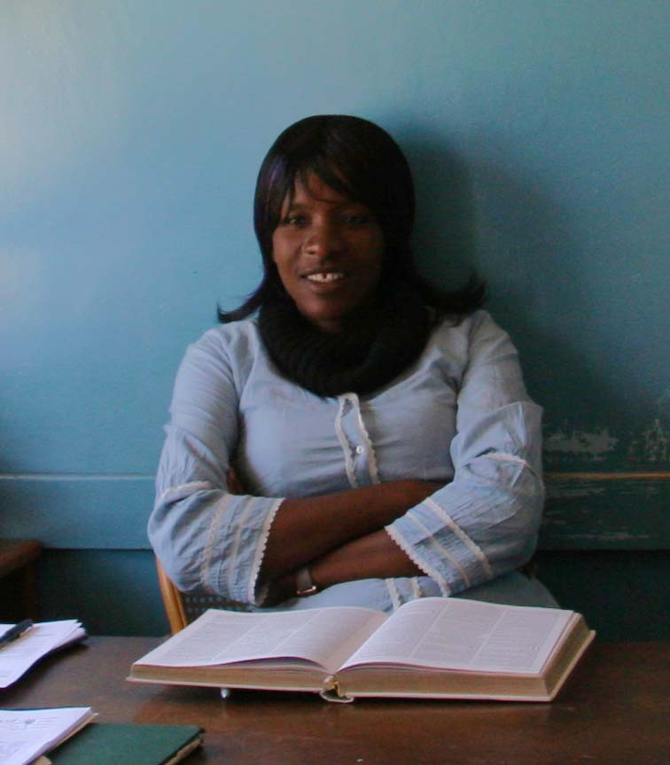
Mwema is a volunteer receptionist, social worker and HIV counsellor. She works voluntarily at MRCH 4 days a week. She works with the HIV children helping them to learn the importance of taking their medication, eating a good diet to stay healthy and how to cope with prejudice and the lifestyle they must lead. She is also part of the training team who visits the outreach projects. The MRCH management feels they need Mwema to join their team and she would love to be a staff member of MRCH but there isn’t the money to employ her. 1 day each week she has paid work to teach at the college.
Mwema is an HIV activist. She has been on national TV and radio because “everyone is affected or infected by HIV”
Mwema and her husband both became very ill in 2000 and then learned they were HIV positive. After they recovered they both became activists. Aaron Chiunduramoyo is a prominent media script writer in Zimbabwe. He asked Mwema and Jonah if they would play cameo roles in a national soap, playing themselves as a couple living with AIDS. The story line covered how lives can be destroyed, how HIV free children can be born to parents with HIV and even including the death of their 3rd child. Mwema has done other TV and radio programmes about positive living, peer pressure and the importance of a healthy diet. She has been a facilitator at conferences and in schools. After meeting Dr Mwasha who paid her fees to train to become a social worker, she did a placement at MRCH and then chose to stay on as a volunteer.
She is an award winner for Outstanding Leadership in Greater Involvement of People Living with HIV/AIDS. She continues to give health talks in schools, conferences and work places and she develops policies for work places and the formation of support groups for children.
She has a 20 year old daughter who is HIV positive, an 18 year old son who is HIV negative, her third son died of AIDS and a 13 year old daughter who is HIV negative.
Mwema has been on antiretroviral drugs since 2004 and is now very well.
Each Tuesday, motivational sessions for all the children are given by Mwema, Astonishment, Lita, a doctor or other influential people from the community. These sessions train them not to be prejudiced against HIV but also cover all aspects of good health, sex, pregnancy, STDs, abortion, marriage and peer pressure.
7

She would like story books for all ages about HIV/AIDS and other life issues. She is ‘on call‘ by phone to give help and support and an iphone or a laptop would make it possible to counsel people more easily at a distance (like Samaritans or Childline) She would also like multivitamin supplements to be freely available at the MRCH clinic for the HIV children.

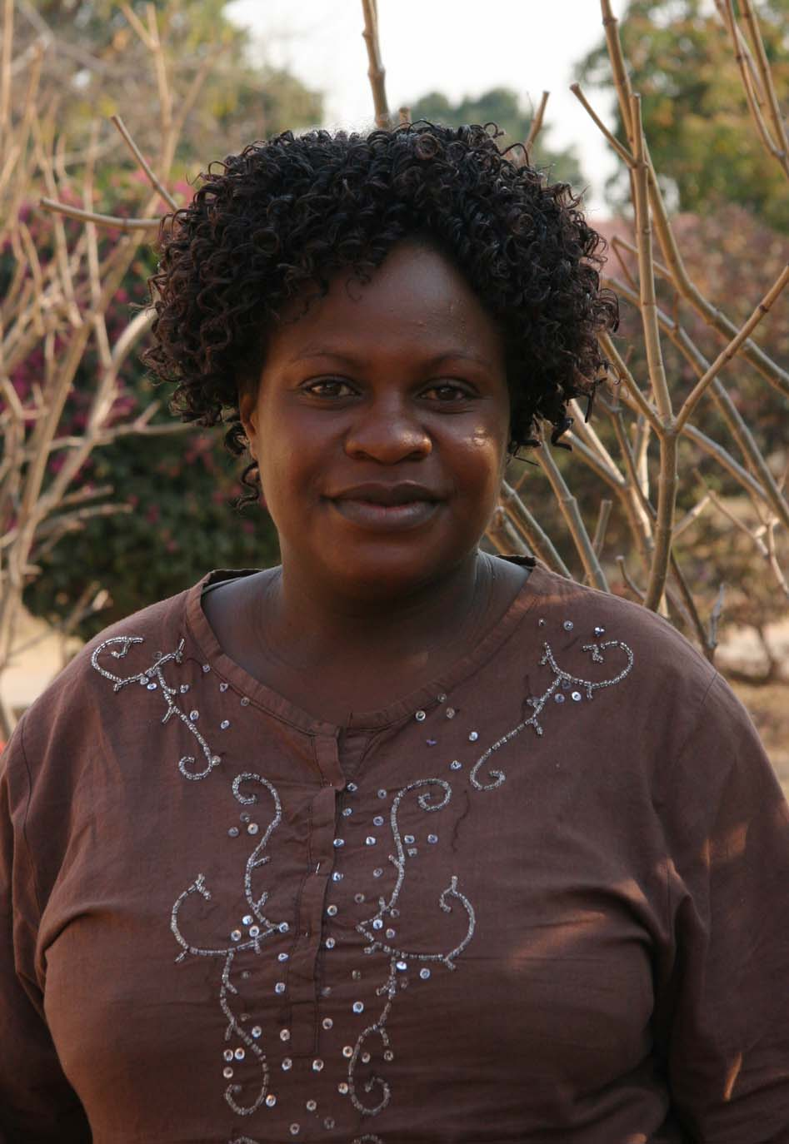
Norlin is the transitions officer.
Social welfare brings a child to MRCH as a place of safety and as a last resort initially for a 2 week placement. The child will be on a court order for 3 years and if the family can’t be traced or a foster family found in that time then the court order will be renewed for another 3 years.
The first morning the child arrives, the probation officer will pass on any known information about the background of the child, including any experiences, so that any extended family can be searched for immediately. Norleen and Rairo decide together how to look after the child in the meantime and they develop health and schooling plans. It is also important to develop a discharge plan about where they will go after leaving the home.
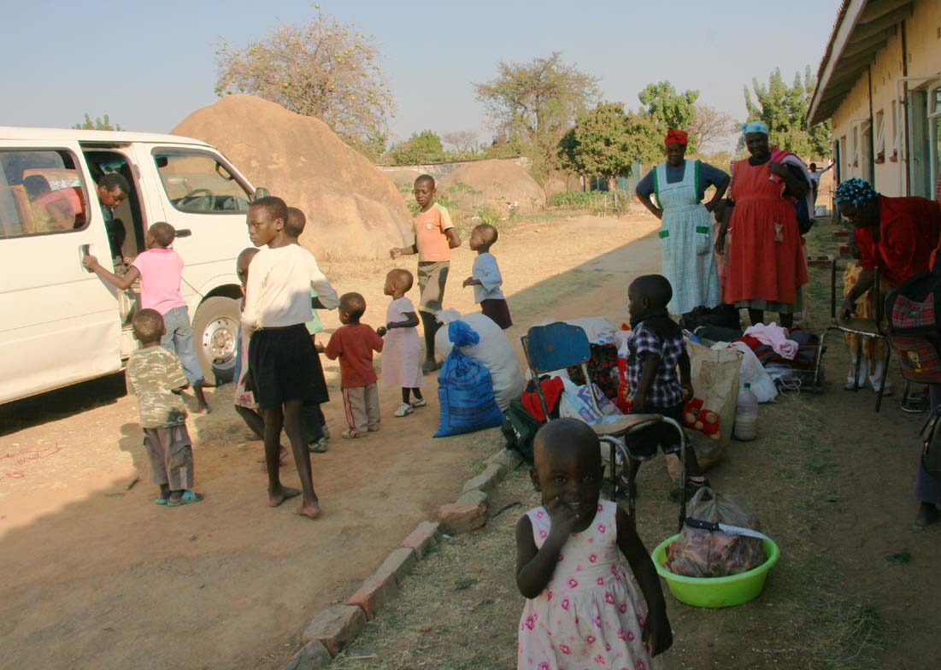
Norleen starts a file and the search begins to find the child’s family. When the family is found, Norleen and Rairo visit the home together. If suitable the child then visits the home for weekends at first. When the child moves to live at the home, Norleen and Rairo keep an eye on the situation and how the child has settled. They continue the contact with the home and if necessary MRCH will help the family with food or school fees.
If none of the extended family can be traced then foster parents are looked for among church congregations who will take the child during the school holidays. These foster families may be a long way from MRCH so children have to be taken and collected by MRCH staff each holiday. (above children return from holidays with their foster families)
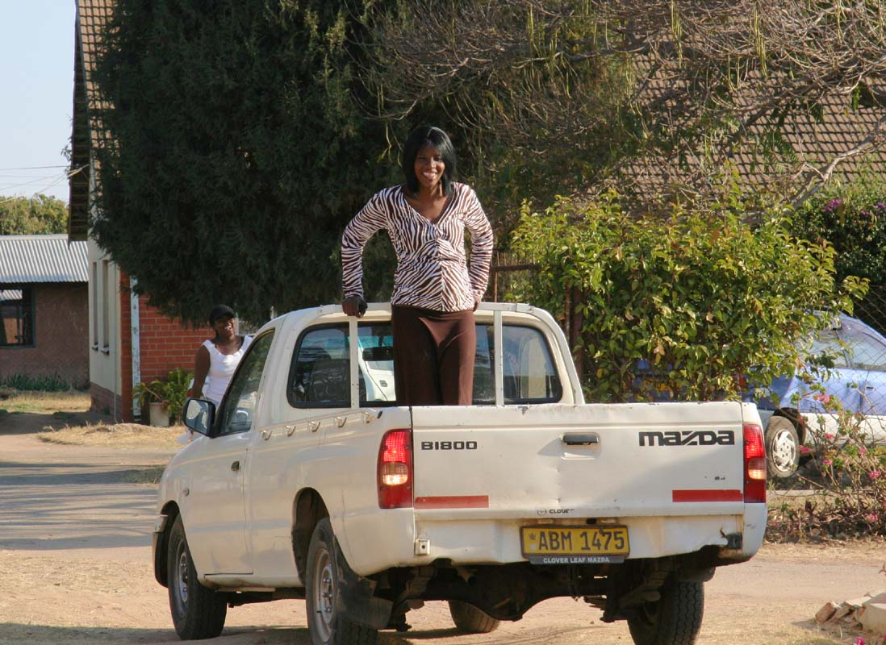
Foster parents are not paid but a programme of support is available to make sure the child attends school. Family reconstruction activities are organised to orientate a child with foster families such as weekends and holidays and Norleen visits the families with the probation officer while the child is there to make sure all is well. The probation officer does all the paper work and checks the child is dealt with properly and that court orders are all in date. After about 4 weeks at MRCH, a child care plan is developed. A child may stay at the home until they are 18 years old. Skills training is available after O level exams if they have nowhere to go. The MRCH staff try very hard to expose all the children to life outside the home. These are necessarily on a small scale due to lack of funds and working vehicles.

“The children need to be exposed to so much outside the Home, especially the older children who need careers guidance, they don’t know what is available as a career. We have 4 vehicles and only 2 are working at the moment. Also many staff can’t do their jobs without a vehicle. I shouldn’t be here in my office, I should be out there visiting homes and searching for families. Ideally there should be 1 vehicle for each office because everyone needs to be off site at some time for visits or meetings or taking children out. Time is wasted doubling up or waiting for a vehicle.
8

When children start asking about why they live at MRCH then when the time is right they are told what is known about their backgrounds. This helps to give them an identity. It may cause them problems because some children can’t accept the information and so with the help of the interns, we counsel them alone or in groups. Our children have food, clothes and they go to school and they think that’s enough but we are doing our best to widen their horizons and help them be good people”

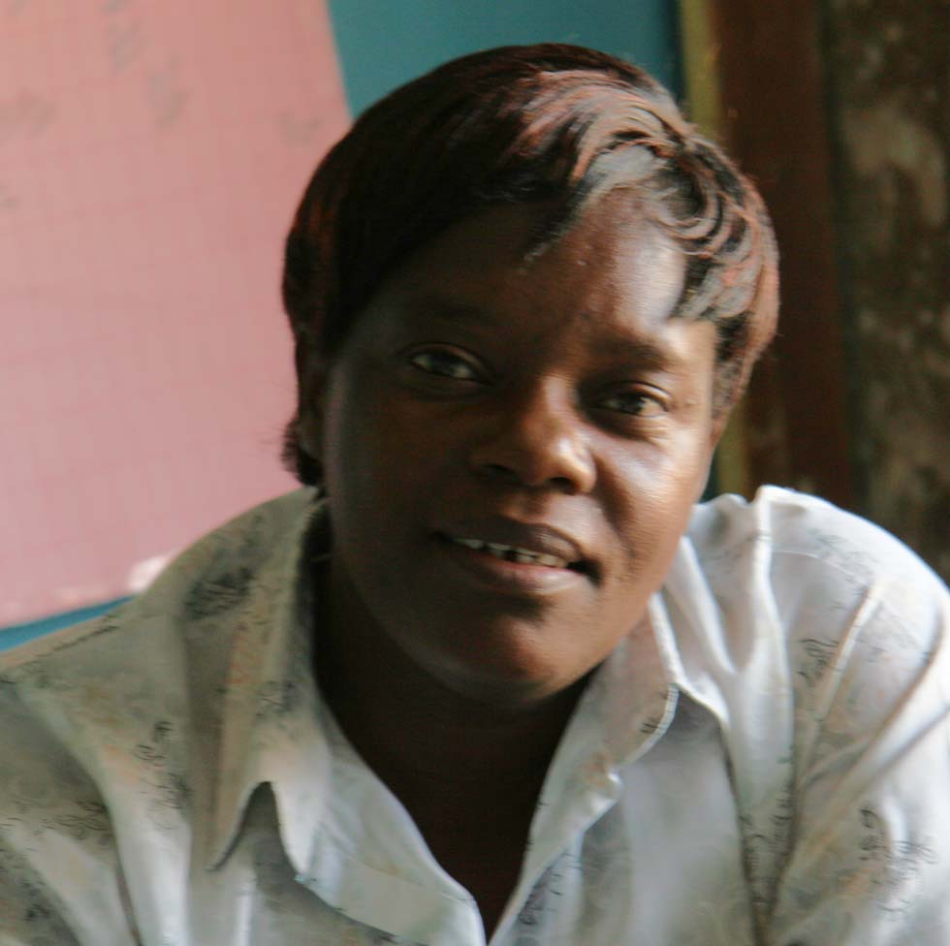
Rairo is the Childcare Manager working very closely with Lloyd and Norleen and supporting the Housemothers on the site. She helps maintain the relationships between the children and the mothers by visiting the houses, listening to the chat and watching how they all relate to each other and the language used. She checks the health of each child before school. Maintains the supply of monthly provisions of food and cleaning materials for each house. Maintains the records for each child, their birth certificates, where they’re from, why they’re at the home and any specific problems they have. She applies for free medical treatment for the children, finds foster parents and applies for permission from the Social services. With Lloyd, she helps to develop programmes of childcare training for the staff. She works with Norleen on relationships between the children and the foster families “because the situation in the homes can be difficult and it can take 2 to learn the truth.”
“When children are discharged from MRCH they still need support. We need funds to support them with career guidance, skills training and bus fares to get them there. This can often be for 3 years and then they may need equipment to get them started as hairdressers, motor mechanics, welders or in hotel management. “

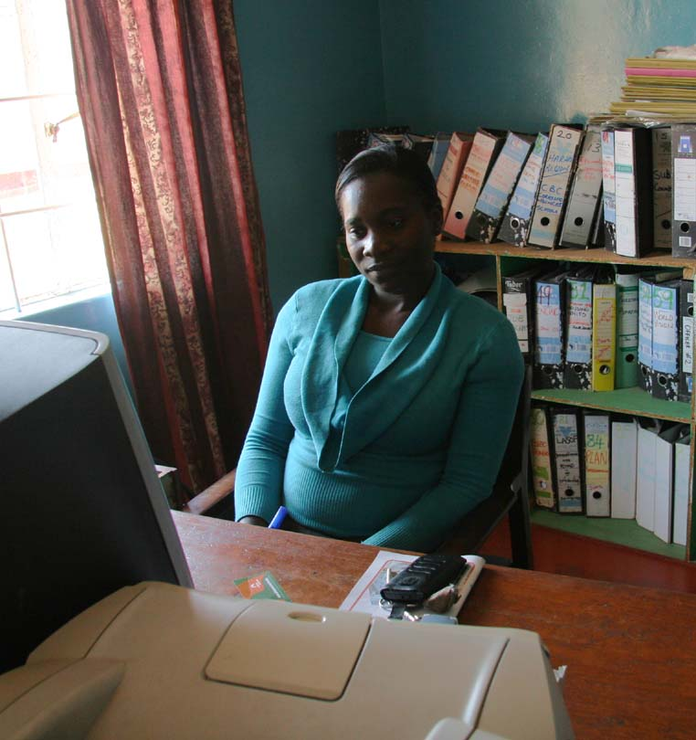
Zvirinane, Astonishment’s PA. She deals with all information and documentation to do with the children, the staff and the activities of MRCH in general and provides interim and annual reports on all the outreach projects. She produces the MRCH newsletter and information packs as required and deals with all correspondence by phone, letter or email. Without electricity her hands are tied.
She works with Rairo for the needs of any visitors, with Astonishment to organise his itinerary and that of visitors, with staff to arrange any events taking place at the home.

“I work on whatever Astonishment is working on. I love what I do. We look for funds for programming purposes, for example, we look, for and maintain partnerships locally and internationally to ensure that programming continues. Everything we receive at the Home is useful in one way or the other. Some people give cash but most give in kind but we really need the cash to cater for operational costs at the Home. As a Home we also develop our local fundraising initiatives for example through activities such as the annual dinner dance to complement what we receive from outside.”
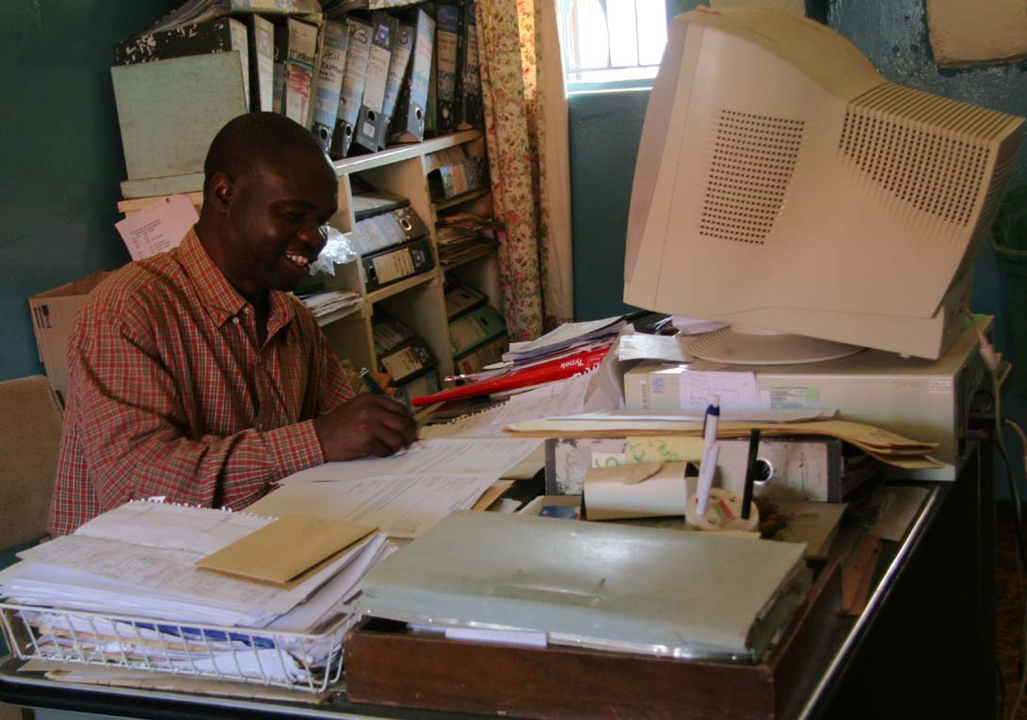
Lloyd is the Senior Child development Officer and Astonishment’s Deputy.
“My role is like a spider web linking everything together”
Rairo passes on information to him about the welfare of the children living at the Home and Lloyd keeps Astonishment informed. He reports to the finance committee for MRCH and works with the National Board when Astonishment is away.

9

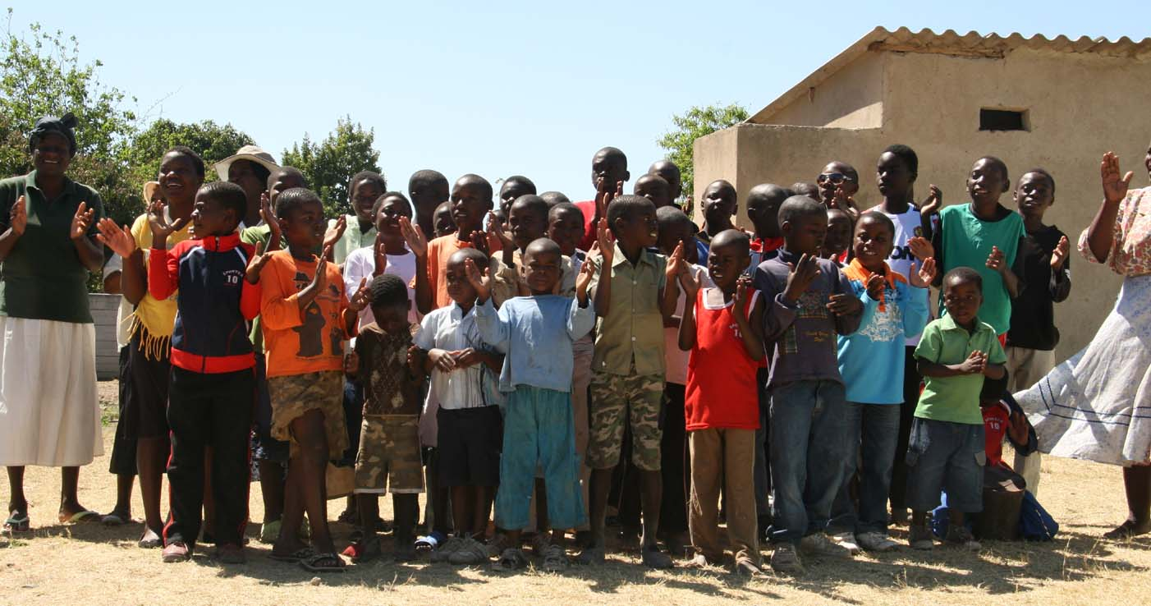
Through the Harare Methodist Churches he organises the Community Based programmes in the Harare region, coordinating the volunteer community care workers and the coordinators from the congregations at circuit and district level. He collects the information about each child in the programme and makes sure everyone who needs to know, is informed of their welfare.
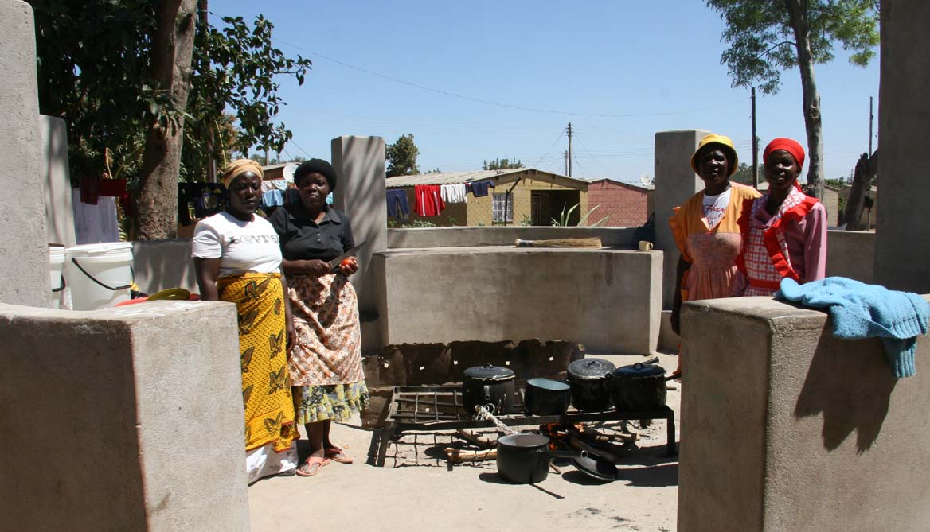
Lloyd designs the programmes and organises workshops and training for each level of volunteers nationally. He has a team of MRCH staff and university students who help him deliver the training to all the volunteers working in the projects across the country.
One of the aims of the home is family reconstruction through finding lost relatives. There are reunification exercises to help both child and family to adjust. There is a gradual introduction of weekends with the family. Links with the family can be re confirmed when the child is an adult and some children may choose to adopt their father’s name.
Lloyd and his team of trainers provide follow up training for the coordinators and caregivers and there are workshops with the children to find out what their needs are.
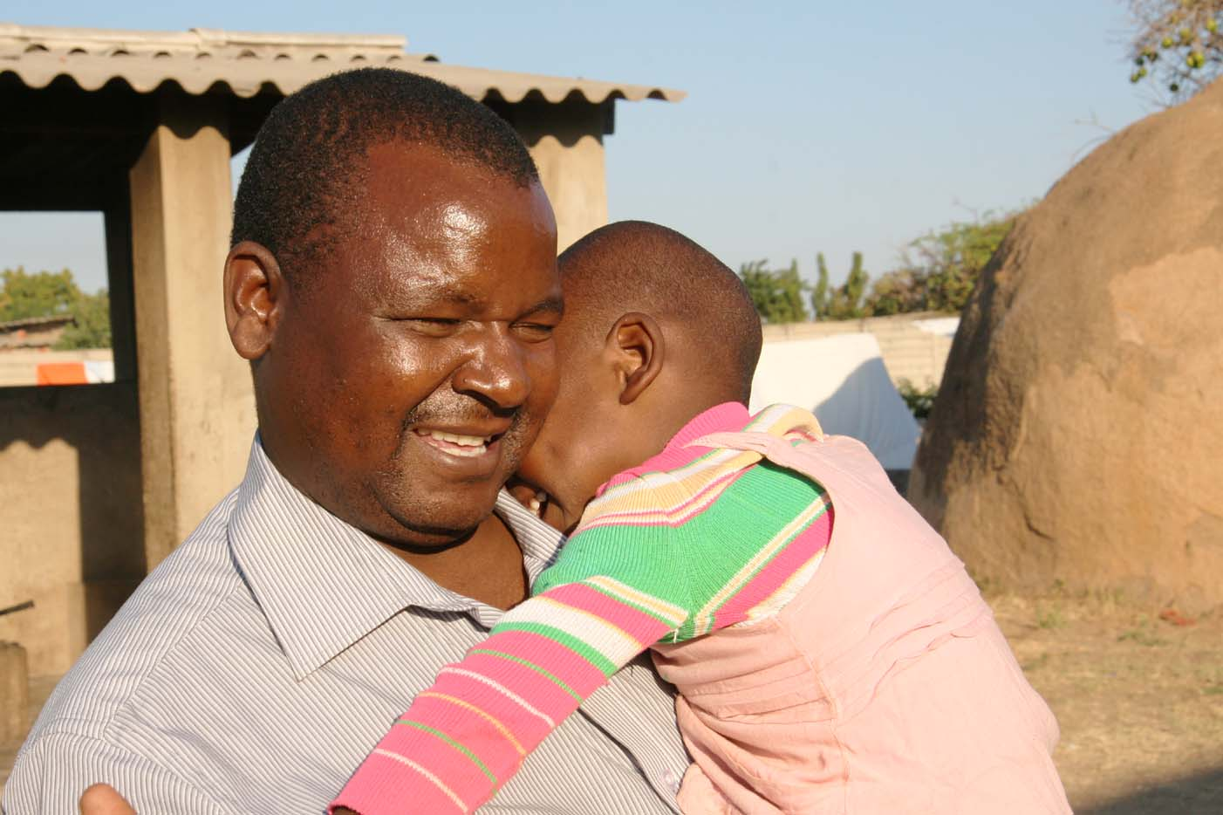
Lloyd networks with relevant organisations in the community such as the government body the National Aids Council who keeps records of who is being helped or the Zimbabwe Aids Network. He coordinates programmes with international bodies such as World Vision and Plan International.

Astonishment, National Director of Childcare for the Methodist Church, Zimbabwe and head of MRCH. He keeps his finger on the pulse of all aspects of the MRCH Organisation.
His senior staff keep him informed about the welfare of all the children and what is happening at the Home in Epworth and all the outreach projects. They refer everything back to him. He keeps in touch with all staff, events and the outreach projects on a personal level too and considers many of the staff as his friends.
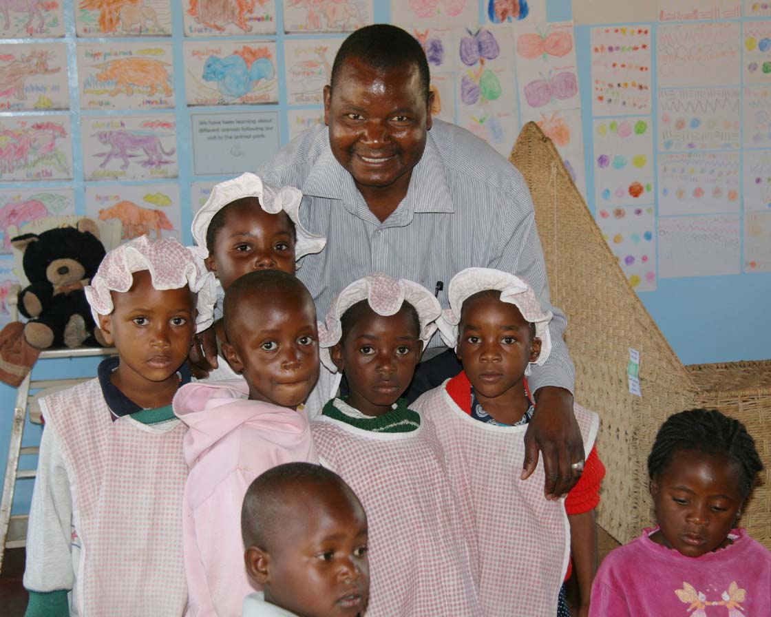
He is involved directly with the children through the children’s council which meets regularly and along with Mwema and other staff he is involved with the weekly motivational programme for the age 12+ children. In this he talks about his own young life spent being passed around families and in foster care, so they are able to identify with him.
A lot of his time is spent in public relations, making contacts with potential donors and supporters of the Organisation, fund raising and obviously a working vehicle is an essential item for him to travel around. The projects in the Gweru area are 5 hours drive away and Bulawayo is a further 2 hours. No one travels by train in Zimbabwe because it is very much slower than driving.

10

Astonishment reports back to the National Board and the finance committee. He is in direct contact with local and overseas supporters such as FoMRCH; Qantas; World Vision; Methodist Church Northern Ireland; Uniting World, Australia as often as the erratic internet and electricity connections allow.

Friends of MRCH UK and Uniting World in Australia have each sponsored him to visit their countries to meet supporters and talk about the work the staff and volunteers do for around 7,000 children reached by the care of the Matthew Rusike Organisation.

Guidance for costs of possible support at MRCH 2012
Money raised by the Friends is rarely for specific projects because the Home relies on the regular 3 weekly remittances for the direct feeding, education, health and care of the children. Astonishment is able to budget and plan because he knows that £2-3,000 will definitely arrive every 3 weeks, for example in the past he has been able go to the school and ask that the children start school on the first day even though he doesn’t have the fees yet and this has been agreed.
However if your group prefers to have a specific project to aim for here are a few suggestions of possible projects based on the above interviews.

- More training for staff in caring for traumatized and disturbed children for staff and volunteers – US$2, 640.00 £1,682.00
- More chickens, gumboots and overalls for staff working with animals
US$3, 600.00 £2,294.00
- Working vehicles or another vehicle so that children can be taken off site more often to widen their horizons and staff can get on with tracing of families, etc –
US$15, 000.00 £9,561
- Plastic cover for the greenhouses, fixing of the irrigation equipment US$3, 880. £2,473.00
- Teaching videos and specific story books for working with traumatized children
US$1,200.00 £764.00
- More drugs and equipment for the clinic and tiles for the floor so its easier to keep clean –
US$3 000.00 £1,912.00
- Shelves for the stores and pantries - US$1,400.00 £892.00
- Fixing of broken items US$2, 000.00 £1,274.00
- Complete set of chairs and tables for the study group instead of sharing with tailoring group – US$8, 760.00 £5,583.00
- Zimbabwe text books for study group - US$4, 600.00 £2,932.00
- Football strips for girl’s and boys teams, kits for the athletics teams, for self esteem –
US$1, 800.00 £1,147.00
Contact carol2021@banham.net registered charity 1120944 Carol Banham December 2011
11

