From our treasurer
The 15 seater minibus is on it’s way!
Bought tax free from Toyota in Gibralter, loaded onto the Hoegh Bangkok, it is due to arrive at MRCH, via Durban, on 20th December. Lloyd is liaising with Zimbabwe revenue to allow tax free importation. A valuable addition for the use of children and staff.


Virgin Money Giving
An easy way to collect money is to use Virgin Money Giving. FoMRCH is registered with them and a donation page can be easily set up on their website to start fundraising. It is advantageous for donors and ourselves:
1 Its safe and secure for card payments and the money comes direct to FoMRCH. 2 Donors can apply for Gift Aid. 3 Payments go directly into the FoMCH bank account with the Gift Aid applied 4 Virgin Money Giving is free for donors and costs FoMRCH very little, in fact it usually improves the donation because Gift Aid is easy to collect this way. More details about how to do it can be found at www. VirginMoneyGiving.com
This year we raised £7,675 this way. David Graaff

Please pay for your Christmas cards before Christmas. Thank you once again to all who send an extra donation which can be gift aided if you have filled in a form and sent it to our treasurer. If you need a form please contact us.

Friends of Matthew Rusike Children’s Home
December 2014 Registered charity 1120944
No new designs will be printed in future and next year will be our last time selling cards unless someone would like to do it instead. Interested? Please contact us.

FoMRCH committee
Another staunch member of the FoMRCH executive committee has recently had to leave us due to ill health. John Bromley, through Action for Children and with his wife Mary, led many residential staff training sessions at MRCH during the 1990s. It was at his suggestion that the Friends of MRCH began in 1997 and he was our first chairman. We shall miss hims input greatly.

Contacts
Chair: Carol Banham
carol2021@banham.net

Secretary: John Richer
jricher001@btinternet.com

Treasurer: David Graaff
The White Cottage
1 Grange hill
London SE25 6SX
david@graaff.co.uk

www.friendsofmatthewrusike.org

This newsletter is distributed by
The Friends of Matthew Rusike
Children’s Home.

NEWS from the HOME

I trust God is keeping you well. We are all fine here despite the heat. All the chiildren are enjoying good health.
I want to share the developments that have come as a result of the generator as well as the upgrade of the water system at the Home. The Greenhouse tomato crop has produced 8.1 tonnes of which 7.6 tonnes were sold and o.5 tonnes were consumed at the Home. We will be replacing the tomatoes with cauliflower.
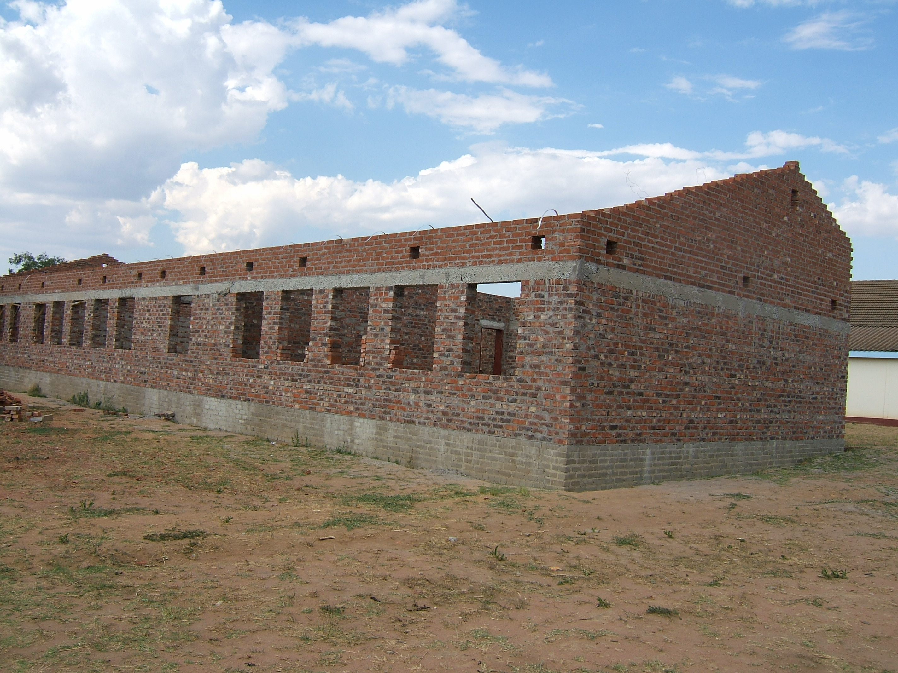
So far we have sold 88 pigs and raised $10 699,50 in sales revenue. We have sold 2650 chickens and consumed 100. Both projects are still on going and we hope to raise more revenue in the future. The most important factor underlying this development is that power cuts and water are no longer a problem. Our piggery and poultry does not go bad in the fridges and we are able to sell fresh products all the time. The generator also helps to pump water for the market gardening project. At the moment we thank God that our salaries are up to date. We try as much as we can to avoid a backlog though most of the time we strain our budget.
In October national exams for GCE "O" Level began and as we are a newly registered centre, the staff at
the college are working extremely
We give support, mainly by cash, but also by advice and assistance to the Home

hard to make sure that everything is in place.
I hope this information encourages you and lets you know about the
tremendous work that you are all doing for the Matthew Rusike Children's Home. We are very grateful and we love you so much.
Margaret M

In October all the staff went away for a training and team building weekend thanks to Action for Children UK. It was held in Banket near Chinhoyi, a little over 100km from Harare. It was both fun and useful to the whole staff group and we learnt a lot of valuable lessons about team building.
Early in November Qantas Cabin Crew Team funded their annual Christmas party for children and staff at MRCH and Chiedza Child Care Centre. Zvirinane M

MRCH College
Over 300 local teenagers now attend the college. It is being extended thanks to Liverpool MWiB for the foundations begun earlier this year, a Zimbabwean donor for the walls and because of a generous legacy we received, in November FoMRCH sent over £10,000 needed for the roof.
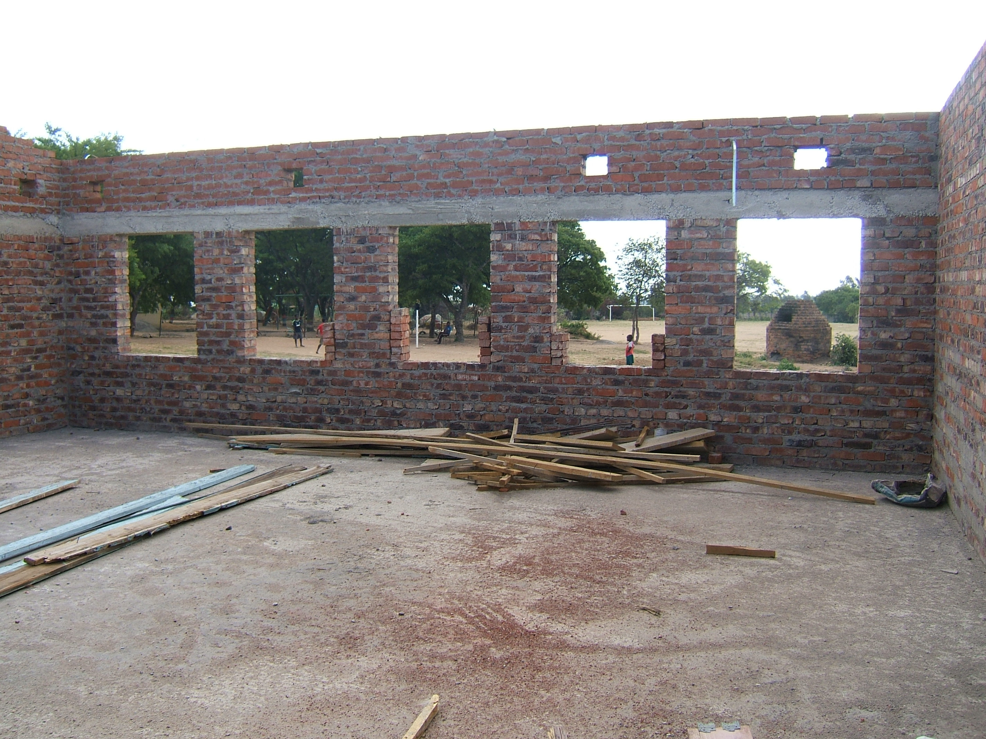

Heart warming story
A young man passes on his experience of living in care and uses his talents in the arts to help vulnerable people in another country. He writes to MRCH to tell them.

9 Months in Romania Tapiwa G

It gives me pleasure to be sitting at my desk jotting down something which in my opinion you deserve to know as it makes me and the Home at large proud to have managed to achieve something which God allowed to happen. Humans are born with different talents; some have natural intelligence and some with talents for serving the world in different ways. I was raised at Matthew Rusike children’s home for 12 years where I came to realise that in this world being uneducated does not mean that’s the end of your life. When I wrote my O level exams I didn’t come out well but I keep on persevering in my talent for writing poems, theatre and serving God. Through His faithfulness I found myself doing voluntary work in Romania in 2013-2014 and learning about various areas including human trafficking and domestic violence.
Teaching theatre, poetry and using art in campaigning was one of my big responsibilities. Playing with children was not something I was used to but one of our responsibilities was to be very creative in a such a way that can bring smiles to children. Curtici and Vis de Copii (Children’s Dreams) are the two centres in Arad where hope is given to less privileged children from different backgrounds. I was very moved to teach these children considering that I was once like them. Each time I visited the centres I could see my home at Matthew Rusike .
You need passion to set your mind to volunteering. I was a Zimbabwean representing southern Africa working with one of the leading organisations in Arad. It requires focus, creativity, trust, obedience and maturity . Volunteering emerged to be a learning experience. I learned patience, the importance of accommodating others, helping and respecting other people’s views and opinions, team work, to be a good listener and communicator, a new language- Romanian - and strategies for improving the communication in a multicultural context. I learned to depend on myself during the course of the project and that has taught me how to manage my finances and be independent. I had the opportunity to express myself and how to use it in different contexts with children, adults or prisoners. Doing the origami course, craft making of bracelets and learning some different dance moves and blending into the European culture has made me develop a new approach to life and some new practical skills which I can use in future when working with people of my race and others.
During nine months in a foreign land, with people of different nationalities, backgrounds and beliefs was a challenge, however I have learnt to appreciate and respect other people’s cultures and beliefs, understand their values and adhere to certain rules and regulations. Discovering something new is a passion for me and life in a multicultural context is the best way to achieve it. Cooperating with Romanian people I always tried to behave in a correct way, respecting others, their spaces, their life style. I involved myself actively in all the local initiatives for improving the social environment. I learnt how to deal with criticism about me and I improved my capacity to express my opinion in a good way to others. Communicating and sharing information with them has made me have a clear view on the importance of giving and receiving feedback in a positive manner which is valuable in creating an effective team.

Thank you Tapiwa for telling us about your experience you are a credit to the love and care of MRCH.

New DVD available
When Rev Margaret Mawire visited the UK in June she brought a DVD and a CD of photographs copies of which are available from our Secretary.

Your Committee
The FoMRCH charity is flourishing at the moment. Thanks to the generosity of you, our supporters, and legacies we have received this year, our bank balance is healthy. We are able to send £4,000 each month for the food, education and health of the 145 residential children in Epworth. Usually we have been unable to support specific projects but in addition this year, we sent £12,000 to pay MRCH staff salary arrears in January, in September £17,300 for a new minibus (includes transportation), and in November over £10,000 for the roof on the 3 new classrooms for the college. Early in 2015 we shall send £5,000 as half the cost of extending the irrigation to another 2 acres of land to grow food.
The executive committee, however, travelling to Droitwich from Dorset Derbyshire, Suffolk, Kent, South London and South Yorkshire is struggling with age and illness. We need new people to join us with ideas and presence at our 4 annual meetings. If you would like to meet us, with a view to joining our committee please get in touch. Our meetings always include spouses and partners who are not actually committee members but who join in the discussions and socialise after each meeting with a ‘bring and share’ lunch so we have time to catch up with each other’s news.
Please consider this request seriously and prayerfully, we need you.
Our next meeting is in Droitwich Methodist Church on Jan 17th 2015. Please contact our secretary for directions and further details
Barry Barnes
It is with great sadness we have to tell you that Barry died in September.
He was a vital personal contact with MRCH for almost 13 years. While working for Action for Children he helped set up a regional forum in South Africa, supporting it for 8 years, so that heads of residential children’s homes could meet regularly 3-4 times a year and share advice and good working practice in childcare.
We, the friends, relied on him greatly for keeping us in touch with progress at MRCH.
He retired from his work in south Africa and Zimbabwe in 2012 and to read more about Barry’s work there please look at our website Archive posted March 2013

Tributes
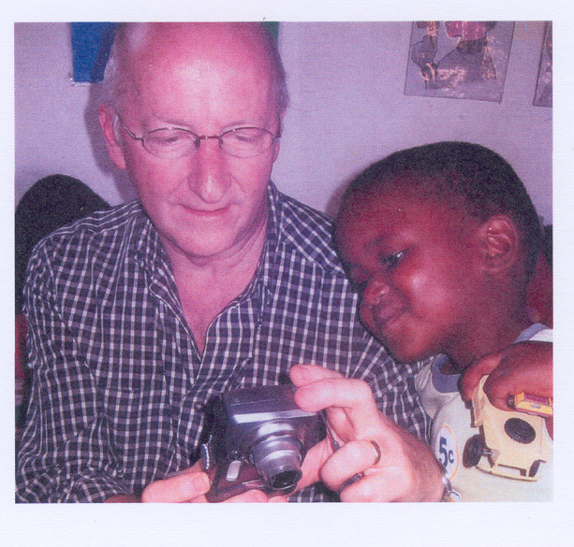
He was a very special man. I remember my last trip to Zim. He was there too and we did quite a bit together. Such a lovely man. I can’t believe he’s gone. Mandy

He was an irreplaceable friend. So wise and calm. So sociable yet an extremely strategic thinker. He was a tactful, critical friend whose correction l cherished. He taught me to build relationships with people and their strengths: and not with their problems. Whenever he came to Zim.we would spent some quality time in the Harare Botanical Gardens. There, Barry would patiently and brotherly turn all my complaints into goals. For me, any time with Barry was followed by many months of relief, resilience and focus. What a brother! What a friend! What a gentle mentor!
Like my brother, Barry nurtured me in management of children's services. He contributed in many ways to my professional development and the transformation of Matthew Rusike Children's Home. He was influential in the development of childcare policies in Zimbabwe including the development of the National Residential Care Standards. Barry was my personal friend and mentor. I am glad he rested and is not in pain any more but l am extremely sad that my friend is no more. I pray that God willing, we will meet again in new life.
Astonishment M
I was shocked on the untimely death of Barry. Certainly it is a sad loss not only to his family but to everyone who knew him. As for us in Matthew Rusike Children's Home we greatly miss him bearing in mind the childcare programs he championed. Certainly we will miss his services and love.
May his soul rest in peace.
Lloyd
I was very saddened to receive the news of the passing on of Barry. I only knew him for a short while but the few years that I interacted with him I learnt so much from him. The contribution that he made to MRCH is immense and will forever be imbedded in our hearts.
Margaret M

Joe Withington

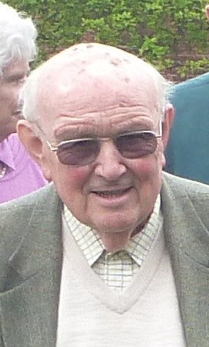

Very sadly, in October we lost Joe, a good friend who has been on the FoMRCH executive committee from the beginning. In his staff training role with National Children’s Home, now Action for children, he first became involved with MRCH in 1981. We have valued Joe’s knowledge and wise words in our committee meetings until very recently and he will be greatly missed.

Tributes
Joe has always been a key person in our planning because of his wide experience and well known devotion to the childcare work he did in Zimbabwe. John R

Joe will certainly be missed by all the people he came into contact with not least his work with Matthew Rusike over the years.
Michael M

Thank you very much for advising me of our lovely Joe's departure. Bridget and l were really sad to hear the news. This is a terrible loss to Eileen, FoMRCH and to us who have had wonderful interaction with Joe. I warmly remember him for being the first person to call me after my appointment. He introduced me to the FoMRCH and their support when we needed money most. We remember all the love we shared with the Withingtons. Astonishment M

To read more about Joe’s work with MRCH please look at our website Archive posted December 2014

