*Two contacts from local people in Harare, through FoMRCH publicity*

1 *From the French community in Harare:*

I have a set of second hand bunk beds

and a chest of drawers. My problem is

transport. Will the home find someone

to help them collect it?

*Zvirinane replied next day:* Wow such is the power of information. That is very close to us and we will not have any problem picking up the donation. Lloyd is going to contact her and arrange pick up.”

2 “I am the Coordinator of Harare Province (Zim Youth Works). We are kindly asking for your permission to host a children’s party at your orphanage. We, as the youth, feel we should also look after our fellow under privileged youth. We wish to make time to spend a day with them.” Zivai Gumbo

*This is now being planned.*

**Our secretary** **is retiring** – John is a founder member of FoMRCH and hopes to continue attending meetings.

**Please consider volunteering to help us continue our work**

- Prepare and distribute agendas and minutes of 4 meetings annually.

- The successful person may be asked to be one of 8 trustees of the charity as the present secretary is one.

**Or could you volunteer to maintain the contact lists of members and supporters without the need to attend meetings? You will need to be on email.**

**Christmas cards**

# Friends of Matthew Rusike Children’s Home Registered charity 1120944

***We give mainly financial support and advice to the Home***

Once again thanks to all who bought cards and sent extra donations. **Have you paid for yours yet?** Special thanks to the lady who sent 3 books of stamps because she can’t receive her newsletter by email. **Do you realise your extra donations can be gift aided if you complete a form and send it to our treasurer?** You can download a form from our website or contact the chair.

FoMRCH has been awarded a Certificate of Appreciation by MRCH and as Friends you receive it too. Thank you all for your support over the years and please continue, their need is still so great.

Carol Banham. Ed

**Contacts**

Chair: Carol Banham  
carol202

1@banham.net

Secretary: John Richer  
jricher51@gmail.com

Treasurer: David Graaff

The White Cottage

1 Grange hill

London SE25 6SX

[**david@graaff.co.uk**](mailto:david@graaff.co.uk)

[www.friendsofmatthewrusike.org](http://www.friendsofmatthewrusike.org)

This newsletter is distributed by **The Friends of Matthew Rusike Children’s Home.**

**December 2015**

**News from the Home**

In September… Thank you so much

for your support. What you are doing is making MRCH habitable. Zimbabwe is facing a serious challenge due to persistent drought and the level of water in the Kariba Dam is seriously going down. Thanks to the generator provided by UK friends we are managing the numerous power cuts.

We thank you again for the funds. We bought sports uniforms for 12 children, boys and girls. What a joy!

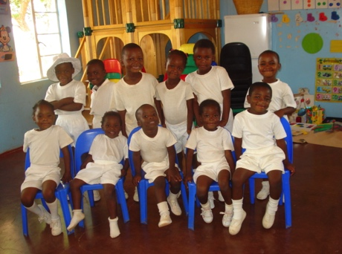

We also bought medicines for our clinic and again we are able to buy fuel for the generator.

In November… We are fine and busy preparing for the children who will be going to foster parents for Christmas holidays. We thank God that our children who were writing their final examinations have now finished and we wait for the results next year.

We also thank God for being with us so far. As it has already started raining we look forward to the festive season being blessed with continuous rains.  
Thank you again for your untiring support. I wish you all a Happy Christmas and a Prosperous New Year. **Rev Margaret Mawire, National Director**

Sincere thanks for the latest remittance. I am so happy with all you are doing to make sure the home is not found wanting in terms of providing for and caring for our children. You help us score more marks from our local Social Welfare because the children in our care are seen to be fit, active and very social when they are visited by their Probation Officers. We always use the money as we agreed especially when it is more than the usual remittance. Thank you once again and may blessings continue to shower on everyone of you.

**Lloyd Kupeta, Deputy director**

Our Clinic had been facelifted now. The floors were tiled and walls repainted. We have done almost everything which was required by the Health Department. We still have a bit of a challenge with drugs. However, Epworth Clinic supplies us when they receive their drugs.

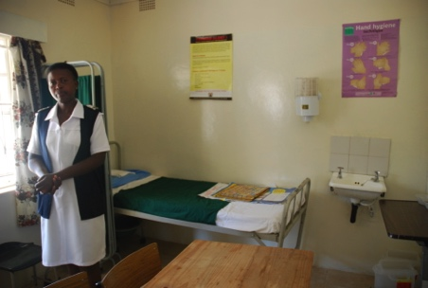

The clinic is now fully operational providing accessible health care for the well being of the children. At the moment we have ten children who are HIV positive, all are doing well on Antiretroviral medicines. Also we have 2 children who are epileptic both are doing well on medications.  
  
Most common illnesses treated at the clinic are acute respiratory infections, ear conditions, injuries and skin infections. The clinic is getting some of the essential drugs from the district Pharmarcy and some others we have to buy. **Litta, the MRCH nurse**

*(Our monthly remittance is often used for the clinic’s need of basic supplies, sight and hearing tests, specialist treatments and vaccinations Ed)*

Family tracing conducted by Transitions office and Department of Social Welfare has been fruitful. A lot of children are in line for tracing of relatives. After 16 years at the institution, one of the children was able to discover that not only does he have relatives but his parents are both still alive although living in different cities. The tracing took us to Norton where the young man’s father is a farmer. The look on his face was priceless as he looked at his father for the first time as a grown person. He is over the moon with excitement and very grateful for such a step being taken for him. He is now on the brink of reunification with his biological father.

**Norlin, Transitions officer**

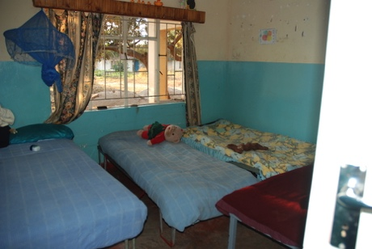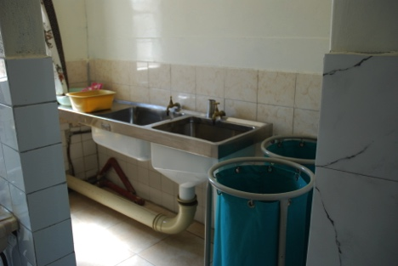The child concerned is now 16 years old. Norlin's efforts in the tracing and

re - unification programmes are paying out everyday. We were all happy for him and hope you will be able to share the joy with us.

**Zvirinane Margaret’s PA**

We had our Speech and Prize giving day on Saturday 17 October. It went well with pupils winning prizes in academia & sports.

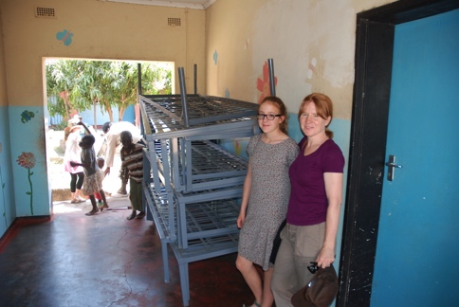Our older students started the National exams on Friday 23 October. Its our 3rd time to host examinations and our team is geared up to do that. Our major challenge is furniture because the same furniture is used for exams as we use in lessons. As exams and lessons run concurrently students not writing exams don’t have anywhere to sit. The new block still needs furniture and the offices are devoid of shelves and furniture too.The middle oldest block has no doors and now that the rainy season is here, we are making frantic efforts to put them on and we hope to do that soon. However we are not disheartened because this is all temporary.

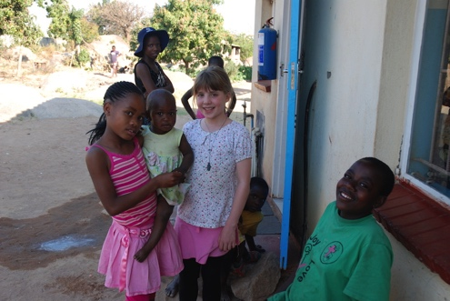 **Kuda, College Deputy Head**

**UK Visitors in July/August**

MRCH was asked about priority needs and visitors fundraised before they went for new bunkbeds. Members of FoMRCH committee, Revs Ed and Audrey Standhaft reported their visiting in our last newsletter and The Methodist Recorder.

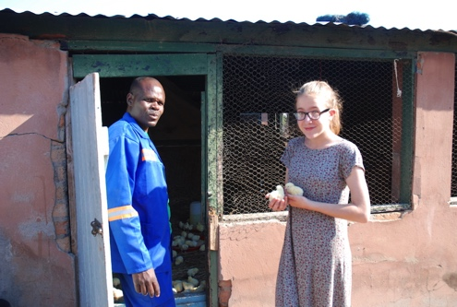The Berrill family have fundraised for the home through FoMRCH for many years.

“Bedrooms have a mixture of single and double beds and social services now stipulate children must have single beds so 150 beds need replacing, they already had 40 new mattresses. A single bed costs £34 and bunkbeds cost £50.

“Our triathalon paid for 14 new bunkbeds”

The children’s memories of their visit are the houses, the animals and that everyone seemed happy and not to mind living in a home;

“the animals and farming projects which help the children learn; one of the small girls carrying a baby on her back and feeling embarrassed by how much I have compared to them but they all play happily and don’t seem to care how little they have“|

“Thanks for all you do so tirelessly for MRCH - it is a real boost to see what a difference the money really makes in such difficult circumstances.” **Debbie Berrill**

**How Matthew Rusike Children’s Home helped me**

Through its Community Based Child Care Programme, MRCH helped me to proceed with my education and find a career. They began supporting me in 2010 when I was in form 1. After my parents died in 2008 there was no one to pay my fees. MRCH continued their support after I sat the ‘O’ level exams and they paid my college fees. I thank MRCH for the great job they do. May the Lord bless them as they look after orphans in the community. MRCH kept my education alive as I am due to start teacher training in Mutoko. God bless you. **Bright, aged 22**