A new gift aid form is available from our website or from our treasurer.

Charity database
You may have heard in the news that some large charities have been passing on the contact details of their supporters. Be assured that our mailing list (database) is held by the officers of the executive committee only. It is never passed to anyone else and never has been. Please feel confident your details will never be passed on.
Editor

Thank you to all who have raised funds for the Children in Zimbabwe, their need is still so great. Please continue your marvellous support.


Contacts

Friends of Matthew Rusike Children’s Home
We give mainly financial support directly to the Home

March 2017 Registered charity 1120944

Chair: Carol Banham
64 Saffron Crescent
Tickhill, Doncaster
S Yorkshire
DN11 9RU

01302 744 920
carol2021@banham.net

Secretary: Gail Richer
25 West Hill
Aspley Guise
Beds
MK17 8DP
gmricher@btinternet.com

Treasurer: Immanuel Mudzinge
103 Linney Road
Leicester
LE4 0UX
manu.mudzinge@gmail.com

Take a look at our website

www.friendsofmatthewrusike.org

This newsletter is distributed by
The Friends of Matthew Rusike
Children’s Home.

NEWS FROM THE HOME
November 2016
We thank God for the rains and hope more will continue to come at the right time. This is a busy time for the Home, a lot of visitors both individuals and corporates, come to spend time with the children in line with the festivities of Christmas.
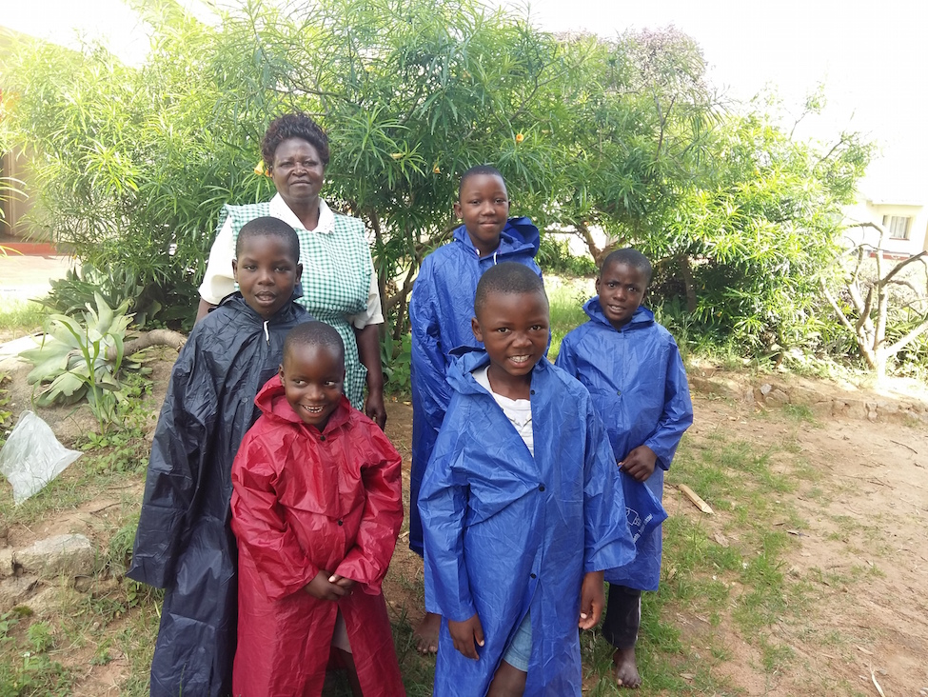
5 Children are leaving the Home this year as they have turned 18.
3 children are being re united with their families after a successful tracing programme by Norlin. Its always a victory when Norlin and team are able to trace the families for some of the children. They will continue to receive support from the Home.
We are in a drive to enrol our children at another primary school with better standards in Hatfield not too far from the Home. We are not happy with the deteriorating standards at Epworth primary school and Widdicombe is a better option. With this in mind we have enrolled 9 children who will be starting grade 0 in 2017. The starting fees for new enrolment is £128 per child and £64.00 per child per term thereafter. These children are not on the sponsorship lIst and fees are
covered by the regular funds from FoMRCH.We still have to buy their school uniform in preparation for January when the new term begins. This brings to 16 the children who are now at Widdicombe primary school.
Rev Margaret Mawire

January 2017
Greetings from wet Zimbabwe
We have started off the year significantly well in the face of the worsening economic and social situation in the country. The children are all in good health and settling into school. Thank God for the last disbursement, we managed to prepare all the children adequately well for the new term. The bill for 15 children starting new schools only came to £1975.00. (fees and uniforms)

It’s just unfortunate that it has been raining non stop for the
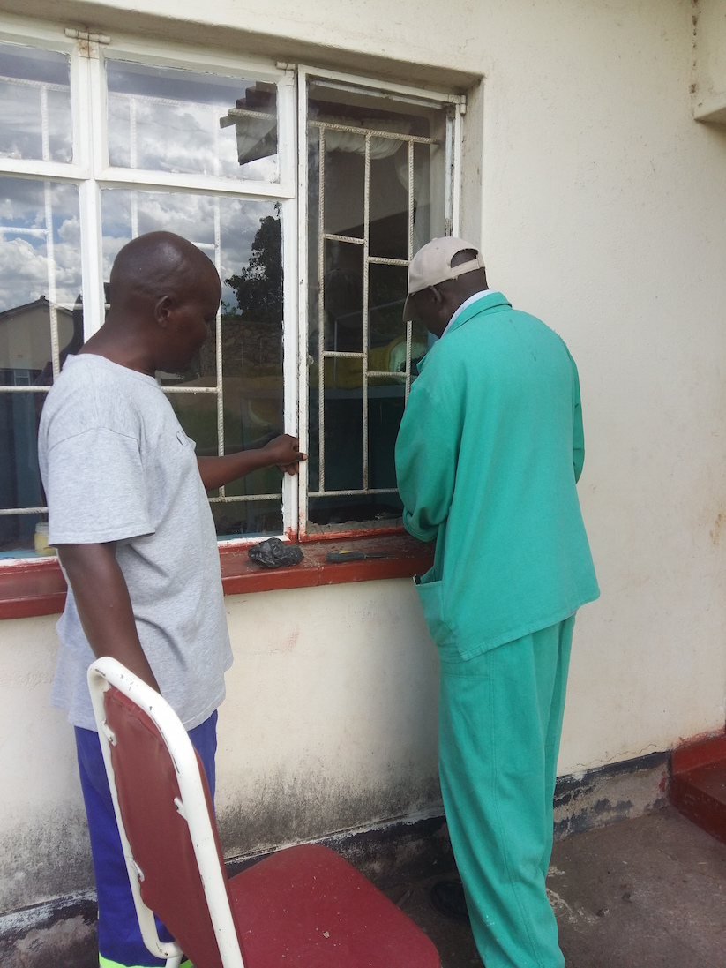
past week. I have not seen this much rain in Zimbabwe in my adulthood. Some low lying areas have flooded, the forecast says we will have this kind of rain for a couple of days to come. October, November and December are the hottest months in Zimbabwe and it gets wet and moderately hot until April when the rainy season comes to an end.

We now have a chaplain to join the MRCH team. His name is Rev Clive Chikomo. He has settled in well at the home.

Refurbishment of the houses
The repairs on the houses began early December thanks to the £6000 raised by Wolverhampton and Shrewsbury MWiB to do the work.
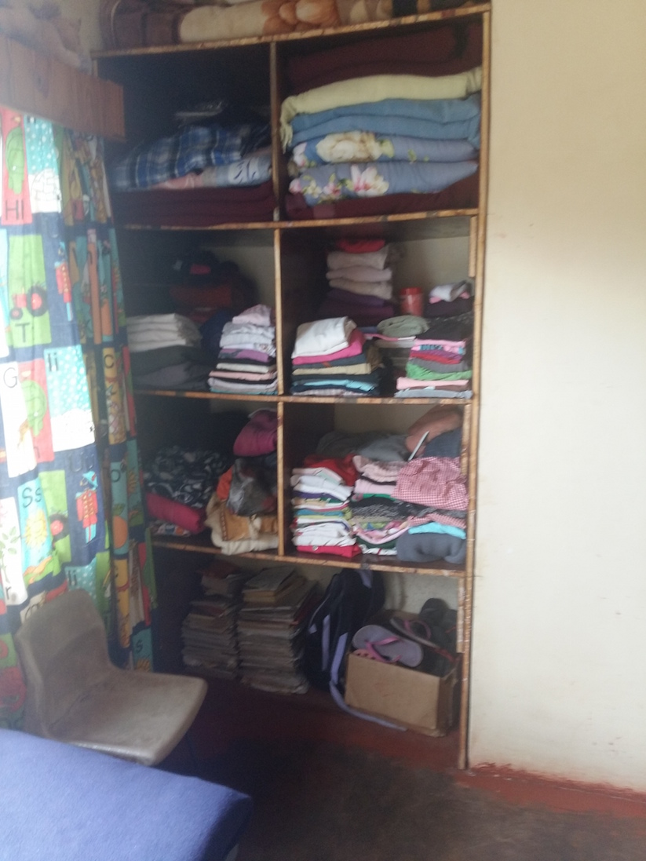

All the dilapidated cupboards are fixed. We decided to eliminate doors because we saw that they were the first to be broken.
(Thank you for your suggestion of making curtains to cover the wardrobes without doors. Its a brilliant idea which we will effect. You know that it gets very dusty here sometimes.)
Broken windows and doors have been replaced, handles and hinges fixed.

Work in progress

A lot of maintanance has been done in the units and we are very grateful for the donation as it has enabled us to attend to most of that work. We realise that maintanance is an ongoing thing but when you can channel such funds towards it at a particular time it really goes a long way.

Thank you to everyone who donated towards this, we are very grateful.
Zvirinane Matore

3 Good News Stories
You may remember in 2015 we asked for sponsors for some young people who were doing well in school but could not afford to pay the fees for a 2 year A level course. A sponsor came forward and their generosity has been rewarded now 3 of those young people have just received these exam results.

EM achieved 3 Bs in Divinity, History and Geography and level 4 in English and Communication.
(The English they write at A level is a supplementary subject for basic English and communication skills.)

JC achieved 3 Bs in Maths, Accounting and Business studies

RL achieved B in Economics, C in business studies and needs to re-sit Accounting to gain university entrance standard.
These 3 have worked very hard against great difficulties and now have ambitions to go to university.

Here are the details :
There are 2 semesters each year costing £700 each. The fees cover tuition, residency and registration. Registration gives access to the university library for books. Stationery is not a huge issue as the Home is able to provide that. The course is four years long and during the 3rd year there is an internship at a relevant organisation.

4 years is a huge commitment – maybe this is something for a group of friends or an organisation to consider supporting? Ed

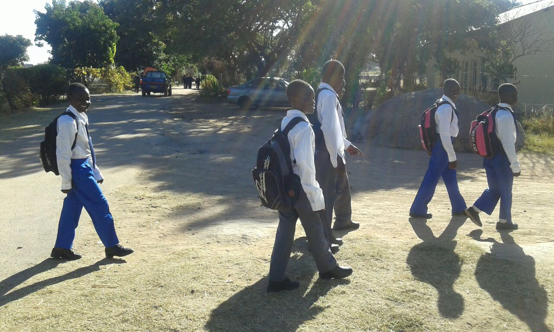

20th Anniversary Grand total
£5,152.31
Thank you to Shirley Richer for heading this appeal and thank you to everyone who had events to raise this marvellous total, all of which has gone to the Home.

AGM
You are warmly invited to join us at Droitwich Methodist Church for our AGM at 11am on Saturday April 8th (See included invitation and membership reminder form) Business is kept to a minimum and we then catch up with news from the Home and with each other over a bring and share lunch. Please contact our secretary for details how to get there.

