**Meetings at Droitwich Methodist Church for 2018**

**AGM** Saturday April 14th

**Executive committee** June 30th

**Anyone** **may attend either or both meetings, you will be made most welcome. Please contact us for details.**

**New Secretary**

Unfortunately our secretary, Gail Richer, is having to step down as our minutes secretary. Could **you** volunteer to attend our 3 annual meetings to produce our minutes. Contact Gail if you are interested in knowing more about this important job.

**Christmas cards**

A big thank you to everyone who bought our cards this year. We raised almost £500 with many people adding a donation to cover postage. We have limited designs left but we shall be selling mixed packs again next year.

**Membership due**

**Your membership of £10 each is due in January. Please send your cheque to our treasurer Immanuel Mudzinge.**

Thank you to all who have raised funds for the Children in Zimbabwe, their need is still so great. Please continue your marvellous support.

**A final thought for end of year**

# Friends of Matthew Rusike Children’s Home

***We give mainly financial support directly to the Home***

December 2017 Registered charity 1120944

“As we work towards the goal of finishing the year strong, we must understand that there will NEVER be a day that will not require dedication, discipline, perseverance, accountability and the opportunity to execute with bold conviction”

Lloyd Kupeta, Senior Childcare Officer and Deputy Director

# Contacts

**Chair:** Carol Banham

64 Saffron Crescent

Tickhill, Doncaster

S Yorkshire

DN11 9RU

carol2021@banham.net

**Secretary:** Gail Richer

gmricher@btinternet.com

**Treasurer:** Immanuel Mudzinge

103 Linney Road

Leicester

LE4 0UX

manu.mudzinge@gmail.com

**Take a look at our website**

[www.friendsofmatthewrusike.org](http://www.friendsofmatthewrusike.org)

This newsletter is distributed by

**The Friends of Matthew Rusike**

**Children’s Home.**

**Our friends in Zimbabwe report on the events in November.**

“Everything happened so quickly. Thank you for your prayers. The whole thing has been very peaceful and we thank God that no blood was spilt, no lives lost, no looting and no damage to property. We just pray that this new era makes everyone's life better.”

**News from the Home**

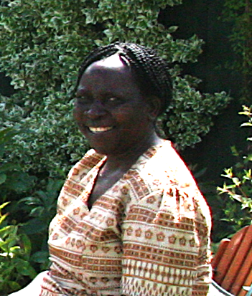

The 5 year contract of Rev Margaret Mawire as National Director and Superintendent of MRCH ends at Christmas. We all wish her well in her new post. The Friends of MRCH wish to thank her for all her work for the children at MRCH and for all her communications which have kept us informed about the continued welfare of the children and progress of the various projects which have taken place under her tenure.

We wait to hear of Margaret’s replacement. Ed

“The children are in good health. We have an unusual case of a child who has been diagnosed with a behaviour disorder. She is attending therapy and we really hope that this will help her and have a positive outcome.

The MRCH dinner dance held at the Meikles Hotel on the 28th of October went very well. The MRCH Fundraising Committee, together with MRCH, organise this annual event. The organising is done over a long period of time and this includes looking for the guest of Honour, selling tickets and coming up with the programme for the event, among other preparations. We like to target corporates and this year we had 6 corporates attending. Besides ticket sales, we auction items on the actual day, for example we have hampers with a value of $30.00 being generously bid at $200.00. We also sell various items such as t-shirts and books. It depends on how creative the MC is - we had people making donations just because they were wearing spectacles or because they were born in a certain month. So we thank God that in this terrible economy we managed a profit of $13 000 after deducting all our expenses.

We are now looking forward to the Christmas period as the children at MRCH get a lot of visitors during this time and its always good seeing them mingling and being merry.”

Zvirinane Matore

**MRCH training workshops**

“As part of its Community Based Care programme, MRCH staff deliver training workshops to local volunteers across the country at 6 different centres raising awareness of the needs of vulnerable children in local communities.

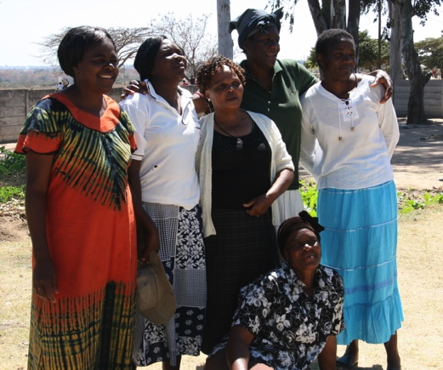

Volunteer careworkers

They are organised through the Methodist Church in Zimbabwe but the thrust in our teaching is every child needing care should be helped despite their religion or none, race, sex, denomination, tribe or family.

The workshops are also an opportunity to raise awareness of the needs at residential MRCH. Areas of training include Children’s Rights and Abuse, Fostering and Adoption, Child Development, HIV and Health needs.

“The whole idea is for people to take seriously the rights of children, despite their social, psychological and economical backgrounds. Children in every community should have their rights upheld by everyone in their community. That means children should go to school, have access to health services, have clothes, have shelter and need to be safe from all forms of abuse.

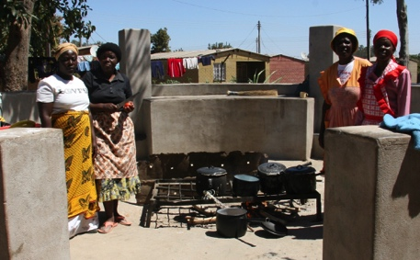“At Matthew Rusike Children's Home we are devoted to do our best in service provision and child protection.

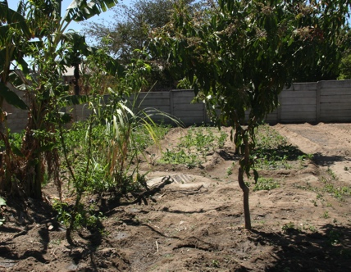We start our training at District level, followed by Circuit level and then Society level. We have an average of 16 workshops each year with the 2 Harare Districts coming to MRCH for the workshops so participants have an appreciation of what we do at the Home and its needs. For districts and circuits outside Harare, our staff travel to the communities. These districts are not geographical ones but they are Methodist Church in Zimbabwe boundaries.

“When we enrol people in the workshops usually the minimum number is 20 and the maximum number is 40 people each time. After the first workshop our training staff go for follow up meetings with the leaders at circuit or District level.

We use a local central venue and then we need to feed the people who attend and sometimes must help in transport fares for those who have come a long away. **We need funding for a proper budget for this training.**

“Once volunteers are trained, drop in style support centres are developed in a local church to provide support for child headed households to continue their schooling, have a cooked meal and receive help with homework.

Each church plants vegetables and builds an outdoor kitchen for volunteers to provide the meals.

Our biggest challenge is finding finances to reach all the places in Zimbabwe. We incur costs on travel, stationery, accommodation and other associated costs for the training team that is involved in this programme. The need is great and with more resources we will be able to widen our scope.

“We mainly rely on annual funds from the World Church Office. Each year they remit funds which are ear- marked for Community Child Care Programs but their budgets fluctuate each year. This budget only covers urban areas who have responded well but we need to reach wider rural areas too.” Lloyd Kupeta

FoMRCH can’t afford to support this project from it’s general fund but if your group/church is wanting a project to support here is one, **Our website projects page has others.** Ed

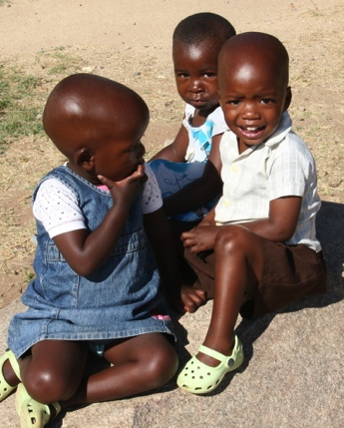

Some children you are helping