people who have given bank details and set up standing

orders, should make it official by letting us know. **If I do not hear from you I’m afraid this will have to be your last newsletter.**

Thank you to those people who included donations in their letters, even if they were saying goodbye, thank you for all your support in the past.

Thank you to those who have asked for their newsletters to be emailed, this greatly reduces our postal costs.

Finally, thank you for acknowledging the work that the executive committee does but remember we couldn’t do any of it without your generosity,

Carol Banham, Ed

**Gift Aid**

Thank you to eveyone who Gift Aids their donations. We received £5,300 from HMRC for the donations made in 2016. A new gift aid form is inside the new brochure but if you have already sent one you don’t need to send another one.

**Secretary**

We are still looking for a new secretary but meanwhile Michael Mapakpo has kindly offered to take the minutes for our meetings on a **temporary basis** until someone comes forward.

**New brochure for 2018**

# Friends of Matthew Rusike Children’s Home

***We give mainly financial support directly to the Home***

June 2018 Registered charity 1120944

The brochure is up dated with new photographs and new officer information.

**Next meeting at Droitwich Methodist Church**

**Saturday June 30th 11am**

**with a ‘bring and share’ lunch, you are welcome to join us.**

# Contacts

**Chair:** Carol Banham

64 Saffron Crescent

Tickhill, Doncaster

S Yorkshire

DN11 9RU

carol2021@banham.net

**Secretary:** Michael Mapako

[michaelmapako61@hotmail.com](mailto:michaelmapako61@hotmail.com)

**Treasurer:** Immanuel Mudzinge

103 Linney Road

Leicester

LE4 0UX

manu.mudzinge@gmail.com

**Take a look at our website**

it has been updated again with new photographs.

[www.friendsofmatthewrusike.org](http://www.friendsofmatthewrusike.org)

This newsletter is distributed by

**The Friends of Matthew Rusike**

**Children’s Home.**

**News from the Home**

In March we received reports of lots of rain in Zimbabwe.

“Rains are still pouring down nearly every day. The grass has grown up and we are finding it difficult to cut using slashers. We were thinking of having a tractor to come and do it so that it won’t take too long.”

“MRCH is doing well and the children are in good health. We have had 2 days of no rain now after continuous rains for weeks and we are enjoying the dry days.“

Such weather coming at the wrong time can seriously damage or delay crops and some did suffer. However some crops recovered and continued to grow as the dry season began.

**April** Everything is well this side, a bit on the quiet side as most of the children are with their foster parents for Easter holiday placement. Schools open on the 8th of May so in 2 weeks time life will be back to normal. Our mornings and evenings are becoming colder now and soon it will be really cold. Thank God our winter is much better than yours. We watched in the news that you had one of the worst winters.

We thank God for the good attendance at your AGM and that you had a good meeting.  We pray that God will raise more supporters for the Home for the FoMRCH remain the only constant and definite funder of the Home.

Litta (the nurse) is going to be so excited when we share with her the news of a generous donor sending money for the clinic. This is very exciting. Please convey our gratitude to the friend for us.

The college is performing satisfactorily well. Current enrolment stands at 378 but we expect this to increase to almost 400 in the second term as they were still enrolling for A levels.

The college has 12 teachers

and offers 12 O level subjects and 9 A level subjects. These include practical subjects like horticulture and garment making as well as the usual academic subjects.

There is a definite need for more funds for infrastructure, textbooks and other learning materials in line with the new curriculum and growing enrolment.”

This year, 2 more students have been fully sponsored for 2 years of A level studies at the MRCH college, by a group of supporters of Friends of MRCH and they were both able to begin their courses on time. Ed

“The  generator remains a great asset for the Home. The power situation has definitely improved in the country but the power faults are so frequent. Just this week we have had two days of no electricity due to a fault and the generator has been running. It is so important for the produce from poultry and piggery projects and it goes a long way to maintaining the normal running in the housing units as there is no interruption in terms of lighting and cooking during the event of a power cut or fault.

You will not believe how the generator is a necessity here.

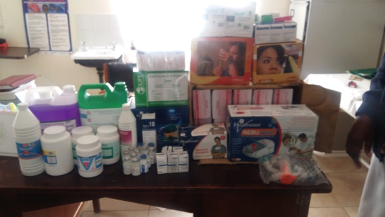

May-June

Thank you for the specific funding for the clinic.

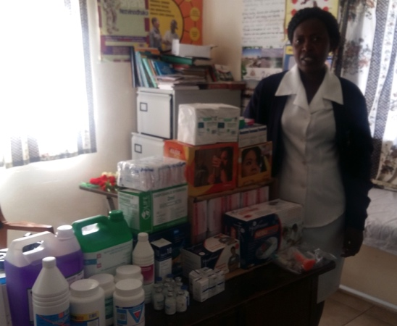

Litta, the nurse, was very excited and happy when we told her and she has bought medication, a nebulizing machine as well as refilling of medical gas for the clinic. We are truly grateful to be able to provide such necessities for the children because of your support. Please do pass our gratitude to the friend who donated these funds. I was very touched that she thought of MRCH. What a blessed heart.

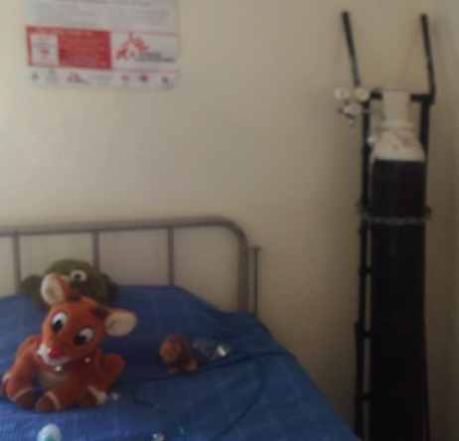

A bedside nebuliser now in the clinic

A new stock of medication

The last couple of weeks have been really hectic and especially today as the MRCH Big Sunday is on the 10th June. A lot needs to be put in place as we are expecting a little over 1,000 people here on Sunday.”

Zvirinane Matore

**Fundraising adventure**

In 2014 you may remember David Graaff and Wayne Cooper driving an old Mercedes to Mauritania and selling it to raise funds for MRCH? Maybe you sponsored their adventure helping them to raise around £4,000? Well they’re off on an even more amazing adventure in a few weeks time.

The drive is approximately 12,000 miles and they have a target to reach of £3000 – **can you help them achieve it?.**

**Mongolia Charity Rally 2018**

This year Wayne Cooper and I are taking the challenge of driving a tiny car a quarter of the way around the world. We are taking part in the Mongol Rally in our sixteen year old 1.0 litre Micra. We bought the car for £500 on ebay. It has only done 40,000 miles, and never previously left Surrey!

We set off on July 13th and the trip should take us about six weeks. We shall travel through Belgium, Germany, Czech Republic, Austria, Hungary, Romania, Bulgaria, Turkey, Iran, Turkmenistan, Uzbekistan, Tajikistan, Kyrgyzstan, Kazakhstan, Russia, and Mongolia, and return through Russia.

As you would expect, we are paying all our own costs!

This will be a big personal challenge for both of us. Please support us by donating to our chosen charities: Cool Earth and Matthew Rusike Children’s Home. **The charities receive your donations directly.**

Here is the link to make a donation [https://uk.virginmoneygiving.com/Team/GoodVibes](https://uk.virginmoneygiving.com/Team/GoodVibes" \t "_blank)

(or send it to our treasurer and tell him you are supporting David and Wayne’s amazing effort for MRCH)

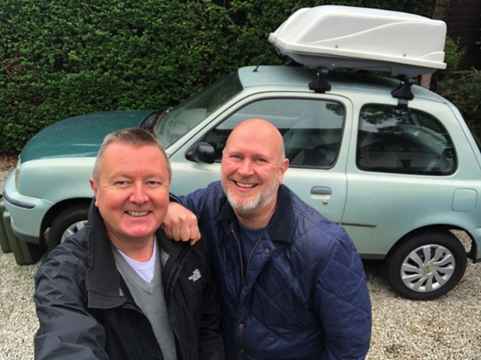Please wish us luck, and follow us on Facebook!

[https://www.facebook.com/mongolgoodvibes/](https://www.facebook.com/mongolgoodvibes/" \t "_blank) David Graaff

**Data protection**

I am very grateful to the many people who replied “yes” so promptly giving their permission for us to keep their contact details. There are still some who have not done so and it is particularly important that those