Open Meetings at Droitwich Methodist Church
Saturday October 13th
Everyone is welcome to join us at 11am for the meeting, followed by the bring and share lunch. We are all on our way home by 2pm

Data Protection
Thank you to everyone who is staying on our database and especially to the 70+ people who have been added to our emailing list. This has greatly reduced our copying and postage costs.

Setting up a standing order
It is important that new donors communicate to the secretary or treasurer that they are setting up a standing order. It’s difficult to keep track of new donors unless they introduce themselves.
With every new donor, we require the following information:

1 Full name and address.
2 Do you wish to be a member or
a "supporter"
3 Are you a UK taxpayer and do you wish to Gift Aid the donation?
If so, please ask for a form.
4 Would you like to receive our newsletters? If so, the treasurer will forward your name to the mailing list manager. Immanuel Mudzinge

We are grateful for the increase in people signing gift aid forms and setting up standing orders but in spite of this, total donations have dropped significantly recently and from September 1st we have had to reduce the monthly remittance to MRCH by US$1000 (£763) This is the 2nd time in 2 years we have had to do this.
New brochure

Friends of Matthew Rusike Children’s Home
We give mainly financial support directly to the Home

September 2018 Registered charity 1120944

You have now seen a copy of our new brochure by email or post. If you need some for a fundraising event or to pass round a group please contact me and say how many you need.
This newsletter has highlighted several ways funds are being raised for the children at MRCH.
Can you help by holding a coffee morning, afternoon tea, sponsor someone else, such as David and Wayne’s Mongol Rally, have a bake sale or similar, buy our Christmas cards, even small amounts add to the fund total and all are very welcome.
Thank you to all who have raised funds in the past for the Children in Zimbabwe, their need is still so great. Please continue your marvellous support. Carol Banham

Contacts
Chair: Carol Banham
64 Saffron Crescent
Tickhill, Doncaster
S Yorkshire
DN11 9RU
carol2021@banham.net

Secretary: Michael Mapako
michaelmapako61@hotmail.com

Treasurer: Immanuel Mudzinge
103 Linney Road
Leicester
LE4 0UX
manu.mudzinge@gmail.com

Take a look at our website
www.friendsofmatthewrusike.org

This newsletter is distributed by
The Friends of Matthew Rusike
Children’s Home.
News from the Home
June The children are doing well under severe cold weather conditions. We thank God for a donation of blankets we received from a child of God just on time.
Thank you so much for the update on remittances. (reduced from September) This will help us to plan well and make necessary adjustments. We understand and appreciate the great effort and sacrifice that is put into raising these funds. We pray and pin our hopes on our projects to cover some financial gaps.
Once again I thank the Friends so much, please pass our deepest thanks and regards to all the friends of Matthew Rusike Children's Home.
Rev Linrielink Mutendzwa

June We had a very good Matthew Rusike Big Sunday on the 10th of June. I'm sorry I did not manage to take any photos this time around as I was busy on the finance desk. Yes the children participated by reciting some poetry and singing some songs. The college choir, which has grown and continues to excel, also did very well performing two beautiful songs.
Although the turn out was a bit lower compared to previous years we managed to raise $4,913.00 (£3,748.67) on the day. Again this is low compared to previous years. I guess the low turn out coupled with the economic situation which continues to deteriorate, all contributed to this. But we do not tire, we keep pressing on.
We have another fundraising activity planned. Fun runs have become quite popular here and it seems they have replaced sponsored walks. We intend to hold our own on 4th August. (Unfortunately, this had to be postponed due to the elections and all 200 people who had registered had to be contacted individually to reschedule the event)
After the Fun Run it will be the Annual Dinner dance in October and possibly a Family Fun Day for the month of November, all things being equal.
Zvirinane Matore

After the elections some emails from friends
Thanks for your prayers. We are all well and still praying for a tranquil time. We are not affected at the home and all the children are really safe. The first group will be going to their foster parents on Monday for the August holiday and the second group will leave on Tuesday. Those whose guardians are in Harare and surrounding towns have already left for their holiday.

We would like to assure you that we are all safe and quite ok, though the situation is not a normal one, the environment is calm.


We had a good pre -election season until last week when things went upside down. We thank God that we are situated on the outskirts of town and are usually spared from most of these nasty things. We are all okay.

Mongol Car Rally
July We’re having a great time though the driving gets tiring. We’ve arrived in Yerevan, Armenia today and it’s 40 degrees, tomorrow we need to get up early to get to the Iranian border and meet the rest of the guys in the convoy…. an eight hour drive covering only 150 miles. So beautiful, so poor, and so hot! Little car struggles up and down the hills between 1000 and 2200 metres.
August We have really enjoyed Russia. Tomorrow we leave for Mongolia, our 20th country, and will hit 10,000 miles.…. we arrived at the Russian border at 11am and finally emerged the other side at 9pm. Cold, wet and very dark. But the night sky is clear and stars are brilliant.”

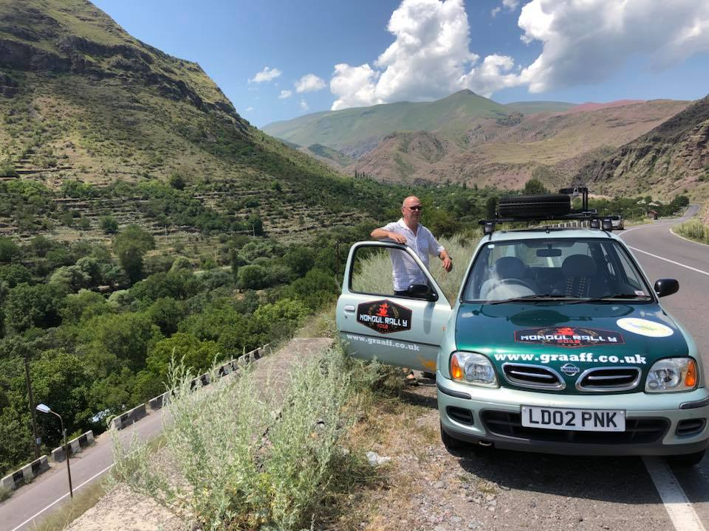
August 26th “We’re finished …. 11,400 miles, 0 mechanical issues, 0 flat tyres 1 blown bulb and 2 happy bunnies.”
David Graaff & Wayne Cooper

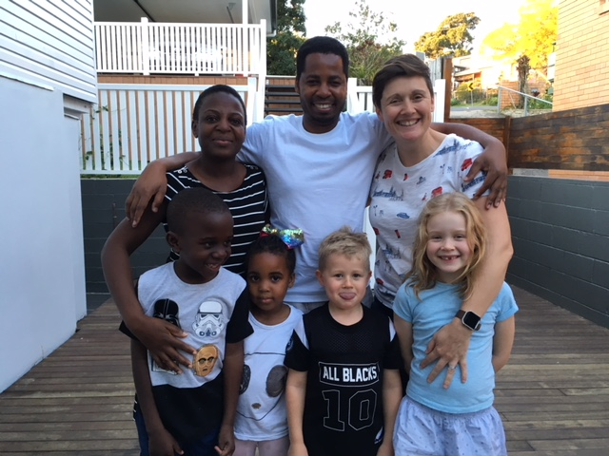
You can still support our intrepid adventurers. Can you help them reach their £3000 target for the children’s home?- Search for “Mongol rally team good vibes” on facebook or Virgin money giving to donate or send a cheque to our treasurer.

Another triathalon
“At the end of June I did a triathalon - my first Olympic distance to coincide with me turning 50. I set up a Virgin money giving page to raise over £996.25 including gift aid.
It was a hot day, which didn't help!! The distances were 1.5km swim, 44km bike and 10km run which I did in just under 4 hours. Pretty slowly really, but the main thing for me was getting round rather than trying to achieve any particular time!” Debbie Berrill

Congratulations and many thanks Debbie for another really marvellous effort for MRCH. Ed

Reunion in Australia
In 1999 Kate Robinson spent 10 months as a volunteer at MRCH before going to university. Here is an amazing story from her.

“When I was at MRCH I met a young man who was only a year younger than me, called Manyowa Karimazondo. Anyway, whilst at work, I saw this name on one of the assessments. Manyowa’s name. I googled him and turns out, he is over here, in Brisbane, working as a psychiatric registrar. He lives less than 2 miles away, has a wife and 2 children the same ages as ours. He is on rotation at the hospital attached to my work. So strange….. Just got off the phone from talking to him and we are going to meet up. I am so excited! It’s just such a co-incidence! Me being from the UK, him from Zimbabwe and living so close now in Australia.”
Kate Giles

Paddy Coles retires
Paddy was our treasurer for over 15 years and with his wife Jenny, a founder member of FoMRCH in 1997. Sadly he is retiring through ill health. We thank him for all the work and support he has given over the years, including managing our journey to become a registered charity in 2007, enabling us to claim gift aid. We have greatly missed him and Jenny in our recent meetings and wish them both every blessing for the future.

“I used to email Paddy as treasurer and we still send emails, I especially enjoy the jokes he shares with me. As you vividly said in your email you all miss his contribution in your FoMRCH meetings, it's equally the same with me here at MRCH.”
Lloyd Kupeta
“The Home appreciates Paddy’s service particularly the immense work he has done for MRCH. We pray that he continues to recover.” Zvirinae Matore

