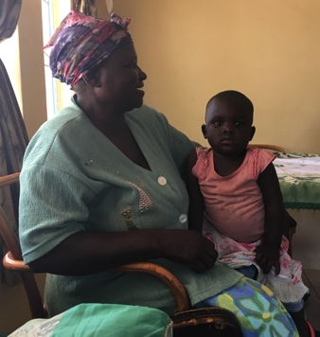§MRCH has had some successful fundraising events and the Friends too have received some. Margaret at Darnall Road Baptist Church sold homemade jam, cards and chutney, raising £135; Cambridge Road Methodist Church donated £1860; Tickhill Methodist Church raised £502 at an annual mince pie evening. Other donations from £20 to £1000 arrived in response to the reports of sudden violence

**Typical reply from Friends**

I am also keeping our congregation updated on events at MRCH. So good to hear that the children are safe and things have calmed down for the moment. We continue to hold them all in our prayers.

**In spite of these donations our committee felt it necessary to change from a monthly to a bi monthly remittance to save on the bank charges in each country. This will save us £180 in UK charges and MRCH will save US$150 in Zimbabwe per year – every little helps.**

**Standing order/gift aid**

**If you can arrange to donate using either or both of these it will certainly help our cash flow to the Home. Please contact us if you need help with this.**

Thank you to all who have raised funds for the Children in Zimbabwe, their need is still so great. Please continue your marvellous support and could you set up a standing order and/or gift aid your donation?



# Friends of Matthew Rusike Children’s Home

***We give mainly financial support directly to the Home***

March 2019 Registered charity 1120944

MRCH staff are so dedicated to the children and childcare work that some of them have been there many years. Here is Lillian who has been a house mother for about 30 years

# Contacts

**Chair:** Carol Banham

64 Saffron Crescent

Tickhill, Doncaster

S Yorkshire

DN11 9RU

carol2021@banham.net

**Secretary:** Michael Mapako

[michaelmapako61@hotmail.com](mailto:michaelmapako61@hotmail.com)

**Treasurer:** Immanuel Mudzinge

103 Linney Road

Leicester

LE4 0UX

[manu.mudzinge@gmail.com](mailto:manu.mudzinge@gmail.com)

Take a look at our up dated website

[www.friendsofmatthewrusike.org](http://www.friendsofmatthewrusike.org)

This newsletter is distributed by

**The Friends of Matthew Rusike**

**Children’s Home**

pie chart

**Report from the National Director**

I have been at the helm of this wonderful institution for a year now and am so humbled by the committed staff, focused board and loving and supportive partners as we serve the lives of these precious children and give them hope for the future.

I joined MRCH in December 2017 amid a whirlwind in the economic-socio-political environment in Zimbabwe so our journey through 2018 was heavily defined by these events while all remaining safe in the Home.

We held a strategic planning workshop in February 2018 to define our vision as a home and came up with a new mission statement:

**Vision:** A Christ woven nest for orphans and vulnerable children

**Mission:** We exist to transform lives of orphans and vulnerable children in Zimbabwe through biblical nurturing, teaching and training into adaptive, responsible God-fearing citizens.

We thank God for managing to meet almost all the basic needs of our children throughout the year with help from our partners, the church and well-wishers.

A few cases of health were beyond our health officer’s capabilities and were referred to hospital treatment.

In our community-based care program we managed to reach out and help 3 children with wheelchairs in Mzinyathi, Bulawayo.

(I am sorry this diagram has to be so small but it does show that FoMRCH provides 33% of the Home’s regular income in **blue**  Ed)

We are so grateful to Higher Life foundation for assisting in the school fees sponsoring program and re-painting the out-side of the housing units to the tune of $43000.

Visits by various individuals and groups like MCZ-UK Fellowship Chaplain Rev C Sibanda and representatives, Birmingham District representatives, Mark Edmund from Australia, Mr Michael Mapako from FoMRCH, church organisations, schools etc all gave us the much needed moral and spiritual support and power to look into the future with hope.

Our Big Sunday held in June, Half marathon in September and Dinner dance in October greatly improved our finances. Faithful monthly contributions from FoMRCH, Totterngram, the honoured pledge from Glow Petroleum and MCZ grant helped us to pull through a shoestring budget.

We experienced two cases of child abuse end of 2017 spilling over into early 2018 which were handled by the courts and social services. The two were discharged of their duties and the affected children received psycho-social support.

A staff member in the projects department left for greener pastures in May leaving a skills gap in the garden area. We also had an accidental fire in June that destroyed 200 chicks and seriously damaged part of the infrastructure. Our borehole broke down once as a result of electric motor failure.

Some parts of Harare were hard hit by a cholera and typhoid outbreak that claimed some lives. However, we thank God that we were spared the scourge and had our children vaccinated against the diseases together with over 8000 from the surrounding Epworth community.

The last quarter of the year proved to be the most challenging following pronouncements of the fiscal and monetary policies which saw goods and services sky-rocketing, demand for medical treatment in foreign currency, disappearance of basic commodities, erratic supply of fuel, striking of doctors, all these have a negative bearing on childcare. We had to keep the children on the premises during the week of violence and staff who live off site had to stay home until it was safe.

We ended the year on a very sad note following the death of Farai Guranungo the son of our Child Care Manager through a tragic road accident on 24 December.

Thank you for remembering us. We really value your prayers.

Rev L Mutendzwa, National Director

**More News from the Home**

We are doing ok under the circumstances, Zimbabwe has become unbearable yet again. Obviously MRCH is affected by such situations but we thank God that with the support of FoMRCH and other well wishers (who have dwindled) we manage to provide the basics for the children. My small family and I are feeling the heat too but we soldier on and hope this all comes to an end real soon. It looks like a bleak Christmas for many.

We wish all FoMRCH a Merry Christmas and a blessed 2019.

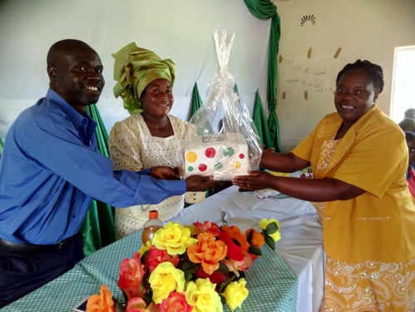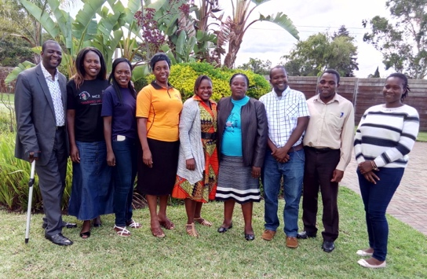

**MRCH Admin staff** after a training workshop. From left Rev Mutendzwa (National Director) Litta Simendi (nurse) Portia Nduna (bookkeeper) Shorai Chindito (Finance and Admin) Norlin Chisoro (Transitions) Rairo Guranungo (Childcare) Darlington Mundondo (projects) Eugene Masendeke (intern) Zvirinane Matore PA.

**February 2019**

We are so grateful for the rains after a dry spell for some  weeks. The weather is good we have green mealies that are doing very well.

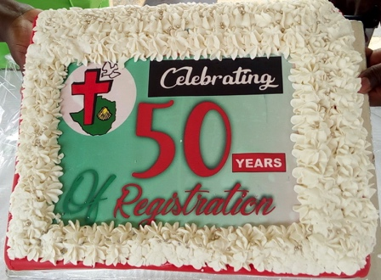In December we had a leaving party for our longest serving house mother Mercy. Here she is presented with



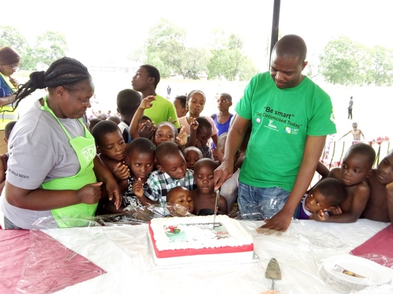

an appreciation cerificate sent by the Friends. We also had a send off for Lloyd and his family as he moves to run the Outreach Centre in Donga, near Gweru. We thank him for all his

dedication to MRCH childcare work.

**Our fundraising events**

The profit from the Marathon was

£3168.27 On the 26th of October we had our annual Dinner Dance and the profit was £6520.04

On the 8th of December we had a Family Fun Day when we also celebrated 50 years since MRCH was formally registered in 1968.

The home has existed much longer.

A cake to celebrate and eager faces await their turn to eat it.



Bouncy castles

provided fun and excitement

A large paddling pool provided fun and a chance to cool off in the heat.