This all takes a lot of money for transport, family support and official paperwork.

The Matthew Rusike Organisation has an excellent system of placement back into the community for children and also for it’s 18 year old leavers *(see our June newsletter)* by finding employment or further training. Of course lack of funding always has an effect on achieving these aims. Ed

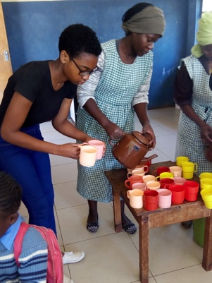

A volunteer stays at the Home

Thiosha spent a week at MRCH volunteering in different areas. We were blessed to have her and we were really amazed at her versatility and how she adapted to the environment so easily and so fast.

Zvitinane Matore

If you use Pay Pal or buy online please mention MRCH for charitable giving it doesn’t cost the buyer or the charity anything.

POLICIES

We now have policies for child protection and anti bribery. You can see them on the Friends page of our website and follow the links.

Thank you to all who have raised funds for the Children in Zimbabwe, their need is still so great. Please continue your marvellous support and could you set up a standing order and/or gift aid your donation?

# Friends of Matthew Rusike Children’s Home

***We give mainly financial support directly to the Home***

March 2019 Registered charity 1120944

**Please keep us up to date with your contact details.**

# Contacts

**Chair:** Carol Banham

64 Saffron Crescent

Tickhill, Doncaster

S Yorkshire

DN11 9RU

carol2021@banham.net

**Secretary:** Michael Mapako

[michaelmapako61@hotmail.com](mailto:michaelmapako61@hotmail.com)

**Treasurer:** Immanuel Mudzinge

103 Linney Road

Leicester

LE4 0UX

[manu.mudzinge@gmail.com](mailto:manu.mudzinge@gmail.com)

[www.friendsofmatthewrusike.org](http://www.friendsofmatthewrusike.org)

This newsletter is distributed by

**The Friends of Matthew Rusike**

**Children’s Home.**

NEWS FROM THE HOME

**Thank you for your support**

We thank you for your May donation amounting to US$9,975.00, it is truly invaluable to us. We thank you especially for your commitment to the welfare of the children here.

You may be aware that at the moment MRCH here in Epworth cares for 97 residential children and supports over 1000 disadvantaged children in the Community Outreach Programme with food packs, school fees, clothing and medication. Your support goes a long way towards helping them all.

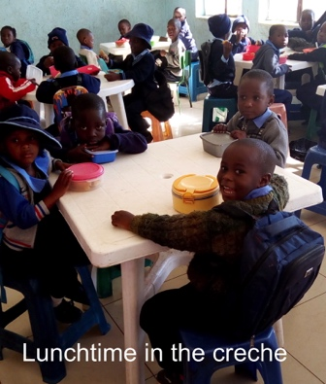

We pray that the happiness and smiles on our children’s faces be an inspiration to you all.

Rev Linny Mutendzwa National Director

June Winter is here and temperatures are dropping drastically. Some of our staff members are writing exams. The water problem is getting worse as we’ve had poor rainfall this year and the water table has dropped, hence we need to deepen the present borehole or sink another one.

“You will be amazed how costs are rising. Yesterday morning I boarded a bus for town for $1.50 but after my exams around 5pm the bus fare was $5.00” (local currency) staff member

Life in Zimbabwe continues to get hard. We are now experiencing serious electricity cuts of up to 15 hours a day. The generator is on standby but we cannot use it all day due to cost/supply of diesel. Our timetable makes life a little easier for children and staff. We switch it on in the mornings so the children can have warm water and breakfast before leaving for school, on again mid morning so the office can get some work done, then again in the evening so houseparents can prepare meals, children can do their homework and water is pumped into the tanks. It is difficult but would be much worse without the generator.

Big Sunday went well under the circumstances. More than 1000 people came bringing goods in kind and spending their money here. A total of £4,195 was raised in a variety of currencies, much lower than other years, even the donations in kind were lower. It is very difficult for people to part with the little they have.

The service was well attended and Rev Chinhara was the guest preacher. We were happy to have the grandsons of the late Rev Matthew Rusike and their familes briefly at the beginning.

The college is growing and we now have 549 students mainly from the Epworth community, We identify children from poor families needing assistance and put them under the Community based care programme. Some of our residential children also attend the college. The former laundry block has been renovated into 2 classrooms but we can’t take anymore with the present facilities.

At the end of June we had sad news of the death of ‘one of our dearest children’ from epilepsy. She was 17”

On 13th July our second half marathon started and finished at St George’s sports club. The response was more than we anticipated. Last year we had about 300 runners this year 576 braved the super chilly July morning and supported the Home. 



The T shirt says “I ran for a child Matthew Rusike Children’s Home Half Marathon 2019” The event was well supported by corporates as well as individuals and after all expenses we raised £231

Life at MRCH is generally quiet in August, most children are in their foster homes except the few in exam classes who stay here for extra lessons in preparation for their exams. Zvirinane M & Rev Linny M

**Outdoor play area**

Earlier this year we received £5000 from Judith McMullan in memory of her husband Jim. His dearest wish was that his legacy would benefit the children so that it 'would bring new life and opportunities to children desperately in need'. Consulting the Home we learned that the outdoor play area was so dilapidated and dangerous that it could no longer be used so it was agreed that the money would be spent on replacing it and anything left over be used for Zimbabwe books for the Home's library.

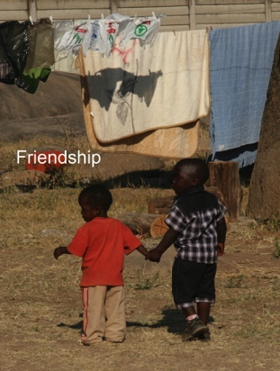

Many thanks, Jim and Judith, we look forward to some lovely photos of the children having fun and reading the books

We are so grateful for the donation towards refurbishing the child play centre. It has been our area of great concern. The funds will definitely go a long way to improve children’s play. We will send pictures before the work is done and the outlook after completion. Work has not yet started due to the rapid changes that are taking place in our economy, we put the plans on hold as quotations kept changing daily. Zvirinane Matore

**Mile Cross Methodist Church, Norwich**  raised £200 at their garden party. Dot Lilley

**Zimbabwe Methodist Youth UK** raised £2959.41 with a sponsored mountain climb. Rev C Sibanda

***A big thank you to all who raise funds for the children.***



Those who remember Astonishment Mapurisa, MRCH’s former director, will be interested in a new book called ‘Astonishment: Laying Ghosts in Mugabe’s Zimbabwe’.  It’s by MRCH supporter, Graham Jones, who travelled with Astonishment into rural Zimbabwe and heard his incredible story of abject poverty, child slavery and the grace of God. The book is that story, including Astonishment’s time at MRCH. The publishers call it “a moving account of nostalgia, race and reconciliation that celebrates the transformative power of forgiveness”.

*Publication is on 19th September and the book will be available on Amazon and through most UK bookshops.*

**Children belong in families, the heart of MRCH policy.**

Children arrive in MRCH through the social services and the courts because they have been found abandoned on the streets, orphaned by AIDs or abused. As soon as they arrive at the Home, (NOT called an orphanage) the Transitions officer begins her work to trace any members of the child’s family in the hope they will take the child in. Often these families will already be struggling to survive so MRCH supports them with food, clothing and school fees for the child. If family members can’t be found, foster families are searched for and these need to be assessed for suitability to determine if they are going to be able to take in an extra child. Children successfully placed are monitored by the home to ensure a successful placement.

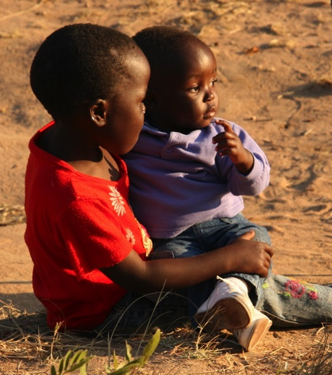

MRCH is the only residential home in the Matthew Rusike Organisation. Community Outreach centres have been established across Zimbabwe where identified poor and vulnerable children can “call in” for day care. Volunteers give love, care and hot meals and pre-schoolers are taken there by older siblings who then can go to school for the day. After school the child carers return to the centre for a hot meal, emotional support and help with homework before taking their young siblings home. These places are sometimes in rural areas without electricity or transport.