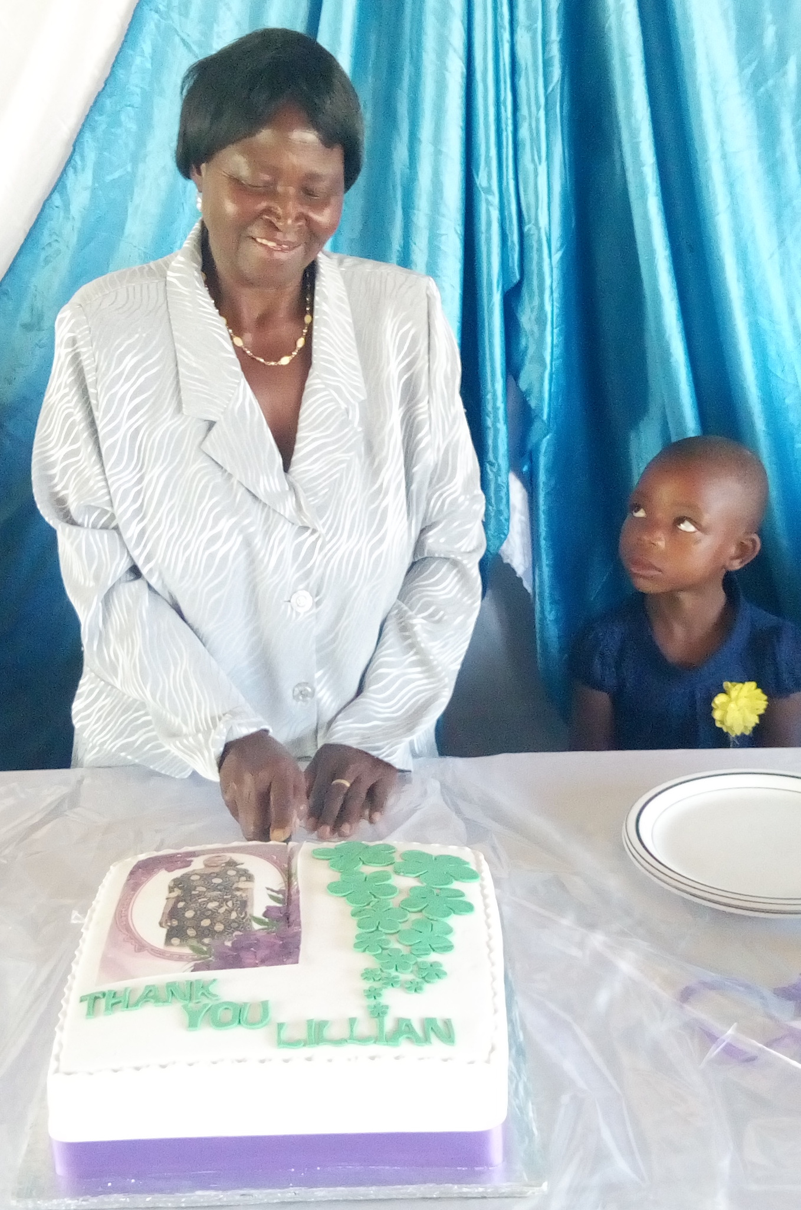
Lillian, a long serving house mother of 31 years retired in August. One of her little boys looks on sadly as she cuts her ‘Thank You’ cake at her party lunch.

The book “Astonishment” tells the story of the amazing life of the past National Director at MRCH, Astonishment Mapurisa. It reveals how he got his amazing name and how his childhood experiences gave him insight into the lives of underpriviledged children and set him on a lifelong course of improving the lives and opportunities of such children. It is available from most book shops or Amazon and also on Kindle. A wonderful man many of us feel priviledged to have met and know. It’s written by Graham Jones a member of FoMRCH.

Treasurer
Our treasurer, Immanuel Mudzinge, has been with us for 3 years but unfortunately now has to leave us so once again we are appealing for someone to offer their voluntary services and join our small team working for the children in Zimbabwe. We cannot run the charity without a treasurer and Immanuel will step down next March. Please will you give this situation your prayerful/thoughtful consideration.
Our Christmas card sales raised almost £300. Thank you to everyone who bought some this year. Carol Banham

Friends of Matthew Rusike Children’s Home
We give mainly financial support directly to the Home

December 2019 Registered charity 1120944

As you can see your regular donations really do continue to enrich the lives of the children at MRCH. Their need persists in this economic collapse so please maintain your generous support and, if you haven’t already, could you set up a standing order and/or gift aid your donation?

Christmas good wishes and thanks come to you all from MRCH and from FoMRCH and we hope and pray for improved lives for our friends in Zimbabwe.

Contacts
Chair: Carol Banham
64 Saffron Crescent
Tickhill, Doncaster
S Yorkshire
DN11 9RU
carol2021@banham.net

Secretary: Michael Mapako
michaelmapako61@hotmail.com

Treasurer: Immanuel Mudzinge
103 Linney Road
Leicester
LE4 0UX
manu.mudzinge@gmail.com

www.friendsofmatthewrusike.org

This newsletter is distributed by
The Friends of Matthew Rusike
Children’s Home.

NEWS from Zimbabwe
Once again the economy in Zimbabawe has virtually collapsed and now they are in the middle of severe drought and extreme heat.
At the Home they are experiencing power cuts which affect their water supply which then affects the irrigation and food production, including the pig and poultry units. The generator has to be used sparingly because of the price and availability of fuel. Without lighting (it is pitch dark by 6pm winter and summer) children can’t do their homework and housemothers are sometimes cooking in smokey outdoor kitchens. Lack of electricity affects the work of the administration staff who can’t access their computers; freezers and the water pumps fail. Fuel shortage affects staff getting to work and use of the minibus to get children to hospital and clinics. Daily business is affected if staff have to walk the 15k to meetings or the bank. The staple food of maize flour and cooking oil is very expensive. Staff have lost their pensions and often their salaries are not paid for months.
MRCH is used to making something out of virtually nothing and coping no matter what the hardships but, as always, their prime concern remains the care, safety and welfare of the children.
Carol Banham
NEWS from the Home
We thank you so much for your prayers and support on our predicament as a nation. As we face the hostile environment we remember how fragile we are and the bountiful love of our creator. Recently we receivedd two more children, one is an 11 month old survivor of the devasating cyclone Idai. She responded well to the tinned milk in our stocks.
Rev L Mutendzwa

In September we heard that the home’s borehole had become inadequate. Australian funds paid for a new hole to be drilled but this didn’t produce water. However, “the drilling company Tandamanzi, one of the biggest in the country, donated their services (worth US$2,000) to try again. We had to meet the cost of the water pump and installation but we are so grateful for their gift of water.”

Ocober has brought a terrible heatwave and we have had sad reports of deaths due to heatstroke in some areas.
MRCH dinner dance was held on 25th October. It was satisfactorily attended but due to the economic environment the uptake from the corporate world was really low. Individuals on the other hand performed really well.
God surely sustains the staff and children at MRCH. Its hard to explain how we get by each day in the face of very difficult socio - economic conditions but we do not go to bed hungry, we have decent roofs over our heads and we are grateful for all the small blessings everyday. We are grateful for the Friends whose support continues to be definite and goes a long way towards providing for the children.
Zvirinane Matore


“We thank God that our children are all in good health. Schools closed for the festive season on December 5th and the children will go to foster families on 11th &12th.
The boarders came back in good health with good performance reports. 2 students sponsored to take A level are doing well. SM wrote his exams and was awarded a prize for excellence. JM also scooped an award and is now a prefect.
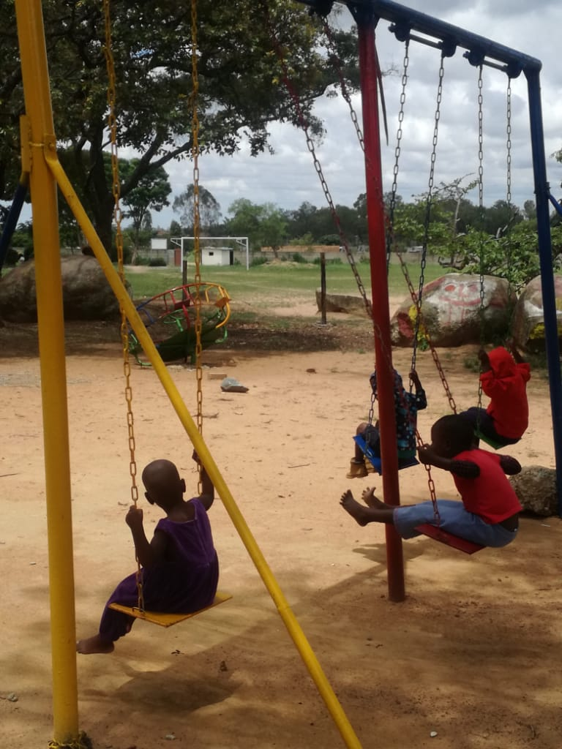
Five children wrote their O levels. All of them have reached 18 and will leave MRCH. Two will be reunited with relatives who were found through tracing and the other three will be reintegrated with their foster parents.
10 children wrote their grade 7 exams but did not perform as well as hoped. We are making plans to help these children with extra lessons to boost their perfomance which will include providing essential materials for their learning process.

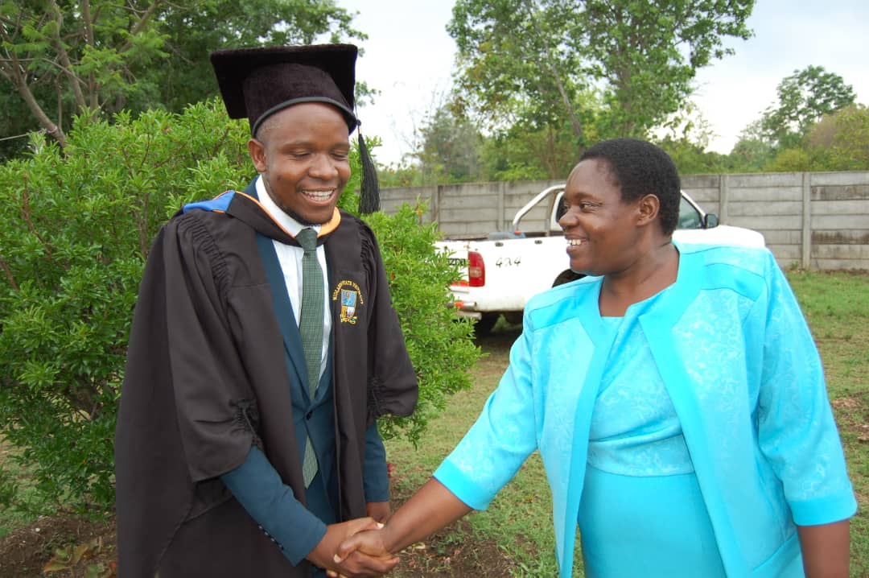
We are very happy to have one of our own students graduate recently at Midlands State University with a degree in Mining Engineering. Lucky Magombedze made us all proud and we thank friends for their unwavering support towards the children at Matthew Rusike Children`s Home.



In support of this young adult, staff members, Lloyd, Rairo, Norlin and Ernest went to his graduation ceremony in Gweru.
Thanks to the generous donation
from Judith McMullen, in memory
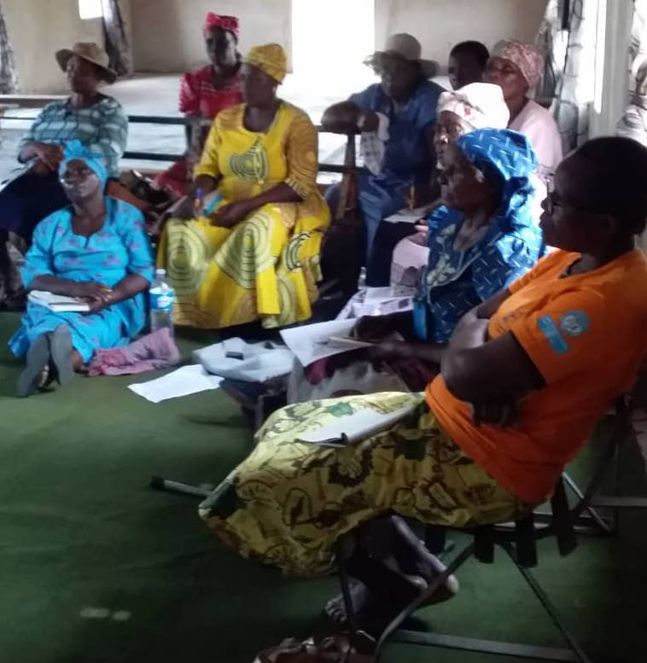
of her late husband Jim, the outdoor play area is being upgraded at the Early Childhood Development centre and is still work in progress. The swings had some repairs and the young ones are enjoying them. We are hoping that all the work will be done in time for the schools opening for the first term in January 2020.

A proud 6 year old graduates as
house mothers look on
E.C.D enrolment has increased and more than 60 young children graduated from the centre, 8 of whom live at the Home. They will all go up to grade 1 in a local school January.

We appreciate the hard work of E.C.D teacher Stella Shoniwa.

In November Rev Linny, Norlin, Litta and Tracy (social work intern) held a workshop in Kwenda for the foster parents and to train new ones. The aim was to strengthen the relationship between foster parents and the home. We now have seven new foster parents who want to take children during the school holidays. Plans are in place to have workshops for foster parents in Chivhu and Gweru next year.

The home gave a workshop for Caregivers who look after the children in residential care. Sixteen caregivers received training and a certificate on areas which include counselling, child protection, child development, parenting, caregiving and behaviour management.
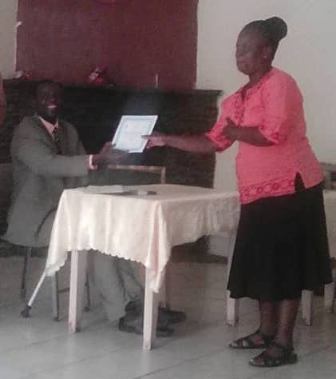

As the year comes to an end, we thank God for the strength to soldier on, for experiences and opportunities and for those who have stood with the home throughout the year.

Wishing you all a merry Christmas and a prosperous new year “
Norlin Tayengwa, Transitions Officer

