us for the next three months. We do not have beans, dried fish and peanut butter, putting pressure on our protein portion which is quite essential for children. Our medicine stocks are such that we have barely minimum essential drugs. Rev L Mutendzwa

**Treasurer So far we have received no nominations or volunteers to take up the treasurer role in early 2020. Our charity cannot continue without one so please think prayerfully about the situation and the needs of the children at MRCH.**

**Secretary**

**We are also still looking for a secretary to join us. These posts are urgently needed if the charity is to continue.**

Michael and Immanuel are kindly still in post so please continue to send your donations to Immanuel.Thank you.

**Subscriptions**

If you wish to be a member then annual subscriptions are now due at £10 per person. Please state that’s what your payment is for when you contact Immanuel.

If you use Pay Pal or buy online please mention MRCH for charitable giving, it doesn’t cost the buyer/seller or the charity anything but brings in much needed funds,

# Friends of Matthew Rusike Children’s Home

***We give mainly financial support directly to the Home***

March 2020 Registered charity 1120944

**Astonishment** – past National Director and Superintendent of MRCH

“I have just read the book about Astonishment – what an incredible man he is.  I feel privileged to have met him in 2003 when you brought him over to Headingley Methodist Church in Leeds where we used to worship before moving south to Melton Mowbray.”

Christine Pickering

Please keep us up to date with your contact details.

# Contacts

**Chair:** Carol Banham

64 Saffron Crescent

Tickhill, Doncaster

S Yorkshire

DN11 9RU

carol2021@banham.net

**Secretary:** Michael Mapako

[michaelmapako61@hotmail.com](mailto:michaelmapako61@hotmail.com)

**Treasurer:** Immanuel Mudzinge

103 Linney Road

Leicester

LE4 0UX

[manu.mudzinge@gmail.com](mailto:manu.mudzinge@gmail.com)

[www.friendsofmatthewrusike.org](http://www.friendsofmatthewrusike.org)

This newsletter is distributed by

**The Friends of Matthew Rusike**

**Children’s Home.**

NEWS FROM THE HOME

January We praise God for the gift of yet another year. Greetings to all Friends of Matthew Rusike Children's Home. We are extremely grateful for the continued support we get from you for child care under difficult conditions. We pray the Lord bless you as you work for his cause.

We had a party for the children in December and prepared some food hampers for staff members from money you sent. That marked a happy close to a very difficult year.

We are currently busy in school preparations with 10 children going for their first grade (age 6) and 10 going up to form one.

Rev Linny Mutendzwa National Director

The children are all well including those with chronic conditions. 61 children went to foster homes for the Christmas holidays. 3 18 year olds left us, one was reunited with family and we look forward to 5 more being reunited by April 2020.

The staff were very grateful for the money sent for meat hampers, they provided a decent meal for their families over Christmas. The children who remained at the home for the holidays also had a special meal because of the funds.

Thank you very much.

Two finance staff left us at Christmas, both have found jobs elsewhere with better salaries. The Church accountant is dealing with our finances until we can replace them. It is a huge loss.

**Alice Shokobishi,** another House mother is retiring in March.

We had a good Christmas break although it was extremely hot, it looked like we maybe headed for another drought. However, the rains came. Its been a huge relief. We are praying that the whole country receives some rain.

The new term started today and we have 10 new grade ones. We thank God the children have all requirements, uniforms and school supplies including their fees, for the new term. It’s such a relief to be able to get the things for them.

One of our children, SM, did extremely well at A level achieving A in all 3 subjects. We are extremely proud of him.

Currently he is applying for university scholarships and hopefully of all the applications he is making one of them will come through. Two more students also worked hard and did well In their studies



History B, Shona language E, Family & Religious studies C

**A JOURNEY OF MERCIES**

It was not easy to be where I am. Thanks a lot to Matthew Rusike Children’s Home through their Community Childcare Programme on which I was enrolled as a child in need of care, I was assisted to go back to school from grade 4 to

form 6. I received educational support, food, toiletries and social counselling. Then UK sponsors helped me to do A level. I am proud to come up with 8 points. My desire is to be a social worker and to be able to help vulnerable people to understand that they have all the strengths to improve themselves. My dreams can only come true if I go to university. I thank honestly those who helped me to achieve 8 points PM

Business studies C, Geography C, Economics B

**FROM DUST TO THIS LEVEL!**

What an amazing support I received from Matthew Rusike Children’s Home Community Based Childcare Programme. They identified me from our community and supported my education from grade 5 to form 6 then up to A level by UK sponsors in 2019. I am proud to achieve 10 points. My goal is to go for Tertiary Education to study Business Management and have professional qualification to be marketable in Industries all over the world. As it is, I am standing on one foot now but with professional qualifications I can be stable with both feet on the ground. Thank you wholeheartedly for raising me from dust to this level. TM

We again received a container from the Methodist Church in Northern Ireland containing various provisions.

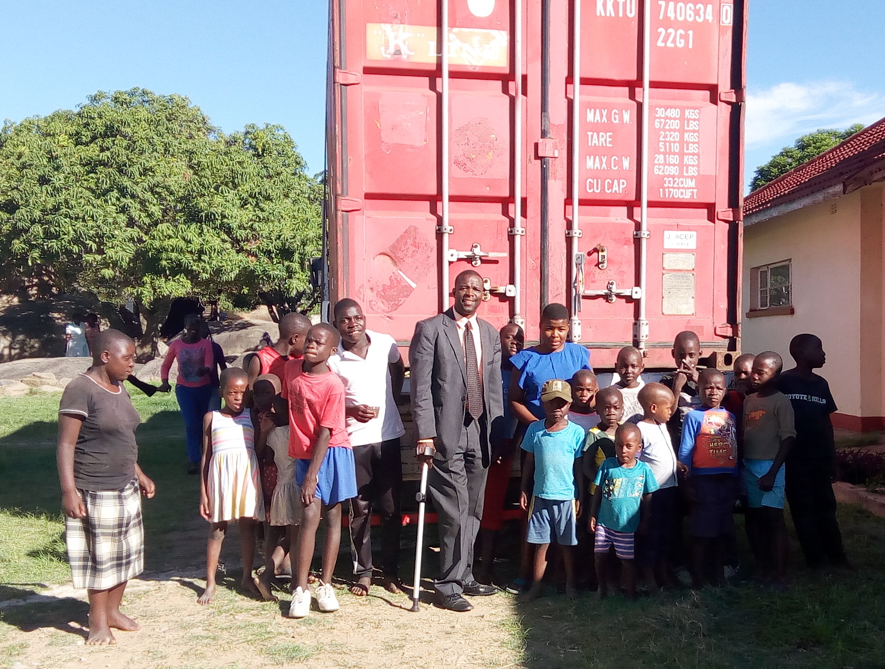We are very grateful for their support. It will surely go a long way towards helping the children.

Zvirinane Matori

**February**

The Zimbabwean situation remains hostile, unpredictable and gloomy. We are deep in the summer season characterised by erratic rainfall casting doubt on the crop yields. There is basically no mealie meal in the supermarkets. . Our maize stocks have gone critically low, just enough to take