payment. Again no cost but Donr takes a small proportion of the donation. Up to £20 can be sent each time –for example

**Text**

RUSIKE3 to 70085 to donate £3

RUSIKE10 to 70085 to donate £10

In addition you wil be charged your normal rate for a message

**3** You can donate directly to the charity’s account by **bank transfer**

Acc name **FoMRCH**

Bank **HSBC Ringwood Branch**

Sort code **40-38-21**

Acc num **01200305**

**4** If you use **Pay Pal** to buy online please mention FoMRCH for charitable giving, it doesn’t cost the buyer or the charity anything

**5** Of course you can also continue to

**send a cheque** payable to FoMRCH

to our treasurer who **remains in post**

**until 2021**

Please remember to let Immanuel know if your donation can **be gift aided** or ask him for a gift aid form. Please also let him know your email address so he can acknowledge donations that way to save stationery & postage

We have recently received **£4028** in gift aid from HMRC for 2017 so a big thank you to everyone who has already signed a gift aid form and returned it to the treasurer.

The **AGM** will happen on Zoom this year, reports are circulated and if anyone wishes to contribute to the meeting please email or write to the chair or the secretary.

Thank you to all who have supported the Children in Zimbabwe, their need is greater than ever. Please continue your support and could you set up a standing order and/or gift aid your donation?

# Contacts

**Chair:** Carol Banham

64 Saffron Crescent

Tickhill, Doncaster

S Yorkshire

DN11 9RU

carol2021@banham.net

**Secretary:** Michael Mapako

[michaelmapako61@hotmail.com](mailto:michaelmapako61@hotmail.com)

**Treasurer:** Immanuel Mudzinge

103 Linney Road

Leicester

LE4 0UX

[manu.mudzinge@gmail.com](mailto:manu.mudzinge@gmail.com)

[www.friendsofmatthewrusike.org](http://www.friendsofmatthewrusike.org)

Please keep us up to date with your contact details

This newsletter is distributed by

**The Friends of Matthew Rusike**

**Children’s Home.**

.



# Friends of Matthew Rusike Children’s Home

***We give mainly financial support directly to the Home***

June 2020 Registered charity 1120944

N**EWS FROM THE HOME**

**10th March before lockdown**

Greetings from Zimbabwe.We are very anxious here because South Africa

has coronavirus cases confirmed and Zimbabwe has five suspected cases reported to be negative. Zimbabwe

with all it’s problems certainly doesn’t need any more. We are trying to guard against it. Litta, the nurse, has been giving us all health talks and we have

put wash basins at certain points to encourage good hygiene.

One of our children has been diagnosed with diabetes and has been in hospital over a week now. E, 14, was healthy

until she started losing weight. We are worried because her sugar levels have been so high they were sometimes unreadable. After a week in hospital it still keeps fluctuating. She is having tests done which are not normally done in Zimbabwe so we pray she will get better soon.

We have had an educational psychologist assessing some children with learning difficulties. Some of them have never set foot in a school but are way too old to start in grade 1.

8 young adults are doing skills training this year. 4 boys are learning

welding and building, 2 girls are

learning auto electrics and 2 are doing hotel and catering. We have managed to to get sponsorships for 2 of them and

this goes a long way to help us.

Zvirinane Matore

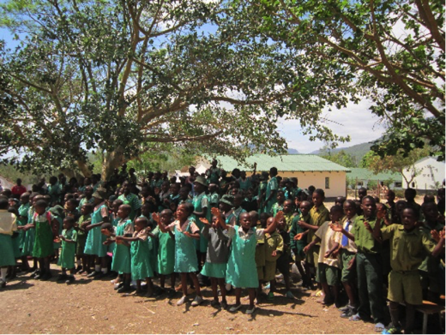

Children singing together before lockdown

25th March

The whole world seems on fire with this virus. We are now locked down, schools have closed and the children are all back home. They are all looking well and we thank God that E who was diagnosed with diabetes is greatly improving in terms of managing it through correct food, exercise and medication.

We have introduced various measures to protect children and staff: no more visitors and we can only leave the site for very essential things like medication, food or a life threatening cause. Staff who live off site must stay at home and a bucket of water and soap is right by the entrance gate and each house. Our nurse, Litta, is doing a sterling job preparing everyone to uphold hygiene standards.

We have a near collapse health system as a nation, inadequate infrastructure, little or no medical equipment or medication and our government has no capacity to contain this disaster. It is our prayer that we take every precaution necessary to save lives. Rev Linny Mutendzwa

The reports from the psychologist did not all arrive before lockdown but we know one child needs to be in a special school, 3 girls need to be enrolled in informal school held at Epworth primary because they are almost 13, it’s a government initiative to assist children who have never accessed formal education, for the rest we will have to wait until lockdown is over.

E is recovering and Litta is monitoring her sugar levels. She has learned to inject herself with insulin twice a day and we buy the drugs for her. Her hospital stay was paid by the Assisted Medical Treatment Order from the dept. of Social Welfare but this did not cover medical tests and medication and so far we have spent US$400 on these. I hope the Friends can see that their donations to MRCH truly go a long way. Through their support children like E are able to survive with chronic conditions. I am not sure she has fully understood what the condition means so she is receiving counselling from Litta, Rairo (matron) and Rev Mhlanga (chaplain)

**April 6th** About 10 staff members live away from MRCH and we are all locked down in our own homes. Most of the college staff live off site too. The children are well catered for by their house parents who are inside with them all the time. Senior staff are there including matron and the nurse so there are no problems. I was chatting with Rairo and she says the children are all in good health and keeping busy in the garden and of course playing games and doing chores.

Zimbabwe is really working hard trying to cope but as in the UK some people are not following instructions and have been arrested. For a country like ours where a lot of people are in the informal sector where no work means no money and no food, this is a very difficult situation. People do not understand that you have to be healthy to work.

**May 8th S**taff members who live away from MRCH are still locked in at our homes but some sectors of the economy have resumed operations. Soon we may be able to go back to work. The new normal is wearing a mask wherever you are or face arrest.

I understand that all the staff are working hard with the children and have had to factor in study time among othe things. We read that school opening will be phased in with exam classes returning first and the rest will depend on circumstances.

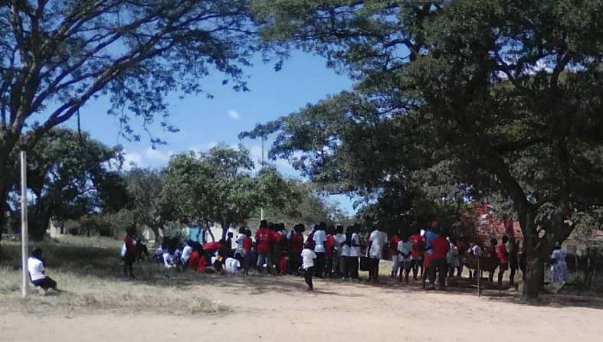

Last week the staff organised a Fun day for the children

Rairo’s husband Martin is the referee so it looks like everyone is playing a part towards childcare in the Home



…and they’re off….

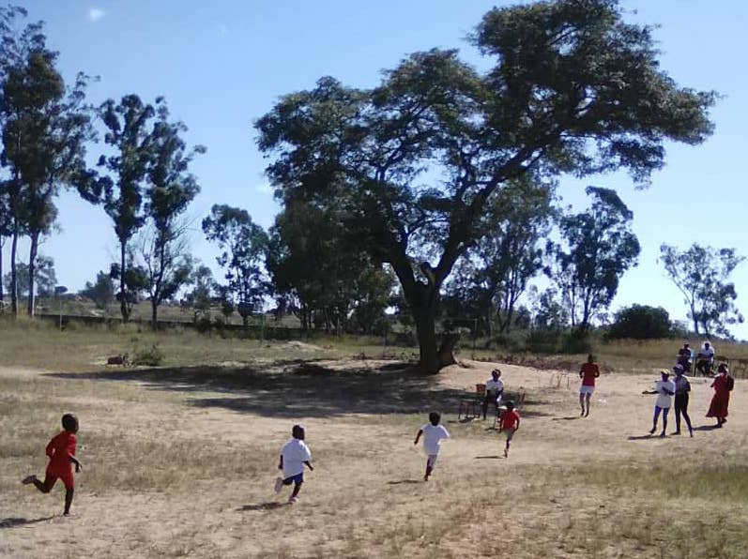

It is refreshing to hear that the children had the opportunity for a fun day amidst the whole situation.

Zvirinane Matore

May 17th

We thank God we are all still safe at MRCH and the children are happy. We have arranged classes from 10am to 1pm Monday to Friday under the tutorage of Mr Guranungo, Rairo’s husband, who is headmaster at a local Epworth school, Rev Faustina Mhlanga, the chaplain, who has a teaching background and my wife Mercy. They are also logging onto tutorials, girls from 2pm-4pm and boys from 7.30 – 9.30 each evening. The house mothers are sewing masks for all the children and Litta is on the alert giving practical advice on observing health and hygiene practices in the houses and around the entire home. Rev Linny Mutendzwa

**Thank you** to everyone who responded to our appeal for emergency donations so we could maintain our regular remittances to the Home, at this very difficult time.

**New** Here are more ways for you to donate set up by our past and present treasurers.

**1** Anyone who shops through **Smile** on Amazon can choose FoMRCH and we will receive 0.5% of your spend. It is free to you and to the charity and you just go to **Smile** and shop as normal.

[https://smile.amazon.co.uk/ch/1120944-0](https://smile.amazon.co.uk/ch/1120944-0" \t "_blank)

**2** We are also set up on Donr

[https://www.donr.com/products/text-giving/](https://www.donr.com/products/text-giving/" \t "_blank)

This allows you to **donate by text** either as a one off or a monthly payment. Again no cost but Donr takes a small proportion of the