Friends of Matthew Rusike Children’s Home
Christmas Newsletter 2020
We give mainly financial support directly to the Home

News from the Home
We hope you and the entire team of friends are keeping safe and well, here Covid19 cases are subsiding but we’re not out of the woods yet.
We have 49 girls and 43 boys in the Home.
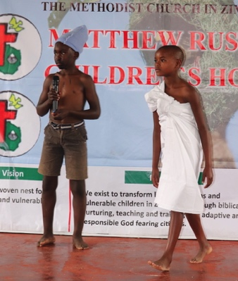
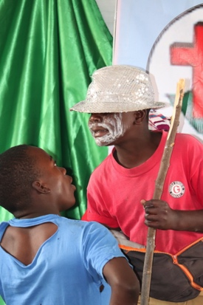
We had a break from lessons during August and dedicated the month to developing children’s communication skills through various activities: drama :-
and fashion modeling :-
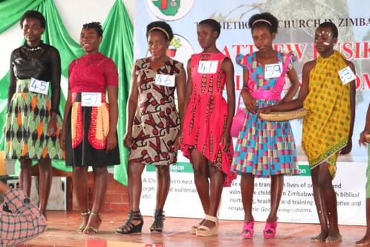
The young ladies made their own dresses and the young men their own shirts
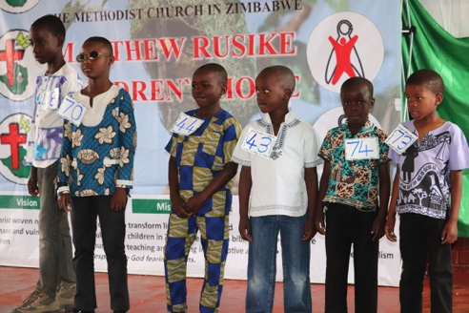
The younger children wore their best clothes and all paraded proudly on the stage.
Other activites were reading, quizzes
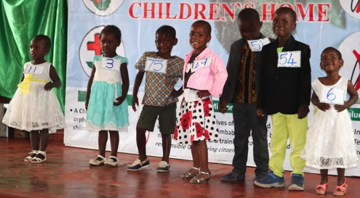
debating, speeches, poems, audio
listening and
lip sync (karaoke).
The children were so excited to participate in these games and show off their many skills with confidence and flair.
Recently one of our children developed a serious condition which Litta, our nurse, could not handle. We rushed him to the Government General hospital where we spent most of the night without assistance because there were no doctors. We had no option but to go to a private health centre to save the child. We thank God after examination and scans he was prescribed with medication. He is now far better and Litta is monitoring him. Apart from this incident all our children are generally in good health and underlying conditions are stable.
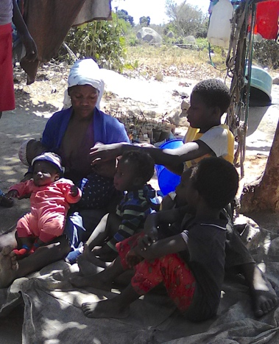
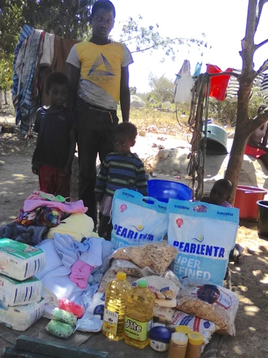
We experienced some sexual misconduct among the teens and immediately reported them to their social workers who swiftly responded and gave counselling. (In November we heard that the boy alleged to have committed the offence had been removed from the Home and put on bail and the girl is receiving counselling at the Home)
We identified 2 local families in dire need, one a grandmother with 5 grandchildren and the other a young mother with seven children including 4month old triplets. We are supporting these two families with food supplies.
We have begun to make improvements in the pre school ECD with funds received from UK Friends.
All our staff have now been able to return to work and it is good to have them back but we have not replaced the retired House parent yet due to covid restrictions. One of our trusted relief mothers is with us until we get a suitable candidate.
We have experienced some shortages, beans, dried fish, toothpaste, toilet paper and stationery. School fees for our 5 boarders who have gone back to take examinations have increased to $988.
Another unbudgeted area is Covid19 testing. We are testing all relief mothers and Caregivers as they come back from days off. The cost is US $15 per test.
The Matthew Ruske college has opened for 140 students. MRCH has 16 children writing exams, 1 A level, 4 O level, and 11 grade 7. PPE was prepared for them. All our boarders and those who attend our college are now attending classes but we made the difficult decision to keep the rest of the children at home because teachers nationwide are on strike so there was no useful teaching happening in the schools. We are considering hiring teachers to provide learning at the Home.
6 young people were reintegrated into society this year, 5 more will leave us in the next few months.
With effect from 1 December 2020, Matthew Rusike College will operate as a stand-alone entity with a substantive Board and a new management, led by the Principal, upon approval by Conference.
Community Outreach projects
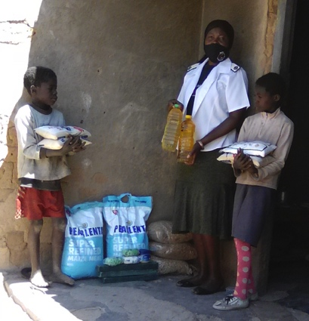
Programmes at Mzinyathi were on hold due to Covid19. and due to lack of food we were unable to support them for awhile. We resumed as soon as donations came in. There are 25 children there.
We continue to assist desperate families in Epworth and Donga especially with food and access to health care.
Mr Lloyd Kupeta is doing great work at Donga (a very rural centre about 20 miles from Gweru). He has 55 orphans and vulnerable children needing food and has organized assistance with the local community. He also came up with an initiative for crop production using climate friendly technology, preparing the land for the coming farming season and setting up a piggery project. He has been given a vehicle to aid his work. His welfare remains a priority. We plan to improve the water supply by solar power as the borehole serves the surrounding community.
The National Board visited both outreach facilities in November. We shall take their recommendations into our programming, resources permitting.

May the Lord our God keep you safe. Pray for us as we also pray for you. Rev Linny Mutendzwa
October – “for the past three days there has been rainfall across the country. We are happy the rains have come and people can start to adequately prepare lands for planting the staple crop”…then we heard crops began to wither as drought came.
My Matthew Rusike Experience
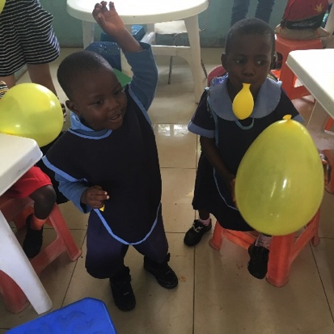
In 2017 I was lucky enough to be able to travel to Zimbabwe with my grandparents and a group of friends to take part in some voluntary work. We travelled from Norwich, a small city in the UK to Harare, Zimbabwe, 5214.2 miles apart. I will always remember the warm welcome we received from staff and children at MRCH. We visited the houses where the children lived and the pre-school (ECD) where they were taught. We took balloons for them and the joy on their faces is a lovely memory for me. They enjoyed teaching us the song “If you’re happy and you know it clap your hands” and we sang along with them. Among all the upsetting backgrounds these children have come from, for me Matthew Rusike is a place of hope and happiness, they had smiles on their faces and hope in their hearts. It was a humbling yet joyful experience to visit them, I hope one day to return to Matthew Rusike Children’s Home. Ella Shemilt

Astonishment: Laying Ghosts in Mugabe’s Zimbabwe’.
Those who remember Astonishment Mapurisa, MRCH’s former director, will be interested in a recent book, it could be a great Christmas present.
Graham Jones, travelled with Astonishment into rural Zimbabwe and heard his incredible story of abject poverty, child slavery and the grace of God.
The book is that story. The publishers call it “a moving account of nostalgia, race and reconciliation that celebrates the transformative power of forgiveness”
It can be ordered from any bookshop, or on www.instantapostle.com under books/biography or on Amazon.
Graham says “I’m happy to post up to 20 free, signed copies (first come first served) to any UK addresses for anyone who can increase their regular giving or set up a monthly standing order for a minimum of £5.
If you are interested in this offer please send your name, address and amount donating to me, Carol Banham, and I’ll pass it on to Graham.

MEETINGS ALONG THE WAY
1950s ZIMBABWE (then Southern Rhodesia)
No two men could have differed more, only bound together by the fact that they were both Methodist Ministers. The first was an African brought up in Southern Rhodesia caring for a group of small churches in the countryside.; the second was an Englishman of about the same age who had spent the second World War years as a senior Army chaplain in the Middle East where many of the soldiers were from different parts of Africa.
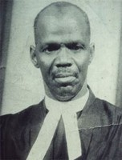
On returning to civilian life in the UK he was asked to take on the role of General Superintendent (that is Senior Minister) in Southern Rhodesia with a clear remit – to be the last GS there with a white skin, an aim not over popular with some of the senior missionaries. But “times they were a changing!”
The Rev. Matthew Rusike comes into the picture as a middle aged man with a family of six who was asked by the local government social worker (a European) to find someone willing to take in an orphan whose parents had died in a house fire. The man had had no success and Rev Rusike did no better so took the child into his own home where, later, others were to follow.
The Rev. Jesse Lawrence then became aware of the situation when grants had to be sought to extend the Rusike manse to accommodate the growing family! Eventually he realized that something more drastic was becoming necessary. He was aware that at Epworth (named after John Wesley’s birthplace) there was Primary School accommodation from when that had been a boarding school. He moved the Rusikes there with Matthew as Warden and his wife as Matron and so, in effect a Children’s Home was born.
The GS was wise enough to realize that here was a situation needing expert advice if it was to develop properly and where better to seek it than with the UK National Children’s Home (now Action for Children) founded in 1856 by a Methodist minister in Lambeth, London and regarded as one of the jewels in the crown in its field of childcare work. From then onwards a bond was created which lasted many years, with childcare advice coming in and training being provided during 6 months in the UK for Rev Rusike’s successors when he retired. There followed many staff training schemes both in Zimbabwe and the UK.
At the same time Rev Lawrence realized that if the Home was to be properly recognized in the wider church, the Warden had to be better known. So it was a surprise to many that the Synod preacher, always in the past a senior missionary, was one year replaced by Rev Rusike. He also began to be drawn more and more into decision making elsewhere.
One very big matter arising quickly was what shape should future work take for it was obvious that the very elderly Epworth buildings could only be a stop gap. Here again advice was sought from overseas and help brought in, not only from the UK but also from places like Australia and New Zealand, news having been conveyed there by stewardesses from Quantas airlines who had been made aware of Epworth when on rest days in Harare (then Salisbury) the capital. Again this support lasted for many years.
So it is that visitors to the Matthew Rusike Children’s Home, as it now is, find not elderly school buildings but a village setting where ‘mothers’ care in individual houses for their family groups which range from infants to teenagers. Around each house are vegetable gardens tended by the house mother and children and elsewhere on the site are poultry runs and a piggery for whose care the youngsters have some responsibility. There is a library, a community hall, an Early Childhood Development centre (ECD) for preschoolers and rooms for homework and recreation times. Most youngsters go off site each day to local schools immaculately dressed in their uniforms. One room was furnished by money raised by Liverpool Methodist women and the British Embassy in Harare furnished one house.
But the Home has also built up a reputation for it’s knowledge of childcare which leads it to being consulted by the hard pressed Zimbabwean government and staff travel long distances to advise in far localities and train volunteers in churches and outreach centres. The staff spend a lot of time tracing the children’s extended families or seeking out families to foster children during the school holidays in the hope they will have a family

to maintain contact with when they leave the home to rejoin society as they reach 18 years of age.
While the Home began as being part of the social outreach of the Southern Rhodesian Methodist Synod linked to the British Methodist Conference, today the whole responsibility for its support and leadership rests with the Zimbabwean Methodist Church, a great headache in such an impoverished country but as the regular newsletters bear witness to, something embraced with vigour and enthusiasm.
To return to our original thought, in Matthew Rusike and Jesse Lawrence, the Home could not have had two more different founders despite their common vocation as ministers. However the two compliment the work, the first bringing compassion to bear in finding under his own roof a place for an orphan child, the second bringing to bear a vision of what was needed to be done to build up a fully operational Home. Thanks to that, over the years, many hundreds of needy children have found acceptance, love and more, that has come not from some distant office in London but from a caring Christian community in their own land, for that was what Jesse Lawrence was told to achieve in his time there. The binding tie between the two men was surely their obedience to a leader who had embraced little children two thousand years before.
Ken Richardson
Ken Richardson went to Southern Rhodesia in 1956 as a lay missionary and teacher at Tekwame High School. There he worked under Mr Griffiths Malaba, the first African to be the headmaster of a secondary school.

FoMRCH
Like most charities during Covid 19 our income has dropped drastically. Only just over 2 years ago we were sending £5000 every month to the home. This amounted to the largest regular donation they received which gave senior management at MRCH the confidence to make plans over several months. We now send £4000 bi - monthly which saves on the exchange rate. We are all volunteers so all your money goes directly to the Home to care for the 92 children from babies to 18 who live at MRCH.
Donations come in all sizes and we’re grateful for them all for the care of the children.
Thank you to those who support us when buying online using Pay Pal and Amazon Smile. We received £180 and £20.59 respectively from sales during the summer. Please remember the children when you shop online for Christmas.
We also received “a one off donation of £1000 towards paying staff salaries because no institution can thrive without staff who are supported, appreciated, treated well and cared for.”
(This is so true and often forgotten.)
“We pray every day for such Good Samaritans”

We still have Christmas cards available at £2.99 for a pack of 10.
Membership subscriptions
If you wish to become a member annual subscriptions are now due at £10 per person. Please let our treasurer know that is what it is for.

Treasurer
We are still needing someone to volunteer to be our treasurer from spring next year. PLEASE give this prayerful thought – we need you.

Once again we thank you for all your support during this very trying year. Please remember it is also very difficult for the children in Zimbabwe and we need your continued support to help them thrive in such devastating times.

Contacts
Chair: Carol Banham
64 Saffron Crescent
Tickhill, Doncaster
S Yorkshire
DN11 9RU
carol2021@banham.net
01302 744 920
Secretary: Michael Mapako
michaelmapako61@hotmail.com
Treasurer: Immanuel Mudzinge
103 Linney Road
Leicester
LE4 0UX
manu.mudzinge@gmail.com
Website:
www.friendsofmatthewrusike.org
Registered charity 1120944

This newsletter is distributed by The Friends of
Matthew Rusike Children’s Home

