

**Friends of Matthew Rusike Children’s Home**

**March 2021**

***We give mainly financial support directly to the Home***

***News from the Home***

It is very difficult to say happy New Year under the prevailing situation. All the same we still give glory to God for going with us through 2020 with all its challenges. We had a subdued Christmas holiday, then got into new year amidst swelling numbers of covid19 cases. The government immediately imposed another lock down as cases are rising and people are dying. We have lost two Methodist ministers as a result of covid19 and others are recovering.

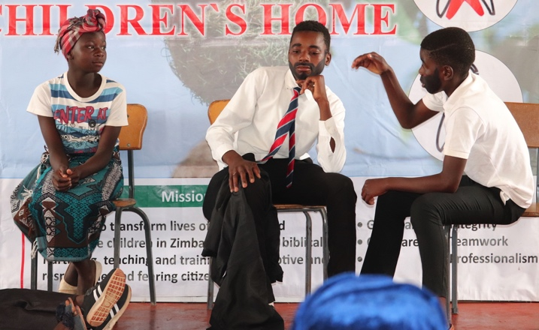In response, we resorted back to March 2020 protocols; off- campus employees are working from home except 3 project workers. No more visitors are allowed and donations are left by the gate. House Parents and relief mothers are locked in for 90 continuous days. When coming back from days off they first go for Rapid Diagnostic Testing.

Generally, children are in good health, calm and trying to get to terms with the new normal. We have internal arrangements for academic sessions with the help of the Chaplain, Mercy (my wife) and 2 undergraduate students on attachments. Our form four children are finishing examinations. We hired a private teacher in November to prepare our grade 7 pupils for the December examinations. Education is difficult now schools are closed again.

**We have basic food stuffs enough to take us to April/May. Our gaps are on milk, kapenta (dried fish) flour, tea bags, peanut butter and beans. We are also in dire need for toothpaste, Vaseline, toilet paper and cleaning materials.**

*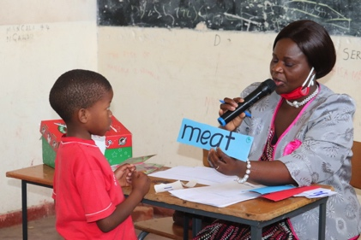(****These are all essential staples and are either unavailable or too expensive)***

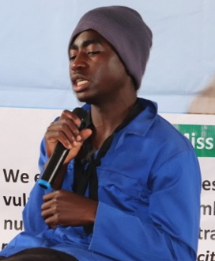Our vegetable garden is doing well and we are selling some excess vegetables after meeting our house requirements. We managed to give employees a bonus in December coming from the proceeds of sales. We planted a hectare of maize and an acre of beans. We also planted some sweet potatoes. We thank God for good rains and our boreholes are filling up.

Our annual fundraising dinner was held virtually on 27 November. Zimbabwe Methodist Fellowships from the UK, Canada and Australia were able to join us at this time when people were able to pledge donations

Here are some more photos of the Communication skills events held last August during lockdown.

The dramas were composed by the children themselves, they were given the theme

***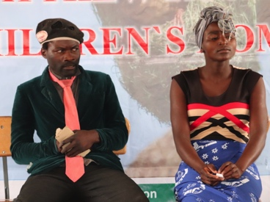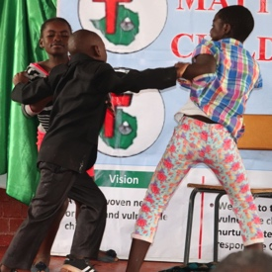* "Dealing with conflict at home".**

*The silent treatment Separate the trouble*

*Sit down, listen and talk about the problem*

The children were put in two groups, group A and group B and competed in various activities. We wanted them to be innovative, just guide them here and there. It was really amazing to see them starting from scratch, organizing themselves and show casing their different talents.

*The infants were given English words to read.*

*They learn English as their second language but some children may speak more than two.*

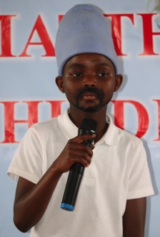

*Two boys*

*lip sync*

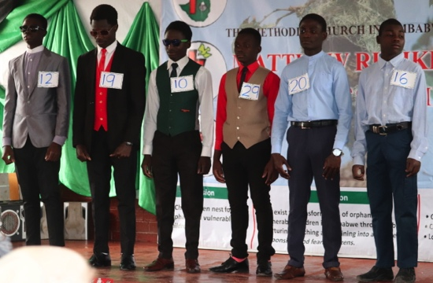

Senior boys model the shirts and waistcoats they made

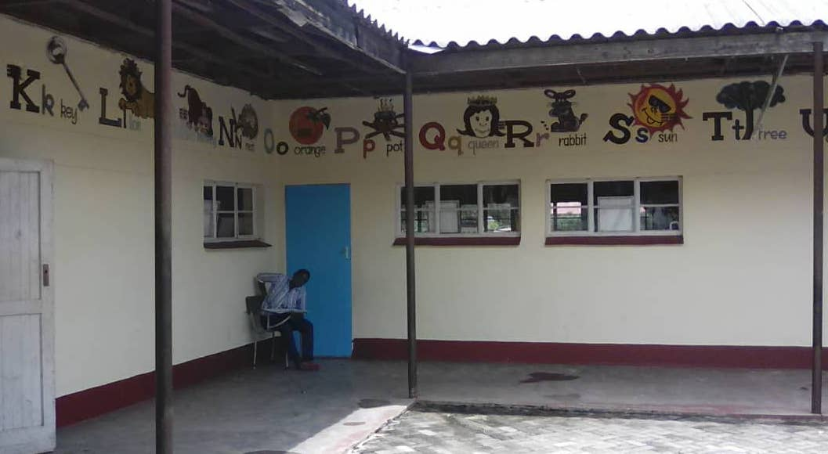Some young people wrote and delivered their own speeches

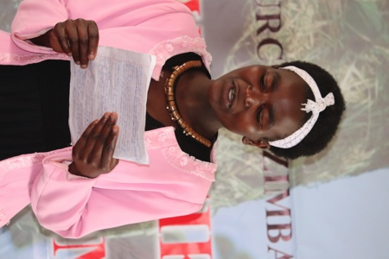

A fun filled week for everyone



Tapiwa Shylet Magonya is the new finance officer at the Home. She came last August and has settled well.

We have 5 children in boarding schools. 6 children have written Ordinary level examinations and if they pass they will proceed to A level and would need sponsorship. Out of these 6 prospective A level students 4 are at Matthew Rusike college.

We have one child who is waiting for A level results. 38 children are in local Primary schools and 30 are in local secondary schools.

I am very happy to share the good news that 4 of our boys have found employment.

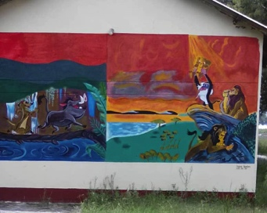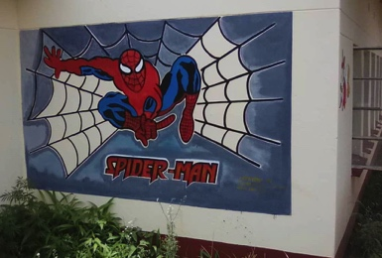We are so grateful for your continued support, more important during these trying times.

Rev Linny Mutendzwa

I hope you are doing well, here everything is pretty much the same as before. Level 4 lockdown has been extended until the 15th of February, although the deaths are starting to decrease the situation remains difficult.  I applaud the move to extend the lockdown, maybe if we open up too quickly we will go back to an uncontrollable situation. We are also experiencing heavy rains. It looks like we have a good farming season this year. We have had a generous supply of rains over the past two months.

Progress has been made in the ECD as a result of the generous donation from a Friend in the UK. The facility has been repainted (inside and out), There is also a lot of work taking place in the play area but this is not yet complete. (I think the photos will look better with children around)  We also purchased a jumping castle with the funds. I must add that the funds enabled a major face lift for the ECD and we are very grateful. Zvirinane Matore

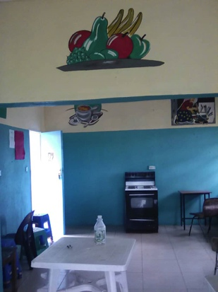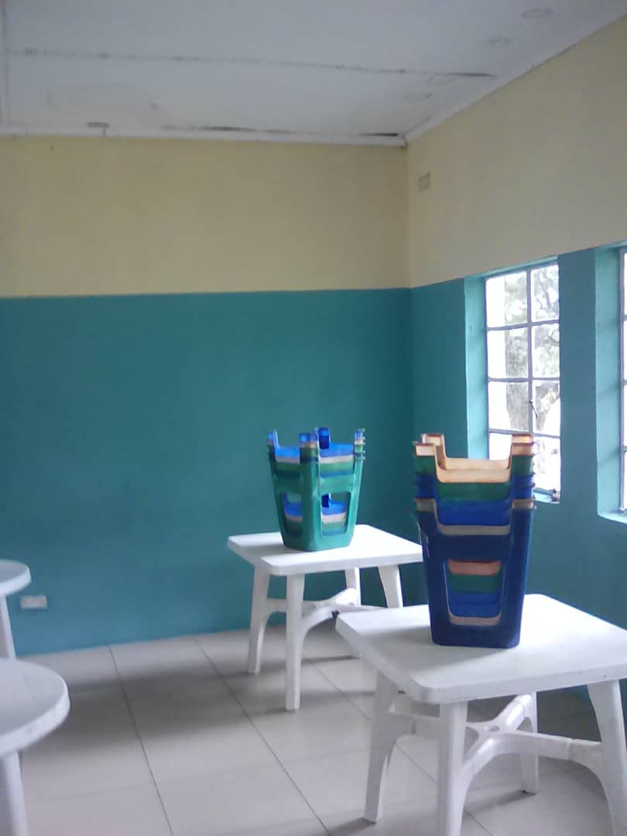

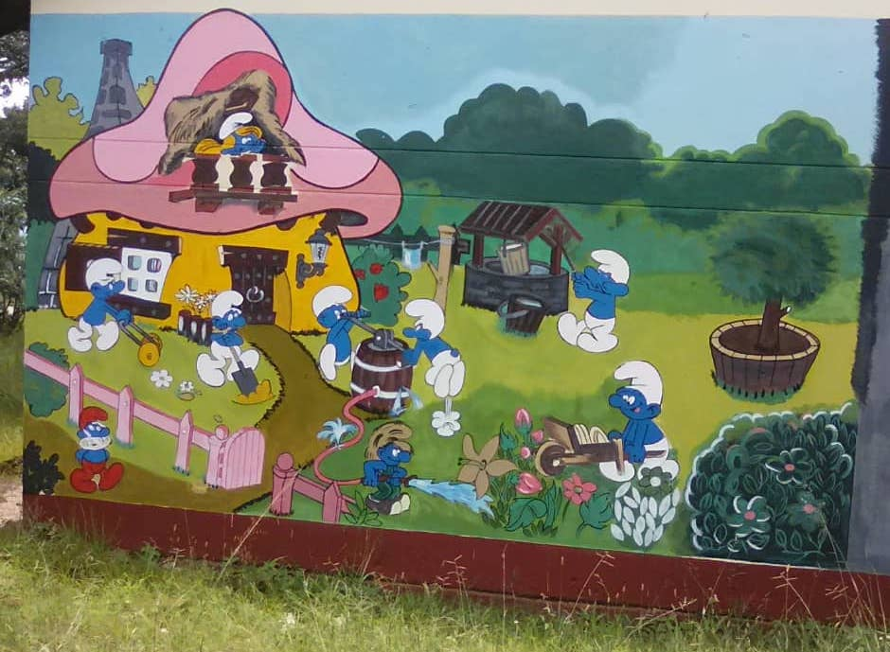

*I also look forward to seeing pictures of children in their ‘new’ surroundings, thank you Judith for making it all possible Ed*

The ECD outside play area is being totally refurbished and safely fenced. It looks as though there will be scope for imaginative play as well as exercise and fun. We look forward to photos of the area full of local children as well as MRCH residential children when the schools are open again. Ed

**Rural Community Outreach in Donga**

Lloyd is doing well in our Community outreach program in Donga. He planted a maize crop and some sweet potatoes which is growing well given the good rains we are receiving. Plans are underway to scout for more sponsors and expand our education support to vulnerable children in the community but at the moment the schools are closed due to the pandemic.

The area has been fenced.

Lloyd finished building a pigsty ready to start a piggery project so that local families will have meat.

Lloyd, on the extreme left, with MRCH Board members who visited Donga

The surrounding communities are fetching water from our manual bush pump borehole following the problem of mud filling up the other water sources so it is serving 47 family households with water. There is still no electricity on the site so Lloyd must travel several miles to use his computer or charge his phone.

He has received a vehicle but money is desperately needed to keep it maintained.

A cottage has been built for the caretaker

Here are some of the schoolchildren being supported at the Donga Community Outreach Centre. This place is non residential and supports vulnerable and needy families in the local rural area. Basic food packs, hygiene items and stationery for children to use in school are distributed. These are sourced by Lloyd from local donors.

The church held it’s annual conference in November and came up with new leadership. The Presiding Bishop is Rev George Mawire, General secretary Rev Dr Martin Mujinga, the Mission Director remains Rev Blessmore Chinhara.

Our new Board chairman is now Mr Lameck Tarupuwa, Vice Chair Mrs Violet Mpinyuri and secretary Mrs Doris Mate. Rev L Mutendzwa

*The FoMRCH committee looks forward to being in contact with some of the new officials with the welfare of the children at MRCH in mind. Rev* *Mawire has been receiving our newsletters now for many years during his time in the UK as minister for the UK Zimbabwe Methodist Fellowship, so will be well aware of the concern for the MRCH children of our supporters here in the UK. Ed*

**FoMRCH**

**Like most charities during Covid 19 our income has dropped drastically. Only just over 2 years ago we were sending £5000 every month to the home. This amounted to the largest regular donation they received which gave senior management at MRCH the confidence to make plans over several months. We now send £4000 bi - monthly which saves on the exchange rate. We are all volunteers so all your money goes directly to the Home to care for the over 90 children from babies to 18 year olds who live at MRCH.**

Once again thank you to those who supported us when buying online using Pay Pal and Amazon Smile. **In December and January we received £230 from Paypal,** so your Christmas shopping helped the children at MRCH, thank you.

This money comes at no extra cost to yourself so please continue to use these opportunities to have Amazon Smile and Paypal . All other details of the different ways you can donate are on the website on the How You Can Help page.

**Donations come in all sizes and we’re grateful for them all for the care of the children.**

**Membership subscriptions**

If you wish to become a member of FoMRCH, annual subscriptions were due in January at £10 per person. Please let our treasurer know that is what it is for when you send your subscription.

***Treasurer***

**We are still needing someone to volunteer to be our treasurer in spring 2021. PLEASE give this prayerful thought – we need you or someone you know who could do this important job for the benefit of the children.**

**Our AGM will be held virtually on June 19th at 10 am and you are welcome to join us. All you need to do is contact us nearer the time and ask for the link to be emailed to you.**

Our website [www.friendsofmatthewrusike.org](http://www.friendsofmatthewrusike.org) has been recently updated and we aim to have even more 2020 photographs added soon. There are more photographs which can be downloaded and there is more information mainly on the MRCH page under Transition, staffing and education.

I’d also like to remind you that all our newsletters are archived and can be read back to when they began in June 2000, if you want to check up on progress and changes over the years!

**Once again we thank you for all your support during this very trying year. Please remember it is more difficult for the children and families in Zimbabwe having to continue living with a dreadful economy and we need your continued support to help them thrive in such devastating times.**

**Contacts**

Chair: Carol Banham  
64 Saffron Crescent  
Tickhill, Doncaster  
S Yorkshire  
DN11 9RU  
[carol2021@banham.net](mailto:carol2021@banham.net)  
01302 744 920

Secretary: Michael Mapako   
[michaelmapako61@hotmail.com](mailto:michaelmapako61@hotmail.com)

Treasurer: Immanuel Mudzinge  
103 Linney Road  
Leicester  
LE4 0UX  
[manu.mudzinge@gmail.com](mailto:manu.mudzinge@gmail.com)

Website:  
[www.friendsofmatthewrusike.org](http://www.friendsofmatthewrusike.org)

Registered charity 1120944

This newsletter is distributed by The Friends of

Matthew Rusike Children’s Home