

**Friends of Matthew Rusike Children’s Home**

**June 2021**

***We give mainly financial support directly to the Home***

# News from the Home

Winter is here, temperatures have dropped and we are bracing ourselves for a chilly period amidst rising cases of Covid19. All the staff have voluntarily had both their vaccines now and we thank God we have had no complications as yet.

The children are generally all in good health and back at school for 2-3 days a week to allow for limiting numbers in line with health regulations. One boy fell out of a tree and broke his arm, which is now healing well under a plaster.

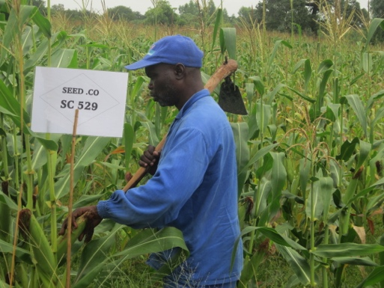Our poultry, piggery and garden projects are doing fairly well and supplementing our food needs in the houses. We are also expecting a good harvest of maize and sweet potatoes. Lloyd also did extremely well at Donga with a very good maize crop and sweet potatoes. Our fields at Donga were selected among the best in the community and came 4th out of 60 participants. (Well done Lloyd Ed)

We share the sad news of Litta’s husband who was involved in a serious road accident on 13 May. He had accompanied Litta (nurse at MRCH) to a workshop some 56km out of Harare. On his way back he veered off the road, hit trees, overturned and landed on the roof. He sustained head injuries and fractured fingers. He is recuperating in hospital.

On a lighter note, we are delighted that some of our children did us proud in their National examinations. A boy, studying A levels at Waddilove High school came out with 11 points and is applying to go to University. We pray that he will get a sponsor.

 A girl who was also at Waddilove High school doing O Levels managed 3As, 3Bs,1C. She is already back in school doing A level after obtaining sponsorship from a local family. We are so grateful to them.

Another boy taking O Levels at Chemhanza High school achieved 4As,3Bs,1C. He receives sponsorship through Friends of Matthew Rusike and is back in school for A level studies. Thank you so much for your resilient support.

We are preparing for the Matthew Rusike celebrations due on 6 June and due to covid19 we are not going to gather, as is tradition. This is going to be a virtual event.

**Staff Restructuring**

We are going through a restructuring exercise following the adoption of a new organogram by the board. It takes into consideration the need for a Social Worker as required by the Government and concerns you have raised in your responses to the strategic plan. This has seen us amalgamating some posts, changing titles and unfortunately laying off some staff members. This has been exacerbated by a 328% salary increase that has put our monthly wage bill equivalent to US$8700. This is against a budget of US$4100 per month, leaving us with a shortfall of US$4600 per month.

Rev L Mutendzwa

**Virtual meeting between MRCH senior management and FoMRCH Executive Committee June 12th**

This came as a shock to the Friends executive committee so I am pleased to say we were able to have a useful and enlightening virtual meeting with Rev Linny Mutendzwa (National Director) Mr Lameck Tarupiwa (Chair of MRCH Board) and Rev Blessmore Chinhara (Mission Director)

We were given the following details.

- income generating projects at MRCH contribute 10% of their income

- the aim is to increase income from local projects to at least 30% within 5 years

- the long term objective is to make MRCH self sustaining

- There are 3 boards for 3 centres (Epworth is residential, Donga and Mzinyathi are Outreach Centres) The budget for the two Outreach Centres is US$75,000

- Each board needs to raise 30% of their budget and MRCH National puts in 70%

**The key reasons for restructuring are:**

- cost cutting, the new structure saves 42%

- eliminating duplication of roles that can be amalgamated into one

- reduce cost of admin staff and retain care givers

- re-aligning staff structures

- compliance with government requirements for a qualified and experienced social worker.

**Please note - Money from the Friends of MRCH is for childcare only and does not contribute to staff salaries or training.** Ed

The Government had reviewed the operations at MRCH and insisted on a qualified, experienced social worker being employed. Everything in the restructuring is child focused. Administration staff are being reduced so that funding can target the childcare. Childcare will be headed by the new social worker, the Nurse, and the Chaplain, who is also trained in counselling.

The childcare manager and transitions officer, both administration posts, will be removed and dealt with by the social worker. The finance department has been reduced from 3 posts to two.

The number of children and carers will not be reduced. MRCH often has to refuse to take more children because demand is so high. Each carer has a ‘family’ of 12 mixed age children. Older teenagers still live in the house they are used to but sleep in the independence units.

Only the social worker post has been advertised, there will be no more new posts.

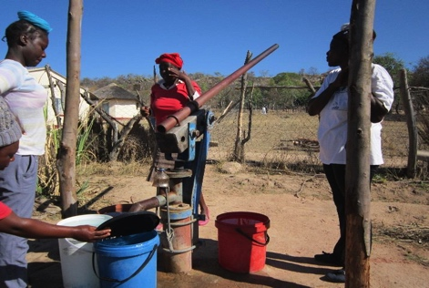When the social worker is in post she/he will revise the MRCH childcare and child protection policy in line with the Church’s Safeguarding policy, which is being worked on at present.

We are very grateful that we were able to have this meeting with the management team and have our questions and concerns explained in detail. Plans are afoot to ‘meet’ twice a year. Ed

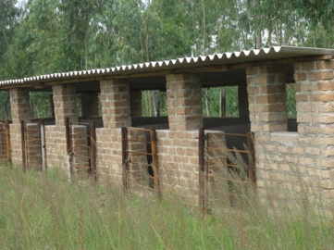In our last newsletter we introduced the new finance officer Tapiwa Shylet Magonya. In April. she sent us a little bit about herself.

“My apologies for not being in touch for some time, I have been busy with the Home’s 2019 external audit, now completed.

I am a single lady aged 35 and holder of a Bachelor in Accountants Degree. I started working for the Methodist Church in Zimbabwe in 2011 as a bookkeeper at Kwenda High School, I was at Kwenda for 7 years and then transferred to Sandringham High School in 2018 as the bookkeeper.

Then in July 2020, I was promoted to the position of Finance and Administration Officer at Matthew Rusike Children's Home. I look forward to working with you guys in this organisation for the protection and upliftment of these vulnerable children”

Tapiwa Magonya

The children are in good health including those with chronic conditions. They are being managed well by Litta. One child with diabetes is under constant monitoring because her sugar levels remained high. Then we realised that she is not doing too well with her diet. When adults are not watching she snacks on sugar and other sweet things. She is now receiving counselling.

We have had some very good results at O level and A level. We also have some who did not attain 5 O level passes but managed to get two or three passes. Some want to go to do vocational skills training and others would like to supplement other subjects. They are being guided by Norlin for their best way forward. Zvirinane Matore

**Outreach Centre at Donga**

Mr Tarupiwa told us that this project at Donga is an ambitious one which reaches out to vulnerable families in a rural area without electricity and with only a hand pumped well being shared with the local community. The area is now fenced but living conditions are very basic.

There are still no burglar bars on the house and the roof needs fixing.

Here is the hand pumped community well…

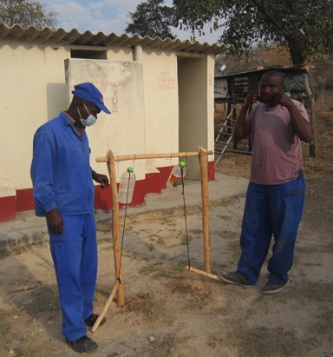and the home made hand washing gadget worked by foot, which stands near the toilets.

Some animals were sent from Epworth to be housed in these new sties

Lloyd organised an Open Day to celebrate the success of the crops and to raise donations.

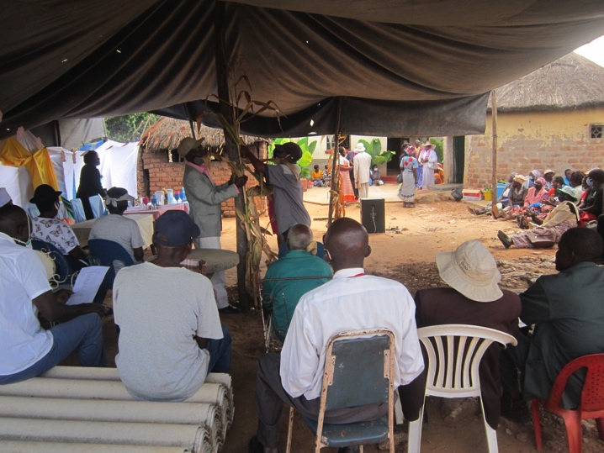

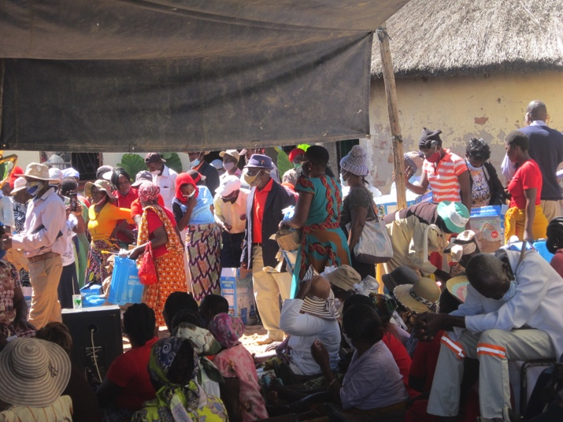

The Outreach Centres receive donations of food and clothing which are distributed amongst the vulnerable families in the local community.

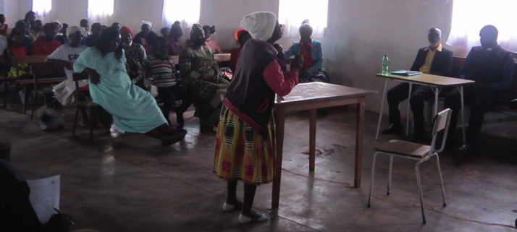

Local families gather in the local church waiting for the distribution to begin.

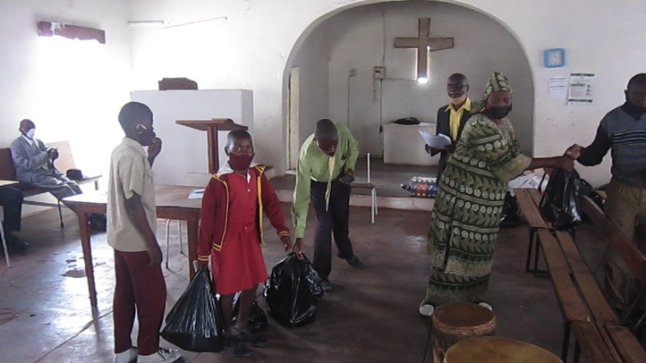

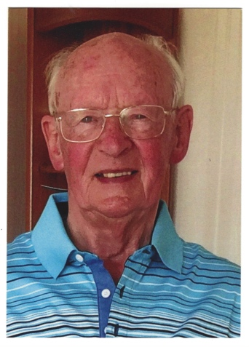**FoMRCH have lost a staunch active member of the committee.**

It is with great sadness that we announce the death of one of our founding committee members

John Richer was with us at the inaugural meeting of the Friends in 1996. He and his wife Shirley had visited MRCH earlier that year with John and Mary Bromley and realised that they could try starting a Friends group to raise some money to help provide Christmas presents for the children. Little did we know how quickly we would grow in the following years.

John served as the Friends’ secretary for many years. He was very conscientious and supportive of the two Chairpersons he worked with. He was focussed on the welfare of the children and always a wise and reliable contributor to our meetings .

He and Shirley organised the special appeals we had for various charity anniversaries, producing posters and information for our fundraising supporters to use for their events. These appeals encouraged our supporters to raise several thousand pounds each time.

He also produced the certificates of thanks and appreciation for retired members, both for the committee and retiring staff at the home.

He and Shirley were wonderful hosts when the charity sponsored visits to the UK of 2 previous National Directors to visit various childcare facilities run by NCH, now Action for Children, each visit raising extra thousands of pounds.

When we arranged meetings in London with the World Church and Action for Children, John was always one of the volunteers to attend.

At his funeral a wonderful total of £1585 was raised in his memory, which was allocated towards the welfare and upkeep of the children at MRCH.

We miss him greatly. Carol Banham

Like most charities during Covid 19 our income has dropped drastically. Only just over 2 years ago we were sending £5000 every month to the home. This amounted to the largest regular donation they received which gave senior management at MRCH the confidence to make plans over several months. We now send £4000 bi - monthly which saves on the exchange rate. We are all volunteers so all your money goes directly to the Home to care for the 99 children from babies to 18 year olds who live at MRCH.

Once again thank you to those who support us when buying online using Paypal and Amazon Smile, the amounts are really worthwhile.

**Income from Paypal for 2020 was £491.32**

**Jan- May 2021 is already £618.75**

**Income from Amazon Smile Feb 1st to end of May £53.12**

This money comes at no extra cost to yourself so please continue to use these opportunities to use Amazon Smile and Paypal . All other details of the different ways you can donate are on the website on the ‘How You Can Help’ page

**Donations come in all sizes and we’re grateful for them all for the care of the children.**

***Treasurer***

**We are still needing someone to volunteer to be our treasurer as soon as possible. PLEASE give this prayerful thought – we need you or someone you know who could do this important job for the benefit of the children.**

Our website [www.friendsofmatthewrusike.org](http://www.friendsofmatthewrusike.org) has been recently updated to 2019, we look forward to more 2020 photographs to add soon.

I’d also like to remind you that all our newsletters are archived and can be read back to when they began in June 2000, if you want to check up on progress and changes over the years!

**Once again we thank you for all your support during the past very trying 18 months. Please remember it is more difficult for the children and families in Zimbabwe having to continue living with a dreadful economy and we need your continued support to help them thrive in such devastating times.**

**Contacts**

Chair: Carol Banham  
64 Saffron Crescent  
Tickhill, Doncaster  
S Yorkshire  
DN11 9RU  
[carol2021@banham.net](mailto:carol2021@banham.net)  
01302 744 920

Secretary: Michael Mapako   
[michaelmapako61@hotmail.com](mailto:michaelmapako61@hotmail.com)

Treasurer: Immanuel Mudzinge  
103 Linney Road  
Leicester  
LE4 0UX  
[manu.mudzinge@gmail.com](mailto:manu.mudzinge@gmail.com)

Website:  
[www.friendsofmatthewrusike.org](http://www.friendsofmatthewrusike.org)

Registered charity 1120944

This newsletter is distributed by The Friends of

Matthew Rusike Children’s Home