

**Friends of Matthew Rusike Children’s Home**

**September 2021 Newsletter**

***We give mainly financial support directly to the Home***

***News from the Home***

**June 21st** We are doing well here and the weather is getting colder each day. Children are bracing up to the cold mornings and evenings, at least they are on school holiday and there are no morning hustles in preparation for school.

**July 13** Well, about two weeks ago we went back to level 4 lockdown. Since then the numbers of new infections and deaths have been increasing everyday and it looks like we are headed for a total lockdown again. There is a curfew in place and most businesses close at 3 pm. Schools are closed and the children are receiving lessons from Mrs Mutendzwa, Rev Mhlanga and a hired teacher working with grade 6s and 7s, as well as interns who are also doing a great job assisting with the children's programmes. Most of the learning has gone online and gadgets are somewhat in short supply but we are trying to manage with the available resources… I must remember to snap a photo for you of the children in various classes.

One child was reunified with her relatives a month ago and the children were happy to host a farewell party for her Norlin and Rairo have also carried out some tracing and found relatives for other children which is really encouraging during this period. Starting this week, some staff members including myself, who do not stay at the Home do not have to come to the office everyday. Most of the staff at the Home have received their covid vaccinations. Voluntary vaccination is available for anyone above 18 years of age. Despite the myths surrounding the vaccines we are happy that at MRCH uptake was really high. **Zvirinane Matore**

*Then bad news came …*

**July** **19th** I am worried to inform you that we detected the first Covid 19 positive case in our children on Friday 16 July. After contact tracing the number of positive cases rose to 9. All but one has no symptoms and are not ill. One has mild flu symptoms. As a result of this development the following measures were put in place after consultations with the Ministry of Health:

1. House 2 has been set as the quarantine centre and all positive cases are housed there.

2. The affected children are receiving medication and counselling

3. All other children are staying in their respective houses for the next 14 days

5. Out of campus staff members, college staff and students on attachment are working from home.

6. 3 administration staff are reporting for duty under strict guidelines

7. Leave and off days for house mothers are suspended for the period under review

8. No visitors are allowed into the institution

9. MRCH will collect donations & there are no drop ins save for essential deliveries

10. All other health guidelines will be strictly observed.

We pray that the Lord our God will continue to watch over us during this difficult time. Linny

**July 30th** We give praise to God through whom we managed to stop further spreading of the covid19 infection among children and staff. We managed to test all the 97 children save for the 8 months old baby and all the resident members of staff. We ended up with 23 children who tested positive and are now recovering well without any complications. House 1 and 2 are set aside as the quarantine centre. Once again we thank God that all our Care givers tested negative.

Oh yes its a mammoth task to keep the children observing the health protocols, care givers are always on their toes to ensure that all the children stay within the prescribed guidelines.

It is however sad to announce that our College Deputy Headmaster's wife succumbed to Covid 19 on 30 July. The deputy Head, Mr Mushava, is recovering at home in Marondera some 73km away from the Capital city. The Methodist Church in Zimbabwe lost 4 Ministers in 1 week. A number of MRCH staff are also bereaved having lost relatives and friends.

 Certainly suppliers of donated goods have been drastically reduced, however we continue to soldier on. There is very little activity from the corporate world and walk in individuals. We have not reached alarming levels as yet and we are still hopeful that some church circuits will respond positively by giving us donations of goods to take us up to the end of the year.

The improvements to the playground, which is currently out of bounds, had to be put on hold temporarily as the children are staying indoors most of the time.

 We are still under lock down as a nation and positive cases and deaths continue to rise on a daily basis. The Government is on a drive to increase vaccinations and the general populace is now responding positively to vaccinations unlike in the recent past when there was a lot of reluctance.

 We pray that the Lord our loving God will also watch over the Friends of Matthew Rusike Children's Home and save humanity the world over. Rev Linny Mutendzwa

*Then in August we received this news of personal experiences from the people involved in the outbreak.*

**Litta Simendi (MRCH Nurse)**

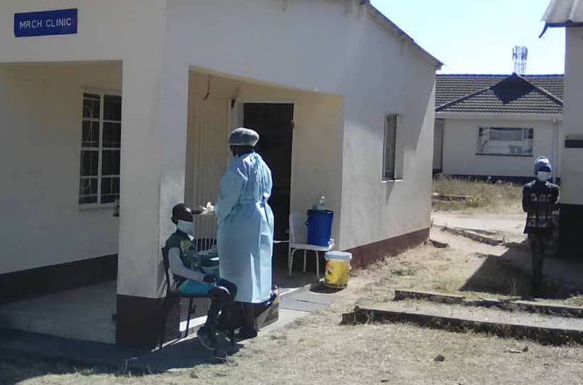"When we had the first Covid 19 case at MRCH, I just asked myself where the infection had come from. I did not panic, I notified the Director and all the staff. I also notified the Ministry of Health at District level about the case. We created an isolation area where we isolated our first case with one caregiver to manage.

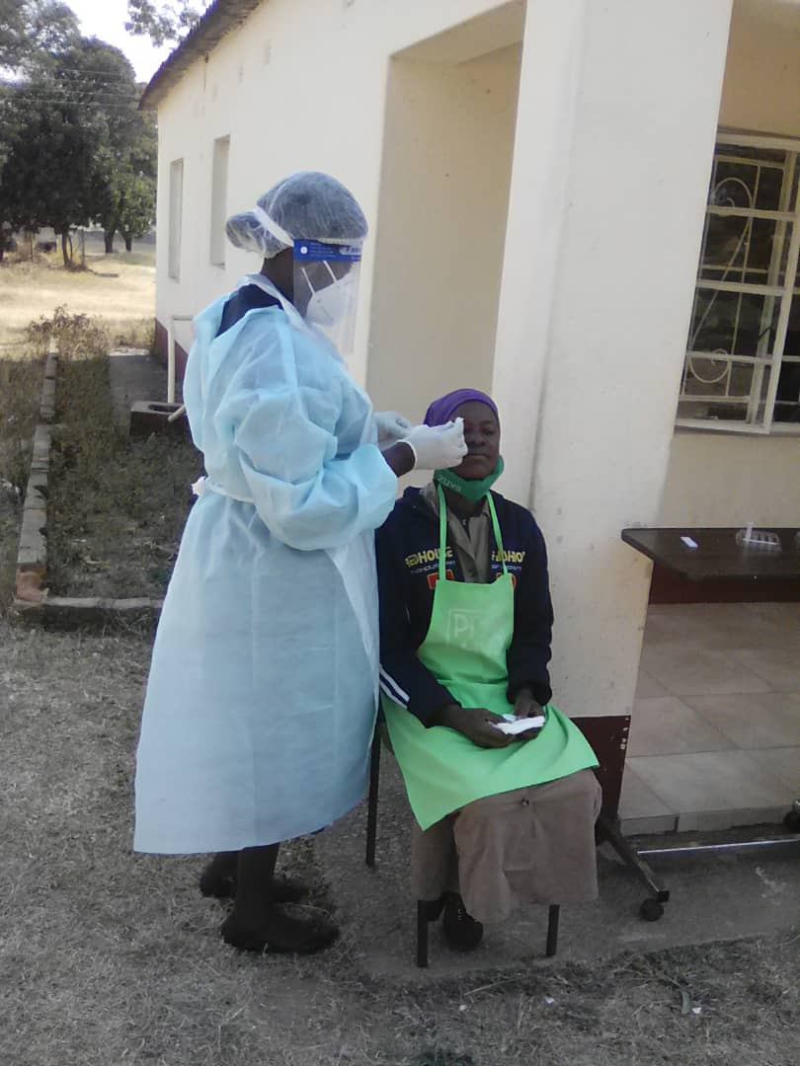I then tested all the children from ages 3 and above. At the end of the testing we had 23 children, 8 boys and 15 girls who tested positive.

All staff residing at the facility were also tested and tested negative. All 23 children were in isolation for 14 days and all tested negative after the 14 days.

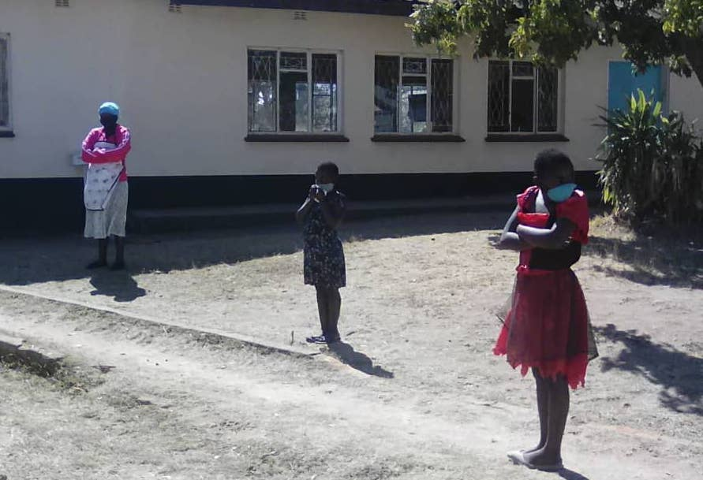

Staff and children wait to be tested

Four out of the 23 children developed mild symptoms and the rest were asymptomatic. Two houses were used as isolation areas with two caregivers who did an excellent job managing the children. We worked as a team with the rest of the staff and at the moment we have no new cases.

I just want to thank God who was with us during this period."

''When I tested positive for Covid I was really scared and panicked as I was the first case and I wondered about a lot of things like where I was going to stay and how I was going to interact with the other children. But Sister was very helpful, she arranged for isolation and put me on medication and ensured that I took all my medication. She also checked on us often. We also made use of home remedies like steaming, use of garlic and lemons and we had lots of fruits. I thank God for my Home at MRCH and I am grateful that I am counted among survivors." **MS aged 18**

"I tested positive on Friday after my sister M had tested positive. I was put into isolation and I really missed playing with my friends and seeing others. However I want to thank Sister Simendi for running around with medication and everything that she did for us during the time that we were in isolation. I also want to thank God for life because I know that a lot of people have died because of Covid but all the children at MRCH are alive." **NT aged 14**

"When I first heard that some of the children had tested positive for Covid I became very afraid because I thought they were all going to die. As time went on, I saw that they were going to be okay. I then started assisting mum Paradza with taking care of those that were in isolation. I was responsible for preparing water for steaming, assisting with their meals and other chores. As they got better they also began to help around the house. I was glad that I could be of help to my friends when they were not well." **PT aged 16**

"I am Fungai Tunha and I have 12 children. One of my older girls became sick and would not get out of bed. I then notified Sister Simendi who tested her for covid and she tested positive. To be honest, I was disturbed. I thought that since we stay in an enclosed institution with minimum interaction with the outside world we were safe. However, Sister Simendi assured me that everything was going to be okay. She then prepared our house as an isolation place as more children tested positive. Rairo and Rev Mhlanga were also very supportive during the period. I also got tested and was negative. I then handed over to Mrs Paradza since I had to be on leave and Mrs Paradza did a great job taking care of the children. I was scared that Mrs Paradza would test positive because of exposure but thankfully she is okay. I thank God for the team work and the moral support, I think if it was not for the moral support we would have had a lot of challenges." **Fungai Tunha (Houseparent)**

Unfortunately I do not have any photos of what was happening during this period. I am working from home but I will find out if anyone has any photos to share hopefully before you publish. I am impressed with the children who assisted the others during this period despite all the fears surrounding Covid.

**Zvirinane Matore**

**New member of MRCH staff, Social Worker, Rumbidzai Mashoko,**

 I am a young lady aged 35 years and I was born and raised in Harare, Zimbabwe. I was raised in a single parent household, together with my older brother, by our mother and we grew up in the Methodist Church in Zimbabwe. I attended Moleli High School and Dominican Convent Harare.

My previous work experience is at the Department of Social Development in Beitbridge District as a MIS Graduate Intern from October 2020 until March 2021. Earlier to that, I was a Project Officer at Childline Zimbabwe from 2014 to 2016. I was also a Graduate Intern at the Department of Social Development Head Office from 2013 to 2014. In the church I held the position of Youth Leader at Mt Pleasant Heights Society from 2017 to 2019 and I am currently responsible for Health and Social Services under the Christian Social Responsibility.

My professional qualifications include a Bachelor in Social Work Honours Degree from the University of Zimbabwe and a certificate in Project Management. I have a deep passion for Child Protection and I bring this passion to Matthew Rusike together with my vast exposure in the Child Protection Sector where I have worked with people from different backgrounds.

*Thank you Rumbidzai, welcome to MRCH and the Friends of MRCH who join together to support vulnerable children in Zimbabwe*

***Child Protection and Safeguarding***

*We have received draft copies of the updated Safeguarding policy of the Zimbabwe Methodist Church and the MRCH Childcare policy which is being modelled on that policy.*

**Maureen Webster**

We’re sad to announce the death of a staunch supporter of FoMRCH. Maureen was a teacher and preacher who worked in Zimbabwe for many years with her husband Rev Gordon Webster.

In the Thanksgiving service for Maureen’s life, many people and places touched by her life were prayed for and Zimbabwe was particularly remembered :

**“May God’s rich blessing rest upon it’s people, churches, leaders, land, animals and natural resources and may your grace restore and transform it,”**

This prayer was followed by everyone singing in Shona:

Chokwadi zita raJesu rakanaka kwazvo: Rinonyaradza mutendi, rinofusa kutya.

Jesus! My Shepherd, Brother, Friend, my Prophet, Priest and King.

*Gordon has sent £500 raised at the service in Maureen’s memory for the Children at MRCH. Thank you to Gordon and his family.*

**Special Appeal**

**We are raising a special appeal to make up for being unable to fundraise since March 2020.**

We hope people will soon be able to have fundraising events again to make up for lost time. Our funds have dropped to a very low level and we wonder how long we shall be able to continue sending £4000 every two months.

If you would like any brochures for any events you feel able to have please contact me and let me know how many you want – the sky’s the limit!

To help boost our fundraising we are going online this year!

***Send an e card this Christmas***

www.dontsendmeacard.com gives you the opportunity to continue to support us as you send your cards this Christmas. Your full donation will come to the charity. It is free for the charities to register too.

Simply follow this link, to choose from one of four design options.

[https://www.dontsendmeacard.com/charities/a569](https://www.dontsendmeacard.com/charities/a569" \t "_blank)

You can purchase them in batches of: 1, 2, 5, 10, 20, 30, 50.

You will be asked for: the email addresses to send the cards to, a donation to our charity and given the option to add your own message. All donations come directly to the Friends of Matthew Rusike Children’s Home.

We also still have some ‘real’ Christmas cards left in three designs, please contact me if you would like some

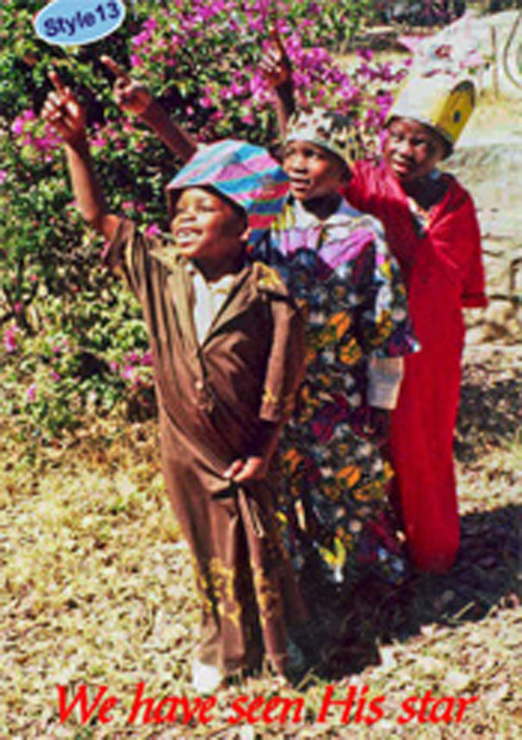3 MRCH boys play 3 kings in the nativity play



Mother and Child

Silver foil reflects in colour

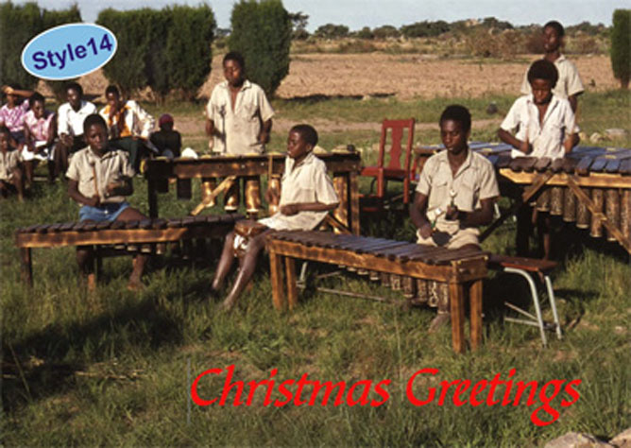

The MRCH Marimba band plays for visitors and celebrations during normal times.

**FoMRCH has now got a second account with The Cooperative Bank** **and we encourage friends to please direct their donations/deposits to this account.**

**Please note the new account details.**

Co-operative Bank

Account name

Friends of Matthew Rusike Childrens Home

Sort code   08  92  99

Account number   65869309

**Treasurer**

We are still praying someone will step forward to be our treasurer. Immanuel continues to stay with us because he believes in the importance of the work we do. Due to changes at work it is getting increasingly difficult for him to have the time to do it. Please give this request your prayerful consideration and ask among your family, friends and acquaintances.

Thank you

**Contacts**

**Chair:** Carol Banham  
64 Saffron Crescent  
Tickhill, Doncaster  
S Yorkshire  
DN11 9RU  
[carol2021@banham.net](mailto:carol2021@banham.net)  
01302 744 920

**Secretary:** Michael Mapako   
[michaelmapako61@hotmail.com](mailto:michaelmapako61@hotmail.com)

**Treasurer:** Immanuel Mudzinge  
103 Linney Road  
Leicester  
LE4 0UX  
[manu.mudzinge@gmail.com](mailto:manu.mudzinge@gmail.com)

**Website:**  
[www.friendsofmatthewrusike.org](http://www.friendsofmatthewrusike.org)

Registered charity 1120944