

**Friends of Matthew Rusike Children’s Home**

**March 2024**

***We give mainly financial support directly to the Home***

**News from the Home**

# Greetings from Zimbabwe.

We are happy to say that all the children are keeping well but the environment is very gloomy.

Weather conditions are extremely bad as we experienced an unprecedented dry spell with hot winds and scorching heat. Crops are a total failure and drought is imminent. The economic environment is not good as well. Inflation is wreaking havoc, raised Government tax is eating into the meagre earnings of the people, businesses are struggling to keep going, the situation is gloomy. Close to home, our second borehole is almost dry, giving us very little water per day. The gloomy outlook is likely going to affect contributions from church circuits and local support. We can only pray to God for means and ways of surviving.

We are going to get advice from engineers on the best way forward on either deepening the existing boreholes or drilling a new borehole completely after surveying and checking on the prospects of getting water. We are also considering reconnecting water from Harare City council although it is not a reliable source of water due to erratic supplies and safety issues.

The last case scenario will definitely be that of purchasing water to supplement our depleting wells. We need to buy extra storage tanks for this option to work well.

*(The cost of this is unknown at the moment) Ed*

Thank you so much for the Bonus we got from those who opted to contribute to our paltry salary which we are still 3 months behind. We really appreciate sincerely the US$100 Bonus given to each staff member, It helped us a lot.

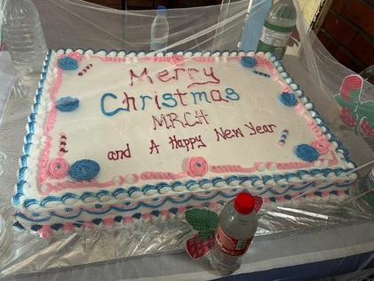 The money was converted into US$2450 and shared equally among staff members each getting US$100. The other US$2450 was earmarked for the children. US$1250 was used to sponsor a Christmas party for children in December. The remaining $1200 was set aside for an educational trip due this coming March. It was indeed a joyous moment for the kids as they enjoyed the festive season courtesy of FoMRCH. (*Great idea!P*

*(From an anonymous £5000 donation received in December we sent £2000 for the children’s Christmas and £2000 as extra bonuses for all staff including those at the outreach centres whose salaries have not been paid for several months) Ed*

I share with you the good news that our two girls who sat for A levels at Kwenda High School in November did exceptionally well. P got 19 points (3As and 1B) and M got 15 points (3As). They both want to study Law at University and are applying for places.

**To complete a four year law degree course US$7880 (£6180) is required. Ed**

6 of our children (2 girls and 4 boys) were enrolled at Chaminuka Vocational training centre for 2 year courses in Metal fabrications, Design Technology, Building and Construction.



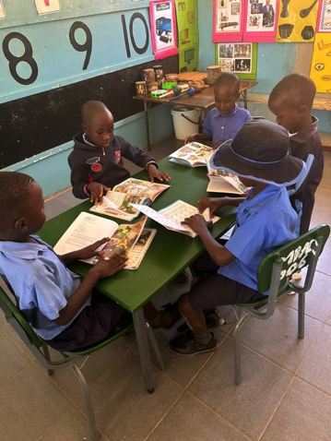Our boys 13 years and above went for a mentorship program in the Eastern Highlands in Nyanga for two days in December.

To start our new primary school we enrolled ten children in Grade 1 using an ECD classroom.

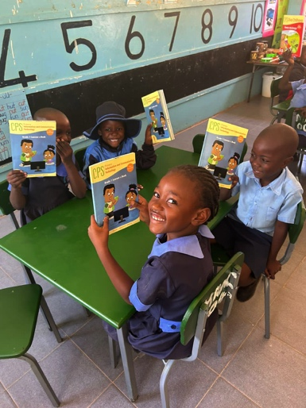

We need to assess the progress and manage the pressure of resources needed. We are engaging an extra teacher to take the other ECD class starting second term in May.

*(Money was donated last year for some Zimbabwe curriculum books)*

ECD is Early Childhood Development Centre

Our Sunday School choir (up to 13 years old) went from winning the circuit and district competitions up to national level when they won the Connexional trophy. Rev Linny Mutendzwa



Congratulations to the Sunday School choir, I wish we could hear them Ed

We are so proud of them for bringing the trophy home, it gave us something to celebrate in anxious times. It has been extremely hot in Zim, we have not received any rains at all which is not normal. The met office is predicting a drought and the situation is not looking good. We pray that we may be able to receive some kind of relief of rain as the heat has become unbearable.

Thank you for the kind gesture that the Friends have extended to the staff and children. You have been so kind when things were looking so bleak particularly for the staff. Kindly extend our appreciation for the wonderful gift. Zvirinane Matore

**Norton Methodist Church**

**Special Missions Project – 2023 – Matthew Rusike Childrens Home**

Norton Methodist Church (NMC) is part of the Stockton on Tees Circuit in the Darlington District located in the North-East of England. Every second year we run a ‘special mission project’ for the calendar year in support of a nominated charity. We have been doing this for over 20 years now, and we find this helps the church to retain a focus on an ‘external’ charity as well as provide fun, social and sometimes challenging activities and events for the church family and friends here in Norton.

During 2023 we chose to support the Matthew Rusike Childrens Home (MRCH) in Zimbabwe. This was in part because our current minister, Revd. Vincent Jambawo, originally came from Zimbabwe and was himself familiar with the work of the charity in Zimbabwe.

Through the year we aimed to raise money for MRCH through various fundraising activities and also become more aware of the work of MRCH. We signed up to receive the Friends of Matthew Rusike Childrens Home (FoMRCH) Newsletter and maintained a display board in the church for publicity, as well as regular articles in our monthly church newsletter.

We held a traditional ‘Smartie Tube’ challenge, where folk are given a tube of Smarties (other sweets are available !!) and invited to fill the empty tubes with 20p or £1 coins. This allows everyone in the church to take part in the fundraising at their own pace as they are able through the year, some filling several tubes and this alone raised around £1,000 for the project.



This year we held a sponsored cycle ride, visiting all the churches in the Circuit (around 25 miles in all)with prayers and singing held at each of the churches visited and ending with a picnic.

We also had a Cornish Cream Tea afternoon in the blazing June sunshine – soon to be replaced by a wet July and most of August ! (my wife Carolyn hosted this in our garden as a proud Cornish lady now living in the North-East !) – this is always popular (Methodists and food tend to go hand-in-hand !).

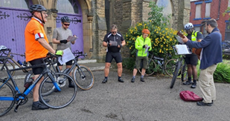

**Newsletter editor**

forward to take on this newsletter, which at the

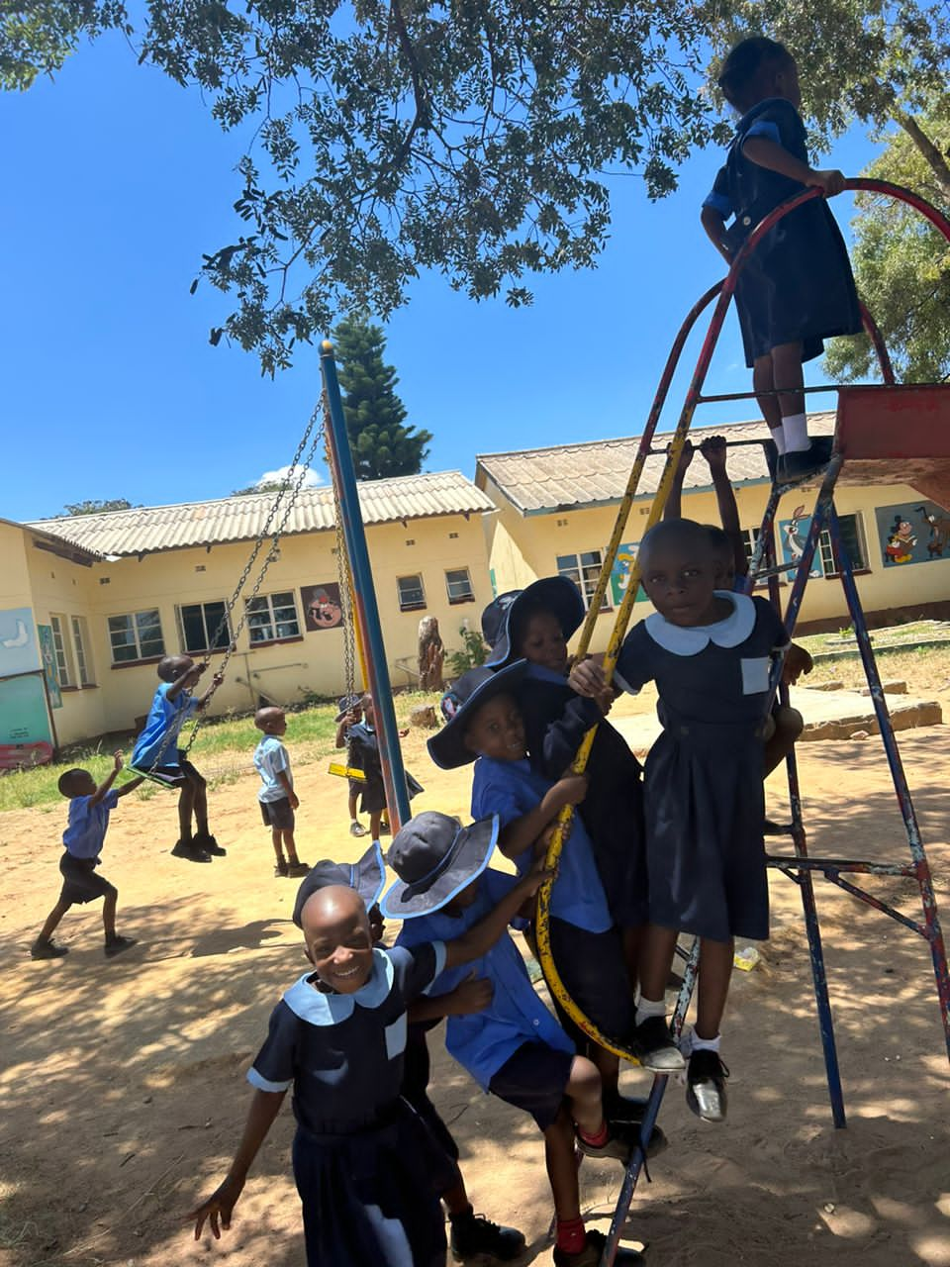

We also had several concerts in the church open to the local community, a fashion show and raffle, a children’s Irish Dancing display, and the making and selling of soft toys and both Christmas and Greeting cards for sale.

We also received several individual donations and contributions from our regular internal groups in the church.

In total some £4,500 was raised during the project year for MRCH (not including gift aid).

As a church we have been blessed by the opportunity to support MRCH – both in terms of developing a connection to the charity and their work in Zimbabwe amongst disadvantaged children - and having all shared in the fundraising activities themselves as a church family.

Steve Dye (NMC Missions Committee Chair)

*Thank you Norton Methodists for this fantastic effort for the children in Zimbabwe. I hope you have inspired another church to ‘adopt’ the children of MRCH for support in the future. Ed*

**More developments**

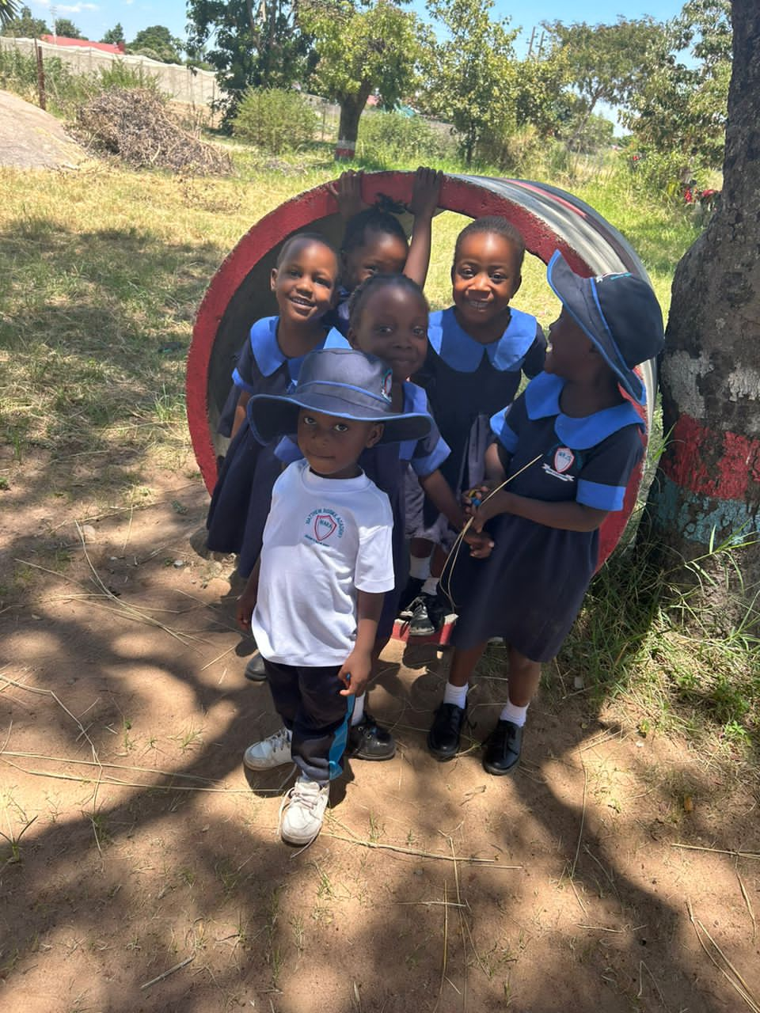A while ago we received a generous donation specifically for something which would bring happiness to the children. Some of this money refurbished the dilapidated outdoor play area. and painted murals on the walls of the ECD.

**Darnall Road Baptist Church, Sheffield**

A lady at this church has been making jams, chutneys and cards for several years raising money for the children and sending £100-150 to me every so often. Thank you, dear lady, for your loyalty and dedication to MRCH for so long.

**Outreach Centres**

The Outreach Centre at Donga is in a remote rural area and they too are struggling with water shortage and drought. The extreme heat was a disaster for their crops.

This and other Outreach Centres which are non residential but part of the MRCH organisation support local vulnerable families with school stationery, clothing and sanitary wear. They also aim to pay the school fees for these children but this is often in arrears.

Staff normally grow crops and keep pigs or poultry but getting feed is a problem. The borehole is shared with the community but water shortage is a problem here too. Unfortunately FoMRCH is not in a position to support these places but their need is also great.

**FoMRCH**

Occasionally I receive emails from people living in Zimbabwe who don’t realise we are based in the UK. These people are usually offering their services and wish to become volunteers at the Home. Sometimes they are social work students hoping for a few months internship. This opens their eyes to the great need of the children and their help caring for them is much appreciated by the MRCH management. Others just want to know what they can do to help or would like to visit MRCH and deliver goods they have collected. I direct them straight to Rev Linny Mutendzwa so they can make their arrangements with him. Carol Banham Ed

**Christmas cards**

Christmas e-card sales via Don’t Send Me a Card this year raised £211.00.

The most popular cards were: Shepherds and a star followed by Hot Chocolate

Tickhill Methodist Church had mince pies after their carol service and raised £453 with £255 being gift aided. *Thanks for your support*

**Archived newsletters** Have you thought of reading our past newsletters available on our website? They started in 2000 with a personal account of an 18 year old who volunteered at MRCH for 10 months before going to university to study her nursing degree. Over the years the newsletters illustrate the huge progress which has been made but also the stark fact that need has been there all along and some how the love and care continues from staff to children and between the children themselves.

**Our WEBSITE** has been upgraded but unfortunately with this wonderful technology supposedly to improve things, all the pop up photo captions have been wiped off. However the photos are still in topic places and years and we hope to add more. They are still downloadable for you to use in your fundraising.

**Can you Zoom (or use Teams)?**

One good thing to come out of the pandemic has been that we learned to use Zoom to ‘meet’ each other. Not usually the best way to get together but when committee members are spread around the country it is so much easier. We used to meet in churches in the Birmingham area but our members were from London, Suffolk, Bristol, Devon and we are in South Yorkshire. Now we are even able to have virtual meetings with Rev Linny and others living in Zimbabwe making catching up with situations and problems more detailed and immediate.

Have you learned to ‘Zoom’? Could you join our committee without leaving your armchair? Our meetings last an hour (they’re free that way) and are always on Saturdays from 10am. We have 3 a year including the AGM plus 1 with Zimbabwean colleagues.

**Newsletter editor**

Separate to this we pray someone will step forward to take on this newsletter, which at the moment is produced 4 times each year. I intend my last one being June 2024. Over the years the newsletters have kept us all up to date with news from the Home and the activities of our supporters generously fundraising in the UK.

**Please** consider these important needs and come and join us. Our support for the Home cannot continue without more people concerned about the welfare of these children. **Please contact any of the officers if you or anyone you know might be interested.**

**Thank you for your help in this**

Carol Banham (chair and editor)

# Contacts

Chair: Carol Banham  
64 Saffron Crescent  
Tickhill, Doncaster  
S Yorkshire  
DN11 9RU  
[carol2021@banham.net](mailto:carol2021@banham.net)  
01302 744 920

Secretary: Rev Audrey Standhaft

[aud.standhaft@outlook.com](mailto:aud.standhaft@outlook.com)

Treasurer: Niki Phillips 3 Badgers Green, Kingsbridge, Devon, TQ7 1UE [phillipstaxservices@hotmail.com](mailto:phillipstaxservices@hotmail.com)

Website:  
[www.friendsofmatthewrusike.org](http://www.friendsofmatthewrusike.org)

Registered charity 1120944