

**Friends of Matthew Rusike Children’s Home**

***A UK charity supporting Matthew Rusike Children’s Home in Zimbabwe***

**Newsletter, March 2025**

**Report from the home**



*Highlights from the latest report by the home’s National Director, Rev Linny Mutendzwa, to the Friends of Matthew Rusike Children’s Home, January 2025.*

______________________________________

Greetings from Zimbabwe.

We started 2025 on a positive note with the welcome return of the rains following last year’s devastating drought. The fields are green and rivers have started flowing, giving hope for good harvests. We thank the Lord for his mercies.

In cooperation with the Department of Social Development, we have begun the difficult task of reducing the number of children we support. So far we have closed two of our houses, bringing our total enrolment to 82 as of January. A number of these children are waiting to be discharged, reunited with parents or relatives or transferred to other institutions. This is a gradual process which we’re carefully monitoring to ensure the protection and wellbeing of every child.

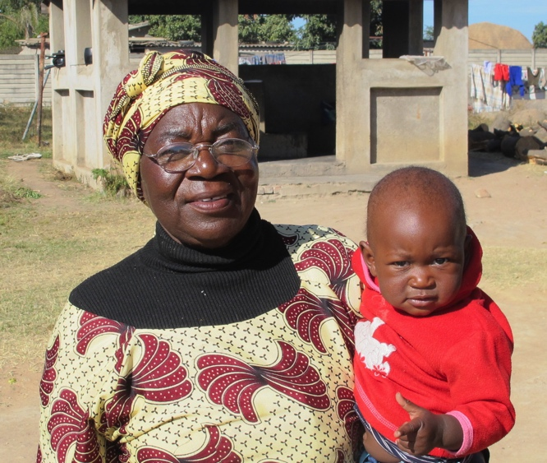Financial pressures also mean reducing the number of staff. Sadly, we were not able to renew the contracts of two of our caregivers when their contracts expired at the end of December.

In other staffing news, our social worker, Rumbidzai Mashoko, underwent a major medical procedure in December. We thank God that the operation was a success and she’s now recovering at home on medical leave. To cover her absence, we have taken on Lisa Razemba, a former social worker graduate trainee. Another serious health need concerns Tafadzwa, wife of Lloyd Kupeta at the Donga centre. Tafadzwa has not been well for some time and needs an operation, but this keeps being delayed for lack of funding.

Our concerns about food supply at the home have eased since last year when we were grappling with the effects of drought. We now have enough food in most of our basic requirements to cover three to four months ahead. We also have enough solar power during the day and into the evening to cover lighting, refrigeration and entertainment. This means our children can now use solar for their evening studies and homework. We still use firewood for cooking when mains electricity fails, but are now looking at the feasibility of cooking with gas.

Funds received from Solihull Methodist Church have gone towards the construction of a classroom block for our infant school. Floor plans are now in place and we’re engaging contractors to start the building work. The walls are expected to be complete by the end of April.

Our on-site projects are doing well, supporting the home with food and revenue from sales. We’ve enjoyed a good harvest of green mealies and continue to breed broilers, layers and free-range chickens in our poultry section. Our piggery is also thriving.

As always, we are grateful for your prayers and support. May the Lord bless you.

______________________________________

*A brighter future for the children of Zimbabwe*

**Money matters: where support is most needed**



Staff salaries are the main expense in running the home. In addition, these are some of the items from the home’s 2025 budget:

School fees, uniforms & stationery £4,300

Education & leisure trips £2,400

Food £4,000

Healthcare £2,000

Vocational training £1,500

Children’s parties £1,200

The first week of June sees the annual Matthew Rusike week when the home invites guests and lays on activities to raise support from local donors with these as its main funding priorities:

* Clear salary arrears and related statutory obligations
* Pay current salaries
* Pay school fees plus uniforms, stationery and other learning materials
* Maintain a health contingency fund to cover hospital treatments
* Recreational and educational trips for children
* Borehole projects at the home in Epworth and the outreach centres at Donga and Mzinyathi
* Finance the solar expansion project and the gas project for cooking
* The classroom project (construction of a new block will begin soon following support from Solihull Methodist Church, but another block is needed)
* Security (razor wire, outdoor solar lights and CCTV)
* Repair and maintenance of buildings
* Transport (the home’s minibus has been in use for over ten years and may need replacing soon).

***If you’d like to support a specific project at the home as a church, a group or an individual, please contact our Chair or Secretary to discuss options.***

**A message to supporters from Pupil C at Matthew Rusike\***

I am excited to share a little bit about myself with you, our dear friends in the United Kingdom. I want to start by saying thank you for your kindness and support. Your generosity has made a big difference in our lives and we are grateful for your friendship.

At school I enjoy learning new things, especially in subjects like mathematics, science and English.

My favourite teacher is Mrs Nyamandiyo who teaches us English. She makes learning fun and exciting.

Outside of the classroom I love playing sports, especially soccer and basketball. I am also part of the school choir and I enjoy singing with my friends.

Living at Matthew Rusike Children’s Home is like being part of a big family. We have caregivers who take care of us and we have lots of fun together. We play games, watch movies and go on outings. It’s a happy and loving environment.

I am proud to be a part of Matthew Rusike Children’s Home and I am grateful for the support of our friends in the UK. Your kindness has given us hope and joy and we are thankful for your friendship.

I hope you will continue to support us and be our friends. *Drawing by Pupil W*

______________________________________________

\**As a rule, we don’t publish names of Matthew Rusike children for reasons of privacy and confidentiality.*

**New horizons for Matthew Rusike leavers …**

***We’re sometimes asked what happens to young people when they leave the home, especially when job prospects in Zimbabwe are so limited. The answer can be surprising, especially for those with ambition and a sense of adventure.***



*With fellow applicants, Turkey-bound at Harare Airport*

Faith, Tinashe and Tendai, all former children at Matthew Rusike Children’s Home, are among a group of Zimbabwean youth who successfully applied for jobs in Turkey under the auspices of an organisation called Destiny Helpers Trust. Run by prominent members of the Methodist Church in Zimbabwe, the Trust helps young adults recently discharged from Zimbabwean orphanages to integrate into society.

By providing guidance, mentorship and coaching, it helps them to be self-reliant and to find and pursue appropriate academic, vocational or self-help projects. It also assists them in applying for scholarships and sponsorships with all support given free of charge.

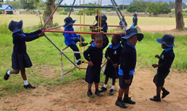After being discharged from Matthew Rusike Children’s Home, Faith took a training course and opened a beauty therapy shop by which she earned her living. Tinashe did a course in bricklaying and Tendai is a university graduate with a Certificate in Accounts. All three were offered job opportunities in Turkey where they’ve since relocated while remaining in constant touch with the home.

Faith, Tinashe and Tendai are testimony to the grounding they received at Matthew Rusike and the excellent work of Destiny Helpers Trust. We wish them well in their new lives and future careers.

**… and trips to Victoria Falls for two Matthew Rusike pupils**

Two Matthew Rusike children, a boy and a girl, went on separate trips to Victoria Falls in December.

The grade 6 girl was chosen on account of good behaviour and joined hundreds of children from Zimbabwe’s ten provinces on a nationally organised trip. The grade 7 boy was part of a visit organised by his school, Widdecombe Primary. This was generously paid for by Chivhu Methodist Circuit in Harare West District. It was a thrilling experience for both children and the home hopes for more such events in the future.

______________________________________

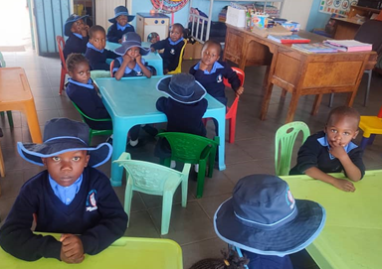

*Scenes from classroom and playground*

# Thank-you, Immanuel

On behalf of the Friends of Matthew Rusike Children’s Home, we’d like to thank Immanuel Mudzinge for all that he’s contributed to our work.



Immanuel joined us in 2017 as Treasurer, stepping in just when we needed him. He continued in this role until 2021, then carried on as a Trustee until December 2024 when ill health meant he needed to step back from this role.

Always thorough and thoughtful in whichever way he supported our charity, he’ll be much missed for his trusted advice on behalf of the Friends and the home. He’s been a valued member of our Executive Committee and we wish him well in his recovery.

Our current Treasurer, Niki Phillips, added: ‘I’d like to express my heartfelt thanks to Immanuel for his thorough and welcoming handover to me as the new Treasurer. With his knowledge and experience, he’s made an invaluable contribution to our work.’

**UK fundraising**

**Christopher Solomon of Ben Rhydding Methodist Church in Ilkley reports on the church’s fundraising this year for Matthew Rusike Children’s Home. Concentrating on one project in particular, the church aims to raise enough to fund the solar power needed to operate the borehole.**

‘Enter the church and you can't miss the notice board featuring colourful photos reminding folk that Matthew Rusike is the focus of our "Charity of the

Year". Enter the church hall on almost any Friday of the year and you’ll find church members and friends enjoying a community lunch. The soups, cakes and drinks on offer are top quality and the profits provide income for the charity.’

The church has so far raised over £1,000 for the home and is now hoping to engage the local school in the solar project.

# C:\Users\Graham\Documents\MRCH newsletter March 2025 WIP\Ben Rhydding.png

# *Local fundraising makes a huge difference to life at the home. If other supporters are involved in fundraising events, we’d love to hear about them – even better if they come with photos for including in future newsletters. We’d also welcome fundraising suggestions – things you find have worked in the past – for sharing with our readers. Do please get in touch with Debbie Berrill (details below).*

# ___________________________________

# Contacts

Chair: Rev Ed Standhaft  
[edstandhaft@sky.com](mailto:edstandhaft@sky.com)

Tel: 01749 701121

Secretary: Rev Audrey Standhaft [aud.standhaft@outlook.com](mailto:aud.standhaft@outlook.com)

Treasurer: Niki Phillips 3 Badgers Green,

Kingsbridge,

Devon TQ7 1UE [phillipstaxservices@hotmail.com](mailto:phillipstaxservices@hotmail.com)

News contact: Debbie Berrill

[debbieberrill@gmail.com](mailto:debbieberrill@gmail.com)

Tel: 07905 277766

**Website:**  
[www.friendsofmatthewrusike.org](http://www.friendsofmatthewrusike.org)

­­­­­­­­­­­­­­­­­­­­ *Registered charity 1120944*