

**Friends of Matthew Rusike Children’s Home**

***A UK charity supporting Matthew Rusike Children’s Home in Zimbabwe***

**Newsletter, June 2025**

**Report from the home**

**

*Highlights from the latest update by the home’s National Director, Rev Linny Mutendzwa, to the Friends of Matthew Rusike Children’s Home, June 2025.*

_________________________

We continue to face enormous challenges, particularly in terms of funding. All the same, we continue to praise God and are profoundly grateful to the Friends of Matthew Rusike for your support and prayers.

This month saw the annual Matthew Rusike Big Sunday when around 700 supporters and friends braved the chilly June weather to enjoy fellowship with our staff and children. It was a memorable occasion with children showcasing their talents through music, drama, speeches and poems. Our guest speaker was the General Secretary of the Zimbabwe Council of Churches, Rev Wilfred Dimingu, who delivered a powerful message encouraging the local church to support childcare work.

The event at the home in Epworth on 8 June raised over US$6,500 while a similar Big Sunday at our childcare centre at Mzinyathi a week later raised over US$1,300. We also benefited from donations in kind which have significantly improved our food stocks.

That said, finance remains a struggle with debts currently exceeding US$170,000. That’s mainly in the form of salary arrears and I pay tribute to the dedication of our staff who continue to run the home and to care for our children under such difficult conditions.

Given the need to cut costs, we continue to reduce capacity in consultation with the Department of Social Development. We now have 76 children in our care against a target of 60. The next phase is to discharge 12 children who’ve reached the age of 18 while ensuring all necessary protection for those involved.

Our Early Child Development (ECD) centre prepares younger children for primary school and we’re in the process of upgrading it into an

infant school. In March, Presiding Bishop Rev George Mawire officiated at the ground-breaking ceremony for a new classroom block.

A grant from Delta Zimbabwe has allowed us to improve security at the home. We now have CCTV in the piggery and poultry sections and around the administration block with solar-powered floodlighting on the housing units. In addition, all the houses now have gas cookers with refillable canisters to cope with power cuts. In the outreach centre at Donga, capacity testing at the borehole indicates that there’s enough water for domestic purposes and work is under way to install a solar-powered pumping system.

In staff news, our social worker, Rumbidzai Mashoko, is back at work after an operation in December. Our cook, Susan Muziri, is also recovering after a major procedure while Tafadza, wife of Lloyd Kupeta at the Donga centre, is improving after her operation.

We praise God for the successes of some of the young people who’ve recently left us. Three are happily employed in Turkey, seven are at college or university studying subjects ranging from forensic accounting to law and theology and 12 are undertaking vocational skills training. Two of our children passed Advanced Level with flying colours.

Again, my heartfelt thanks for your prayers and support. May the Lord bless you.

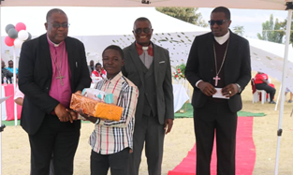

*Big Sunday included awards to children in a range of categories from hard work to academic performance to sport. Presiding Bishop Rev George Mawire was on hand to present the awards.*

**Staff recognised for many years of dedicated service**

# 

# Big Sunday awards went not only to Matthew Rusike children, but also to long-serving members of staff. Faith Marugasi, Abel Muziri, Julius Mwale, Susan Muziri and Lloyd Kupeta received awards for periods of service ranging from 26 to 37 years – testament to their dedication over many years to the home and its children.

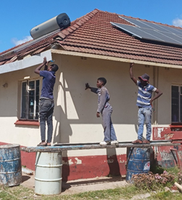Lloyd (pictured) is known to many of our supporters for his difficult work in charge of the outreach centre at Donga, often battling drought and lack of essentials such as electricity and transport to continue running the community-based childcare programme in Zimbabwe’s Midlands Province. The programme focuses on the educational needs of over 80 disadvantaged children, including the provision of school fees.

In the picture below, children in Donga receive gifts of precious school stationery.

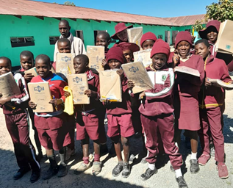

*Friends’ Chairman, Rev Ed Standhaft, reflects on the challenges facing the home and its supporters in this extract from his report to the 2025 AGM.*

**The year 2024 was a challenging year for the home and for the Friends. Conditions in Zimbabwe affected the home in radical ways. The years of drought, the high inflation rate, global warming and poor harvest meant that local support in Zimbabwe declined despite noble efforts by the home. In the UK, our supporters grow older, churches see fewer numbers, and support for overseas work in general declines. Thus our support-base has become smaller and, since Covid, churches do fewer fundraising events. We are greatly indebted to the Zimbabwean Fellowship groups in the UK for their support for the home and for the efforts of some churches who have made the Matthew Rusike home a major project. Individual legacies are growing, often from unknown sources.**

# *A grant from a local golf tournament fund has been used for repairs to staff and childrens’ houses and the home’s admin block. The work has covered plumbing, electrical repairs, leaking roofs, ceilings and floor tiles.*

**Success for Matthew Rusike Sunday School choir (in uniforms provided by the Friends)**

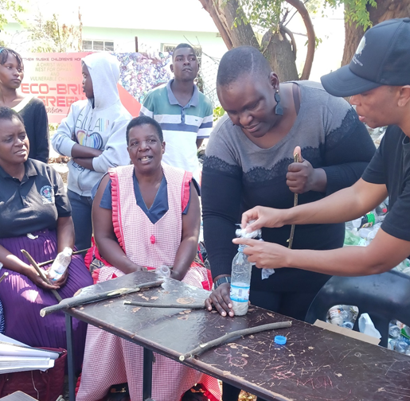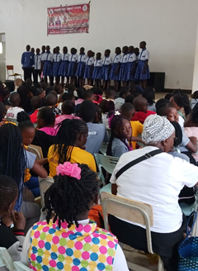

The Matthew Rusike Sunday School choir has been performing in Zimbabwe’s Circuit and District competitions, coming first at Circuit level in music and drama. Competing with 21 other groups at District level, the choir gained first place in drama and second in music. The Matthew Rusike choir director was voted best director of the tournament. Congratulations to all involved.

Before the competition, the home was looking for a donation to buy material and pay a tailor to make uniforms for choir members. Thanks to a gift from the Friends, the members were able to look their best on stage.

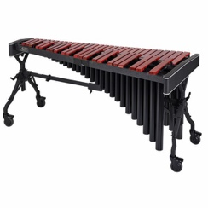As a result of these successes, there’s growing interest in music among the children at Matthew Rusike and the home is looking to acquire more instruments including keyboards, guitars, drums and marimbas.

**Bottles into bricks**

On 21 May, staff and children at Matthew Rusike took part in a waste-management project run by a South African organisation called Earthly Touch. Known as Ecobrick, the project involves collecting soft plastic waste and empty plastic bottles and turning them into bricks capable of being used in construction. It’s possible that bricks made from plastic waste could even be used to build classrooms at the home. People from the surrounding community and schools also attended the event.

Earthly Touch are pioneers of the concept in South Africa and were introduced to Matthew Rusike though the home’s board member, Dr Miriam Mukorombindo. The home is now engaging with local schools and churches to encourage the collection of waste plastics.

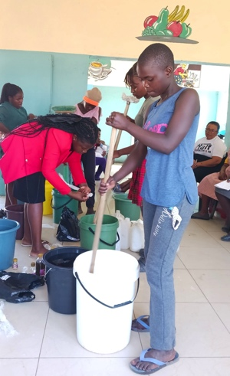

____________________

*Also on 21 May, children and staff were taught to make detergents such as washing-up liquid, pine gel and toilet cleaner – potentially useful skills for life after the home.*

**Donga water project**

The outreach centre at Donga provides practical support for vulnerable families in a remote part of Zimbabwe particularly prone to drought. Borehole drilling has always proved difficult, but recent testing shows the new borehole yielding enough water for domestic purposes. The centre is now going ahead with solar and pump installations.



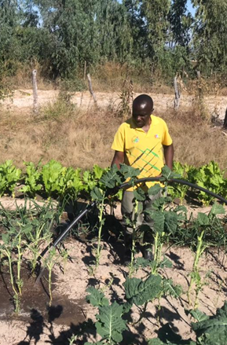

**Are you a potential sponsor?**

We know that some supporters are interested in sponsoring a Matthew Rusike child through school or paying a teacher’s salary for a period.

Boarding school fees for a child are roughly £330 a term or £1,000 a year – less for day pupils. Uniform, books, stationery and pocket money would add about £890. A teacher is paid £310 a month, giving an annual salary of £3,720 (all depending on exchange rates).

If this would be of interest to you as an individual, a group or a church, or you’d simply like to know more, please contact Debbie Berrill (details below).

# ___________________________________

****We get a lot of cheques that have to be sent back to the donor because they’re made out to Matthew Rusike Children’s Home and won’t be accepted by our bank. We appreciate all donations, but please make cheques out to our official name which is ***Friends of*** Matthew Rusike Children’s Home. Thank you.

# ___________________________________

# Contacts

Chair: Rev Ed Standhaft  
[edstandhaft@sky.com](mailto:edstandhaft@sky.com)

Tel: 01749 701121

Secretary: Rev Audrey Standhaft [aud.standhaft@outlook.com](mailto:aud.standhaft@outlook.com)

Treasurer: Niki Phillips 3 Badgers Green,

Kingsbridge,

Devon TQ7 1UE [phillipstaxservices@hotmail.com](mailto:phillipstaxservices@hotmail.com)

News contact: Debbie Berrill

[debbieberrill@gmail.com](mailto:debbieberrill@gmail.com)

Tel: 07905 277766

**Website:**  
[www.friendsofmatthewrusike.org](http://www.friendsofmatthewrusike.org)

­­­­­­­­­­­­­­­­­­­­ *Registered charity 1120944*