Friends of Matthew Rusike Children’s Home
A UK charity supporting Matthew Rusike Children’s Home in Zimbabwe
Newsletter, September 2025

Report from the home


Earlier this month, Executive Committee member Michael Mapako visited Matthew Rusike Children’s Home in Harare and interviewed its National Director, Rev Linny Mutendzwa. He reports back with the latest from the Home.

Helped by the ending of Zimbabwe’s lengthy drought, food supplies for the Home are more secure than they have been for some time. Thanks to improving conditions, local supporters are better able to donate gifts in kind such as cooking oil. That said, the Home still faces intense financial pressures, especially in the payment of staff salaries which remain several months in arears.

Previous reports have mentioned the drive to cut costs by reducing the number of staff and children. This continues. The Home has now laid off four house-mothers after their contracts expired and is making up the loss by recruiting volunteer relief mothers for a small token payment each month.

The number of children fell from 82 in January to 71 in August. Since then, however, a foster mother with several children in her care has died and three of her children have had to be transferred to the Home – an illustration of the desperate need that still exists in Zimbabwe.

“We thank God for keeping our children in good health,” comments Linny. “We’ve had no serious issues, though it’s always a challenge to make sure we have sufficient stocks of medicines.”
The on-site projects are doing well, providing food for the Home and revenue from the sale of produce. Crops grown on the compound include green mealies, tomatoes, peppers, butternut, cabbages, lettuce and onions. Chickens and pigs provide further food and income.

A generous donation from Solihull Methodist Church in UK has gone towards the construction of a classroom block with two learning halls for the Home’s infant school. The project is now at roof level and due to be completed with help from the Methodist Church of Zimbabwe. Longer term, the aim is to expand the school to take in more fee-paying pupils and use the income to benefit the Home.
Water projects are top of the agenda for the community-based childcare centres at Donga and Mzinyathi. The borehole project at Donga has now been completed and work is under way to install solar-powered water supplies at Mzinyathi. Both centres are embarking on fund-raising projects for their infrastructure and community programmes.
I came away impressed, as always, by the hard work and dedication of the staff, battling difficult conditions to provide a better future for Zimbabwe’s children. And the Home, of course, remains immensely grateful for the interest and support of all its UK supporters.
______________________________________
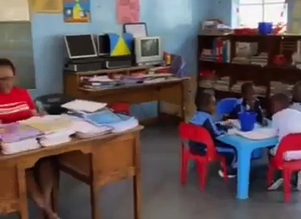

A detail from a two-minute video showing some of the buildings and activities at the Home (including the new classroom block) and giving an insight into daily life at Matthew Rusike. Produced to help with UK fundraising, it’s available online by looking up VIDEO-2025-09-15-09-14-41.mp4

Donga water project
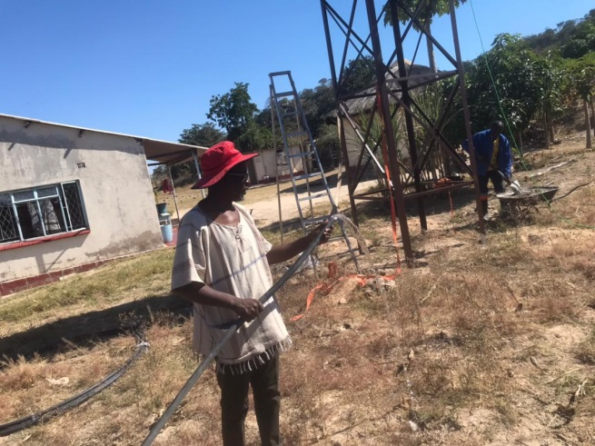
The outreach centre at Donga supports vulnerable families in a remote part of Zimbabwe particularly prone to drought. A borehole has long been needed and has now been completed with financial help from the Friends of Matthew Rusike Children’s Home. The pictures show more of the project in its final stages.

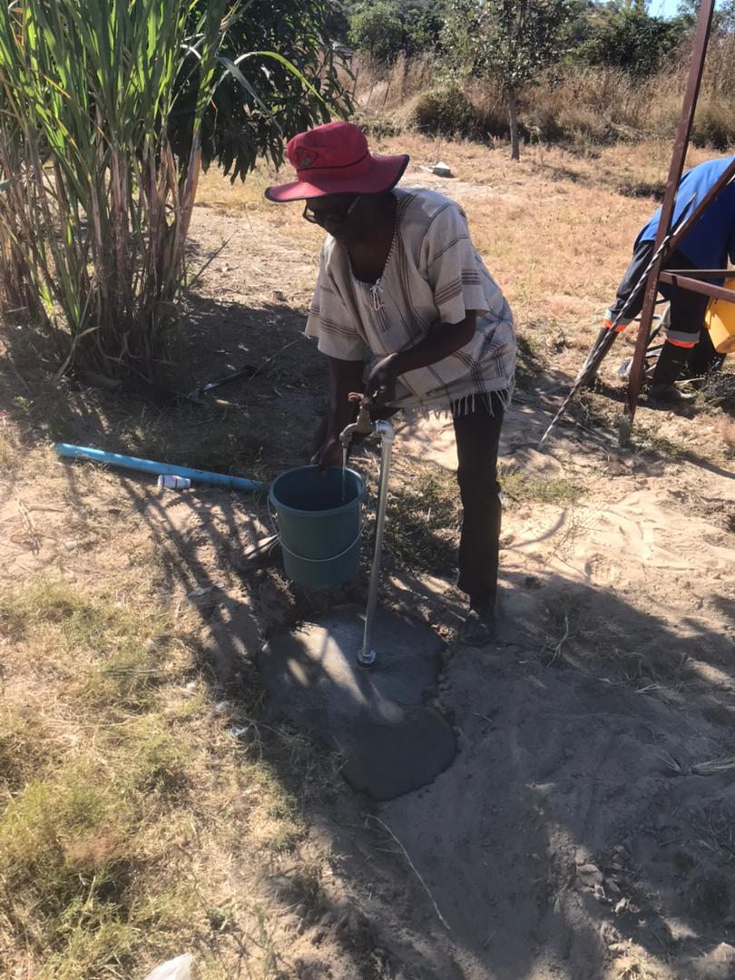
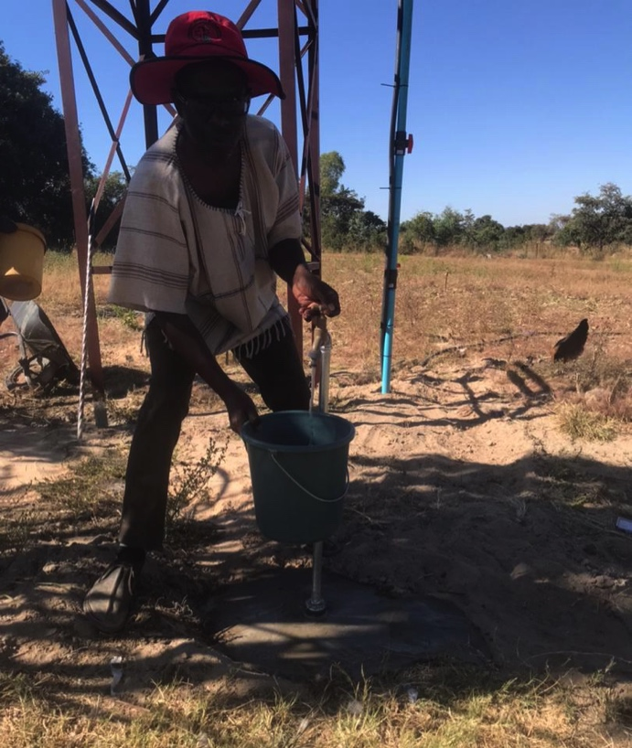

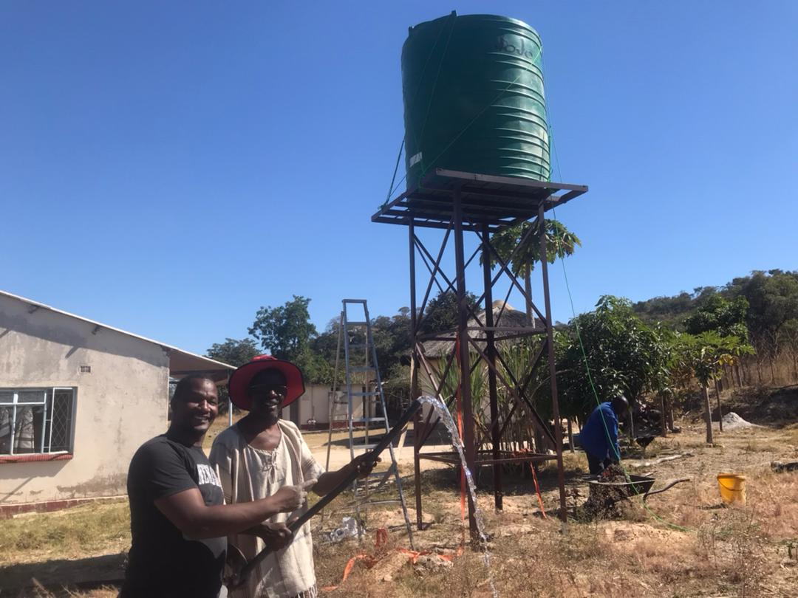
______________________________________

Shirley Richer
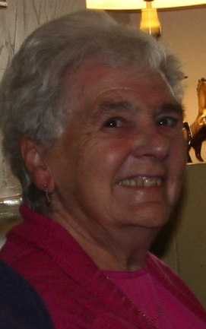
We’re sad to announce the death of Shirley Richer, a founder member and past secretary of Friends of Matthew Rusike Children’s’ Home. With her husband John, also a past secretary, Shirley visited the Home in 1996 as the charity was being started. Secretary from 2000 to 2004, she led the 20th anniversary fundraising appeal in 2016 and another in 2018, each of which raised about £5,000. Among her many contributions over the years, she always provided a good cuppa for Committee meetings. We’ll miss her greatly and extend our sympathies to daughters Gail and Kathryn and all the family.

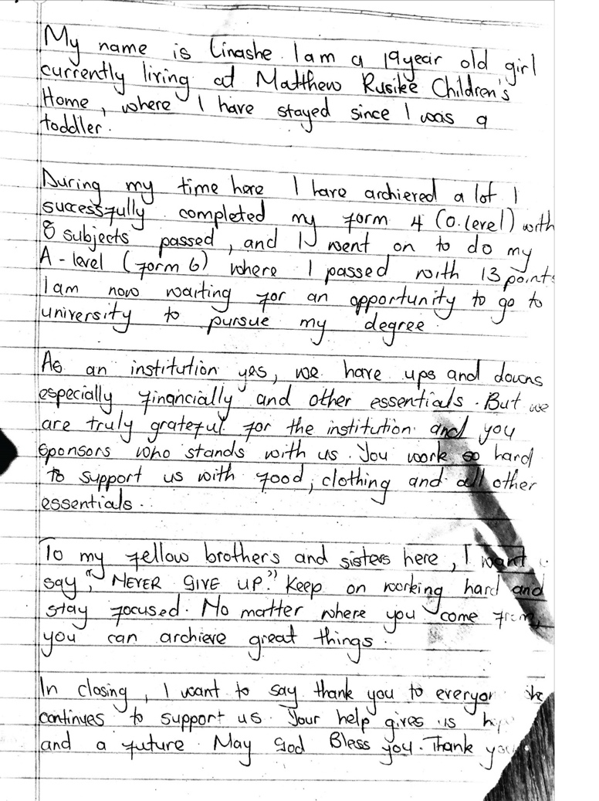
Gallery: how it looks from the children’s point of view

A selection of artwork from some of the very young members of the Home and a letter to supporters from one of the oldest.

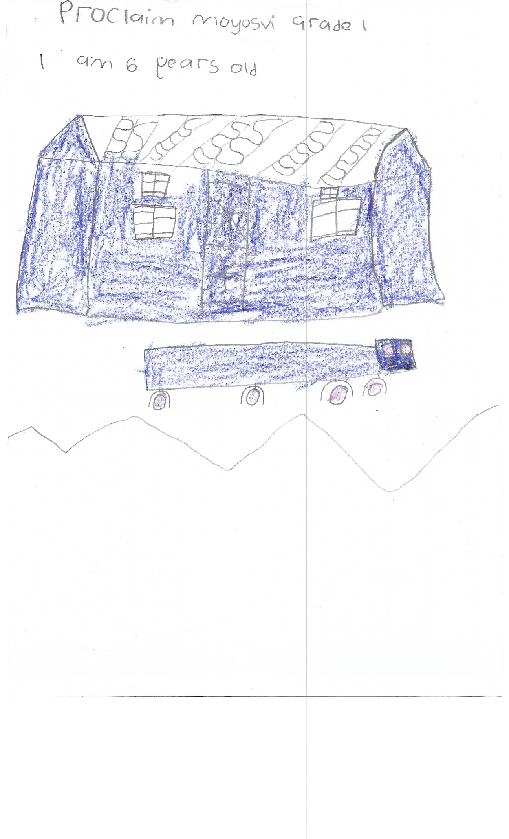






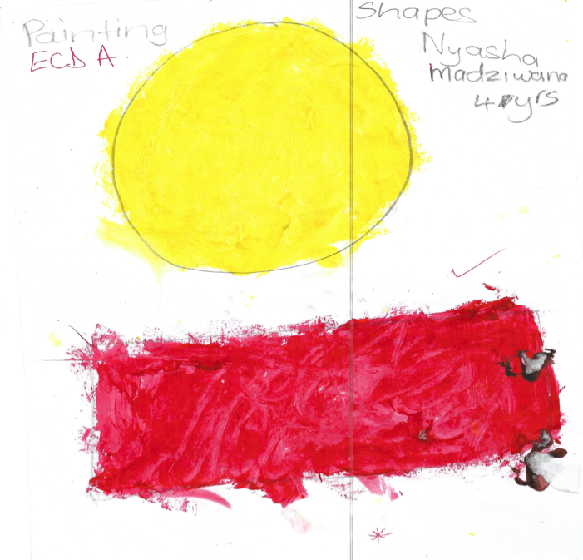

______________________________________

Christmas cards

With Christmas in mind, we can offer a variety of electronic cards. These are a great way to avoid the cost of physical cards and stamps and you may like to use the savings as a donation to the Home. For details, go to our website (see page 4) and look under ‘How you can help’, or go direct to:

https://www.dontsendmeacard.com/ecards/charities/friends-of-matthew-rusike-childrens-home

UK fundraising

Cambridge Road Methodist Church in Birmingham is the venue for a Matthew Rusike awareness-raising day on 4 October. Committee member Michael Mapako will be reporting back on his visit in September, providing an insight into life at the Home and the challenges it faces. We also hope to arrange a live link with Zimbabwe to speak to National Director, Rev Linny Mutendzwa. Refreshments and a light lunch will be available and we welcome any supporters to join us on the day if you can. Please contact Debbie Berrill (debbieberrill@gmail.com) with any queries.



A year of fundraising for Matthew Rusike Children’s Home has just come to an end at Ben Rhydding Methodist Church in Ilkley with £4,000 raised in the course of the year. Aware of the need for solar-powered pumps for the Home’s boreholes, one church member raised over £300 by walking 14 miles round two local reservoirs – ‘raising money to raise water’. Other funds came from profits from the church's weekly community soup lunch and after-service coffees on Sundays.

In Wells, committee members Audrey and Ed Standhaft have raised funds this summer by providing Somerset cream teas. Along with proceeds from a church coffee morning in August, they contributed just under £500.

A church in Leeds has just ‘adopted’ Matthew Rusike Children’s Home for a year and we hope to bring news of more churches doing the same in the coming months. In addition, one of our supporters is covering the cost of a primary school teacher’s salary which is remitted on top of our usual monthly donation.

Huge thanks to all those who’ve helped to raise funds in the course of the year – it really does make a difference. Among the many ways we’ve used donations this year, we’ve funded gas stoves and tanks for the Home, helped repair the generator, provided choir uniforms and enabled the borehole at Donga to be completed.

Particular thanks to James M. who’s been donating funds into our bank account for some time. We don’t have contact details, so are unable to thank him personally, but his contributions are much appreciated. Thank you, James!

___________________________________

Contacts
Chair: Rev Ed Standhaft
edstandhaft@sky.com
Tel: 01749 701121

Secretary: Rev Audrey Standhaft aud.standhaft@outlook.com

Treasurer: Niki Phillips 3 Badgers Green,
Kingsbridge,
Devon TQ7 1UE phillipstaxservices@hotmail.com

News contact: Debbie Berrill
debbieberrill@gmail.com
Tel: 07905 277766

Website:
www.friendsofmatthewrusike.org

Registered charity 1120944

